In Memory of my super boss and Godfather--Rev. Dr. Thomas Wang (February 20, 2018)
Juno Wang – former staff of GCI, serving with the Late Rev. Thomas Wang

I have just completed the second module at Western Seminary, and finally have time to reflect and write out my grief of losing my super boss and Godfather, Dr. Thomas Wang, on January 4th. To lose a person who is closer than my birth father is hard, especially when I was on campus this time and recalled him talking about attending my graduation once I finish my doctoral study.
When I just joined the Chinese mission organization founded by Dr. Wang years ago, I was only a two-year old Christian and had never heard about him. After he returned from a Russia mission trip, we finally met but had a hard time adjusting to each other for working together. Dr. Wang had to put up with me a lot as he is a perfectionist, I would say, and very busy because of his global mission leadership. I was a new graduate without any work experience and was also well pampered by my father growing up. During the probation, once after he corrected my mistake and told me not to cry, I could not hold my tears and went to the restroom to cry. A harsh boss with two big eyes was my first impression of him. After working alongside him further, I began to realize why he always strives to serve the Lord with his best. He taught me that a mission organization needs a well-equipped soldier to fight for the Lord, which is different than a church. He kept putting up with me when I followed him from Pasadena to Dallas to Sunnyvale. I learned to tell what his emotions were from his eyes.
As Dr. Wang got older, jet lag became a struggle for him after each trip. Many times, he had to keep on with his next trip even before he recuperated from the last one. He had to get over the fatigue and continue to travel for global missions, and he would ask me and the staff to pray for him. Because of the demand of his global missions ministry, he sacrificed his time with family and he regretted it later in life. Serving with him for almost 18 years, I rarely had opportunities to arrange for his vacations. Throughout those years, several times we had financial crises, but God has always provided in various miraculous ways, and I have learned to trust God for His provision while working with him.
After knowing Dr. Wang was hospitalized from a fall the day after Christmas, I had a hard time talking with him at Stanford because I was used to looking at him when we conversed, but his enlarged pupils could not see anyone clearly. For my first two hospital visits, I only went to pray with him and left. It was heartbroken to see him struggled to breath during his last few days, yet he was truly a fighter. The day before he passed away, I went in his room and held his right hand to pray for a miracle. While I was saying my prayer, I noticed that he was very responsive and talking to God through his throat even though he was breathing hard. After prayer, he opened his eyes to look at me and I saw a miracle. His irises changed to gray and pupils were normal and in orange color. We saw each other eye to eye. After talking to him for a minute or two, suddenly I saw in his eyes that he was upset and then he shouted a word, smile in Chinese笑, from his mouth loudly. In spite of his suffering, he still did not want me to cry. I have never realized how strong his fatherly love for me was until then.
That night I went to visit him again after he was sent back home for his last hours, his eyes were wide open and filled with hope when I played “Nearer, My God, to Thee” and “Face to Face with Christ, My Saviour” two hymns for him through my cell phone. He had no fear of dying and was ready to meet the Lord whom he has served faithfully for 60 years. Few hours later, he became unconscious until he passed away the next morning. Dr. Wang is a man who used up all his time and energy for the Lord. He can finally rest in Jesus’ arms now.
Last February, Dr. Wang called and invited me to be his Goddaughter and to attend a gathering for all of his immediate family members and Godchildren. At the end of the gathering, he asked if we would all gather again as a family this year, but said he might not live. After that gathering, his health began to deteriorate from kidney dialysis. Last month we did gather again, but it was for his memorial service. Please pray for Mrs. Wang as she is mourning over the loss of a partner by whom she had been fully supported for 55 years. Dr. Wang told me several times that without her bravery to marry and support a yet-to-be-known Chinese minister when they met, he would not be able to develop the ministries throughout his life. My hat off to Mrs. Rachel Wang.
So Long, Dr. Wang! 王牧師, 再見了.
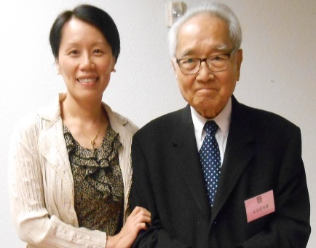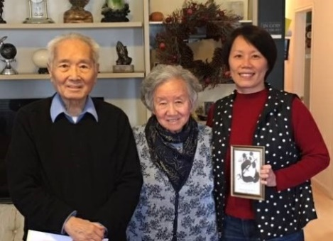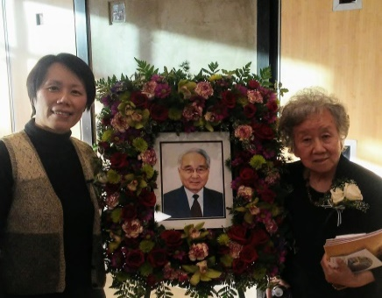
My only solo photo with Dr. Wang taken during his 90th birthday celebration in 10/2015.
With Godparents during family gathering in 2/2017.
Sample colors of Dr. Wang’s eyes I saw on 1/3/2018.
With Mrs. Rachel Wang after the memorial service on 1/27/2018.

《环球华人宣教学期刊》 第52期 2018年4月号

