圣 乐 共 赏

愿主赐福保守你

" The Lord Bless You and Keep You "-----in Chinese

Deborah Ko 高黄秀珍女仕 (Soprano) Peter Tang, M.D. (Tenor)

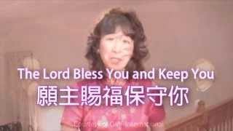

神未曾应许" Tribute to Miss Barbara Fei "----------------in Chinese and English
Music Video by Deborah Ko高黄秀珍女仕

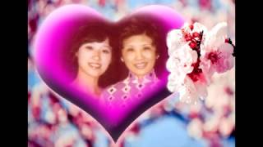

有福的确据 " Blessed Assurance "------------------in English
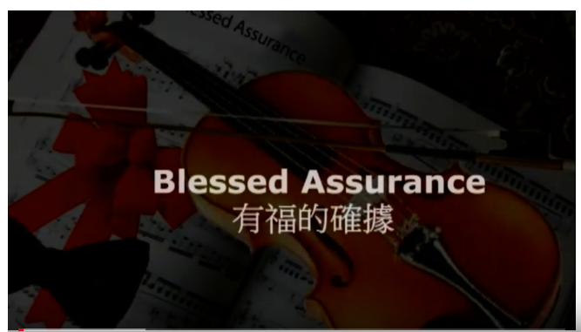

祂看顾麻雀 " His Eye is on the Sparrow "------------in English
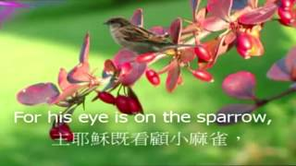
His eye is on the Sparrow version 2017

《环球华人宣教学期刊》 第55期2019年1月号

