我挚爱的爸爸

女儿 梁家恬 (2022 年 2 月 19 日)

今天是个非常难过的日子，但是我们在这里庆祝我爸爸美丽的一生之际，我也要借此对他怀念及致敬。

世上的爸爸应该是值得人敬重，是会保护和引导儿女，亦是会倾听和成为他们诉心声的对象。最重要的，爸爸应该是我们生活中所有大小事都可以分享的人。我很感恩也很高兴，自己可以站在这里告诉你，我的爸爸不单让我拥有这一切，并且远超以上所说的。
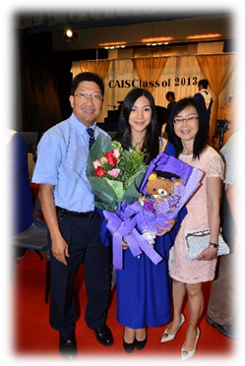
我的爸爸是一位了不起的父亲，他非常聪明，总有办法解决所有问题。无论是修理房子里的东西，还是帮助和教导我完成学校功课，他总能够找到超有创意及出色的方法。在找到解决方法以前，他绝不放弃。虽然他的工作很繁忙，也因事工之故需要经常到其他国家出差，但他总是预留时间给家人。他从没有缺席我的学校活动，不论是乐团音乐会、音乐剧、科学展览或比赛，他一定到场支持我。我特别记得，在过了更改期后，他仍为我更改航班的日期，以确保能够出席我的中学毕业典礼。这只是众多例子之一，他以我的人生里程碑为优先考虑，无论是大是小，这对我而言意义非常重大。

对我妈妈来说，他也是一个了不起的丈夫，我有幸成长于这个家，并见证著这牢固且充满爱的婚姻。在任何境况下，他总是有耐性、喜乐和体贴。他爱我们家庭的方式展现了上帝无条件的爱。

他不单是一个了不起的爸爸和丈夫，他还会透过付出自己的时间来帮助他人，以回馈及服侍上帝。在疫情以前，我记得我们家常常有不同的客人，因为爸爸妈妈会为着能用自己的家来彰显上帝的爱而快乐。我的爸爸不单是众人的好导师，同时也是我的最佳导师。我们之间的倾谈，他给予的意见，不单是从一位父亲的角度出发，也来自作为朋友的角度。我们称自己是一对知己，因为我们就是这样相处。我们有无数的秘密笑话及有趣的对谈，是我会永远怀念的。
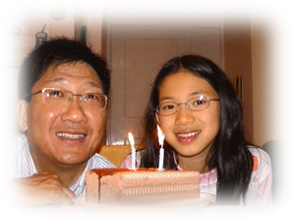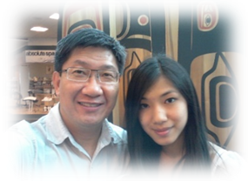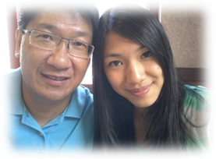

我的爸爸是一个勇于冒险的人，正如很多人都知道。他喜欢行山、露营、旅行和体验这个世界。我很感恩，他让我有机会与他一起到访不同的国家。我通过这些短宣及旅行所获得的文化及生活体验是无法测量的。透过这些旅程他总是以最适切的方式，将我带出个人的安舒区，鼓励我克服我个人的恐惧，并且总会在我跌倒时扶起我。我感谢上帝，让我可以与他一起经验这些冒险之旅。
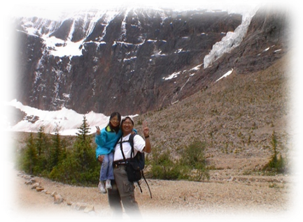
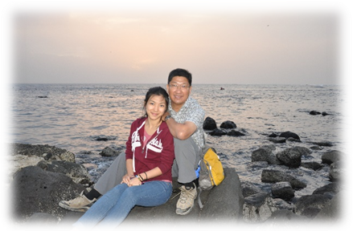
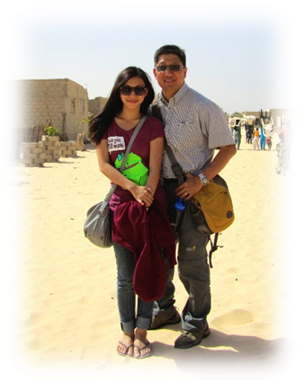
我的爸爸也喜欢且擅于摄影。今日我回顾他所拍下的照片，我很感恩他记录了那些美丽的时光。其实有很多次，我因为不想拍照而表现得烦躁，但现在我非常感谢他当时把照片拍下来，因为我可以一次又一次通过这些照片，去回顾我们生命所走过每一页的场景。

亲爱的爸爸，我很怀念和珍惜与你一起的美丽回忆。你教导我明白，无论做什么，最重要是爱上帝，秉持正直，并且尽力而为。我怀念你的幽默风趣，你的勇气，你的慷慨，和你的善良，这些都不会被人遗忘。感谢你成就了今日的我，纵使你已不在这里，我会永远记得你是最无懈可击的爸爸，因为你的生命是我和你身边所有人的祝福。我爱你，期待我们再次相见的一天。

My Dearest Daddy

By Chariss Leung (February 19, 2022)

Today is a very hard day, however we are here to celebrate the beautiful life of my dad and I want to take the time to remember and honor the person he was.

Dads are someone to look up to, someone to protect and guide us, someone to learn from and respect, someone to listen and talk to, but most of all, someone to share everything life has to offer with. I am so grateful and happy that I can stand here and tell you that I have had all this and so much more with my dad.
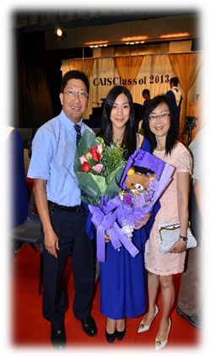
My dad was a wonderful father. He was so intelligent and always had a solution for everything. Whether it be fixing things around the house, or helping me with my school projects, he always found a way to be super creative and skillful. There wasn’t a moment where he ever gave up until he found an answer. Despite his busy schedule with work and travelling to other countries regularly for his ministries, he always made time for family. He never missed a single school event of mine, all my band concerts, musicals, science fairs and competitions; he made sure he was there to support me. I remember specifically, him moving his flight dates after the deadline had passed already, to make sure he could attend my college graduation. This is just one example out of many others, where he prioritized every single milestone in my life, whether it be big or small, and that is something that means so much to me.

He was also an amazing husband to my mom, and I have had the privilege of growing up to, and witnessing a strong, loving marriage. He was always so patient, joyful and thoughtful in every circumstance. The way he loved our family demonstrated the unconditional love of God.

He wasn’t just an incredible father and husband though, he wanted to give back and serve God by dedicating his time to helping others. Before Covid, I remember us always having different guests at our house, because it brought joy to my dad and mom to be able to use our home to spread God’s love. My dad was a great mentor to many people, including myself. The conversations we’ve had, and the advice he gave me in life did not only come from the perspective of a father, but also as a friend. We called ourselves a pair, because that’s what we were. We had so many inside jokes and fun talks that I will miss.
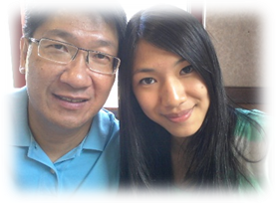
My dad was an adventurous guy, as I’m sure many of you know. He loved to go hiking, camping, travelling and just experiencing the world. I’m so grateful that he gave me the opportunity to go with him to so many different countries. The amount of cultural and life experience I’ve gained though these trips, is immeasurable. Through our travels together, he pushed me out of my comfort zone in the best ways, encouraged me through any fears I had, and was always there to pick me up when I fell down. I thank God that I got to go on all these adventures with him.
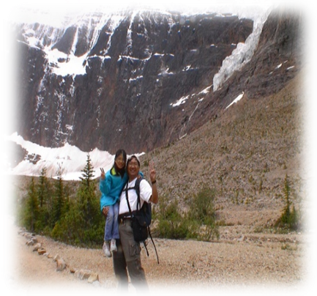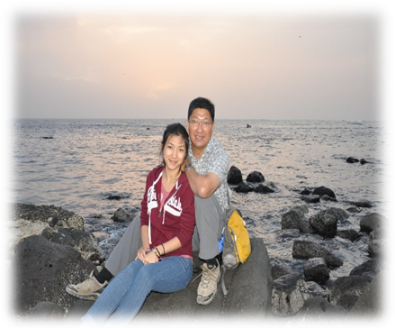

My dad loved photography as well, and he was amazing at it too. Today I look back at all the photos he took, and I’m so thankful that he captured all of those memories. There were so many times I got cranky because I didn’t want to get my picture taken, but I’m glad he did now because I get to revisit all the chapters in our lives again and again through these images.

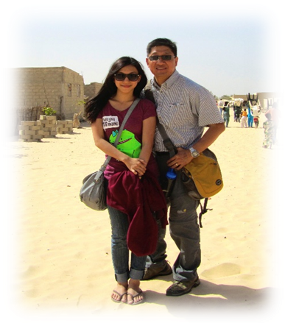
Daddy, I cherish all the memories I had with you. You taught me no matter what I do in life, as long as I love God, have integrity, and do my very best, that’s all that matters. I miss your humor, your courage, your generosity and your kindness, but they will not be forgotten by anyone. Thank you for building me up to the person that I am today. Even though you are no longer here with us, I will forever remember you as the most incredible dad, because your life was a blessing to me and everyone around you. I love you, and look forward to the day we will meet again.

《环球华人宣教学期刊》第六十八期 Vol 7, No 2 (April 2022)

