Remembering Our Beloved Rev. William Leung

Andrew & Gigi Mak
Board Member - Alliance Global Serve Canada

We have known William and Sharon since 1989 when they moved from Toronto to Edmonton and have maintained our long time friendship ever since. We count our great blessings to be able to serve together at the Edmonton Christian Community Church (ECCC) as well as at Alliance Global Serve Canada.
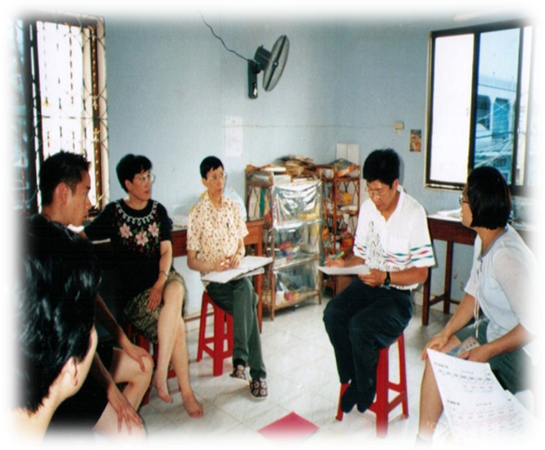
Cambodia STM in July 1999
Rev. Leung was instrumental in helping us to step out by faith in the field of short term missions. He organized and trained a team at ECCC to embark on a short term mission to Cambodia in July 1999. Rev. Leung’s passion in mission inspired us all and motivated us to step outside our comfort zone. We learned a lot at the STM. Rev. Leung was very organized in conducting mission ministries. He developed detailed daily schedule and held debriefing and prayer sessions each evening.
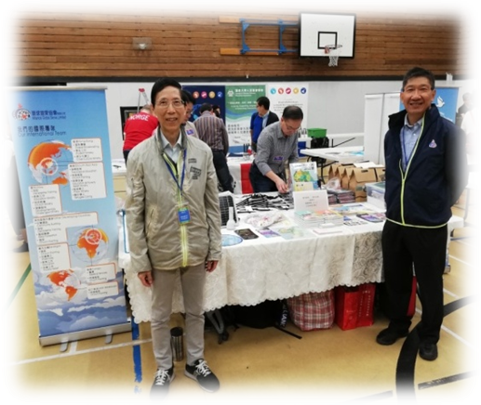
Applying what we learnt in Cambodia, we later had opportunities to take part in STM’s in Northern Alberta and other places. Beyond STM, Rev. Leung also taught us how to prepare for and teach mission courses, promote mission ministries at seminars and conferences, how to support missionaries as well as serving at Alliance Global Serve Canada.
Mission Conference in Vancouver 2019
Praise the Lord for giving Rev. Leung a long term and broad vision for missions and passions for developing others. His faithfulness and dedication in serving the Lord in missions have inspired many people. We treasured the long time friendship with the Leung family and benefited greatly from the mentorship by Rev. William Leung. We will always remember him as our beloved pastor, mentor and friend.

怀念我们敬爱的梁伟材牧师

加拿大环球宣爱协会董事 麦兆康与麦容正萍
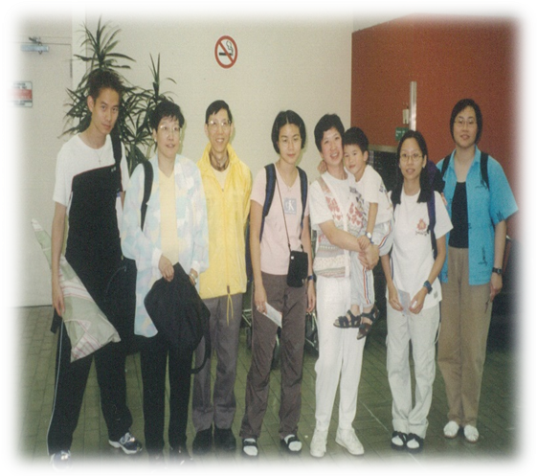
我们1989 年认识了梁牧师和师母，他们当时刚从加拿大多伦多搬到亚省爱民顿市。自此我们建立了漫长的友谊。我们深深的感恩能够在爱民顿福音堂 (ECCC) 以及在加拿大环球宣爱协会(Alliance Global Serve Canada) 与牧师和师母一起侍奉主。

梁牧师帮助我们在短期宣教领域凭信心走出去。1999年7月，他在福音堂组织和培训了一个团队，前往柬埔寨作短期宣教。梁牧师对宣教的热情激励了我们整个团队，并鼓励我们踏出安舒区。我们在短宣学到了很多功课。他在宣教事工方面非常有条理。他制定了详细的每日时间表，每天晚上举行汇报会和祈祷会。

我们在柬埔寨学到的短宣经验，后来有机会应用在亚省北部和其他地方的短宣事工。除了短期宣教学习，梁牧师还指引我们如何准备和教导宣教课程，在不同的研讨会和宣教会议上推广差传事工，学习支持宣教士以及在加拿大环球宣爱协会中侍奉。

赞美主给了梁牧师一个长远而广阔的宣教愿景和培育他人的热情。他在宣教事奉主的忠心和无私的奉献鼓励并影响了许多人。我们很珍惜与梁牧师和师母的友谊，并感谢在梁牧师的指导下受益匪浅。我们将永远铭记他是我们敬爱的牧师、导师和朋友。

《环球华人宣教学期刊》第六十八期 Vol 7, No 2 (April 2022)

