Front Row of the Great Cloud of Witnesses!

AGS International Member (CONGO New Sight) Joyce & Henri Samoutou
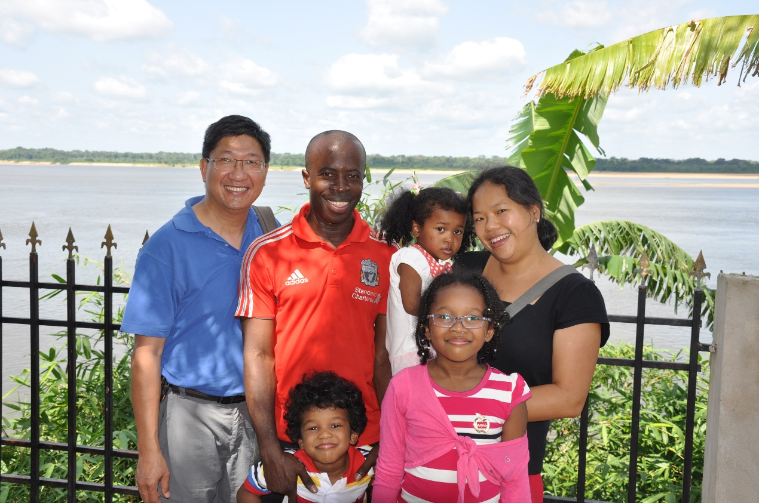
Dear Pastor Leung,

We are so fond of you and are so indebted to you. We love and miss your warmth, sincerity, sense of humour and fun loving nature. You have played a pivotal role in our lives.

First of all, thank you for helping us get married! We can never forget the 600 plus pre-marital counselling questions or the inspiring sermon at our wedding! No matter how busy you were, you never once forgot to wish us happy anniversary!

Thank you for believing in us and empowering us to launch our mission in the Republic of Congo. We cannot imagine how we could have managed to go if it had not been for you and Alliance Global Serve.

Thank you too for leading the first mission team for New Sight Congo. There are too many precious memories to name - one thing for sure though was that God's presence with you was undeniable as evidenced by the miraculous provision of courage, timely resources, protection and fun!
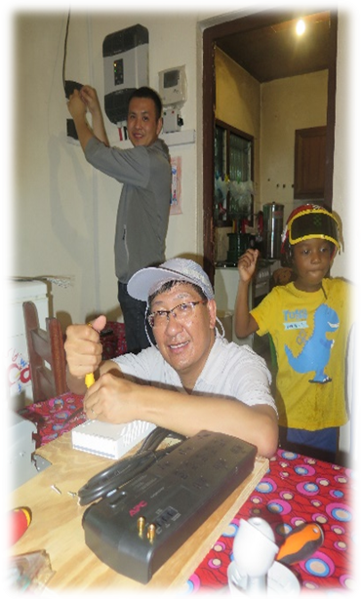
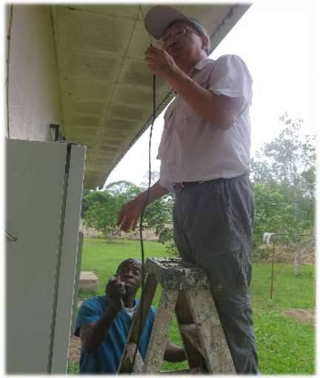
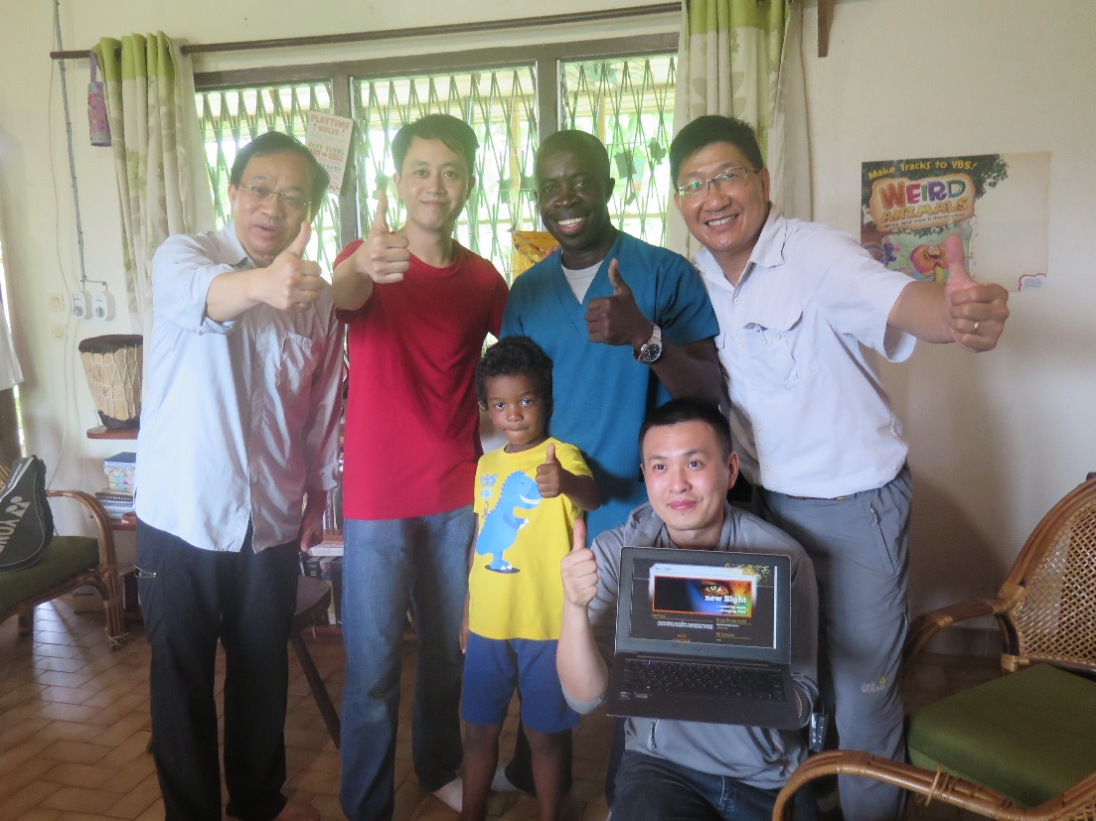

We did not get to see or even talk to each other often, but your love, support and prayers have carried our family and ministry every step of the way, and even now, we can hear you cheering us on loudly from the front row of that great cloud of witnesses.

With much love, fondness and deep gratitude

Joyce and Henri

大群见证人的首席！

环球宣爱协会国际同工（刚果目养计划） 宋安理、黄凯恩
亲爱的梁牧师：

梁牧师，我们真的非常喜欢你并且很感激你。我们亦很爱你，并会永远怀念你的亲切、真挚、幽默感和爱玩的天性。你在我们一家的生命中有著关键和重要的角色。

首先，感谢你帮助我们能结成夫妇。我们永不会忘记那600多条婚前辅导问题和你在我们婚礼上启发性的训勉！不管你有多么忙碌，你总不会忘记传来短讯，祝愿我们结婚周年快乐！

谢谢你对我们的信任，并赋权我们在刚果共和国开展我们的事工。我们不能想像，如没有你及环球宣爱协会，我们怎能安排出发呢！

谢谢你带领了第一队的短期服侍队到刚果。实在有太多的珍贵回忆无法一一分享。但有一件事可以完全肯定并无可否认的，是神与你同在，这在你得到上帝那如神迹般的供应，勇气、适时的资源、保护和快乐便可以证明了。
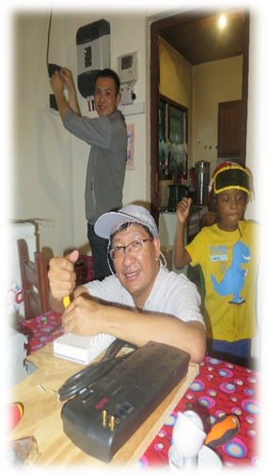

虽然我们无法常常见面、联系，但你的爱、支持和祷告、见证我们的家庭及事工的每一步。甚至到现在，我们还可以听到你在一大群云彩见证人的第一排中，大声地为我们打气喝彩。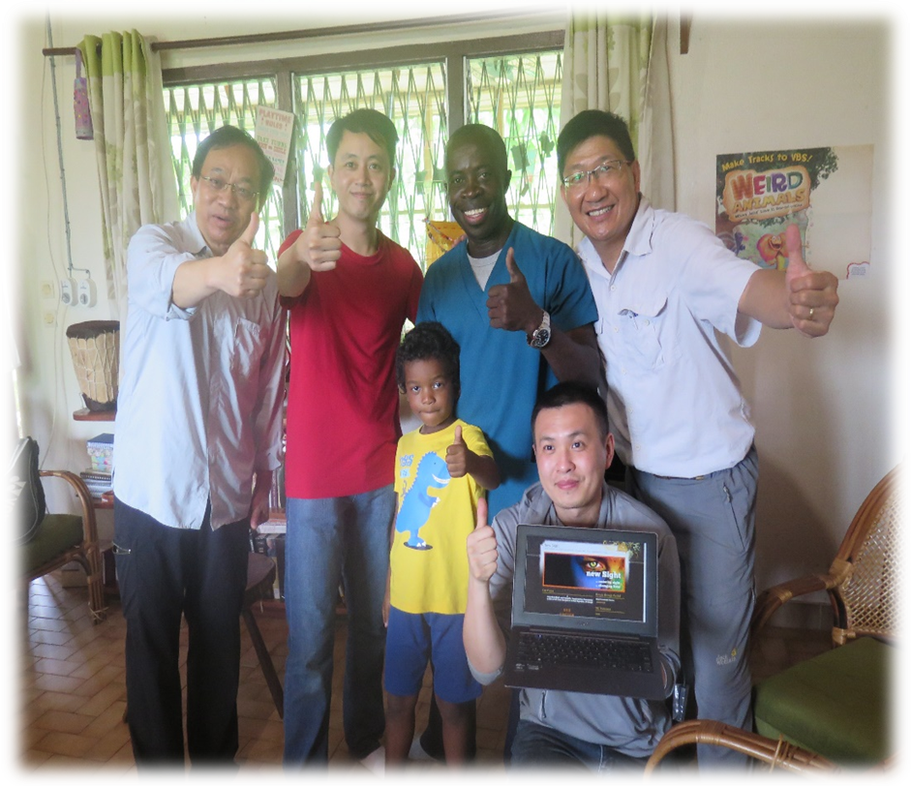

衷心爱你、深深感激你的
Joyce and Henri

《环球华人宣教学期刊》第六十八期 Vol 7, No 2 (April 2022)

