My Memories of William

前多伦多长老会团友 周健民弟兄Stanley Chau

I am Stanley Chau (周健民) and have known William Leung for more than 40 years. I have accepted Jesus as my Lord and savior at the Young People Society, Chinese Presbyterian Church (CPC), Toronto, Canada

I met William at CPC and he had always been like a big brother and a friend to me. He was respected by many at CPC. He was like a counsellor in the fellowship. He had always been given me the impression that he took things very seriously. As I got to know him better, we saw the fun side of him. We, and a group of fellowship members would go out for camping almost every summer. The first time that we went to Algonquin Provincial Park interior was with William. We had to backpack, canoe and portage and we learned so much from him and had so much fun. There was one year that we took Thursday off for a longer long weekend to go camping. It was raining on Thursday, then Friday, and Saturday morning so we decided to pack up and go since we were all getting very wet. After we left, it was sunny from Saturday afternoon to Monday. We were jokingly blamed William for “bad luck” because it appeared that we always had rain whenever we go camping with him.

We also shared our interest in photography. Our fellowship started a few interest groups to bring brothers and sisters-in-Christ closer together to serve God. The group that I was in with William was the CPC AV group. We had 7 to 8 people in the group. At that time, we were using slides to create presentations for various fellowship/church meetings. With William’s leadership and direction, we worked together to create our very first evangelistic slide show. The slide show was called东鸟西飞 (East bird flying west). The focus was about a Visa student coming over from Hong Kong to Toronto, through different circumstances, got to know and accept Jesus. The group spent many days/nights and took many slides as if we were shooting a movie, and worked together to create the multi-projector slide presentation with the message of salvation. We remember working through many nights to get the presentation completed at William’s parents’ home. We would then go to McDonald’s at 6 am, when it opened, for breakfast. Even though it was tough but all the AV members were close and enjoyed serving God together to bring a message of hope and salvation to Visa students.

When William and Sharon were married on June 25, 1988, a group of brothers and sisters-in-Christ went to their apartment to celebrate with them. When we went, we wanted to play bride and groom games with them. That was the one and only time that I saw William got upset with us on our crazy demands. We ended up being “kicked out” by him.

Once they were married, I have only seen him a few times including one time in Edmonton when we visited them. I was fully aware of his Missions at various countries.

In 2011, I received an Email from Rev. Hugo Lau that William was coming back to Toronto with 2 pastors from China to exchange knowledge of Christian school operations. I was, at the time, a Board of Directors at Peoples Christian Academy (pca.ca). I was so excited to work with William once again, now with visions in Christian education and schools. The two Chinese pastors from Zhongshan, Guangdong, with one of them running a kindergarten in a church, were not able to obtain Visas but we still met with William and another missionary Greg Mosby. William was so keen to start schools in rural Cambodia as well. We met at PCA on November 9, 2011 with couple of Board members and our Director of Operations and Ministry to share our visions. They also met our chaplain and we provided our Senior School’s Senegal missionary contacts to William and the Alliance Global Serve (alliancegs.org).

On September 27, 2012, some Board members and I met a couple, Peter and Jane Cheung, running a school in China that William coordinated with PCA. We continued to share our visions and discussions on Christian education cooperation for a couple of years.

In 2018, we met William with Nancy from AGS Cambodia on March 26 and shared our visions and Senior School’s operations. We continued to work together to further God’s work in Christian education. Over these many years, our visions for Christian education and schools were growing stronger each time we met. We believe God has a great plan for “Train up a child in the way he should go; even when he is old he will not depart from it” (ESV Prov 22:6)

Even though William has left us to be with the Lord, his legacy in Christian education and the effort established is not in vain. If God is willing, we might see more vision sharing and partnership in the future to further His work in Christian education between PCA and AGS.

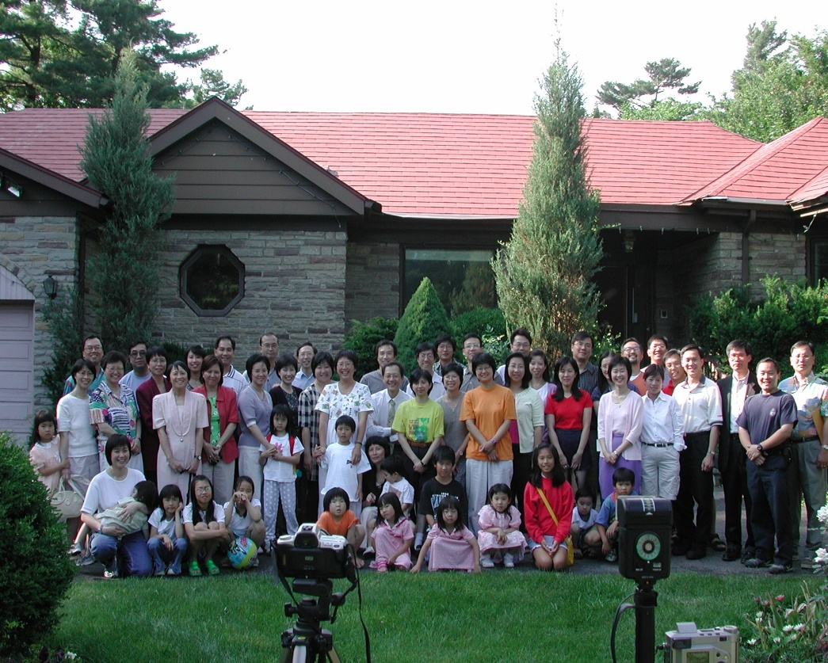

《环球华人宣教学期刊》第六十八期 Vol 7, No 2 (April 2022)

