Our Big Brother William

前多伦多长老会团友 林志坚弟兄 (Stephen Lam)

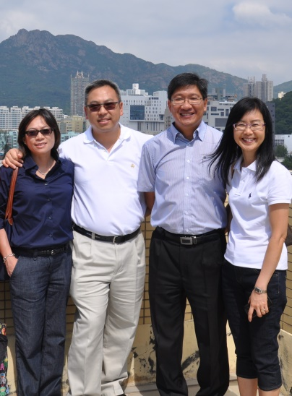
My memory with our big brother Rev. William Leung starts all the way back to the late 1970s when we were studying in Toronto. I still remember the day when we first met. I saw a quiet and hungry young man came home late from the library. He started enjoying his dinner right from the rice cooker pot with no complaints. These were the days when we studied abroad.

We attended the same fellowship and he was a big brother and role model to many, including myself. When my life hit a roadblock and I felt lost, he reached out to me and walked through the difficult time with me. He even welcomed me into his family like a younger brother. He taught me a lot and lived out his faith, loving and caring for those who needed it.
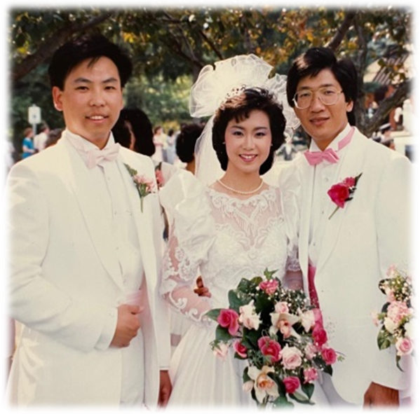
I was so honored when William asked me if I could be his best man at his wedding. With no hesitation, I accepted the invitation as William & Sharon are truly a perfectly matched couple, who loves God first, others next, and last, themselves.
Throughout the years, our relationship continued to extend from a brotherly friendship to family. William and Sharon even aligned their homecoming trip from Edmonton with my wedding date. Our families shared countless precious moments like family BBQs, camping, and even celebrating their 20th anniversary in Thailand together.
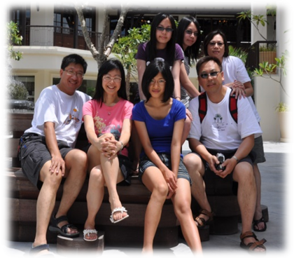
Surely, we all miss William very much. However, the impact that he had in the lives of those who he encountered will stay forever.

《环球华人宣教学期刊》第六十八期 Vol 7, No 2 (April 2022)

