向我们的William (High-Five) 致敬

前加拿大爱城福音堂团友 周恩亮夫妇

根据维基百科，举手击掌（High-Five）是一种手势，用于两人之间，动作是两人各举起一只手，并向对方的手拍击。其含义因使用上各有其异，但可以包括问候、祝贺或庆祝。

为了庆祝William 的一生和他对我们俩的影响，我们希望分享这五方面的事情，以此作为庆祝和举手击掌向他的一生致敬。我们深深懐念William，而他永远是我们的:
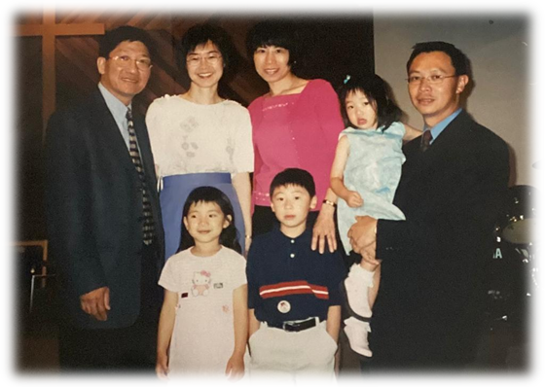
团契导师：你每每花时间聆听我们所面对的挑战，并在我们需要你的帮助时候给予我们建议。你从没有因我们的错误而作出批评，而是通过圣经的话引导我们。还记得你带我们到麦当劳，用上帝的恩典和寛恕的话语来解开一个冲突。

牧者：你对所有弟兄姊妹，无论他们是年轻的，还是年长的，你都一心一意的服侍。 你总是把别人的需要放在自己前面。当你和Sharon 提出让素未谋面的Corrina家姐在你家住宿一个多月，以便照顾她刚动手术的幼儿。你对主的爱真在此大大显明。你指导我们如何成为基督的使者，并鼓励我们在事奉上跳出框框思考创新。你展示了美丽的榜样，帮助我们建立上帝的领导品格，并以喜乐的心去服侍神。

宣教士：你在接触非信徒的使命中，拥有无限的创意和一颗仆人的心怀。在宣教上，你的前瞻性思维和独特有效的方法进一步证明了你的天赋。你标志性的喜喜洋洋和动力充沛的笑容，提醒我们宣教工作实际上是一种满足乐事。你是如此谦卑地分享你在宣教上，神的作为和祂的奇迹，这都激励我们回应神的呼召，并促使我们随时随地愿意参与宣教事奉。

朋友：即使你很忙，你总是为我们腾出时间。谢谢你向我们推介吃苹果枇的「正确」方法是热食和加雪糕。从爱民顿、香港、多伦多至温哥华， 你仍然关心我们与家人、教会和工作上的困难。在你的主动下，你为我们的父母和孩子们提供无数的支持和帮助。在第一次接触我们的小狗时，你甚至和她玩了一整个晚上。这些都是甜蜜的回忆，也永远铭记在我们心里。

婚礼主礼人：你主持了我们的婚礼。尽管你尚未获得签署结婚文件的许可，你在卅十年前主持了第一次婚礼(嘘！) ！ 你给予我们的婚前辅导和对婚姻的忠告是我们一生中最美好礼物。 你对婚姻的秘诀：「请」、「对不起」 和「谢谢你」，成为我们每天的金石良言。最后，在你忙碌的生活中，你永远不会忘记每年祝福我们「结婚周年快乐」。

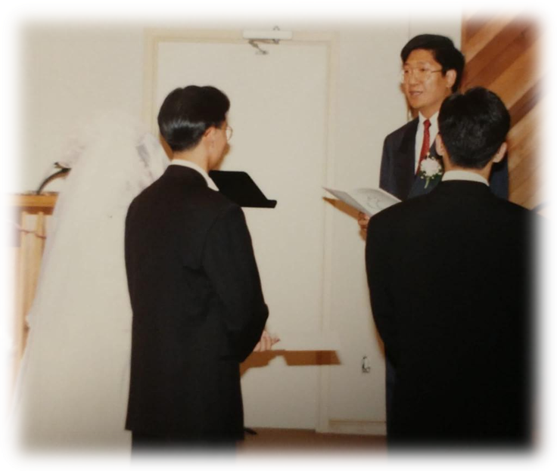

感谢你成为我们生命中的一部份。你真诚的微笑和幽默感将永远留在我们心中。 现在告别了，但当我们重见你的时候，我们必会对你举手击掌。
Our High Five to William

Alvin & Corrina Chow
Former Members of ECCC (Edmonton Christian Community Church)

According to Wikipedia, high five is a hand gesture that occurs when two people simultaneously raise one hand each, about head-high, and push, slide, or slap the flat of their palm against the flat palm of the other person. Its meaning varies with the context of use but can include as a greeting, congratulations, or celebration.

To celebrate William’s life and his impact on both of us, we hope to share the five aspects and to high five with him. William will be greatly missed and always be our:
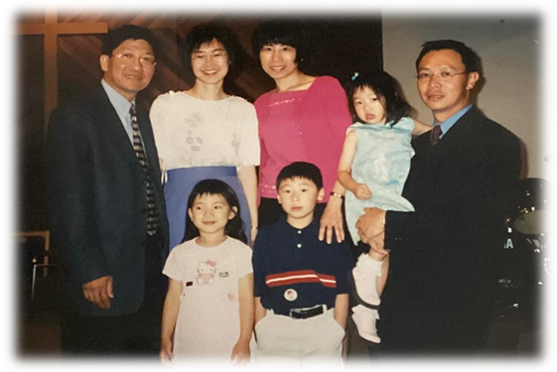
Fellowship Counselor, you spent time listening to our challenges and gave us advice whenever we needed your help. You never judged us for our wrong decisions, instead, you walked along with us through the words of the Bible. We still remembered that time you took us to McDonald’s to resolve a conflict using God’s word of grace and forgiveness.

Pastor, you have an undivided heart for all brothers and sisters regardless of whether they were young or elderly. You always put others’ needs before your own. Your love to God was magnified when Sharon and you offered to let Corrina’s sister whom you have never met to stay at your home for over a month while she took care of her son after a surgery. You mentored us on how to be Christ’s followers and encouraged us to think out of the box in ministry. You displayed beautiful examples which aided us to build characters of God’s leadership as well as to serve with our joyful hearts.

Missionary, you have unlimited creativity and a servant’s heart in the mission to reach non-believers. Your forward thinking and unique approach further testified your God-gifted talent. Your signature beaming and energetic face reminded us that mission work is actually a fulfilling pleasure. You were so humble and willing to share God’s work and His miracle in your mission ministry which inspired us to respond to God's calling and do whatever we can participate whenever and wherever we are.

Friend, you always made time for us even when you were busy. Thanks for introducing us to the “right” way to eat apple pie which is to have it served hot and with ice-cream. From Edmonton, Hong Kong, Toronto to Vancouver, you still tuned in our struggles with family, at church as well as from work. You have provided countless support and assistance to our parents and our children at your own initiation. You even played with our fur child for a very long night the first time you met her. These were all sweet memories which will always be dear to our hearts.

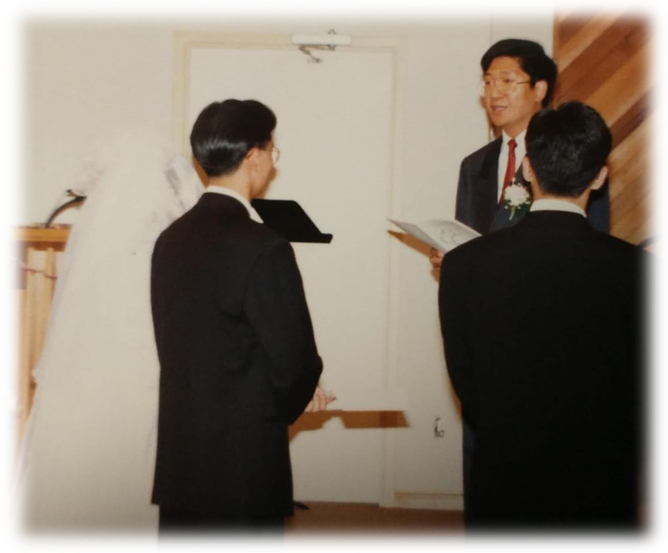
Marriage Officiant, you officiated a wedding, the very first wedding you have officiated 30 years ago even though you were yet to be licensed to sign the marriage papers (shhh!). Your pre-marriage counselling courses and constructive advice for a marriage was a lifetime gift to us. Your secret words for a successful marriage, "PLEASE", “SORRY” and "THANK YOU" became our golden rule each day. Lastly, you never forgot to wish us “Happy Anniversary” every year amid your usual hectic schedule.

Thank you for being a part of our life. Your genuine smile and sense of humour will forever be in our hearts. Farewell for now, but we will definitely give you a high five when we see you again.❤

《环球华人宣教学期刊》第六十八期 Vol 7, No 2 (April 2022)

