非一般的冒险家 “An Extraordinary Adventurer”

梁牧师二姐夫 邝士奇

In the Name of God –
以基督之名 –
He adventured in fostering faith:
他因激发信仰去历练：
Seminary studies and mission training in Edmonton.


He adventured into cross-cultural mission:
他探索实践跨文化福传：
Missions pastor in Hong Kong and founded Alliance Global Serve.
Field work in Africa, Cambodia, ……. for the poor and underprivileged.
Assisted missionary development in Zhuhai, Zhong Shan, ………China.
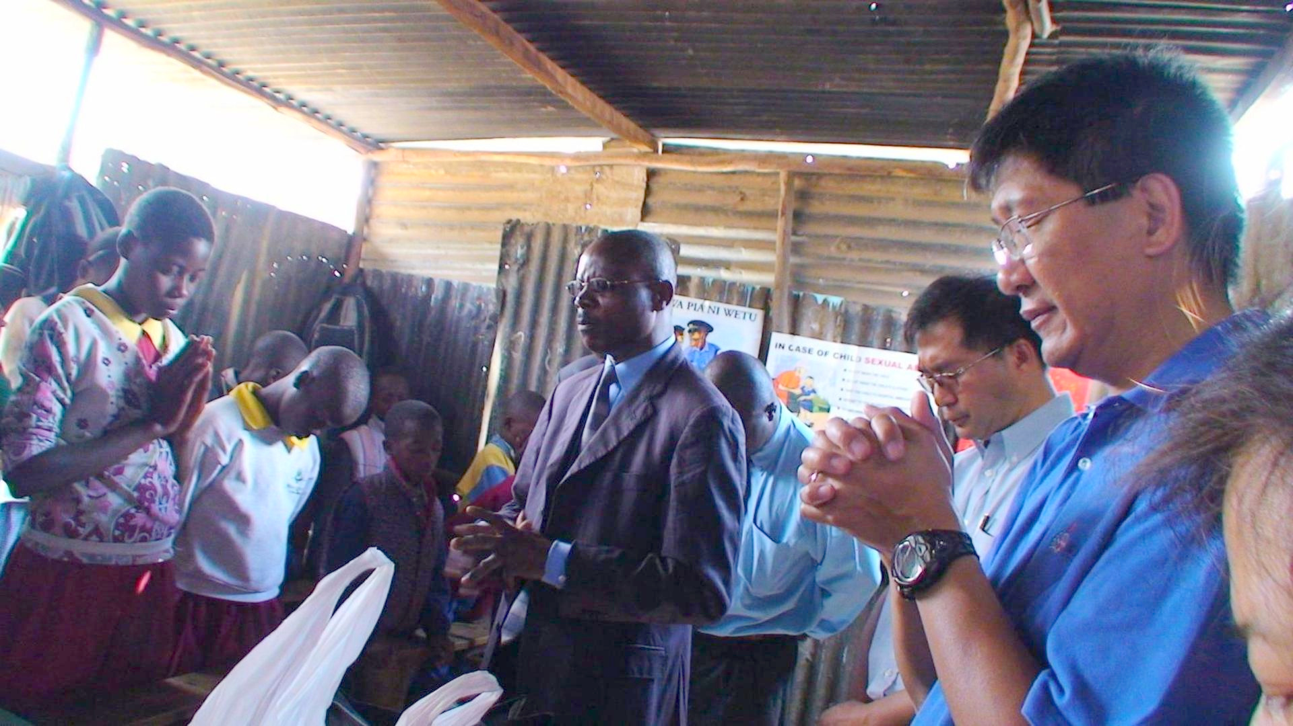
He adventured for the family:
他为家庭亲人美好生活去闯：
Pioneered his parents and siblings emigration to Canada


“Rest in Peace”
“Praise the Lord”

Louis (brother-in-law)
二姐夫邝士奇

《环球华人宣教学期刊》第六十八期 Vol 7, No 2 (April 2022)

