In the Banquet House

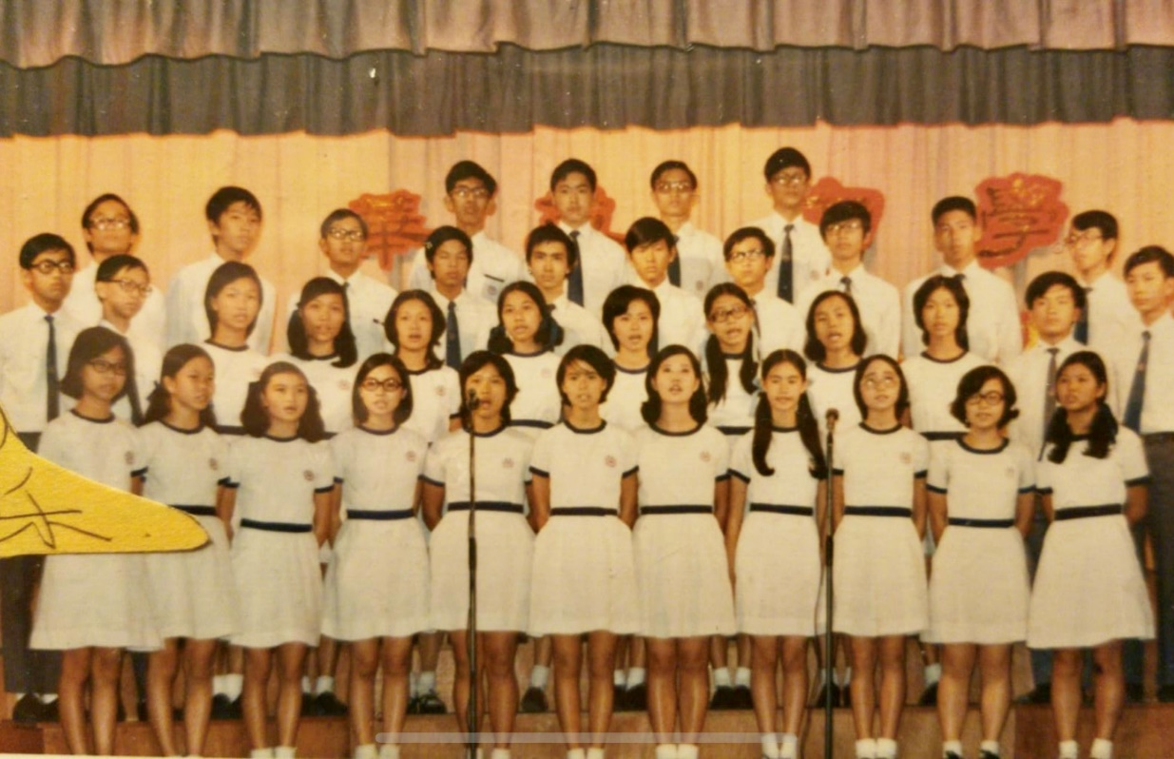
华英中学同学 刘昭姸 Amanda Lau-Virdi

William and I were high school classmates. He was friendly and always had a smile on his face. After finishing Form 3, I left Hong Kong and immigrated to Canada with my parents. I praise and thank the LORD for continuing our friendship throughout our lives.

William became an engineer, then he was called to devote himself to serving the LORD in full-time ministry as a pastor. I became a widow in 1998 after our family’s visit with William and Sharon in Edmonton in 1997. We were very grateful for William and Sharon’s hospitality.

I watched William’s heart grow to be very passionate about missions’ work. So, he and his family moved to Hong Kong to be a mission pastor. After a while, he started Alliance Global Serve.

William was always very caring and loving. Despite his very busy schedule for different missions trips, he would make time to see my children and me when he came by Vancouver. I was very blessed each time as I heard him share about the different mission fields Alliance Global Serve was working on. His tender heart for the loss and his fervent desire to bring the gospel to the different people of different nations were very evident. I truly appreciated his inter-cultural and inter-racial mission work which exemplified Jesus’ love for all people regardless of race and color.

William had completed the work the LORD had prepared for him. In God’s sovereign plan, He called him home. As Billy Graham said:

“Death is the fiery chariot, the gentle voice of the King, the invitation to
non-stop passage into the banquet house of the world of glory.”

William is in the banquet house of the world of glory with Jesus. There are no more tears, pain, or suffering. We will join him one day in the glorious eternal home. Meanwhile, I miss his texts, enlightening and uplifting fellowship!

《环球华人宣教学期刊》第六十八期 Vol 7, No 2 (April 2022)

