Tribute to the Late Rev. Thomas Wang

Dr. Roger Parrot, President - Belhaven University

Editor’s Note:
Dr. Roger Parrott was the US Director of LCWE when Rev. Thomas Wang served as the Executive Director of Lausanne Congress of World Evangelization (LCWE) and was mainly doing fund raising for the 2nd Lausanne Congress

January 29, 2018

Dear Family and Friends of Thomas Wang,

It is with such great sadness to hear about Thomas' death, although I rejoice with him entering into the presence of God in heaven. I can almost picture him now with his hands raised in the way I've seen him do so many times in joyful adoration to our Lord and Savior.

Thomas was a great inspiration to me, especially in the late 80s when we worked together with the Lausanne Committee for World Evangelization. We traveled many miles together fundraising, in meetings, and I always treasured learning from him. And, he learned from me how to drive while balancing a McDonald's meal on my lap.

My most treasured moment with Thomas was when we had offices next door to each other in Charlotte. He had been in his office with the door closed for many days on end, which I found out later was the beginning of his vision for AD 2000. He had been collecting plans from around the world to reach the entire globe by 2000 and was sensitizing them and praying through God's direction from all that he was seeing.

He finally came out of the office one afternoon about 3:00 p.m. with a huge stack of papers in his hands and came to me and shook it high above his head and said "Roger, this will change the world" and laid out the vision for AD 2000. He believed it was possible and went to work to mobilize millions of people for the Gospel through that and his ongoing work with the Lausanne Movement.

I am a wiser person, a stronger person, and a more faithful person because Thomas Wang was my friend. He was a great gift of the Lord to me.
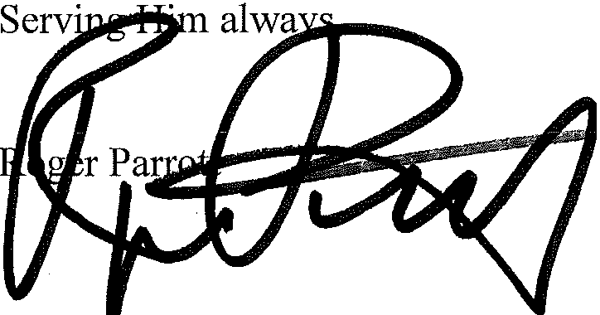

Office of the President I WWW. BELHAVEN.EDU
PRESIDENT@BELHAVEN.EDU I 800-960-5940 I FAX 601-968-8946 1500 PEACHTREE STREET, CAMPUS BOX 153 I JACKSON, MS I 39202


UNIVERSITY
Our Standard is Christ

GM-Chinese: www.GlobalMissiologyVol 1, No 15 (April 2018)

《環球華人宣教學期刊》 第52期 2018年4月號

