MY TRIBUTES TO REV. THOMAS WANG

Dr. Bong Rin Ro - President, Asia Graduate School of Theology-Pacific

What a surprising and sad news! Thomas Wang was certainly one of the few great Asian church leaders in the 20th an 21st C. Thomas brings me lots of memory of working together in the Asian Lausanne Movement (ALCOE), Evangelical Fellowship of Asian
(EFA), and the AD 2000 and Beyond Movement.
His contributions of founding the CCCOWE movement in Hong Kong and of the Great Commission Center International have greatly promoted the Great Commission of our Lord Jesus Christ within the Chinese Church in Asia and around the world. Thank God, for He is working among the Chinese churches around the world.

A close Korean friend in the Lord, Bong Rin Ro, Th.D.
President, Asia Graduate School of Theology-Pacific

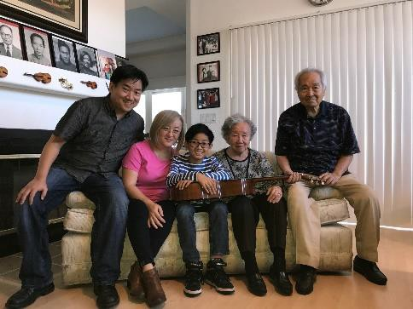

GM-Chinese: www.GlobalMissiologyVol 1, No 15 (April 2018)

《環球華人宣教學期刊》 第52期 2018年4月號

