我摯愛的爸爸

女兒 梁家恬 (2022 年 2 月 19 日)

今天是個非常難過的日子，但是我們在這裡慶祝我爸爸美麗的一生之際，我也要藉此對他懷念及致敬。

世上的爸爸應該是值得人敬重，是會保護和引導兒女，亦是會傾聽和成為他們訴心聲的對象。最重要的，爸爸應該是我們生活中所有大小事都可以分享的人。我很感恩也很高興，自己可以站在這裏告訴你，我的爸爸不單讓我擁有這一切，並且遠超以上所說的。
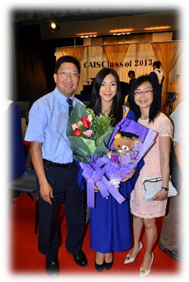
我的爸爸是一位了不起的父親，他非常聰明，總有辦法解決所有問題。無論是修理房子裡的東西，還是幫助和教導我完成學校功課，他總能夠找到超有創意及出色的方法。在找到解決方法以前，他絕不放棄。雖然他的工作很繁忙，也因事工之故需要經常到其他國家出差，但他總是預留時間給家人。他從沒有缺席我的學校活動，不論是樂團音樂會、音樂劇、科學展覽或比賽，他一定到場支持我。我特別記得，在過了更改期後，他仍為我更改航班的日期，以確保能夠出席我的中學畢業典禮。這只是眾多例子之一，他以我的人生里程碑為優先考慮，無論是大是小，這對我而言意義非常重大。

對我媽媽來說，他也是一個了不起的丈夫，我有幸成長於這個家，並見證著這牢固且充滿愛的婚姻。在任何境況下，他總是有耐性、喜樂和體貼。他愛我們家庭的方式展現了上帝無條件的愛。

他不單是一個了不起的爸爸和丈夫，他還會透過付出自己的時間來幫助他人，以回饋及服侍上帝。在疫情以前，我記得我們家常常有不同的客人，因為爸爸媽媽會為着能用自己的家來彰顯上帝的愛而快樂。我的爸爸不單是眾人的好導師，同時也是我的最佳導師。我們之間的傾談，他給予的意見，不單是從一位父親的角度出發，也來自作為朋友的角度。我們稱自己是一對知己，因為我們就是這樣相處。我們有無數的秘密笑話及有趣的對談，是我會永遠懷念的。
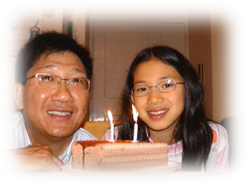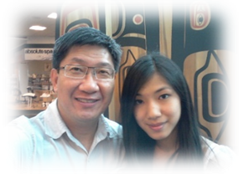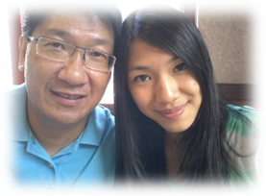

我的爸爸是一個勇於冒險的人，正如很多人都知道。他喜歡行山、露營、旅行和體驗這個世界。我很感恩，他讓我有機會與他一起到訪不同的國家。我通過這些短宣及旅行所獲得的文化及生活體驗是無法測量的。透過這些旅程他總是以最適切的方式，將我帶出個人的安舒區，鼓勵我克服我個人的恐懼，並且總會在我跌倒時扶起我。我感謝上帝，讓我可以與他一起經驗這些冒險之旅。
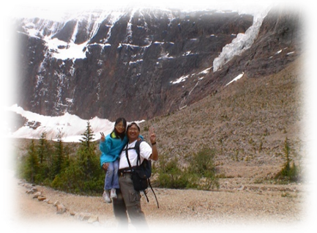
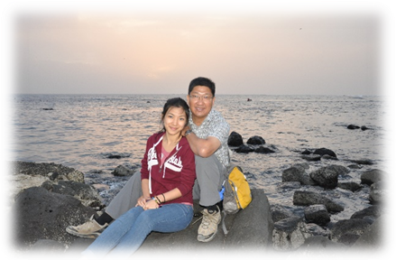
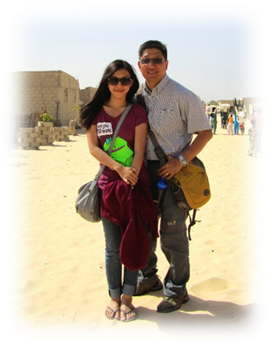
我的爸爸也喜歡且擅於攝影。今日我回顧他所拍下的照片，我很感恩他記錄了那些美麗的時光。其實有很多次，我因為不想拍照而表現得煩躁，但現在我非常感謝他當時把照片拍下來，因為我可以一次又一次通過這些照片，去回顧我們生命所走過每一頁的場景。

親愛的爸爸，我很懷念和珍惜與你一起的美麗回憶。你教導我明白，無論做什麼，最重要是愛上帝，秉持正直，並且盡力而為。我懷念你的幽默風趣，你的勇氣，你的慷慨，和你的善良，這些都不會被人遺忘。感謝你成就了今日的我，縱使你已不在這裡，我會永遠記得你是最無懈可擊的爸爸，因為你的生命是我和你身邊所有人的祝福。我愛你，期待我們再次相見的一天。

My Dearest Daddy

By Chariss Leung (February 19, 2022)

Today is a very hard day, however we are here to celebrate the beautiful life of my dad and I want to take the time to remember and honor the person he was.

Dads are someone to look up to, someone to protect and guide us, someone to learn from and respect, someone to listen and talk to, but most of all, someone to share everything life has to offer with. I am so grateful and happy that I can stand here and tell you that I have had all this and so much more with my dad.
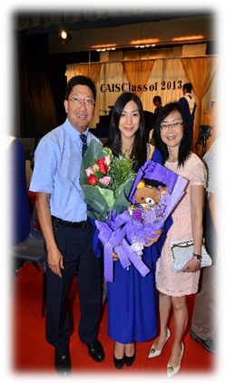
My dad was a wonderful father. He was so intelligent and always had a solution for everything. Whether it be fixing things around the house, or helping me with my school projects, he always found a way to be super creative and skillful. There wasn’t a moment where he ever gave up until he found an answer. Despite his busy schedule with work and travelling to other countries regularly for his ministries, he always made time for family. He never missed a single school event of mine, all my band concerts, musicals, science fairs and competitions; he made sure he was there to support me. I remember specifically, him moving his flight dates after the deadline had passed already, to make sure he could attend my college graduation. This is just one example out of many others, where he prioritized every single milestone in my life, whether it be big or small, and that is something that means so much to me.

He was also an amazing husband to my mom, and I have had the privilege of growing up to, and witnessing a strong, loving marriage. He was always so patient, joyful and thoughtful in every circumstance. The way he loved our family demonstrated the unconditional love of God.

He wasn’t just an incredible father and husband though, he wanted to give back and serve God by dedicating his time to helping others. Before Covid, I remember us always having different guests at our house, because it brought joy to my dad and mom to be able to use our home to spread God’s love. My dad was a great mentor to many people, including myself. The conversations we’ve had, and the advice he gave me in life did not only come from the perspective of a father, but also as a friend. We called ourselves a pair, because that’s what we were. We had so many inside jokes and fun talks that I will miss.
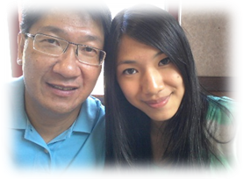
My dad was an adventurous guy, as I’m sure many of you know. He loved to go hiking, camping, travelling and just experiencing the world. I’m so grateful that he gave me the opportunity to go with him to so many different countries. The amount of cultural and life experience I’ve gained though these trips, is immeasurable. Through our travels together, he pushed me out of my comfort zone in the best ways, encouraged me through any fears I had, and was always there to pick me up when I fell down. I thank God that I got to go on all these adventures with him.
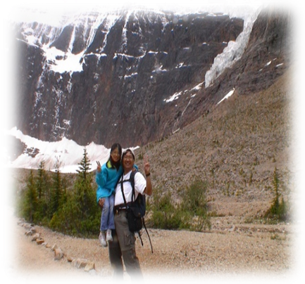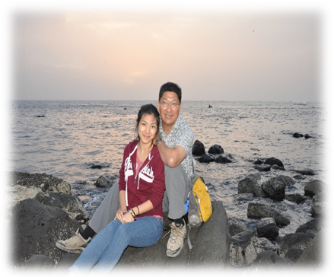

My dad loved photography as well, and he was amazing at it too. Today I look back at all the photos he took, and I’m so thankful that he captured all of those memories. There were so many times I got cranky because I didn’t want to get my picture taken, but I’m glad he did now because I get to revisit all the chapters in our lives again and again through these images.

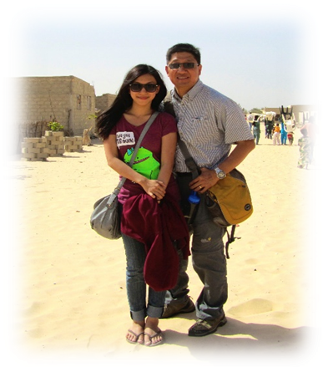
Daddy, I cherish all the memories I had with you. You taught me no matter what I do in life, as long as I love God, have integrity, and do my very best, that’s all that matters. I miss your humor, your courage, your generosity and your kindness, but they will not be forgotten by anyone. Thank you for building me up to the person that I am today. Even though you are no longer here with us, I will forever remember you as the most incredible dad, because your life was a blessing to me and everyone around you. I love you, and look forward to the day we will meet again.

《環球華人宣教學期刊》第六十八期 Vol 7, No 2 (April 2022)

