Remembering Our Beloved Rev. William Leung

Andrew & Gigi Mak
Board Member - Alliance Global Serve Canada

We have known William and Sharon since 1989 when they moved from Toronto to Edmonton and have maintained our long time friendship ever since. We count our great blessings to be able to serve together at the Edmonton Christian Community Church (ECCC) as well as at Alliance Global Serve Canada.
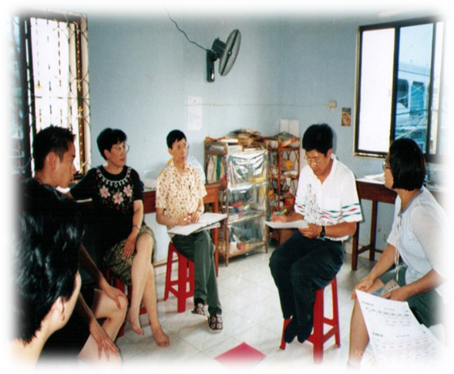
Cambodia STM in July 1999
Rev. Leung was instrumental in helping us to step out by faith in the field of short term missions. He organized and trained a team at ECCC to embark on a short term mission to Cambodia in July 1999. Rev. Leung’s passion in mission inspired us all and motivated us to step outside our comfort zone. We learned a lot at the STM. Rev. Leung was very organized in conducting mission ministries. He developed detailed daily schedule and held debriefing and prayer sessions each evening.
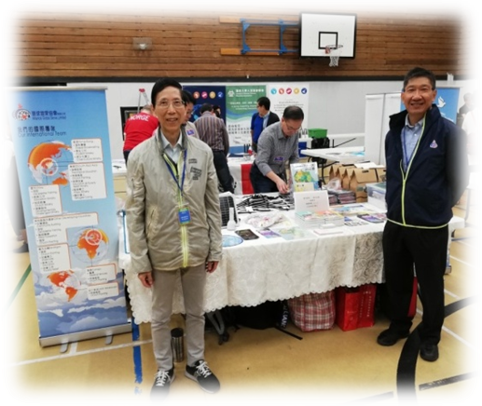
Applying what we learnt in Cambodia, we later had opportunities to take part in STM’s in Northern Alberta and other places. Beyond STM, Rev. Leung also taught us how to prepare for and teach mission courses, promote mission ministries at seminars and conferences, how to support missionaries as well as serving at Alliance Global Serve Canada.
Mission Conference in Vancouver 2019
Praise the Lord for giving Rev. Leung a long term and broad vision for missions and passions for developing others. His faithfulness and dedication in serving the Lord in missions have inspired many people. We treasured the long time friendship with the Leung family and benefited greatly from the mentorship by Rev. William Leung. We will always remember him as our beloved pastor, mentor and friend.

懷念我們敬愛的梁偉材牧師

加拿大環球宣愛協會董事 麥兆康與麥容正萍
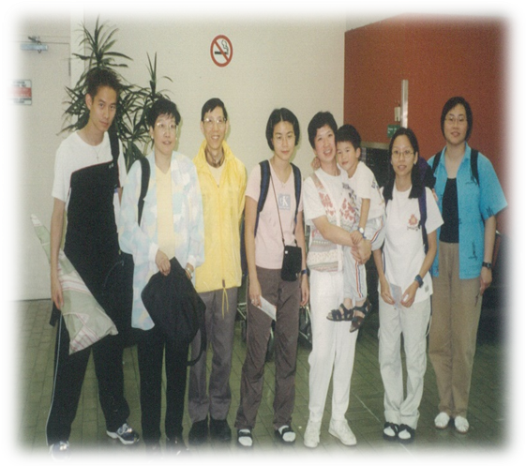
我們1989 年認識了梁牧師和師母，他們當時剛從加拿大多倫多搬到亞省愛民頓市。自此我們建立了漫長的友誼。我們深深的感恩能夠在愛民頓福音堂 (ECCC) 以及在加拿大環球宣愛協會(Alliance Global Serve Canada) 與牧師和師母一起侍奉主。

梁牧師幫助我們在短期宣教領域憑信心走出去。1999年7月，他在福音堂組織和培訓了一個團隊，前往柬埔寨作短期宣教。梁牧師對宣教的熱情激勵了​​我們整個團隊，並鼓勵我們踏出安舒區。我們在短宣學到了很多功課。他在宣教事工方面非常有條理。他制定了詳細的每日時間表，每天晚上舉行匯報會和祈禱會。

我們在柬埔寨學到的短宣經驗，後來有機會應用在亞省北部和其他地方的短宣事工。除了短期宣教學習，梁牧師還指引我們如何準備和教導宣教課程，在不同的研討會和宣教會議上推廣差傳事工，學習支持宣教士以及在加拿大環球宣愛協會中侍奉。

讚美主給了梁牧師一個長遠而廣闊的宣教願景和培育他人的熱情。他在宣教事奉主的忠心和無私的奉獻鼓勵並影響了許多人。我們很珍惜與梁牧師和師母的友誼，並感謝在梁牧師的指導下受益匪淺。我們將永遠銘記他是我們敬愛的牧師、導師和朋友。

《環球華人宣教學期刊》第六十八期 Vol 7, No 2 (April 2022)

