Front Row of the Great Cloud of Witnesses!

AGS International Member (CONGO New Sight) Joyce & Henri Samoutou
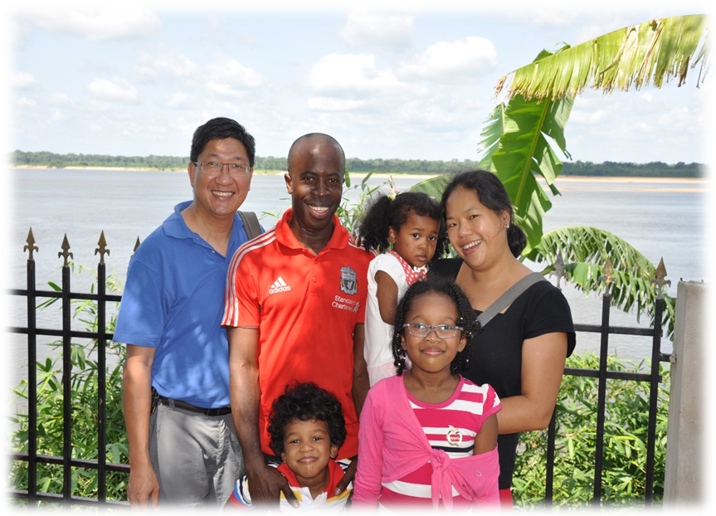
Dear Pastor Leung,

We are so fond of you and are so indebted to you. We love and miss your warmth, sincerity, sense of humour and fun loving nature. You have played a pivotal role in our lives.

First of all, thank you for helping us get married! We can never forget the 600 plus pre-marital counselling questions or the inspiring sermon at our wedding! No matter how busy you were, you never once forgot to wish us happy anniversary!

Thank you for believing in us and empowering us to launch our mission in the Republic of Congo. We cannot imagine how we could have managed to go if it had not been for you and Alliance Global Serve.

Thank you too for leading the first mission team for New Sight Congo. There are too many precious memories to name - one thing for sure though was that God's presence with you was undeniable as evidenced by the miraculous provision of courage, timely resources, protection and fun!
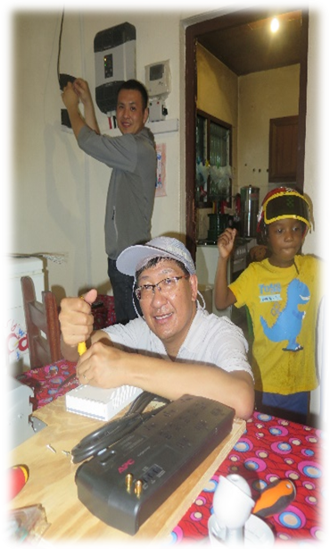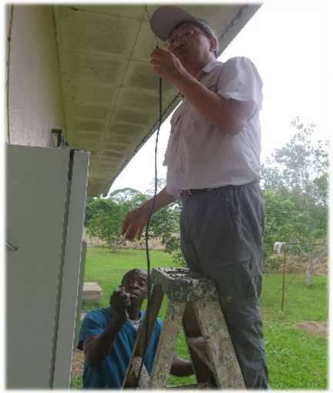
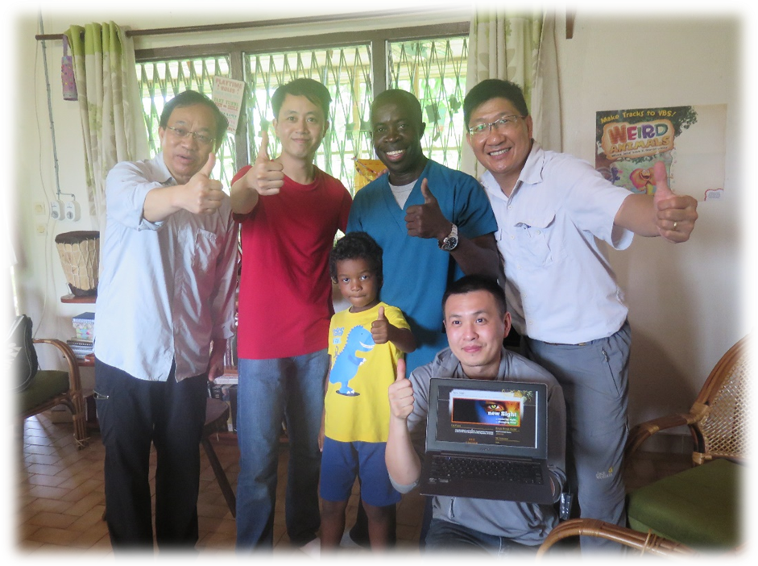

We did not get to see or even talk to each other often, but your love, support and prayers have carried our family and ministry every step of the way, and even now, we can hear you cheering us on loudly from the front row of that great cloud of witnesses.

With much love, fondness and deep gratitude

Joyce and Henri

大群見證人的首席！

環球宣愛協會國際同工（剛果目養計劃） 宋安理、黃凱恩
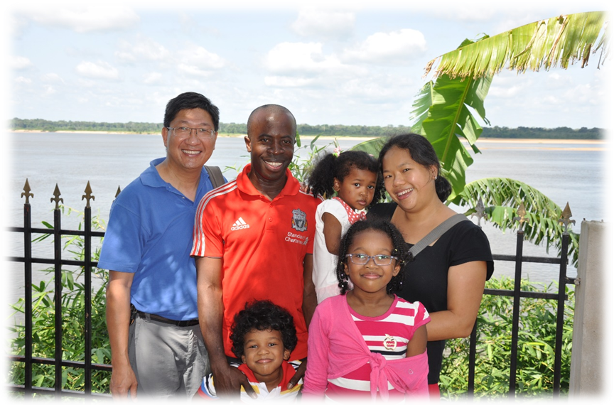
親愛的梁牧師：

梁牧師，我們真的非常喜歡你並且很感激你。我們亦很愛你，並會永遠懷念你的親切、真摯、幽默感和愛玩的天性。你在我們一家的生命中有著關鍵和重要的角色。

首先，感謝你幫助我們能結成夫婦。我們永不會忘記那600多條婚前輔導問題和你在我們婚禮上啟發性的訓勉！不管你有多麽忙碌，你總不會忘記傳來短訊，祝願我們結婚周年快樂！

謝謝你對我們的信任，並賦權我們在剛果共和國開展我們的事工。我們不能想像，如沒有你及環球宣愛協會，我們怎能安排出發呢！

謝謝你帶領了第一隊的短期服侍隊到剛果。實在有太多的珍貴回憶無法一一分享。但有一件事可以完全肯定並無可否認的，是神與你同在，這在你得到上帝那如神蹟般的供應，勇氣、適時的資源、保護和快樂便可以證明了。
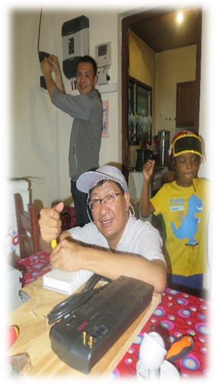

雖然我們無法常常見面、聯繫，但你的愛、支持和禱告、見證我們的家庭及事工的每一步。甚至到現在，我們還可以聽到你在一大群雲彩見證人的第一排中，大聲地為我們打氣喝彩。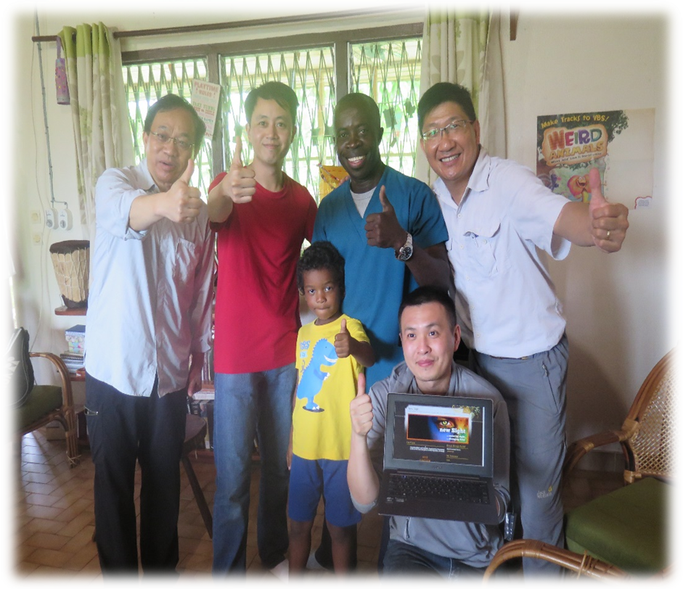

衷心愛你、深深感激你的
Joyce and Henri

《環球華人宣教學期刊》第六十八期 Vol 7, No 2 (April 2022)

