向我們的William (High-Five) 致敬

前加拿大愛城福音堂團友 周恩亮夫婦

根據維基百科，舉手擊掌（High-Five）是一種手勢，用於兩人之間，動作是兩人各舉起一隻手，並向對方的手拍擊。其含義因使用上各有其異，但可以包括問候、祝賀或慶祝。

為了慶祝William 的一生和他對我們倆的影響，我們希望分享這五方面的事情，以此作為慶祝和舉手擊掌向他的一生致敬。我們深深懐念William，而他永遠是我們的:
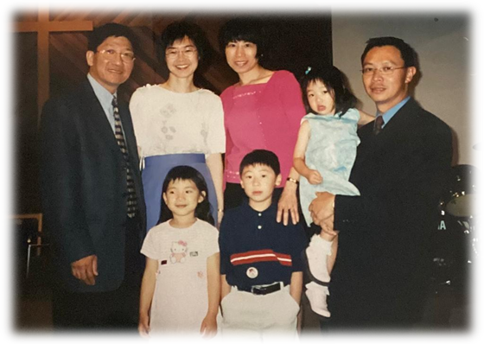
團契導師：你每每花時間聆聽我們所面對的挑戰，並在我們需要你的幫助時候給予我們建議。你從沒有因我們的錯誤而作出批評，而是通過聖經的話引導我們。還記得你帶我們到麥當勞，用上帝的恩典和寛恕的話語來解開一個衝突。

牧者：你對所有弟兄姊妹，無論他們是年輕的，還是年長的，你都一心一意的服侍。 你總是把別人的需要放在自己前面。當你和Sharon 提出讓素未謀面的Corrina家姐在你家住宿一個多月，以便照顧她剛動手術的幼兒。你對主的愛真在此大大顯明。你指導我們如何成為基督的使者，並鼓勵我們在事奉上跳出框框思考創新。你展示了美麗的榜樣，幫助我們建立上帝的領導品格，並以喜樂的心去服侍神。

宣教士：你在接觸非信徒的使命中，擁有無限的創意和一顆僕人的心懷。在宣教上，你的前瞻性思維和獨特有效的方法進一步證明了你的天賦。你標誌性的喜喜洋洋和動力充沛的笑容，提醒我們宣教工作實際上是一種滿足樂事。你是如此謙卑地分享你在宣教上，神的作為和祂的奇蹟，這都激勵我們回應神的呼召，並促使我們隨時隨地願意參與宣教事奉 。

朋友：即使你很忙，你總是為我們騰出時間。謝謝你向我們推介吃蘋果枇的「正確」方法是熱食和加雪糕。從愛民頓、香港、多倫多至溫哥華， 你仍然關心我們與家人、教會和工作上的困難。在你的主動下，你為我們的父母和孩子們提供無數的支持和幫助。在第一次接觸我們的小狗時，你甚至和她玩了一整個晚上。這些都是甜蜜的回憶，也永遠銘記在我們心裡。

婚禮主禮人：你主持了我們的婚禮。儘管你尚未獲得簽署結婚文件的許可，你在卅十年前主持了第一次婚禮(噓！) ！ 你給予我們的婚前輔導和對婚姻的忠告是我們一生中最美好禮物。 你對婚姻的祕訣：「請」、「對不起」 和「謝謝你」，成為我們每天的金石良言。最後，在你忙碌的生活中，你永遠不會忘記每年祝福我們「結婚週年快樂」。

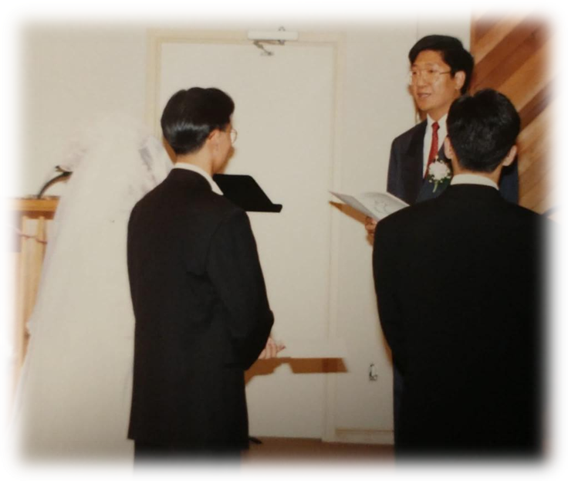

感謝你成為我們生命中的一部份。你真誠的微笑和幽默感將永遠留在我們心中。 現在告別了，但當我們重見你的時候，我們必會對你舉手擊掌 。
Our High Five to William

Alvin & Corrina Chow
Former Members of ECCC (Edmonton Christian Community Church)

According to Wikipedia, high five is a hand gesture that occurs when two people simultaneously raise one hand each, about head-high, and push, slide, or slap the flat of their palm against the flat palm of the other person. Its meaning varies with the context of use but can include as a greeting, congratulations, or celebration.

To celebrate William’s life and his impact on both of us, we hope to share the five aspects and to high five with him. William will be greatly missed and always be our:
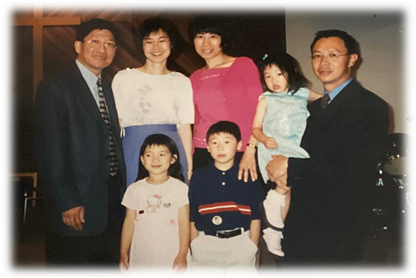
Fellowship Counselor, you spent time listening to our challenges and gave us advice whenever we needed your help. You never judged us for our wrong decisions, instead, you walked along with us through the words of the Bible. We still remembered that time you took us to McDonald’s to resolve a conflict using God’s word of grace and forgiveness.

Pastor, you have an undivided heart for all brothers and sisters regardless of whether they were young or elderly. You always put others’ needs before your own. Your love to God was magnified when Sharon and you offered to let Corrina’s sister whom you have never met to stay at your home for over a month while she took care of her son after a surgery. You mentored us on how to be Christ’s followers and encouraged us to think out of the box in ministry. You displayed beautiful examples which aided us to build characters of God’s leadership as well as to serve with our joyful hearts.

Missionary, you have unlimited creativity and a servant’s heart in the mission to reach non-believers. Your forward thinking and unique approach further testified your God-gifted talent. Your signature beaming and energetic face reminded us that mission work is actually a fulfilling pleasure. You were so humble and willing to share God’s work and His miracle in your mission ministry which inspired us to respond to God's calling and do whatever we can participate whenever and wherever we are.

Friend, you always made time for us even when you were busy. Thanks for introducing us to the “right” way to eat apple pie which is to have it served hot and with ice-cream. From Edmonton, Hong Kong, Toronto to Vancouver, you still tuned in our struggles with family, at church as well as from work. You have provided countless support and assistance to our parents and our children at your own initiation. You even played with our fur child for a very long night the first time you met her. These were all sweet memories which will always be dear to our hearts.

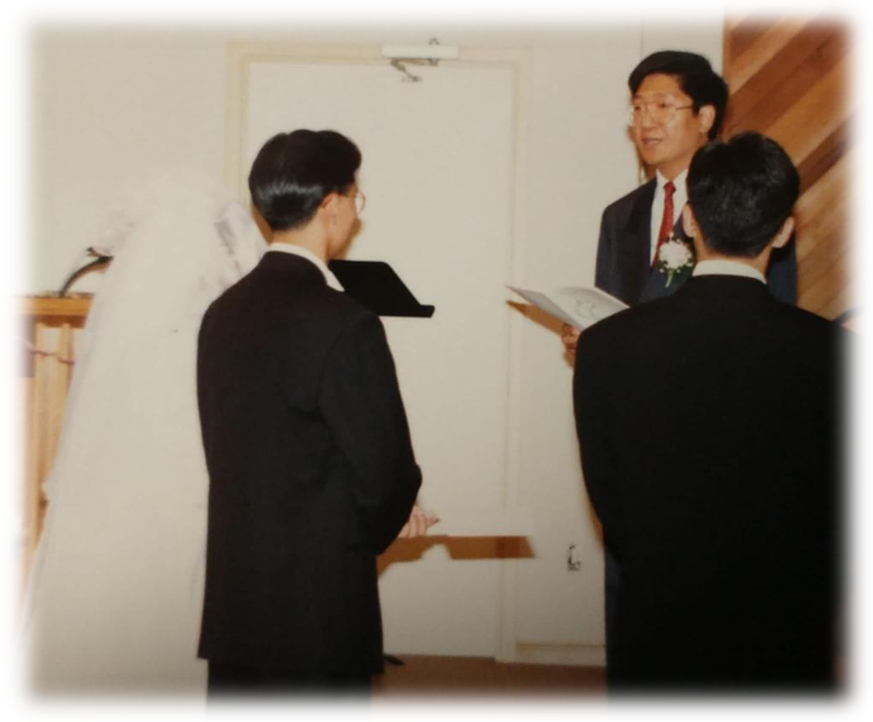
Marriage Officiant, you officiated a wedding, the very first wedding you have officiated 30 years ago even though you were yet to be licensed to sign the marriage papers (shhh!). Your pre-marriage counselling courses and constructive advice for a marriage was a lifetime gift to us. Your secret words for a successful marriage, "PLEASE", “SORRY” and "THANK YOU" became our golden rule each day. Lastly, you never forgot to wish us “Happy Anniversary” every year amid your usual hectic schedule.

Thank you for being a part of our life. Your genuine smile and sense of humour will forever be in our hearts. Farewell for now, but we will definitely give you a high five when we see you again.❤

《環球華人宣教學期刊》第六十八期 Vol 7, No 2 (April 2022)

