非一般的冒險家 “An Extraordinary Adventurer”

梁牧師二姐夫 鄺士奇

In the Name of God –
以基督之名 –
He adventured in fostering faith:
他因激發信仰去歷練：
Seminary studies and mission training in Edmonton.


He adventured into cross-cultural mission:
他探索實踐跨文化福傳：
Missions pastor in Hong Kong and founded Alliance Global Serve.
Field work in Africa, Cambodia, ……. for the poor and underprivileged.
Assisted missionary development in Zhuhai, Zhong Shan, ………China.
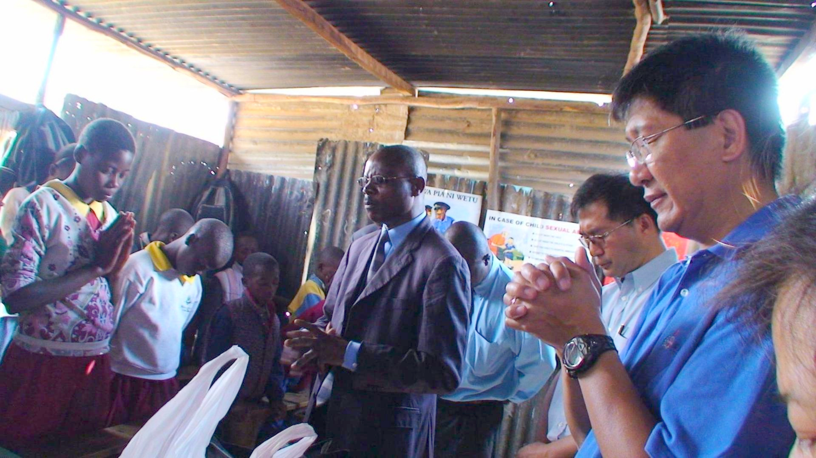
He adventured for the family:
他為家庭親人美好生活去闖：
Pioneered his parents and siblings emigration to Canada


“Rest in Peace”
“Praise the Lord”

Louis (brother-in-law)
二姐夫鄺士奇

《環球華人宣教學期刊》第六十八期 Vol 7, No 2 (April 2022)

