A1
For Such A Time As This: Journeying with Tribal Peoples
- Georgia Grimes Shaw
Published in Global Missiology, October 2012, www.globalmissiology.net

In August 2011, Dan and I landed at the Honinabi airstrip on the MAF Cessna 206 (a small aircraft that can take off and land from short, rugged airstrips). It didn’t seem possible to me that we were returning again to the Samo people after spending four months with them in 2010. I had left that first experience saying, “That was a one-time experience for me and I will never return to the sego swamps of the Western Province of Papua new Guinea.” Famous last words, for here we were again climbing out of that little plane into another world, a much more relaxed one than that of our home in Pasadena, California.
We were returning to help establish the Karen Shaw Memorial Library at the community school in the area where Dan and Karen had been Wycliffe Bible translators from 1970-1982. Another MAF plane would arrive later that day with the heavy materials we had brought, including two solar panels with batteries, four trunks of books, 50 copies of the 1980 Samo Scriptures translation, and two laptop computers with watertight, airtight, dust proof, and crush proof storage boxes (vital in the PNG swamps).

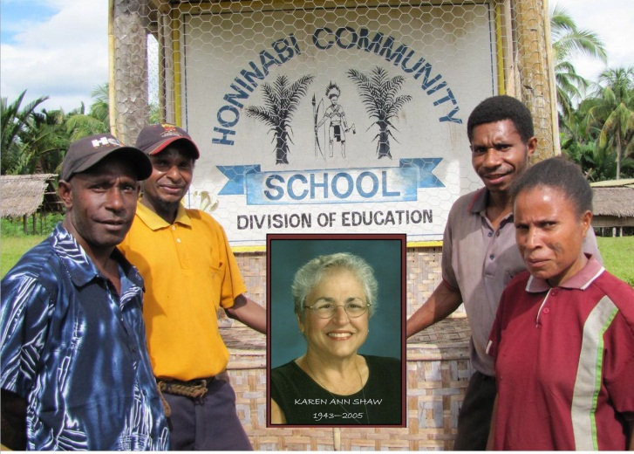
Samo headmaster Philip Toyobo and teachers Robin, Wasi and Seron ready for the dedication of the Karen Shaw Memorial Library 2011

My main task during that three-week stay (along with meals, laundry, cleaning and entertaining visitors) was to help the Samo teachers and translators use and care for the new laptop computers. The previous year I had become friends with Seron, the single woman school teacher (among five men teachers,) and acquainted her with my computer. I was looking forward to see how much she remembered. I sensed leadership qualities in Seron as she faithfully taught the younger ones and took care of her aging mother. Plus I felt the need to help encourage this young woman as she struggled in this ‘male’ dominated developing country.
The phrase that kept me coming to my mind during our time with the Samo was “for such a time as this” (Esther 4:14). I had heard it various other times in my walk with the Lord, but this was a more powerful awareness for me. Here I was with Dan 40 years after he and Karen first arrived in the Samo village—at the precise time a cell tower was being set up 6 miles away at No Mad River (a three hour hike). Civilization was quickly surrounding these tribal people and so much of the ‘old ways’ were being left behind in the wake of overwhelming technology. On my first trek through the sego swamps we came upon a solar panel propped up in the middle of a village with a wire running into the house and I could hear Barbara Streisand singing “The way we were”. Talk about culture shock! A few nights later our neighbor turned on his battery operated radio and got Glen Campbell singing “Like a rhinestone cowboy,” all I could do was smile and say “for such a time as this.”
During our 2010 time with the Samo, I noticed there were no copies of the Scriptures Dan and Karen had published in 1982—paper does not last long in the swamps of PNG. Only a few of the people had even seen the blue Baibo Booka. The Samo pastors and teachers were amazed that it was in their language and asked for a copy like the one Dan brought with us. Back in California, between trips to PNG I scanned the Baibo Booka so that we had a digital version to print new copies and take back with us. I struggled for weeks with the Samo texts that the scanner had miss read, and yet that is the kind of detailed work I enjoy. We designed the book to look very much like the original blue one and got 50 copies printed. We took copies back to the village in 2011, and the Samo translation committee decided how they would be distributed (five churches got five copies each) and the remainder went to the new library. I was humbled to realize that 30 years after the first publication I would be the one to help Dan do a digital transfer and printing, “for such a time as this”.
As I review the 3 weeks with the Samo in August, 2011, the picture I see is a mosaic made up of broken bits and pieces of my life put together years later to form a wonderful scene, as only the Lord can design. I became aware that during those few short weeks all of my skills, talents, training, and gifting had been pulled together in one place “for such a time as this” (convergence as Bobby Clinton labels it).

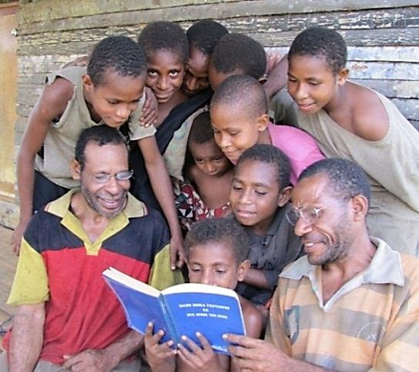
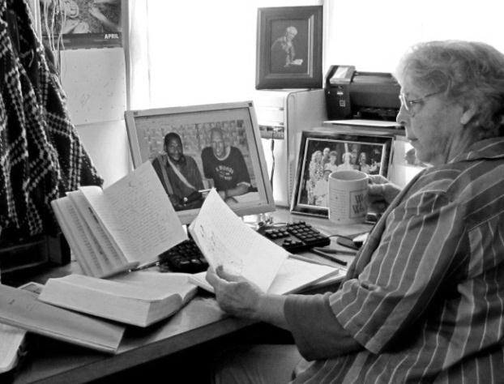

Georgia working on digital version of Baibo Booka Samo listening to Pastor Tom read John 3:16

Shortly after WWII ended, I was born the fourth child of six to a poor Michigan dirt farmer/factory worker. During the day my third-grade educated dad worked the farm and then worked the night shift as a heavy duty machine operator in Grand Rapids, until he retired in 1978. During the war his machine shop was refitted to make air plane parts and the company would not let Dad join the military. This restriction affected his outlook on life from that point onward. Both of my grandfathers were bootleggers and had stills in their root cellars (called a clandestine underground brewery) during Prohibition. However, my maternal great grandparents, Eunice and Allen Mead (GG and Baba) came to the Lord as adults and were Free Methodist preacher/evangelists in central Michigan where Baba served several communities as a circuit rider.
My childhood was colored by alcoholism, child abuse and divorce. My three brothers struggle with drugs and alcohol and broken marriages while my two sisters married and each raised 5 children. Sarah Stirman expresses my feelings very well as she writes the following about the mosaic of life;
Many of the disasters of my life seemed to be pieces shattered beyond repair at the time, or tiny fragments completely useless for any purpose. But God. As I offered them up to Him as a sacrifice of praise—or, let’s be honest, sometimes threw them at Him in disgust and said, “What in the world am I supposed to do with THIS???”—He scooped up the pieces, gently picking out the beautiful parts.

In the early 1950s a neighbor invited us to Daily Vacation Bible School (DVBS) at an undenominational Bible church in the next town. It was then that Mom committed her life to Christ and became a charter member of that church. Later, at age 8, I raised my hand to accept the Lord as Savior during a session of DVBS, and the next year I raised my hand again as I wasn’t sure it worked the first time because I continued to get in all kinds of trouble. Wisely, the director asked if I had been praying and reading my Bible, he then instructed me to trust the Lord because the Lord promised to never leave me and that settled my concerns. At age 16, I ‘rededicated’ my life and committed to full-time Christian service when an old man from a Minneapolis Skid Row Mission shared his story and challenged us during a Wednesday night prayer meeting.
In the early 1960s I attended Youth for Christ (YFC) and organized a YFC chapter at my high school. Most every Saturday night a group of young people got in the old yellow Sunday School bus and traveled 25 miles to attended YFC meetings in Grand Rapids at the Mel Trotter Mission in the heart of Skid Row. As we walked from the parking lot I noticed men standing here and there who smelled and acted like my grandfathers and didn’t find it strange. Every YFC service ended with singing, “Just As I Am” and young people were invited forward to put their trust in Christ. I became one of the leaders and would sit up in the balcony behind our group to watch and pray for any who raised their hand. To this day I prefer to sit in the back of the meeting so I can keep an eye on what is happening.
The course of my journey brought me a ‘spiritual mother’, Lillian VanderMolen, during my teen years who introduced me to Christian writers such as Amy Carmichael (If and Edges of His Ways), C. S. Lewis (Skrewtape Letters), Elisabeth Elliot (Through Gates of Splendor), Isobel Kuhn (Greenleaf in Drought Time) and to other translations, especially the Amplified New Testament. Most precious has been the copy of Oswald Chambers’ My Utmost for His Highest. These and many more were such a part of my spiritual development.
Lil also introduced me to the work of North America Indian Mission (NAIM) on the Pacific Northwest Coast. I remember in 1963 asking Lil if she thought the mission would let me work with them and she said, “If the Lord wants you to go then obey him, you will be the one to miss out if you don’t obey because God’s work will be done with or without you.” That was good ‘Dutch Mother’ teaching I have used many times over the past fifty years with other young people desiring to serve the Lord. Today, the aging process has removed Lil’s ability to communicate with me, but the Word and modeling of integrity she planted in my life continues.
I visited with my GG in 1965, before leaving for my first year of college and she shared I Corinthians 13 with me. “And now I will show you the most excellent way…these three remain: faith, hope and love. But the greatest of these is love”. GG said she couldn’t give me anything of value as I left to follow God’s plan for my life, but she would give me the treasure of her life, ‘love’. Howard Snyder wrote, “Free Methodists have a specific calling to uphold biblical Christianity and bring good news to the poor. This is lived-out holiness.” Through the years my life became an unfolding of GG’s love gift in stages of “lived-out holiness”.
I was the only one in my family to go to college and in 1965 I attended Northwestern College in Minneapolis. On the Northwestern College campus, as you entered McAllister Library there was a large photo of alumnus Roger Youderian and the story of his death in 1956 along with four other message bearers involved in Operation Auca in Ecuador. I remember thinking through that event of just ten years earlier and committing myself to serve the Lord even if it meant death.
My first adventure with NAIM came in 1968 with 58 other college students in the Summer Missionary Institute. That summer was the beginning of NAIM’s north camp at Terrace, BC, Camp Kla-How-Ya. The camp director took the yellow bus and went to gather the campers from 14 villages. I went on the run to the coast to pick up kids from four villages and four cannery areas near Prince Rupert, including Metlakatla where I had spent 2 weeks prior. We had a full load as we headed back to Terrace. All the kids were fearful as we started out, so I began to joke and play with them and asked them if they could speak Indian and could they say ‘how’ without smiling (little did I know that “how” was a Sioux greeting not Gitxgan). No response, no matter what I tried, they just looked at me and talked to each other. Finally, I said “I bet I can make you laugh, you won’t be able to say ‘how’ without smiling.” An important lesson learned over the years was that Indian people, young and old, love a bet or gamble, so they all took me on.
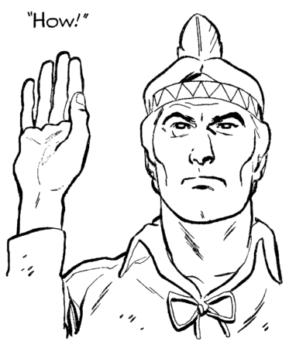
I said they had to raise their right hand and say ‘how’, just like I had seen Tonto do so many times on the Long Ranger TV program (yes, I did have a lot to learn about language and culture). One by one, the kids tried to be serious and say ‘how’ but I was making faces at them and not one of them could keep a straight face. The result was a bus full of laughing kids trying to say ‘how’ without smiling. This simple game was the beginning of a life changing ten days for those boys and girls, their families and for each of the ‘white’ counselors. It also set a pattern for my ministry as I asked myself, how can a Spirit-filled believer build relationships and share the love of the Lord Jesus Christ without smiling? Some day I will write a book titled, “How Without Smiling?”
By 1974 I had completed all the preliminary steps for becoming a full-time staff member of NAIM and was assigned to Kuper Island between Vancouver Island and the British Columbia mainland. The years I spent with First Nation peoples (1968-1986) allowed me time and place to be good news to the poor as I learned their cultural ways and languages. Looking back, I was indeed seeing God write my story.
For five years, I was the only single NAIM field staff and this gave me wonderful freedom because I did not have other family members to be responsible for, and I literally could come and go as needed. During those years key families in Tulalip, WA, Penelakut, Seabird Island, Merritt, Pentincton, Kispiox, Metlakatla, Prince Rupert and Port Edward, BC took me in as family which provided me a position in their village ‘for such a time as this’ to be a message bearer of good news.
Initially, one of the attractive points for NAIM recruiting on any American college campus, was that all the First Nations groups they worked with were literate in English so staff were not required to learn another language. However, in 1974 the more I got involved with the people on Kuper Island, the more I heard the halkomelem language in their homes. Initially I asked then, “Do you speak your own language?” And always got a negative response. I learned that all of the people my age and older spoke in their heart language so I just began mimicking words here and there and gradually different ones would correct me or add more words and all of a sudden I was learning.
I had attended my first four years of schooling at a one-room country school in central Michigan (the same one my mother had attended). The mode for teaching reading was phonetics rather than the current “look-say’ or ‘whole word’ technique. Therefore, it was natural for me to sound out and write down the language I was learning phonetically. The people were pleased with my efforts to capture their language. “Hey, that’s my language, I’ve never seen it written, I can read it! How do you know how to write my language?”
I had become friends with two Wycliffe women who were doing translation in Papua New Guinea (PNG) and after visiting Kuper Island with me, they advised me to get linguistic training. In 1976, I wrote a proposal to NAIM leadership requesting to do language work among the Coast Salish and got clearance in 1977 to attend the Summer Institute of Linguistics (SIL) at the University of Washington in Seattle. It was at this SIL that I got my first taste to anthropology in the course Dan Shaw taught. He and his family were home on furlough from PNG and he and Karen were teaching second year courses as well as the anthropology course.
After that 9-week SIL course I plunged right into language learning and initial Bible translation back on the island. Actually, I just talked thru the text and recorded the translation I received then transcribed the recording (not exactly what SIL teaches). But I was eager to get the Bible message into the hearts and lives of the people and ground work needed to be done to explain what I was trying to do. One elder asked me, “You mean you want to put the Bible in my language after the church came and forced us to learn English and punished us for speaking our own language? Why would you want to do that, are you better than the church?”
I had to stop and think through that question and the Lord gave me the insight to say; “This Bible has only been in the English language for 370 years so my people—white people, could read it. Before that a priest had to read it for the people to know what it said. Now, I’m asking you to help me translate the English into halkomelem so you and your people know what it says in your own language.” This satisfied his question and we proceeded. While helping me with Luke 5 he read verse 3 and asked; “What did he teach?” This stopped me again and I wondered how I was going to work with an adult who didn’t understand the word teach, so I tried to explain the verb. “No, I know what teach means, what I want to know is what did Jesus teach the people when he was on the boat?” It was like a computer screen came on in my head and all the Bible reading and teaching was displayed for such a time as this. I began from creation in Genesis and talked him thru the Biblical narrative ending in the new heaven and earth in Revelations. His response was, “I never knew that is what Jesus taught, why didn’t the white people tell us that?”
I was learning that sometimes the Lord shows a woman what he wants done and trusts her to pray for the male leaders to see the plan, rather than keep bugging the leaders about a needed change (as I was prone to do). I also learned not to use, or rarely use the phrase, “but the Lord told me…” (nothing puts leadership off more surely than that phrase). I kept praying for the NAIM male leadership to catch the vision of the importance of language learning. Finally in 1979 another staff member, Dan Kelly was studying at Fuller and met Tom and Betty Sue Brewster. Dan advised the leadership that language and culture learning needed to be implementing in the work of NAIM through the newly formed training program IMCO (Inter-Mission Cooperative Outreach). In 1980, because of my language training, I was asked to assist Brewsters with the LAMP course at the IMCO training program, and I was nervous but ready for such a time as this. We had a wonderful time, I learned a lot, and that was the beginning of my involvement with Tom and Betty Sue.
My first trip to Pasadena to work with Brewsters was in March 1981 when I earned seminary credit for helping them develop LEARN! During that 3-month stay I attended the Golden Jubilee in Anaheim Convention Center, marking the 50th year since the completion of Cameron and Elvira Townsend’s Cakchiquel New Testament and the beginning of the Wycilffe Bible Translators. This was two months after Chet Bitterman had been killed in Columbia and I remember someone reading the following from Chet’s journal at the Jubilee and how his words pierced my heart. I now realize I was there for such a time as this.
The situation in Nicaragua is getting worse. If Nicaragua falls, I guess the rest of Central America will too. Maybe this is just some kind of self-inflicted Martyr complex, but I find this recurring thought that perhaps God will call me to be martyred in His service in Colombia. I am willing.

One of the prominent cultural activities among the Coast Salish is the winter ‘spirit dance’ ceremonies when new dancers are initiated according to specific rituals. I attended the big house dances regularly until 1977 when my Indian parents said they wanted me to be initiated as a dancer…it would be a great honor for them and for Kuper to have a religious white woman dancer, because the nearby Saanich Reserve had just initiated a young priest as a dancer. I spent long hours in prayer and Bible reading, looking for an answer to this request. I experienced how the enemy of God had twisted a God-given ritual and ceremony to bring honor to himself and destroy the community. The ceremony involved getting a new name (as in Rev. 2:17), a song and membership in a new family. I used aspects of this ritual as a stepping off place for the Gospel, redemptive analogy if you will. However, I had to share with these wonderful people that I could not walk two ways, I had to choose either the spirit dance way or the way of the Cross so I could not become a dancer. Unlike Chet Bitterman, my thinking was that I would not survive the initiation ceremony and my birth family in Michigan would turn away from God for letting me die in such a way.
When I shared my decision with my adopted parents, they stood up, turned their backs on me, walked out of my home and did not speak to me for a week. A friend later told me it was because they understood that I was condemning their cultural ways. But God had a way prepared to keep me in that family. That same week I received a call that my birth dad had shot himself and I needed to fly home to Michigan. When my adopted parents heard about my family need they collected money in the Indian way, “Indian insurance” they call it, and helped me get home. We never talked about my choice again. Never, would I have chosen to have my dad nearly lose his life so the Kupers could hear the Gospel, but God always has a plan for such a time as this.
While working on a Masters degree at the School of World Mission (SWM), I wrote a paper for Paul Hiebert’s Phenomenology and Institutions of Folk Religions course titled The Threat of the Spirit Dancers and described what I had observed in the culture. Dr. Hiebert called me into his office to discuss the paper and explained what plagiarism was and that I needed to cite my source for the ‘facts’ I was giving. I didn’t exactly know what he was referring to about plagiarism and explained that it was my personal participation and observations I wrote about. As a result he invited me to submit the paper for the Case Studies in Missions book he and his wife were putting together.
As I review the story of my life I see that when various employment positions ended in what seemed a crushing change, the Lord was moving me on in his plan for my life and usefulness in his work, I was learning that change requires change. After 1980 I was seconded to Brewsters several times and in 1984 I spent nine months at the Spanish Language Institute in San Jose, Costa Rica developing the learner track for them where students spent mornings in classroom and the afternoon in community learning Spanish. It was a fascinating time for me learning Spanish, developing the new track and building relationships with the very poor in San Jose. Previously I had made ministry decisions based on the belief that God had called me to Indian people in America. Now, I was sensing the call was not to a specific people group, as much as to a marginalized people—the poor.
There were tender moments of receiving care from families who lived in los quadros (the squares) outside of San Jose, in shacks that were later replaced with one-room cement block ‘homes’ up on the hillside. One day I was caught in a rain storm on my way to visit Hortencia and her 5 children, and I arrived soaking wet. She immediately removed my wet sweater, wrapped me in a dry blanket, towel dried my hair, washed my feet, gave me hot water to drink and insisted I rest on their ‘only’ bed. Another day I brought a pound cake for her family and I noticed she cut it in two and took half to her neighbor who had nothing. I was learning about the joy of poor people.
The fall of 1985 I resigned from NAIM after 18 years of involvement, to join Betty Sue and Tom in Pasadena. A core group was forming for developing ministry to the poor and we were all so encouraged to sense the Lord was pointing us all in the same direction and I knew I was there ‘for such a time as this’. Change does indeed require change and the first such change for me was when Tom Brewster did not survive surgery in Dec. 1985 and God brought him home to walk in glory.
I continued to work with Betty Sue while finishing a Masters in missiology degree at SWM. Marilyn Clinton got me a job directing the In Service Program, which resulted in my having missionary contacts all over the world. In 1992 a change in SWM leadership brought about my transition to Union Rescue Mission (URM) in downtown Los Angeles. As I got involved with the poor and needy, very needy people and families on Skid Row, I began to develop relationships and contacts. On one occasion as I walked to the bus stop a man approached me for money and all I had in my pocket was a large chewable vitamin C, so I offered it to him. At first he was angry, but as the days and weeks went by he remembered and would ask for a ‘big C’ and we became friends and he became my street guardian.
A change in leadership at URM resulted in my moving from California to Oklahoma in 1996.Yes, change requires change. Oklahoma for me was like going to the backside of the desert. It truly was a desert experience for me…but God was there to comfort and direct me as I learned lessons that were important for what was yet to be in my life and ministry. In Oklahoma I was involved in Full Gospel circles and learned more about spiritual warfare. I was working and teaching at American Bible College and Seminary (ABCS) and developed a spiritual authority course and co-taught with Evert Cox, one of the board members of the college who had a weekly prayer ministry at City Church in downtown Oklahoma City. It was a rewarding, renewing experience for me and once again I realized that “for such a time as this” the Lord had directed me to be used in the Lord’s work even as he was healing my heart.
I received a Doctor of Ministry degree while at ABCS and along with teaching both undergraduate and graduate courses, was the registrar and then the assistant to the President, Floyd Shealy. In 2002 a leadership change at ABCS left me without employment and for the next couple of years I worked in retail sales. During an especially difficult personal time in the fall of 2005, I was convinced the only use I could be to the Lord was to support missionaries with prayer and finances. In an attempt to get out of Oklahoma, I asked a friend of twenty years, if I could live with her in Michigan. To my shock and disbelief she said, “No, that would not be a good move for either of us.” Well, I was stunned, I just expected her to say, “Hey that would be great!” But the Lord had a plan “for such a time as this”.
Not many days into this smothering depression I had a dream and the dear Lord reminded me that He had never failed me and assured me that he did have a plan and for me to be patient because a change was coming that would far surpass my life experiences to that point, “opportunities I could not imagine” is the phrase I remember. The dream was so real and I woke with a deep settled peace that the Lord was in control and as always I needed to trust and obey for such a time as this. This was encouraging for me to share with my Michigan friend, as her negative response was part of God’s plan.
In late October 2005 I got a phone call saying I needed to call Dan and Karen Shaw in Pasadena, because Karen was very ill. That weekend I learned that Karen had died of a blood clot and Dan was in hospital recovering from emergency surgery. While in Pasadena, I had spent a good deal of time with the Shaw family, house sitting and taking care of their three sons periodically. But I hadn’t kept up the friendship since leaving California in 1996. Now, working through the sudden loss of a good friend and helping her husband through the grieving process was difficult from such a distance.
Dan and I got better acquainted by phone and email and gradually the Lord showed us he had a plan for our lives together. I returned to California three months prior to the date we set to get married and I stayed with Betty Sue. During that time she shared about her son’s growing up, attending college, marriage and birth of her grandchildren; her cancer surgery and treatment and what the Lord had been teaching her through new learning experiences. She was busy editing her mother’s book, Pioneers in Pith Helmets, as well as continuing to teach at Fuller and basically felt over whelmed by pressing needs. It was a good getting reacquainted time and needful for both of us. I could see the Lord had put me in her home again “for such as time as this” to help Betty Sue. That fall she sold her home and we packed up her belongs and together drove to Vancouver, WA where she bought a house to share for a time with her son and his family before they left for ministry with the urban poor. This seemed an appropriate closure to our 26 years of shared adventures.
Now, Dan and I have been married six years and are so enjoying the synergy we create. Initially, Dan was forever talking about ‘finishing well’ until I suggested we needed to focus on ‘starting well’ before moving on to finishing! He had that dah look and then said, “well of course!” That is the kind of give and take we experience and for the most part enjoy together. Our travels have taken us into new ministry and learning experiences as I related in the beginning of this article, and now the Samo even call me Abo (grandmother).
As I reviewed the experience in the Samo village in 2011, I asked Bobby Clinton what he thought of my response of being done with all of my former activity and anticipating something totally new. He shared some key thoughts (in very Clinton fashion) that may be helpful to others in my stage of life;
In terms of a focused life folks in ministry 50+ years of age are basically working on firming up their legacy (the set of ultimate contribution types that are theirs)…It is rare for a person to acquire a new life purpose or even new ultimate contribution types past 50 years of age and 20 or 30 years of active ministry. But folks in your stage of life can firm up their legacy by identifying and working on confirming their ultimate contribution types and working to make sure that they are leaving behind a legacy.
So then to answer your question, you are in the latter stages of convergence and it would be unusual to have a new thrust of life purpose. Instead the normal thing would be for you to make sure of your legacy by working on establishing your on-going parts of your ultimate contribution set. Some of your ultimate contribution items may be already completely done. Others need further work to guarantee a legacy (personal email 2012).

It is most interesting for me to learn this now, because in the last several months I have been in close communication with ‘kids’ (now grown with families of their own) from Metlakatla, BC who are sharing their lives again with me after more than 40 years. And last month I had a wonderful interaction with a friend from Kuper Island who I haven’t heard from since 1986. The internet is wonderful for reconnecting and building again on relationships from years past. So I am actively working on firming up my legacy with my ‘lived-out holiness’ for such a time as this when God may again step in, tap me on the shoulder and say, “Let’s go”.

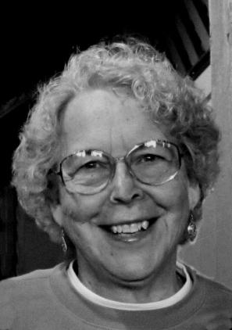

GEORGIA GRIMES SHAW served with NAIM for 18 years in Canada and then joined Brewsters in Pasadena for 12 years. She lives in Altadena, CA with her husband Dan Shaw and has a home business editing graduate level writing projects and enjoys traveling the world with Dan.

This can be found at http://www.sarahstirman.com/2012/04/mosaic-of-my-life.html.
Available from fmcusa.org/uniquelyfm/distinctives/.
Renamed Penelakut Island in 2010 to honor the people living there.
The current preferred title for the Aboriginal peoples of Canada.
Alternate spelling of hul’qumi’num.
I stopped language work in halkomelem in 1986, but today the Penelakuts have an active language program through the Chemainus Native College. One regret I have is not being able to find a word in halkomelem for ‘forgive’, the closest I found was ‘feel bad for’ which did not capture the meaning of the Cross that would unlock the Gospel message for the Coast Salish.
Now I know this is called ‘chronoligical Bible storying’ and is something New Tribes Mission has been using since the 1970s, about the same time frame as I was learning the process.
I also learned to respond to the statement by kindly saying, “If the Lord told you this, I know He will tell me the same.” There is no way to argue with what they ‘know’ the Lord has said.
IMCO was founded in as a joint training program of NAIM, Arctic Mission, Northern Canada Evangelical Mission, United Indian Mission and Native Evangelical Fellowship.
Language Exploration and Acquisition Resource Notebook is a 300 page syllabus with 16 cassette tapes.
Available at http://womenindiscipleship.org/weekly.php?date=2011-11-07.
Saanich is a reserve on the south end of Vancouver Island. In 1977 Brother Terry McNamara was initiated as an Indian dancer in Saanich and in 1979 was ordained in the Quamichan Long House in Duncan, BC.
The name was later changed to School of Intercultural Studies (SIS).
My article is in the 1987 edition on pages 103-108.
The format was similar to the sessions John Wimber, Pete Wagner and Chuck Kraft used in the 1980s.
Depression seemed to be ever present from 1974 or so. Finally a friend recommended taking Omega3 regularly, and it has indeed leveled out the ups-and downs of my emotions.
Dan and Karen Shaw left PNG and moved to Pasadena in 1982 when Dan began to teach at SWM.

