B3
Mongolians: They Came Into My Heart
- K. Sue Chung
Published in Global Missiology, October 2012, www.globalmissiology.net

The phone was ringing.
I answered it and could hardly believe what I was hearing. It was a missionary who had just been in the countryside of Mongolia for a year. She got our number through our friend and wanted to know whether we were working with Mongolians in LA area. It was summer of 1992.
The call came the day before we were going to send $1,000 to the Mongol travel agency (the only one in the USA at that time) in Washington DC to get a 10 day visa. Yun (my husband) and I had been praying for 4 years to visit Mongolia and we had not been able to get visas to enter. We were waiting for God’s timing and it happened suddenly in a way we had never expected. The lady wanted to meet with us the next day and told us she could help us get visas for free! It was a divine appointment of God and perfect timing.
God spoke to us about Mongolia while we were in a Bible school in Switzerland in the spring of 1988. Yun was praying for the nations in a small group (the school called for small groups to be praying for the nations three times a week), and God gave him the impression of Mongolia. When we were married a year earlier, we made a decision that we would go to a new mission field where little mission work had been done. So when I heard that Mongolia was the country we were going to, I was very excited.
In 1921, Mongolia was the first country to join the Soviet Union. In the winter of 1990, after 70 years of Communism, the Soviet Union fell and Mongolia was opened up to the world. In1992 for us as Koreans to get into Mongolia, we had to go through Korea, Hong Kong and Beijing because Korea did not have diplomatic relationships with China. It was a long and expensive journey. But Yun and I were very excited and full of joy to see the land and to meet the people of the nation God had spoken to us about four years earlier. We had already tasted His miracle through getting visas so we were confident He was leading us and would open the way.
Yun and I prayed that God would send someone to help us when we arrived in Mongolia. Another divine appointment God had already prepared for us. Before we left Pasadena, we heard the name of a pastor who lived in the capital city Ulaanbaatar (UB) and was a missionary. At that time only a few foreigners lived in UB, and we found him easily. He
introduced us to a young girl who had just become a Christian six months earlier and she was very passionate for Jesus. She was our guide for the whole time we were there. It was such an encouragement for us to be introduced to Mongolian people by a passionate Christian. Everywhere she went, she talked about Jesus, and she became our first Mongol friend. She gave us our Mongolian names Taivan (peaceful) and Saihna (good). We were very pleased with our new names since they described how she felt about us, peaceful and good.

My first Mongol friend

My first impression of the Mongol people was that they had very pure hearts and were not influenced by materialism. It was refreshing to see people like them. They had been hidden from the world because of Communism; and I believe that was a blessing for them in a way, because they retained their innocence. I found the Mongolians to be very relational and quite spontaneous in every way so that I felt connected with them instantly.
When we arrived at the airport of Ulaan Baatar in September 1992, I was surprised how small it was. They carried the luggage by a big truck from the plane to the conveyor belt; it was a totally different world. We stayed in a hotel that cost us $2 per day and we paid the taxi driver $1 for all day use. One day we went to one of the best hotels in the country for lunch and had to wait for an hour only to be told they had run out of food. There were few things in the biggest department store and little food in any of the other stores. They had ration cards and people waited a long time but could not get bread. No toilet paper and no shampoo in stores, very few cars in the streets, no hot running water in the city and no electricity in many places.
I realized what the fall of the Soviet Union meant and how difficult it made the daily lives of the people. The Soviets had provided everything for the Mongol people and after 70 years that provision was no longer available. I sensed uncertainty and fear throughout the city. One lady was selling carrots on the street and people ran and grabbed everything she had. Within a few minutes everything was gone. I wondered how they could survive, not just because of lack of material things, but from the confusion in their mind and emptiness of their hearts. What was going to happen next? Where would hope for the future come from for them?
I sensed that God was asking me, “Do you still want to come and live here? Do you still want to be with them after seeing this difficult situation?” My answer was a firm, “I would come and live here and love this people, for You gave them to me and I want to obey You. I want to tell them about Jesus the ‘Hope of Glory’ for You are the only hope for them.”
Yun and I agreed that suffering in this world was not important, but their hunger for hope and for God was important, so that would be our focus. We were sure that this was the place where God wanted us and that He would give us His grace to live here and love them to the Lord.
I tell you the truth, unless a kernel of wheat falls to the ground and dies, it remains only a single seed. But if it dies, it produces many seeds. The man who loves his life will lose it, while the man who hates his life in this world will keep it for eternal life. Whoever serves me must follow me; and where I am, my servant also will be. My Father will honor the one who serves me (John12:24-26).
We visited the first church established in Mongolia where some 300 young people gathered and worshiped, it was called Monhing Gerel (Eternal Light). When they sang a praise song that a Mongolian believer had written it touched my heart deeply. They only had one guitar but the sound of praise was heavenly and it wasn’t even Sunday. I could feel their hunger for God and their passion for Jesus. I could sense that these young people had found what they needed in life, HOPE.
During our first year in Mongolia, Yun was working in a humanitarian organization, and I was teaching English to medical doctors in a hospital. The doctors were all women. In fact, 80% of the medical doctors in Mongolia at the time were women. I found that most of them were single moms, and the ones who had husbands were responsible for taking care of the family rather than the husbands. Men were there, yet they were not there. I observed the absence of husbands and fathers were very common, and the wives and mothers carried the burden of the family. Women feared that there were not enough men for them to marry, so they tolerated unfaithfulness and irresponsibility from their husband. Even though this fear was not proven true statistically, they firmly believed it.
I became friends with one university student who came from a middle-class family. She had recently married a rich young man and was pregnant. She was working two jobs and I asked her why. She told me that she did not know when her husband would abandon her, so she needed to save money to buy an apartment to live in, just in case. Only a few months of marriage and she was already worried about being abandoned because many of her friends and relatives had been abandoned by their husbands. Over the years this fact turned out to be true for many women whom I had known.
Yun and I came to the conclusion that this was a curse from the past. In the13th century, when Genghis Khan conquered a huge part of the world, he killed many men, husbands and fathers, in the nations he conquered. Now his descendants are suffering from the consequences of his sins. Over the last 15 years we have encouraged our Mongol discipleship school students to repent of this sin on behalf of their ancestors, just as Nehemiah repented and prayed for his people. In our students’ lives, we have seen positive results from this prayer of repentance. Some of their families have been restored and husbands came back home.
Let your ear be attentive and your eyes open to hear the prayer your servant is praying before you day and night for your servants, the people of Israel. I confess the sins we Israelites, including myself and my father’s house, have committed against you (Nehemiah 1:6).
After we had been in Mongolia for a year, we decided to register our own humanitarian NPO (non profit organization) and found it was a difficult process. The professors at the university we wanted to work with on this project to help the poor were not sure about our motivation for the project. They thought we wanted to use it for Christian mission work, and their suspicion was true as that was our motivation and intention. Without their permission we could not renew our resident visas to live in the country. A resident visa for foreigners must be renewed every year, and they could deny extending it if we were doing Christian work.
Yun and I prayed through the situation and finally gave up our desire to be in Mongolia. It meant that we had to die to our vision and our calling, which we had been praying about for eight years. It was very difficult for us to put it on the altar and forsake many years of praying and planning. We decided we would go to Canada where Yun’s family lived and to wait until God opened the door again to return to Mongolia and I cried a lot.
The very next morning a professor from the university called and told us that they decided to give us a two year permission to do the project on one condition: we could not do any Christian work through this project. If we broke the agreement, we would have to leave the country and re-enter with new visas. We promised that we would not use the project for a Christian mission purpose…and we kept our promise.
We sensed that because we gave this vision back to God as a sacrifice and died to our desire, God had resurrected it. What an important lesson we learned: If we want to experience the power of resurrection of Jesus, we have to die first to ourselves so that it is His will being done, not ours.
In our 15 years of doing that project, we never mentioned “Jesus” to the people. But with our life and action we expressed His love. We did not use the project for our ministry therefore; we fulfilled our promise to the university. The professor who was in charge of the project from the university side told Yun; “You kept your word and you were true to us. Therefore we will give you permission to continue this project.” We were able to work and help the poor for 15 years total. We also could help the blind to make gardens and plant vegetables in their backyard. It was exciting for us to be a part of such a program.
Most of our workers in the project became Christians over the years through our Mongol Christian friends. One of them became an elder of the church, and one of them became the wife of one of the denominational leaders. After nine years of working with Yun, our project manager told us she had become a Christian because Yun never forced her to become one. She wanted to read the Bible and she believed it was true. We learned that God is more than able to work in peoples’ hearts without us speaking any words.
Yamar untei be? (How much is it?) I woke up speaking this sentence and in my dream I was practicing the language I wanted so much to speak. I had been in Mongolia for a few months, but I could not reach the fluency level that I wanted. I was thinking inside, “How long do I have to experience this ‘baby like stage’?” It means that I am not able to speak, not able to understand, not able to know what’s going on around me. I need to learn everything from the beginning like a baby. “Why did God not help to shorten this process?” I was frustrated.
As a Korean, I learned how to speak English in a very short period of time, so I was quite confident in learning another language. This very confidence (probably pride) was blocking my ability to learn Mongolian. Also in those days I was always thinking in English and trying to learn this language through English which did not work, because the sentence structure of this language was the opposite to English.
Time passed and I saw the ‘pride’ in my heart. I repented and earnestly sought God’s help to learn this new language. To have an ability to learn was by His grace, not mine. After humbling myself I felt peace inside and my learning process was going forward rapidly. I realized that I had to have a habit of thinking in their language. By doing so, I was learning their way of thinking and their way of doing things. I was rushing to own this language so that I, for a while, forgot this precious and important principle; learning the language means learning to understand people and their perspective. The process of learning the language itself is precious and the process prepared me to enter into their lives.
In those days I could not wait to teach the Mongolian people the Bible in their own language, the wonderful teachings I thought they needed to hear. But what they needed first before anything was for me to learn about them, their life, and their culture. I needed to make room for them in my heart and let them in before teaching them. I had been taught this principle in seminary, yet I had not learned it.
Now, after 18 years I can freely speak and teach in their language. Yet over the years I have learned the most valuable lesson concerning the heart of other peoples. Teaching the Bible in their own language will not change their hearts, but the Holy Spirit will. My teaching will not change them, but the work of Holy Spirit will.
Yun and I took a language-learning course for three months at a school, the only language school available in 1995. Most of the language teachers at that time did not have experience teaching foreigners so learning went slowly. We had enough teaching for grammar and how to write but we needed to practice conversations with people. We decided to practice with our local friends at home in real life settings. This method improved our conversational skill. One of our language teachers came to our apartment twice a week to help us practice, which was helpful. She helped our ministries in many ways even though she did not know the Lord. It was one of the divine appointments God brought to our lives. We prayed for two years for a camp facility where we could have the Discipleship School and our language teacher let us use her summer house for ten years. They were among the key people who helped us do the Lord’s work in Mongolia.
During the first 3 years of our time, Yun and I had established friendship with many people and now most of them have become pastors of Mongolian churches and key people in other Christian organizations. Spending time with them was precious. We were not trying to do ministry. We we were just enjoying the people and bonding with them. Those times knit our hearts together and I felt that they were becoming my people in my heart as I was slowly becoming one with them. I have learned that when we simply enjoy people, God will do more things through us to touch other lives with His love. God provided the opportunity for us to teach at the first Bible school in Mongolia called Union Bible School. God knew I needed this opportunity for encouragement and strength to adjust to a new culture, and it truly was such a joy and a fulfilling time for me.
The very first students of UBTC were on fire for God, and it was refreshing to see their passion for God. Even though I had to teach through a translator, it was fulfilling to me to touch students’ hearts with God’s Word, and I established a friendship with the translator which was an extra blessing from God. Many of those first students became the key people of the Mongolian churches today and Yun and I knew it was God’s provision for us to be with them at the crucial time of their lives. I had more opportunities to teach in the different seminars and to preach in the different churches. God knew how to arrange my schedule for me to grow spiritually as I waited for His timing. He was also preparing me for future ministry as we established relationships with people. It was reassuring to me to know God was in control of my life and that I did not have to strive to make things happen.
A vital aspect of what the Lord was teaching Yun and I was to understand how the Mongol people learn. They learn through immediate and bold practice. For example, when Mongols give driving lessons, they do not explain the driving process to their students with many words nor do they explain for many hours. Instead, they teach for a brief amount of time and then they just put the students in the driver’s seat. They have them practice on a real road right away. I found this very interesting. When their cars break down in the countryside, they methodically take the motor apart and try to fix it by themselves, even though they may have only watched a friend do it. They learn how to do things by doing it themselves!
In the year 2000, Yun and I, a few Korean-Americans, and some Mongol friends went to the countryside northwest of UB, about 1,000 kilometers away where the reindeer people live nearby. On the way there, our Russian jeep broke down. Two drivers took the motor out and took it apart (we were naturally concerned whether they could put it back together). To our amazement they did it in four hours. Even though they did not have a proper part to fix it, they simply used substitute parts from what was available. They call it “mongolchilah”. They were adventurous and not afraid to try something new.
I thought about how I was teaching the Bible and wondered if this mongolchilah could be the best way they would learn about God and the Bible, to experience God in their real life. Yun and I thought that maybe they did not want years of teaching about Bible, but instead preferred short periods of teaching and wanted to be put in real life settings to taste and test it. As a result of this mongolchilah we changed the Bible study course to 6 weeks of lecture, and 4 weeks of outreach, followed by another 6 weeks of lecture. It turned out to be very effective and, we noticed that we were able to keep their attention fully on learning during the lecture phase. God knows them and gave us wisdom how to teach them the Bible. We were learning to do it in Mongolian way.
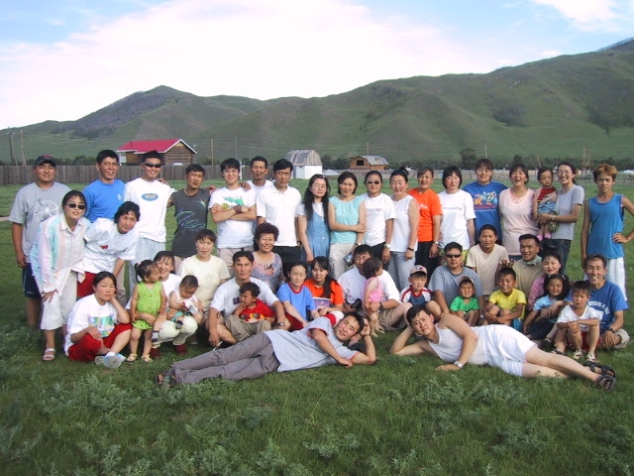
SOD students (2004)
Yun and I prayed for many years to start a discipleship program with young people from many churches. God had allowed it to happen in 1998 with a European couple in another city, but we wanted to do it in UB. After two years of waiting we were able to start preparing the staff for a School of Discipleship (SOD). For 6 months, from 9:00 AM to 6:00 PM we had an intensive training for the staff in the areas of worship, prayer, Bible teaching, and praying for inner healing. Our staff did very well and they were full of joy and excitement for the new ministry. God allowed us to buy one apartment for our staff to live in and two months later another apartment for our office. We renovated these apartments with our own hands.
On the first day at our new office we were there to teach Bible, and a lawyer and some people from the court came to ask us to leave the apartment because the apartment (our office) was theirs. We showed them our legal document and they showed us the court order. They were surprised to see our legal document, but they forced us to leave. Later we learned that according to Mongolian law; if we leave the apartment physically, we cannot claim our right for it later. Because we did not know this law we lost the apartment.
The day we lost our apartment, I needed to go to Korea immediately to see the ceremony of my pastor putting my father’s body in a coffin. My father died the day before. I did not have an exit visa. I could not leave right away and my family could not change the date of the funeral because the government had arranged it since my father was a retired general. We were delayed in arriving in Seoul and the funeral was finished.
I struggled with this and asked the Lord why He had not allowed me to arrive in time for the funeral. Didn’t I have a right to be there? I had been serving God for 19 years as a missionary and had only asked to be with my father when he was going to be with Jesus. I wanted to tell him how loving he had been to me and how proud I was to be his daughter. When I saw my dad’s tomb, I cried. Then suddenly I could hear the sound of a praise song in Mongolian:
Ta bol sain Burhan, Ta bol ariung Burhan.
Ta bol Etseg Burhan, enerngui, nigulsengui
Monhin monhood, Hair Iveel Tani orcoor bna.
You are good, You are holy.
You are Father God, gracious and merciful.
Forever and ever, Your loving kindness will be with us.

God was clearly speaking to me. “I am Holy, I can never do wrong in your life. I am your Father and I will carry you.” This comforted me and I could say to Him, “no matter what happens in my life You are still Good and Holy. Our sad circumstances cannot change who you are.” “He is the Rock, his works are perfect, and all his ways are just. A faithful God who does no wrong, upright and just is he” (Deut. 32:4).
Also I remembered something. When I decided to be a missionary (1980), God gave me a scripture: Luke 9:59-62 He said to another man “Follow me.” But the man replied, “Lord, first let me go and bury my father.” Jesus said to him, “Let the dead bury their own dead, but you go and proclaim the kingdom of God.”
The first year of our SOD was full of surprises and learning experience to us. Yun and I came to an understanding that without inner healing and deliverances our students could not receive and retain God’s truth into their hearts. We heard from all of our students (23 of them) that they were involved in some sort of religious activities (shamanism and Buddhist ceremonies for example), some form of abuse at home, and many cases of rape.
One year, 10 days after classes began, I was translating for a 19 year old student during her inner healing prayer session when she confessed that she was six months pregnant. She had hidden the fact because she was afraid of not being accepted into our school. She repented of her sin and received inner healing from the Lord. We told her we would not send her away from school, but that deceiving us was wrong. The boyfriend had abandoned her when he found out she was pregnant and she had grown up in a home with a stepfather who abused her.
Within a week she began to show that she was indeed 6 months pregnant, and we thought the baby must have felt safe to grow then. It was an interesting experience for me to see the change of the size of the baby within a week. Every student was happy to hear that she was pregnant, even though she did not have a husband and would become a single mother. It seemed the students were able to rejoice because they knew the preciousness of life.
We were scheduled to have a seminar at the third largest city of Mongolia. We traveled for 12 hours by train to get to the seminar place. When we arrived at the apartment where we would stay, my husband realized that he left his back pack in the taxi with our new laptop computer inside. At that very moment a scripture verse suddenly came to my mind, “Naked I came from my mother’s womb, and naked I shall return there. The Lord gave and the Lord has taken away. Blessed be the name of the Lord” (Job 1:21). Laptop computers were very expensive at that time and I prayed to God realizing that He knew exactly where it was, so He could help us get it back. I said I had faith that He would do it. “… I tell you the truth, if you have faith as small as a mustard seed, you can say to the mountain, ‘move from here to there’ and it will move. Nothing will be impossible for you” (Matt. 17:20). I also mentioned in prayer that I would not be resentful if He decided not to get it back for us.
I went to a European friend for help. He told me that I would never find it and that it probably was on the way to Beijing to be sold. This was not encouraging to hear. One Mongol friend called the radio station for the lost and found ad. Yun went to a main street hoping to find that white taxi. At the time there were not many cars on the street. After two hours he came back empty handed. No phone call from the radio station. I remembered again the scripture Job 1:21.
The next day was Sunday and before I went to Sunday service, I wanted to do the right thing and give up my right to get the computer back. It was not easy. That morning a lady preached on ‘being thankful in any circumstance’ and she shared the story of her arguing with her husband that morning before coming to preach. She encouraged us to thank God for the difficult thing we had right at that moment by applying the verse Eph. 5:20; “always giving thanks to God the Father for everything, in the name of our Lord Jesus Christ.” I prayed, “I am thankful to You in Jesus name even though our computer was lost.” And even though I cried hard, I then felt peace.
Batbayra, one of our Mongol friends, said he and I should go to the police station and report the incident. I told him we did not need to because I had given it to God. But he insisted that he had faith that God would get it back for us. I did not want to disappoint him since he believed he had faith and I went with him for his sake. We went to two police stations to report the loss but they were not interested in our case. When we described the taxi driver, one of the street police said he knew of the driver. He gave us the driver’s name and told us that if we were able to find the driver and bring him back, then he would help us to get our computer.
We went to the main street and prayed and waited to find that taxi. To our surprise, within minutes the same taxi showed up in front of us thinking we were waiting for a taxi. We asked him to give back our backpack and he did. He did not know what a laptop computer was. He thought it was a toy for children. We had dinner with him and his wife and he said, “You must have prayed a lot to your God, because somehow I felt some sort of strange fear inside so I could not sell it.” The Lord had arranged this divine appointment and we shared with them about God who listens to us, loves us and takes good care of us.
We were learning more and more about these people whom God had sent us to. One of our Mongolian professor friends, who was working with us in the project, gave Yun an insight about his people: “We are nomadic people, we are always moving around. So our mind is moving around too. We do not stay on one thing for a long time in our mind. We keep changing our mind.” Usually the people do not stay in one job for very long. They easily feel bored in one place and want to change a job or working place. They often renovate stores, even though it looks new and clean and does not appear to need renovation, they like to change things. I think their adaptability to a new environment is incredible. Maybe that is why they are not afraid of new situations. This quality would enable them to be good short-term missionaries and be comfortable doing mobile evangelistic ministry.

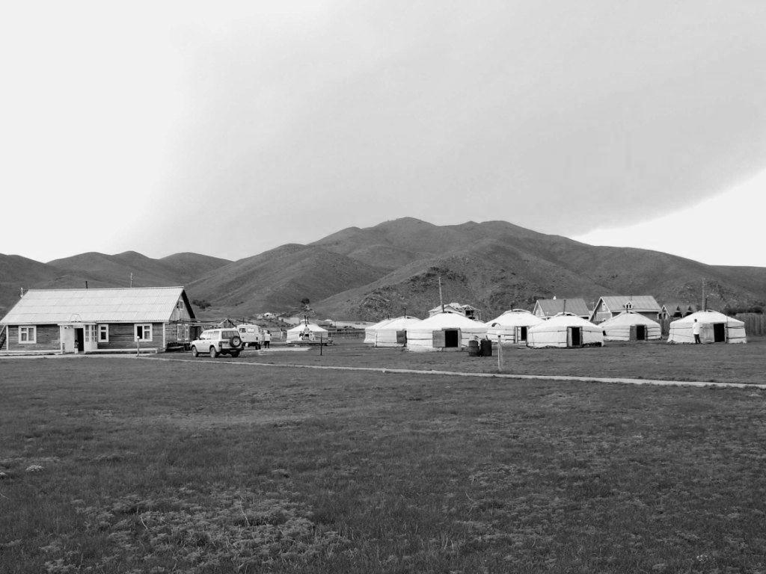
SOD summer school grounds

It was just 20 years ago Mongolia became an open mission field. Many Christian organizations and denominations arrived with good intentions. But the population of Mongolia is only 2,800,000 and less than 2% of them attend church on Sunday. It is not known among these, how many have a personal relationship with the Lord and there are few committed Christian workers available for ministry. Yet because organizations want to establish their work quickly, they often recruit good workers and mature leaders immediately. They end up getting workers that other organizations have trained. This situation creates confusion among Christians who have not yet learned about commitment to God’s work and stability in ministry.
Over the years I observed friends who moved easily between churches and ministry places. I believe foreign mission organizations should not rush to establish their ministry in a short period of time and be so desperate to establish their work. They are rushing would-be leaders and encouraging them to take responsibility that they are not ready or prepared to handle. We believe mission organizations need to hold God’s standard of integrity and commitment among their workers. Yes, the time is short to share the Gospel message, but rushing seems to be doing more harm than good for the Mongolian people.
To me it is a sad situation that undermines what we are working to do in establishing a Biblical standard in this society. The people who are supposed to build the society and community end up tearing it down. Hopefully in the near future, every Christian organization in Mongolia will realize the importance of leaders having commitment and integrity in their life, and will not be too quick to establish their work.
In Mongolia, women are the faithful ones in the work place. They stay with family and take care of children. They are the ones who are working and bringing food for the family. In churches women are the ones who are faithful, committed and stable. I believe that women are the main force to carry the Mongolian church today. Our project manager (a lady) stayed with us for 15 years, proving that they could learn about commitment if we missionaries create the atmosphere of considering commitment essential in the Christian worker’s life.
I have been blessed by God and this people. I have experienced God and learned His ways with them. Because I went to the place He led me to. It was a privilege to follow Him, to walk with Him and to work with Him.
When I obeyed Him, they came into my heart.

Mark 10:29-30 “ Jesus said, “Truly I say to you, there is no one who has left house or brothers or sisters or mother or father or children or farms, for My sake and for the gospel’s sake, 30 but that he will receive a hundred times as much now in the present age, houses and brothers and sisters and mothers and children and farms, along with persecutions; and in the age to come, eternal life.”

Betty Sue’s love for people has made students respond to her teaching very well. Our Mongol students appreciate her knowledge of the Bible. I have found the Mongols very perceptive and they can tell when a person is genuine or is pretending to have a relationship with the Lord. Our students trust Betty Sue and go to her for prayer and counseling. They are inspired by her diligence and faithfulness to study Bible, and they are amazed by her love for the Bible. She has come to Mongolia 7 or 8 times in the very cold winters to teach the Old and New Testament books such as; Leviticus, Deuteronomy, Joshua, Isaiah, Ruth, 1 and 2 Thessalonians, Galatians, Ephesians, Colossians, Philippians, and so on. This next generation of Mongolians have benefited greatly from Betty Sue’s relationship with the Lord and willingness to go to the ‘ends of the earth’ teaching the Good News.
For the last 18 years while Yun and I were pioneering the work in Mongolia, Dr. Brewster has been our mentor, counselor, encourager, prayer partner, and a close friend. We appreciate her very much and I cannot adequately describe how her life and teaching has influenced my life. We are better teachers and missionaries because of the Christ-like model, Betty Sue, and that in turn has helped us to better spread the Good News in Mongolia.

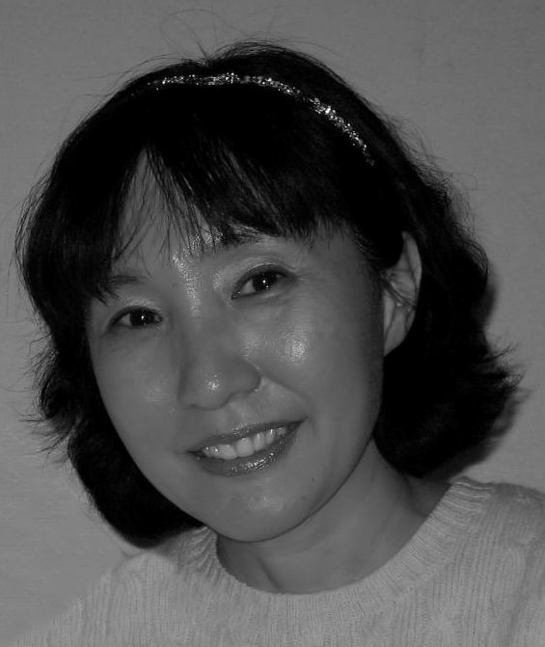C. SUE CHUNG and her husband Yun are from Korea and have been missionaries in Mongolia since 1995. They established the School of Discipleship in the capital city of Ulaanbaatar and have been actively training young Mongolians to carry the message of the Gospel of Jesus to the world. They are in the stage of turning over to work to Mongolian believers, but return periodically to teach. Sue and Yun are currently in Seoul, S. Korea praying and waiting on the Lord to show them where they are to go next to start a new work

