B5
Journey from Obedience to Joy
- Jude Tiersma Watson
Published in Global Missiology, October 2012, www.globalmissiology.net

My pilgrimage begins with my own experience of living on the immigrant margins. I was born on a dairy farm in Friesland, the Netherlands, and lived there my first five years. When my family emigrated from the Netherlands to California, we moved from a place where we had been rooted for generations to a place where we were the new immigrants. This uprooting defined my early formative years as we found ourselves in this unknown and foreign land. When I started kindergarten, I understood little of what was said around me and I did not speak the entire year. Outwardly I may not have looked that different, but I felt like “the other.” I knew we were different.
It took years for my family to find our way in this new homeland, from being the uprooted to becoming transplanted into this new place and culture. My parents, raised as children of farmers, now worked for others. My dad was a “milker.” We moved frequently in those early years, living in small wood frame houses that my mom worked hard to turn into a home. We spent some time living in a farm labor camp. Instead of watching TV, we sang songs around a pump organ that had traveled across the Atlantic with us. When we rented our own dairy, the workers on the farm were called “okies,” and were looked down on by my classmates at school. I am deeply grateful for the way my parents modeled understanding of people from every class and culture. My dad would say, “Don’t judge them, Jude. It is hard to be poor.”
My immigrant roots have remained part of me, and along the journey was birthed a compassion for those on the outside, even a certain comfort in living on the margins. It is not surprising, perhaps, that my life has been lived accompanying those on the margins. In this article I will share several views of my journey walking with and learning from people on the margins: View 1 of a family in Mexico City, View 2 of Josie, a neighbor in the Cambria Apartments in Los Angeles, View 3 on simplicity and gratitude and View 4 on sustaining joy learned from my spiritual director and companion, Sister Ann.

View 1: “It is more blessed to give than to receive”
One year after taking Betty Sue Brewster’s classes, reading about bonding, learning language through community, hearing stories of relationship with the poor, I was staying in Mexico with a family in a large dry lakebed west of Mexico City. Here migrants from the countryside built homes from whatever materials were available. Pirated electricity provided the lights and water was brought in on a truck twice a week.
My adopted family shared one room - mom, dad, three daughters, abuela, and now me, with a make shift outhouse in back. They set up a cot for me in the middle of the room, under a “quilt” made from old scraps of clothing. Formerly they had been rag pickers—they were beyond grateful for a roof, food, and enough money to afford a cake and celebrate a birthday. Each night we went through the ritual of counting the money that had come in that day, so we would know what we had to live on. Life was a daily gift for them. Living day-to-day, loving day-to-day and receiving each day as gift. Generously and graciously they shared their lives with me, drawing me into their family. It was a rich and formative time in my life.
Behind the one room cinder block house was a tiny shack of corrugated iron, their former home. Here lived Don Roberto, an old man with no place to go, embraced as part of the family when he did not have a family of his own. Each meal, Don Roberto and various neighbors broke bread with us. I learned then what I have seen so often—those who have little are often more generous than those of us who have been given much.
One of my great life lessons took place at the end of that summer, preparing for our final celebration before I returned to Los Angeles. My family decided I needed new shoes to replace the ones that had disintegrated in the mud of the old lakebed. As we went from shop to shop looking at the various black leather shoes it hit me—my Mexican father was going to buy me new shoes. I baulked inside. I had money and could pay for my own shoes. How could I possibly let them buy me new shoes? I wanted to refuse, desperately, but I heard a voice remind me, “It is more blessed to give than to receive.” I was learning that it is a great poverty to have nothing to give. Out of their generous hearts, this humble Mexican family wanted to buy me shoes. I was to let them be blessed by buying me handmade leather ballet slippers—not to rob them of the joy of giving. I wore those shoes proudly until they fell off my feet.
Indeed, it is more blessed to give than to receive. Most of us would rather have the resources to give than to be the ones that need to receive. Listening to Betty Sue Brewster in her Incarnation and Mission Among the World’s Urban Poor class, she spoke of friendship with the poor, not giving to the poor as a one-way street. She told stories of humbly sharing life with those on the margins. When we share life, relationships are reciprocal, and we give and receive. Transformation is mutual, relationships are reciprocal, and we are all equally in need of God’s grace and transformation.
Those with financial resources also need to learn to receive. Jesus did wash the feet of his disciples but he also asked the woman at the well for a drink of water (John 4). He graciously receives the anointing of the woman preparing him for burial and He regularly ate food in the homes of friends. How do we follow Jesus in learning to receive from others? How do we open our hearts to receive the gifts of the poor, the weak, those on the margins of our society?
View 2: “It is shameful to be poor in this country”
Los Angeles had not been the city of my dreams. In fact LA was one of the “nevers” of my life. When I finished my MA at Fuller Seminary’s School of World Mission, and sensed God’s call to move to Los Angeles, I resisted. I did not know then what I know now—that my pilgrimage of obedience into LA would be a journey into unexpected joy, and has led me to a life I could never have imagined. This joy is not a joy that avoids the suffering of life, but a joy that is deep enough to embrace the abundance of life, the challenges and sorrows, the valleys as well as the mountains. Obedience comes from the word audire, “to listen”. Listening would become a major theme for me —learning to listen to God in the city, listening to my neighbors in my context, and listening for the new song God was putting in my heart.
When I moved into my new neighborhood of recent immigrants from Central America and Mexico, I felt myself drawn to the vitality of the area—with vendors selling tamales on the street corner, and more pedestrians than I’d ever seen in an American city, the air bustled with excitement and life. At the same time I was overwhelmed by the needs that I encountered at every turn. Over the years, what first seemed such a God-forsaken place became a place of joy and worship, a place of seeking and encountering God, a place I have come to love and call my home.
I joined a team that had moved into the Cambria Apartment building. Influenced by Betty Sue Brewster and Viv Grigg, we moved in as learners, intercessors and storytellers. Perhaps ‘story-listeners’ would be a better term. We listened to many stories as we lived as neighbors.
One of the first stories I heard was from my friend Josie. Her story was a story of leaving a country in the midst of a civil war, and also escaping the abuse of a stepfather. Josie welcomed me warmly into her small family and tiny apartment and helped me to feel a sense of belonging in the neighborhood. She served me Central American food and shared her gift of laughter with me. I saw how much love a single mom working in the garment district can have for her kids, and how that love can mediate against many other negative forces at work around her. But even love cannot always protect our children, and I remember when her family of three slept on the floor of the very small room so the bullets wouldn’t hit them in their beds.
My friend Josie shared many insights with me. One that had a deep impact on me was her insights on poverty. “When I was growing up in Central America,” she said, “we were all poor. It was not shameful to be poor. Here in this country, poverty is shameful. You feel like you are a bad mom, that it is your fault somehow. Living with these feelings is the biggest struggle for me. Here it is shameful to be poor.”
I also learned how many gifts Josie and her neighbors have to give. Looking at them only through the lens of the “needy poor” does them and our communities a great disservice. Josie went on to become one of the community leaders in the rehabilitation of the Cambria Apartments from a slum house into a beautiful cooperatively owned building. It has become a place where neighbors care for each other, where gifts flourish and thrive, an anchor in an otherwise struggling neighborhood.
View 3: Simplicity and Gratitude
Some years ago I had a recurring dream. I woke up in my small LA apartment, and everything was gone. No clutter—none! I was alone in an empty room. And I was happy. Clearly the stuff of my life was not contributing to joyful living. From my neighbors I have learned that celebration is possible whatever our circumstances. Our consumer society tells me that more stuff will increase happiness. In reality, the more we have, the more we think we need. Instead of becoming more grateful, gratitude disappears among all the stuff.
Much of my adult life has been a search for a simple life. Growing up in a Dutch immigrant family, simplicity was not new to me. But the bombardment of our consumer culture takes its toll. In my early twenties, Ron Sider’s landmark Rich Christians in an Age of Hunger came out. I was guilted into more simple ways of living, although it was not rooted in my heart, and it became a new legalism for me. Later on I would read Richard Foster’s Celebration of Simplicity, but the celebration part seemed to elude me.
When I met Betty Sue, I saw simplicity lived out in someone over the long haul, not as a trend. Betty Sue did not even talk much about simplicity, but she lived it, daily, and this deeply challenged me. Her simple life was not only a simplicity of things, but a simplicity in her faith. Her mind is capable of holding many complexities, but she is sustained by a simple trust that is not simplistic but deep and abiding.
I am still on a journey with simplicity. Simplicity cannot be legislated. It will look different in various contexts throughout the world. Simplicity is one of the core commitments in InnerChange/CRM, a Christian Order Among the Poor. Simplicity can be viewed through the three dimensions, or currents, that describe our life together as InnerChange, based on Micah 6:8. These three dimensions are; the missionary (love mercy), the prophetic (do justly) and the contemplative (walk humbly with God).
Viewed through our missionary current, we choose to live simply as part of our identification with our neighbors, who live economically on the margins of society. I do not pretend that this makes me poor—I will always have my education and other privilege to fall back on. My simplicity is a choice. Poverty is a cruel reality, a daily struggle to survive, and these two are not the same by any means. But we can make choices about where and how we live that help us to understand the lives our neighbors live daily. I have learned that the struggle to survive can devastate families, but it can also be a place where joy thrives.
In our prophetic current, we “live simply that others may simply live.” We recognize that we are global citizens, and that our choices affect not only ourselves, but impact our local and global neighbors. We are not on this earth only for ourselves, thus we make choices for the common good, and not just our own good. Stewardship of the globe is part of our discipleship and not to be taken lightly.
In our contemplative current, we walk humbly with Jesus, who had nowhere to lay his head. We can debate how poor Jesus really was, but clearly he did not carry a lot of stuff with him in this world. Stuff can clutter our lives. Many of us are drowning in our possessions. The more we own, the more complicated our lives become, and the more we need to protect what we own. Simplicity impacts not only our external lives, but our inner lives also. Owning less can contribute to an internal freedom, and help us to travel lightly in this world. There is much to be learned from our sisters and brothers around the world who love and serve God without the support of so much material wealth.
While studying Spanish in Guatemala, my husband, John, and I worshipped with a congregation of Mayans, simple folk, full of love, life, and gratitude. They had so little by the standards of our country, yet were grateful to God for everything, overflowing with praise and genuine thankfulness.
The art of simple living is tied to our capacity for gratitude. Gratitude runs counter to our consumer culture that tells us that more is better. Gratitude says this is enough. I will be content with what I have been given. I can choose to grumble or to be grateful. Life is a gift—let me give thanks for every day is a gift to be received from God. In Thoughts in Solitude, Thomas Merton writes the following:
To be grateful is to recognize the love of God in everything He has given us—and he has given us everything. Every breath we draw is a gift of his love, every moment of existence is grace, for it brings with it immense graces from Him. Gratitude therefore takes nothing for granted, is never unresponsive, is constantly awakening to new wonder, and to praise of the goodness of God. For the grateful person knows that God is good, not by hearsay but by experience. And that is what makes all the difference.

When we truly realize life is a gift, and every day can be received as a gift, we enter into mission not as the one who has the answers but the one who is also asking questions, as one beggar telling another where to find food.
View 4: Sustaining Joy
Encountering joy has been a growing journey, the journey of learning to know God’s presence in my neighborhood and in my city. When I first moved into Los Angeles, God seemed very absent. I knew that God was present, my theology was clear on that. But I was a farm girl, used to long walks among orchards or vineyards as a way to talk to God. My first deep encounter with God was among pine trees of a Christian camp. Now here I was, among the concrete density of urban life, and God seemed silent. Not knowing where to turn, and becoming increasingly desperate, I found myself at the Spirituality Center of the Archdiocese of Los Angeles, not far from my neighborhood. I was asked if I would like a spiritual director. I had not heard of spiritual direction then, but my heart jumped. I knew this was what I was looking for.
Sister Ann became my companion until her death two years later, she was God’s gift to walk me through this season of life. Sister Ann’s life had been devoted to prayer for many years, and increasingly as she lived with a terminal illness. God’s Spirit was deeply evidenced in Sister Ann’s life, and I was eager to learn from her. She reminded me God’s presence was all around me in the city, but I had to learn to see, to notice God, to become attentive to the ways God is present in this context. Sister Ann introduced me to ancient practices that have become a deeply valued, sustaining part of my life. One of my favorites is called the Examen. She encouraged me to stop at the end of each day, and to review my day, stopping to give thanks for God’s grace and presence that day. The whirlwind of the day would take a new form as I looked over my day this way, in the presence of the Spirit. And indeed I began to see in new ways, and to embrace God’s gifts each day.
Sister Ann also reminded me that my first vocation was not to a people or place, but to love God and be loved by God. Mother Teresa’s words clarified this for me. When asked about her call to the poor, she responds that her call is not to the poor, her call is to follow Jesus, who calls her to the poor. If Jesus called her to the rich, she would go to the rich. My call is not to fill the needs of my neighbors, which is a sure road to burnout. My call is to love God, to live a life of worship and joy in my context. When I stay close to Jesus, I will do as Jesus did, doing what he saw the Father doing.
Sustaining joy comes from Sabbath rest. I was raised in a Sabbath keeping tradition, but the city never stops—what is Sabbath in a 24/7 city? I used to think that Sabbath rest was for the purpose of working harder and being able to keep up the next week. But God did not rest so that he could create more. He ceased, stopped, and told us to do the same. When I do this, I am reminded that ministry does not belong to us but to God. The city can be an overwhelming place. It is not my job to rescue the city, or rescue my neighbors and Sabbath rest reminds me that the world belongs to God.
Sustaining joy also comes from our relationships and my neighbors have become my friends, and even my family. Roxy, one of the girls I was mentoring in the neighborhood, introduced our team to Chris, a lost and struggling youth from Guatemala. Early on I sensed that Chris would have a special place in my heart, he would be the son I never had. God also spoke to his heart and told him I would be the mom he never had. It was a holy time and has carried us through an incredible journey through pain, brokenness and into deep joy. At times I wondered if our lives would implode, but God again and again showed himself to be the faithful one who restores not only individuals but brings restoration to the generations. Roxy and Chris were married in 1999, and are the parents of two beautiful boys, my grandsons.

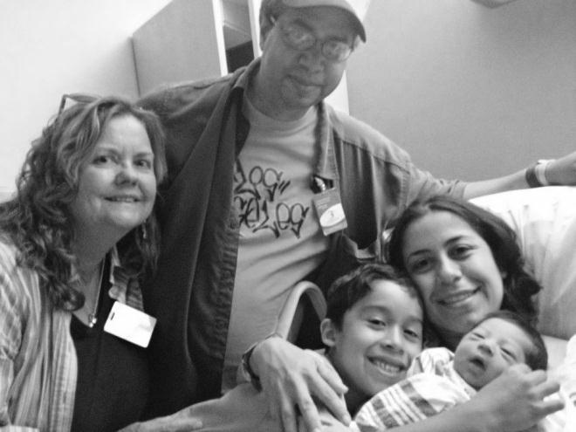
Jude and John with Roxy, Lance and Emanuel 2012

In 1993, John Watson, an intern from New Jersey came to join the InnerChange team for the summer. Those were difficult days in our neighborhood—the sense of struggle and violence was palpable in the streets. In the midst of this, God led us to facilitate a mural project in a neglected, overrun alley behind our apartment. We cleaned the alley, and then neighborhood children, two local gangs and others painted beautiful murals on the alley walls. It was during this project that John Watson and I became acquainted and worked together, and two years later we were married in a multi-cultural LA wedding.
Daily we get the privilege or working out reconciliation in our lives and marriage. We often ask each other, “What does it mean to sustain compassion for the long haul?” Clearly, joyfully, having each other has been a sustaining grace.
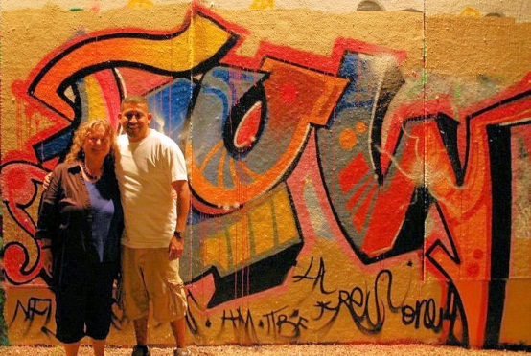
Jude and Chris with a street mural in Miami “Joy” mural in Los Angeles by Chris Albisurez
(photo by Laurie Cook)

We journey not alone but in the company of others. InnerChange is a Christian Order among the Poor. Rather than an agency I work for, InnerChange is an order, a place of belonging. We share our vocation to live with those on the margins, and we also share commitments and values that mark our way of being in the world. We are learning the meaning of the African proverb, “If you want to go fast, go alone. If you want to go far, go together.” Being part of InnerChange is a sustaining grace and joy. Reflecting back, I truly could not have imagined the life God had planned for me.

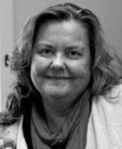

Judith (“Jude”) Tiersma Watson, PhD is Associate Professor of Urban Mission in the School of Intercultural Studies, Fuller Theological Seminary. She and her husband John Watson, live in central Los Angeles as members of InnerChange/CRM, a Christian Order Among the Poor.

In 1994 Jude co-edited the book God So Loves the City: Seeking a Theology for Urban Mission with Charles Van Engen.

Note: in Jonathan Bonk’s look at the problem of affluence among Western missionaries, Missions and Money, he cites Betty Sue’s course as a hopeful sign of ways we can move forward in extricating ourselves from the problem of affluence and mission. Missions and Money, Orbis Books, 1991, p. 129).
See www.innerchange.org.
Thomas Merton, Thoughts in Solitude quoted in Space for God by Don Postema, 1997 p. 62.
For more on this, see http://fulleryouthinstitute.org/2009/01/sabbath-rest-in-a-247-city.

