EXPLANATION AND REFLECTIONS

Enoch Wan

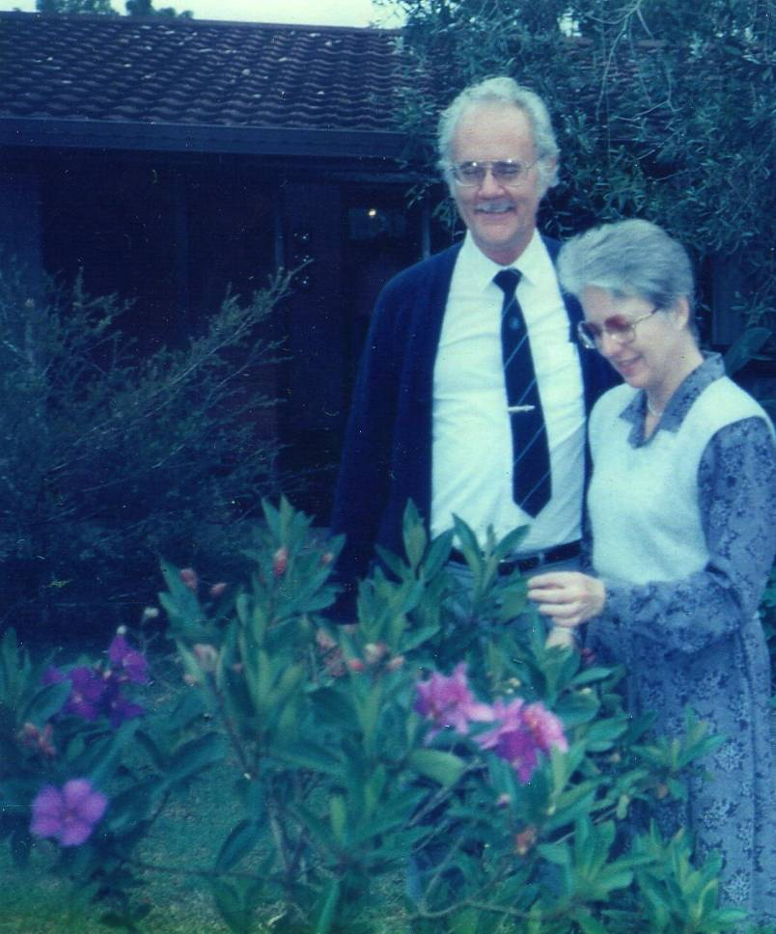

(Paul & Fran Hiebert,
Brisbane, 1988

Credit: Paul E. Grant)

Though hard to believe,
Paul is really gone;
Reunited with Fran,
And beloved parents he joined.

On this side, we remember his sharing,
Giving his best, without sparing;
Yonder, rings the supreme compliment -
“Welcome home, my faithful servant!”

Special Issue of Global Missiology

This special issue is occasioned by Paul’s departure thus the rush in preparation/production, all within about two weeks. Yet part of this period I was in the Philippines STM with limited internet access. Thus errors/omissions are inevitable and would require the understanding of readers of Global Missiology and their input for correction. On this score, Paul’s daughter Barbara is to be credited.
(If Paul can read this opening statement, he would immediately point out that the Asian side of me is showing. Sorry! Paul.)

The objective reason for the inclusion of Fran in this issue is due to the fact that the two worked best as a team so tributes should be given to both together. And the subjective reason is my friendship with both. Therefore in the “Featured Article” section, tributes to Paul are followed by those for Fran. For more information about Fran’s life and ministries, please visit the “Hiebert Family Website” at http://www.hiebertweb.net/fran/fran.html
For tributes to Fran, credits are due Georgia R. Grimes Shaw who regards Fran as:
“a dear friend” and Paul as “a gentle giant.”
But I respect both being God’s faithful servants.

Paul’s Trademark - Sharing

Paul’s departure has been anticipated because he had prepared those around him well. For instance, last month he sent me by snail mail items such as contact info of family members and since my sabbatical at OMSC we stayed connected only by cell phone when he found it hard to use e-mail.

With hardship (as evidenced by many typing errors), he typed out two separate pages authorizing my use of his publications and telephone conversations -- thus the MP3 pieces in the “Legacy of Paul G. Hiebert” section.
That is the spirit of Paul’s sharing; in spite of his health being ravaged by cancer.

Sharing through Global Missiology

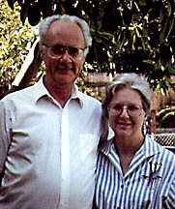
He tried to show his support for Global Missiology (GM) by submitting articles and authorized the posting of his out-of-print book at GM. (Please see the “Legacy of Paul G. Hiebert” section of this special issue). He even typed out “the light-hearted piece” from his death bed and sent the hard copy to me by post which had typing errors. (Very atypical of Paul, indicative of his poor health); but showed his eager efforts to “participate in this electronic way of sharing - low cost but high efficiency” (Paul’s own word).

Sharing his Residence

– “Hosting Students as Fran Would Do”

Years ago, I served with Fran at CHEPSIS (“Christian Higher Education Professional Serving International Students” - now defunct) and one time Paul came from TEDS with her to share with participants from member schools (e.g. Reformed Theological Seminary, Wheaton, Moody, etc.).

Both Paul and Fran were ready to generously share with others in many ways; especially foreign students. Paul often said that “I was once a guest in other people’s country so I know what it is like to be a foreign student.” He spoke from his experience as a MK in India.

Tite Tienou, my wife and I were foreign students at Nyack College in the early seventies and all of us are from C&MA background. Our lives intersected with Paul & Fran; different eras and dynamics. Yet we all enjoyed their friendship and ministry partnership for decades.
Coincident? Hardly. Consistent life style and Christian hospitality? Surely!

Fran partnered with Paul in the ministry of hospitality to students both at Fuller and TEDS. They worked as a team, more than a couple. Paul did the same, since 1999 when he was single, by opening his residence to house students from TEDS. He wanted to “create a community and enjoy fellowship, that’s the type of thing that Fran would have me do” were Paul’s own words. Many doctoral students from TEDS came to his house to stay and studied with him for days and weeks. Not a few enjoyed Paul’s hospitality, personal mentoring and dissertation coaching. In recent months he hosted a doctoral student (of NT Studies) from China, just based on my recommendation. He felt bad for the half-a-dozen residents when he had to start the process of putting up his house for sale and moving away from TEDS to be hosted and cared for by Barbara and her husband for health reason.

Sharing Even towards the End of his Life

In the spirit of sharing, Paul was willing to let me tape our conversation on March 3 when breathing was hard due to cancer in the lungs. He could not talk smoothly without a supply of oxygen; but insisted on doing so. Days before his departure on March 11, he spent time sharing with my doctoral students his experiences in research, again sitting up from his bed with help from his daughter and the aid of oxygen supply by way of his cell phone. Yet he proceeded to accomplish the task – Paul’s way of sharing with others.
After my sabbatical at OMSC and when Paul was severely weakened by cancer, weekly we talked and prayed by phone, increased in frequency when he no longer could go out.

One Sunday evening, before being limited in mobility, he excitingly shared with me the major points of his talk at a local congregation on “glorifying Christ in dying – the practical way” (wording from my personal recollection). I complained that he should have alerted me of such an occasion for taping so that boomers like me can learn from him. He just chuckled and said, “I want to prepare others in case they happen to follow my path.” That is Paul’s Christian trademark – sharing.

It was providential that his “light-hearted piece” happened to be in line with the annual theme of EMS so it was shared at several regional meetings. Weeks before he was confined to stay indoors, he authorized me to give out his cell phone number so that he could continue enjoying Christian fellowship with others. Though I have no way to gauge how many took his offer; a week later several callers told me how much they had enjoyed Paul’s encouragement and prayers for them from his death bed.


“A photo of the last Styrofoam cup Paul doodled on at a faculty meeting for School of World Mission 3/13/90. He was famous for drawing on coffee cups during meetings. Marilyn Clinton kept this “last” one done at Fuller to remember Paul by because he was the one who taught her so much of what she needed to know in her academic advising role at the School of World Mission.”

(Photo and explanation by Georgia R. Grimes Shaw)

Friend and Fellow Anthopologist/Missiologist

My friendship with Paul began in 1982 when he wrote me a two-page letter in response to my 2-part series “critique of functional anthropology” – an unknown Chinese anthropologist on the faculty in Canada. He spoke for his colleague Chuck Kraft; yet cheered me for exposing the problem of reductionistic approach of functionalist orientation.

In the long letter, he explained that he embraced “holistic concept of culture” and declared, “I am not a functionalist.” Since then we found a kindred spirit in many things.

There were many happy occasions we worked together. Here I would just mention two examples. In 1998 when I served as the regional VP of EMS-SE and the theme was on the contributions of anthropology to Christian missions and the methodology missiological research methodology, Paul came to joint me at the ETS/EMS Regional Meeting, Columbia International University, S.C., March 20-21, 1998. Unfortunately Darrell Whiteman had to have a last-minute cancellation for unexpected causes; but Paul and I had excellent collaboration and we enjoyed Christian fellowship together.

Another time was that we worked together to plan and implement the program for EMS/IFMA Annual Conference 2002. Afterwards, due to his other obligations and urgent matters, he had to opt out of co-editing with me the annual monograph - Christian Witness in Pluralistic Contexts in the 21st Century!. Evangelical Missiological Society Series: Number 11. Pasadena, CA: William Carey Library. 2003. Yet he managed to write the “Forward” for the volume.
Theoretical/methodological/missiological dimensions

Theoretically, as fellow anthropologists we agree on the importance of “holism” – beginning from the perspective of “culture” to areas beyond, such as interdisciplinary
integration and integrative methodology, multi-dimension of reality and complexity of
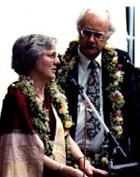

(Taken at their farewell from Fuller in 1990:
the Indian students hand made their matching leis
– by Georgia R. Grimes Shaw).

human understanding (e.g. worldview). The missiological implications are manifold
including integration of theology and missiology, incarnational approach and the

importance of contextualization.

Theologically, Paul is Mennonite/Armenian and I am Reformed; but we have no problem getting along. Epistemologically, we are both “realist” but disagree on the details: “critical realism” for Paul but “relational realism” for Enoch. Ontologically we agree on the primary importance of relationship in life and service (over function and success, structure and phenomenon), fellowship of the faithful (in spite of theoretical and theological differences) and partnership for the Kingdom (though with ecclesiastical, ethnic and cultural diversity).

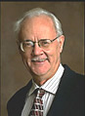

Practical matters

We both seek to contribute to Western learning and ministry style by bringing in the positive elements of Asian culture (i.e. Indian and Chinese) for enrichment and integration, such as “both-and” instead of “the excluded middle” paradigm and emphasis on relationship (over pragmatism and managerial missions), team work and communal approach (over individualism and obsession with quantifiable efficiency/productivity), partnership (instead of denominationalism and parochialism), and spiritual warfare.
We both are aware of the negative elements of Asian culture and how Western influences could be helpful, e.g. religious syncretism (as exemplified by folk religion), social

nepotism, Asian ethnocentrism (boasting of millennial heritages of the Indian and the Chinese), pessimistic attitude (fatalistic and escapist orientations), etc.

In musing, we called ourselves: “cultural brokers,” “interdisciplinary muddling” and “in-betweeners.” Paul encouraged me to maximize the use of new media of communication for networking, coaching and sharing. He kept saying that he had been limited to WordPerfect and e-mail; but I should be more daring since I am younger. The burden to do so is on me; but Paul is my cheer leader to launch the free e-journal www.globalmissiology.org. We used e-mail to communicate and we are probably the only two anthropologists/missiologists using “juno” for our personal e-mail (phiebert@juno.com and e.wan@juno.com)

Paul & Fran, we appreciate and miss you,
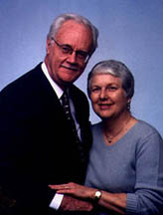
Lord, for giving us these two, we thank you!

Teaching a module and speaking at the commencement of Alliance Graduate School to launch IDS-Asia (Institute of Diaspora Studies – the Asian branch).
Paul Hiebert: - Anthropological Insights for Missionaries. 1985. Grand Rapids: Baker Book House. - Cultural Anthropology. 1976. New York: 1. B. Lippencott. Revised version printed by Baker Book House, Grand Rapids, MI. 1983. See the theoretical section of Hiebert’s Incarnational Ministry. 1995, Baker. Most clearly are the figures dealing with reductionism, compartmentalization and integration through complimentarity., - A Conversation with Doctoral Students at Western Seminary on Research Methodology” (MP3, 27 minutes) Paul G. Hiebert via telephone on March 6, 2007 http://www.westernseminary.edu/Media/DIS/DrHiebert.mp3 - “Reflections on a Life-time of Research and Publication in 5 stages” (MP3, 26 minutes) By Paul Hiebert via telephone on March 3, 2007 http://www.westernseminary.edu/Media/DIS/DrHiebert2.mp3 Enoch Wan - “The Paradigm & Pressing Issues of Inter-Disciplinary Research Methodology” Published in Global Missiology, Research Methodology, January 2005, www.globalmissiology.net - “Rethinking Missiological Research Methodology: Exploring a New Direction,” Published in Global Missiology, Research Methodology, Oct. 2003, www.globalmissiology.net - “A Critique of Charles Kraft’s Use/Misuse of Communication and Social Sciences in Biblical Interpretation and Missiological Formulation,” Published in Global Missiology, Research Methodology, October 2004, www.globalmissiology.net - “Social Sciences and Mission,” Published in Global Missiology, Research Methodology, April 2005, www.globalmissiology.net - “Evangelical Theology, Postmodernity, and the Promise of Interdisciplinarity,” (with Mabiala Kenzo) Published in Global Missiology, Featured Articles, January 2006, www.globalmissiology.org - “Holistic Ministry/Missions: Reflections & Resource Material,” Published in Global Missiology, Featured Article, October 2005, www.globalmissiology.net
Paul taught a doctoral course on “worldview” the summer of 2004 at Western Seminary with the manuscript soon to be released by Baker, Transforming Worldviews, in 2007. Also Paul’s articles: - “Worldviews and Why They Matter,” Continuing Jesus' Ministry of Deliverance. edited by Loren L. Johns and James R. Krabill. Institute of Mennonite Studies/Herald Press. (release date 2006). - “Anthropology, Missions and Epistemological Shifts.” (to be published in 2007). - “An Anthropologist Looks at Worldviews: The Invisible Worlds in Which We Live.” Brethren in Christ: History and Life. 21(April): 122-144. 1998. - “Cross-cultural Lessons, and Conversion and Worldview Transformation.” In Perspectives on World Mission: South Asian Version. Bangalore: New Life Literature. 1997. - Conversion and Worldview Transformation. International Journal of Frontier Missions. 14:2 April-June: 1997. pp. 83-86. - “Metatheology: The Step Beyond Contextualization.” 1988. Retrospect and Prospect: A Missiology for 2001. Hans Kasdorf, ed. Bad Liebenzell, West Germany: Liebenzeller Missions Verlag. Translated version: “Metatheologie: Ein Schritt tiber die Kontextualisierung hinaus.” Bilanz und Plan: Mission an der Schwelle zum Dritten Jahrtausend. Liebenzeller. 1988. Enoch Wan published two books in Chinese on understanding the Chinese worldview for contextualization (“Sino-theology”). Also see “Theological Contributions of Sino-theology to The Global Christian Community,” Published in Global Missiology, Contextualization, Oct. 2003, www.globalmissiology.net For works dealing with multi-level, multi-dimensional, multi-contextual matters in Missiology, see http://missiology.org/missionchina/missionchina.htm
Paul Hiebert’s upcoming title on “missional theology” due to be released by Baker. See also his article, “Missional Theology,” (with Tite Tiénou) Published in Global Missiology, Featured Article, April 2005, Enoch Wan - “An Old Testament Theology of Multiculturalism Diversity: God’s Eschatological Plan for the Nations (with Richard J. Konieczny) Published in Global Missiology, Featured Articles, July 2004, www.globalmissiology.net - “A Biblical Theology of Multi-Ethnicity and Multi-culturality: Diversity in Unity and God’s Ultimate Purpose for Humanity,” (with Alonzo Ramirez) Published in Global Missiology, Featured Articles, July 2004, www.globalmissiology.net - “Ethnohermeneutics: Its Necessity and Difficulty for All Christians of All Times,” Published in Global Missiology, Research Methodology, January 2004, www.globalmissiology.net - “Missionary Anthropology= Cultural Anthropology + Theology?” in Pastoral Journal, Issue 16, May, 2004: 115-130 - “Traditional Mission Theology and Contextual mission Theology,” in Pastoral Journal, Issue 16, May, 2004: 149-158.
Paul Hiebert, Incarnational Ministry: Church Planting in Ban, Tribal, Peasant and Urban Societies. 1995 Baker. See also Paul’s articles: - “Changing Perceptions of Contextualization,” For David Hesselgrave's book to be published by John Knox, 2007. - The Gospel in Human Contexts: Changing Perceptions of Contextualization. In Proceedings of the Union Biblical Seminary Missions Conference, 2006. (Puni, India-to be published in 2007). - “Critical Contextualization” in Anthropological Insights for Missionaries. - “Form and Meaning in Contextualization of the Gospel.” In The Word Among Us. Dean S. Gilliland, ed. Dallas: Word Publishing. 1989. Enoch Wan: - “Practical Contextualization: A Case Study of Evangelizing Contemporary Chinese,” Published in Global Missiology, Contextualization, Oct. 2003, www.globalmissiology.net - “Critiquing the Method of Traditional Western Theology and Calling for Sino-theology,” Published in Global Missiology, Contextualization, Oct. 2003, www.globalmissiology.net - “Jesus Christ for the Chinese: A Contextual Reflection,” Published in Global Missiology, Contextualization, Oct. 2003, www.globalmissiology.net
Paul Hiebert, Missiological Implications of Epistemological Shifts. 1999. Harrisburg, PA: Trinity Press International. Enoch Wan “The Paradigm of ‘Relational Realism’,” Occasional Bulletin, Vol. 19, No. 2, 2006
Paul Hiebert covered the relational aspect of ministry in various parts of his book Anthropological Insights for Missionaries. 1985. Baker. Also Paul’s article: - “Flaw of the Excluded Middle.” In Perspectives on the World Christian Movement. 3rd ed. Ralph Winters, ed. Pasadena, CA: William Carey Library. 1999. - “Mission's Devastating Dichotomy.” Christian Herald. 1999. 224. - “Response to Split-level Christianity and Folk Religion.” International Journal of Frontier Missions. 16:4:173-181 (winter 1999-2000). - “Partnership in the Gospel: Misers, Accountants and Stewards.” Paul Hiebert and Sam Larsen.Die Mission der Theologie. Bonn Verlag fur Kultur and Wissenschaft. 1998. Republished in Direction: A Mennonite Brethren Forum. 28:1:55-62, Spring. - “The Whole Image of God; A Theological and Anthropological Understanding of Male-Female Relationship.” Frances F. and Paul G. Hiebert. In Incarnational Ministry: The Presence of Christ in Church, Society and Family. Christian D. Kettler and Todd H. Speidell, eds. Colorado Springs: Helmers and Howard. 1990. Enoch Wan formulated the “Trinitarian paradigm” on “relational basis” - “Exploring Sino-Spirituality,” Published in Global Missiology, Spiritual Dynamics, Oct. 2003, www.globalmissiology.net - For an overview of the “Trinitarian paradigm,” see Mark Hedinger’s doctoral dissertation supervised by Enoch Wan, “Towards a Paradigm of Integrated Missionary Training,” at Western Seminary in 2006. Posted at: http://www.globalmissiology.org/english/resource/Hedinger_Dissertation.PDF
Paul G. Hiebert: - “Spiritual Warfare and Worldviews” Published in Global Missiology, January 2004. - The Biblical View: The Nature of Spiritual Warfare. Mennonite Brethren Herald. 31 (October 9): 4. 1992. - Spiritual Warfare: An Anabaptist View. Mission Focus. Fall. 1992. Enoch Wan: - 1988 “Spiritual Warfare: Understanding Demonization.” Alliance Family (Manila, Philippines: CAMACOP), Summer, 6-18. - 1989 “Deliverance from Demonization” Alliance Family (Manila, Philippines: CAMACOP), Spring, 8-12. - 2003 “Spiritual Warfare: Overcoming Demonization” Global Missiology, Oct. 2003, - “Spiritual Warfare: What Chinese Christians Should Know and Do,” Published in Global Missiology, Spiritual Dynamics, Oct. 2003, www.globalmissiology.net
See Paul’s article: - “Syncretism and Social Paradigms. Van Rheenen, Gailyn, ed. EMS 2004 conference papers. Fall 2005. - “A Christian Response to Hinduism.” Christian Witness in Pluralistic Contexts in the 21st Century” Enoch Wan, ed. Evangelical Missiological Society Series: Number 11. Pasadena, CA: William Carey Library. 2003. 83 - 123. - “Missiological Issues in the Encounter with Emerging Hinduism.” Missiology: An International Review. 28:1:47-63. See Enoch Wan’s articles” - “The Christian Response to Chinese Folk Religion.” Christian Witness in Pluralistic Contexts in the 21st Century!. Enoch Wan, ed. Evangelical Missiological Society Series: Number 11. Pasadena, CA: William Carey Library. 2003. 181-208. - “Ethnocentrism,” Evangelical Dictionary of World Missions. P.324-325. Edited by Scott Moreau. Baker Books. 2001
See “Tribute to Paul G. Hiebert: Professor, colleague, brother, pilgrim” by Tite Tienou and Paul’s article, “Missionary As Mediator of Global Theologizing.” 2006. Doing Theology in a Globalizing World. Craig Ott and Harold A. Netland, eds. Grand Rapids, MI: Baker Book House. April, 2006.

