WINDOW A
LEARNING FROM PEOPLE OF DIFFERENT CULTURES
Window A contains five stories by women learning from people in different cultures. Georgia Grimes Shaw shares about learning from First Nations people in Canada as well as the Samo people in Papua New Guinea. Aretta Loving and Joy McCarthy have both translated Scriptures in Papua New Guinea, Aretta and Ed with the Awa and Joy with the Kanite and Inoke. Jean Van Engen writes about leaving Mexico and adjusting to the change involved. Rie Manabe-Kim brings the perspective of a Japanese as she writes about the need for meaningful relationships while language-culture learning.

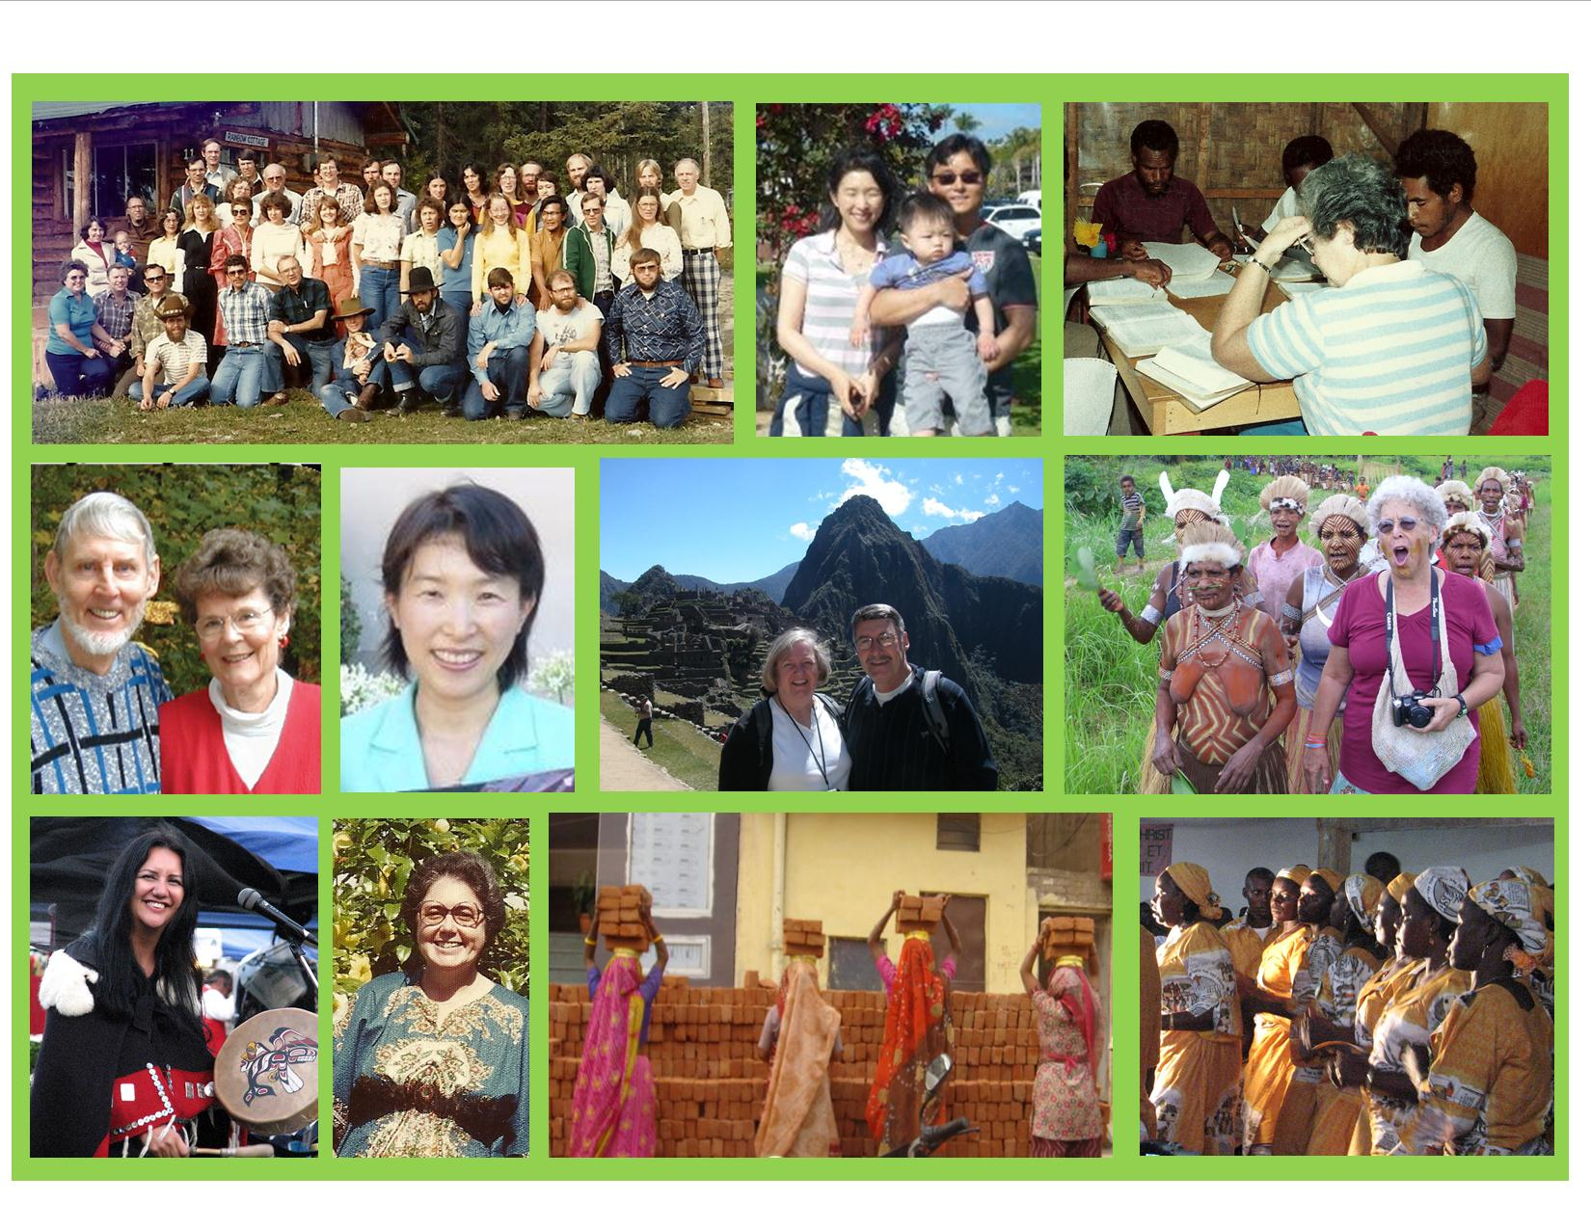

Top left to right: IMCO 1980, Rie Manabe-Kim and family 2012, Joy McCarthy translating; 2nd row: Aretta and Ed Loving, Rie Manabi-Kim, Jean and Chuck Van Engen at Machu Picchu in Peru, Georgia Shaw with Samo women in PNG 2011, bottom row: Cheryl Bear a Carrier First Nations believer, Joy McCarthy, working women in India taken by Betty Sue Brewster 2009, Cameroon women rejoicing over new Mofou-gudur translation in 2008.

