What God is doing in China Recently
Anthony Bollback - pj@bollback.com (source: www.ChurchInChina.com)

Published in www.GlobalMissiology.org “Spiritual Dynamics” - January 2010.

THE HMONG OR MIAO PEOPLE OF CHINA

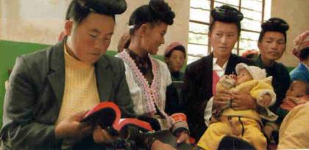
The Hmong or Miao people of China numbering 9,000,000. During the past 80-90 years, God has been moving in a most spectacular way, until today more than 70% have come to the knowledge of Jesus Christ. One of the subgroups of Miao is known as the Big Flowery Miao. In spite of great persecution and living under the extremely harsh and restrictive measures of the Chinese government, they have developed strong, indigenous churches with a passion to reach other tribes. The Miao are China’s fourth largest minority group, but a subgroup called the Blue Miao, have only recently begun responding to the Gospel. It started with a young father who acted as a guide for some Christian workers who traveled through the mountains for several weeks making a survey of their villages. During those weeks, this young man listened attentively to the truths of God’s Word that he had never heard before. A short time later, he repented of his sin and became a new creation. So dramatic was the change, his wife and family could hardly believe he was the same man. Immediately he began to share his faith in Christ, and one by one, other families joined him in following Jesus.
- Today, the Blue Miao number 20 families or over 70 people with nearly all adults of the group baptized.
- In June 2009, they had grown large enough to legally form a church group and register with the government.
- In July they purchased property for their new church, the first among the Blue Miao. In October they were given permission to begin construction of a building that will seat 2-300 people.
The international worker who shared this wonderful story is trusting God that funds will be received to help them complete the building. Anyone may contribute to the Blue Miao Church
Construction Fund through Church In China, Inc. (See below for more details.)

CULTURAL CENTERS REACH YOUNG PEOPLE

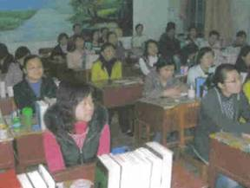
This is a follow-up article on these Centers as they are providing a meeting place for inquisitive students to gather and talk in a non-threatening situation. Books, computers and the coffee shop atmosphere break down barriers and open up opportunities for meaningful life-changing conversations. The Centers we are acquainted with are operating in conjunction with local churches so that the fruit being gathered can be preserved. Workers in these Centers are urgently in need of prayer support so that they will be wise when counseling troubled young people who have lost their way in a godless society. New Centers will be opened as God provides the funds and the workers. Make this a matter of earnest prayer that the whitened harvest field will have sufficient laborers to reap the harvest.

RAIN IN A DRY LAND

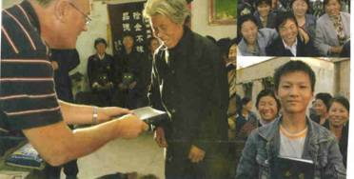
“Our brothers and sisters here are very hungry and thirsty for God’s Word, says Zhang Shenlin of Yu Lin Church in Shanxi Province in Northwest China. We thank God that Bibles and portions of Scripture are beginning to flow to this area like the great Yellow River winding its way through the desert. We treasure these booklets like water in a dry and thirsty desert. bringing nourishment to our souls. Zhang was speaking at a presentation of Scriptures to his congregation by the American Bible Society. “You have indeed brought living water to quench our thirst,” he continued,” and power to ignite the fire with us.” Bibles AND Christian literature are urgently needed for the thirsty millions who are coming to Christ each year. A Bible can be placed in the hands of a Chinese in China for just one dollar. What an investment for eternity!

MORE ON 'THE WAY TO HEAVEN" BOOKLET

“The Way To Heaven” booklet is another example of the tremendous thirst of the people for God’s Word. The Malaysia Faith Mission works through an international worker living in Macau, China and circulates thousands of the booklets all over the country. They are closing in on one million copies for China right now! This picture of one of the pages of the little booklet shows how to get rid of the burden of sin—at the cross of Jesus Christ. House churches all over China are regularly placing orders, and thus far, there have been just enough funds to meet the new demands. Placing literature in the hands of one Chinese means that dozens of others will also see the word. Pray for each booklet and Bible portion distributed so that each will bear a hundredfold.

IT’S HARD TO BELIEVE
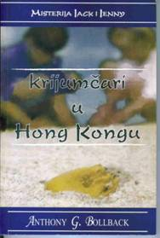
Several months ago Kathy Ikost, a C&MA missionary in Bosnia came across my children’s books and immediately felt that these books were desperately needed in Bosnia and Herzegovina. In miraculous ways God has provided the funds for the translation of Book 1, “Smugglers in Hong Kong,” A few days ago I received two copies from Kathy with the news that the books are now for sale there. A pastor’s wife did the translation. Kathy reported that they hope this first book will help fill the void of children’s literature in the country and they are hoping the thousands of Chinese living there will be attracted by the title. All royalties and profits from the sale of this book will go toward printing Book 2. Will you please pray that this book will sell well so that Book 2 can be started?
REQUEST MORE INFORMATION ON THE AUTHOR'S BOOKS IN
ENGLISH AS THEY SPEAK TO OUR PRESENT DAY SITUATIONS.

YOUR PARTNERSHIP IS VITAL
Church In China, Inc is currently involved in many important projects that are building the church and preparing people for ministry. As the Lord leads, share in these ministries through prayer and giving. ALL GIFTS TO CHURCH IN CHINA, INC ARE TAX-DEDUCTIBLE AND GO ENTIRELY TO THE DESIGNATED PROJECTS. TAX-DEDUCTIBLE CONTRIBUTIONS for Church In China, Inc projects should be made out to: Church In China, Inc and mailed to Rev. Jonathan Bollback, Treasurer, at 619 Coral Way, Winter Springs, FL 32708. E-Mail contact: pj@bollback.com
EDITORIAL OFFICE: Send comments to Anthony Bollback, 1622 Calvin Circle, Kissimmee, FL 34746. E-mail address: agbollback@cfl.rr.com -
Website: www.ChurchInChina.com

