A5
Creating Windows: Planting God’s Word in Papua New Guinea
- Joy McCarthy
Published in Global Missiology, October 2012, www.globalmissiology.net

There sat the box full of all my letters written to Mum and Dad from Papua New Guinea beginning in 1957…what was I do to with them? Both of my parents had now gone to be with the Lord and I was resettled in Canada as a retired missionary. After organizing the contents of the box according to date I began to read one or two then more and was soon carried across the miles and back over the years to a time of beginnings when I first put my foot on Kanite soil. It seemed I was like a gardener planting seeds. Amy Carmichael pictures my feelings in words so well in her Bud of Joy poem;
Come, bud of joy, the driving rain that all thy young, green leaves doth wet,
Is but a minister of gain to that which in thy heart is set.
Come forth, my bud; awake and see how good thy Gardener is to thee.

And pass, my bud, to perfect flower, dread not the blast of bitter wind;
Thy Maker doth command its power; it knoweth not to be unkind,
Haste thee, my flower; unfold and see how good thy Gardener is to thee.

The following is taken from those letters as I look back, forming windows in time to see how good the Gardener has been in my task of planting God’s precious word, first like a seed, then a flower, to the Kanite and then the Inoke people. Truly it has been a journey to and through these cultural gardens.
Feb. 12, 1957 – It was so exciting as the five of us, Ruth and Ray Nicholson, Gladys Neeley, Lois Heyer and myself began our voyage to Australia. We were the first from North America to join Wycliffe in Papua New Guinea. We boarded the S. S. Orsova in Vancouver, BC and reveled in all the luxury, even though our cabin on the lowest level was very crowded. The next day, when the ship docked at San Francisco, we were met by a seasoned Wycliffe missionary who gave us this sage advice; “You are going to a brand new field. Don’t be anxious to get out to your own work in a village. Be prepared to just help out in any way that is needed.”
Mar. 4, 1957 – It was wonderful to arrive at Sydney, Australia and be able to disembark after 3 days of hurricane weather with seventy-five miles-per-hour winds. The ship tossed from port to starboard and stem to stern. They said it was the worst storm this ship had ever been through in these waters. We had to wait in Australia until housing could be built for us in New Guinea. Then we were delayed by a Qantas Empire Airways strike.
Apr. 1, 1957 – While staying in the Missionary Home in Sydney I had a very scary asthma attack – the first in 10 years and the worst I’ve ever had. I turned blue, even my eyelids. Glady rushed and phoned a Dr. who came and gave me a shot of adrenalin.
Apr. 27, 1957 – We took an all night, 13 hour, flight in a rattley DC 8 to Port Moresby in the Australian Trust Territory of New Guinea. It was a new experience to step out at dawn and immediately be soaked with perspiration. On Apr. 29, 1957 – we flew through the clouds from Lae in Aiyura where the Ukarumpa base was located. The next four months were spent searching out available tribes for the language groups where Gladys and I would be assigned.
Aug 11, 1957 – ten days after my 23rd birthday, we settled in the Kanite tribe. Right after breakfast we left the Ukarumpa base and started out on the 40-minute drive around endless hairpin turns. The jeep sped down the last hill, over a rickety bridge and up again to the Kiap House (government rest house) where we will be staying until we can do a survey of the villages and decide which one is the most suitable location for us to build a house. Hearing the jeep a crowd soon gathered and we were surrounded by people welcoming us, must have been fifty or more. A few moments later the exuberant Luluai (the government appointed chief) rushed in puffing as he had run all the way from his village when he heard we had arrived. He wasn’t more than 5 feet tall and was clothed only in a loin cloth and short bark skirt. “Masta”, he said, grabbing six foot-four Bill Oates around the knees and lifted him high in the air. Then Bill picked him up. Then both Gladys and I were thrown into the air. I never again saw this welcome given to anyone! I vividly remember being so excited to be there and, as I looked out at the crowd, feeling that in four months, by Christmas, we would be able to tell them the story of Jesus and they would all believe.
Later we learned that the Kanite thought we were the spirits of their ancestors come back to bring them all the “cargo” that had been stolen from them by the “white skins”. This was a very logical conclusion since until recently they thought that they were the only people in the world. Then, during World War II they saw strange, noisy birds flying in the sky and heard tales of how these birds landed and disgorged all sorts of things including animals with wheels that carried the strange looking people who also came out of the large bird. What window would the Lord create for viewing this information, both for us and for the Kanite?
We had been briefed about the “Cargo Cult” while at Ukarumpa and learned there were two main results of this belief. (1) People refuse to plant their crops and sometimes even burn their crops and then go and sit on a hill and wait for the plane to come down loaded with “cargo” for them. (2) If they got rid of the white man the cargo would be theirs. It is thought that this is why the Christian and Missionary Alliance plane was destroyed in Dutch New Guinea (West Irian) in 1955. After hearing this, I thought, we sure do need wisdom as to how much “stuff” to take into the village with us.
Glady and I were the first single women with Wycliffe to go live with a New Guinea tribe, and for safety reasons, it was suggested we live in a village near the road, and this was our window for safety. Since we were only the third allocation of Wycliffe linguists in New Guinea and the first two tribes had only been occupied within the past two and a half months there was no one to prepare us for the fact that the New Guinea languages were some of the most difficult in the world and would take much more than four months to conquer! The expectation of Canadian Christians of the 1950s was that people in other lands were waiting with hands outstretched to receive the Gospel. They had no idea that the bondage of centuries of animism had such a strong grip. Or that Satan would not release the people from his grip that easily.
August 1958 – Glady is going to Australia to marry David Strange and Gwen Gibson will be joining me in the Kanite allocation as we form the Gibson-McCarthy team.
Dec. 13, 1959 – Tuesday night we had our first geography class using a World map. The room was full and they were all so interested. I tried to explain that the world is round; that when it is dark here it is light where my family live. One of the fellows said “We always thought our place was the biggest but now we see that it is only tiny and there are lots of other places!
Jan. 24, 1960 – the men have started pit-sawing the wood for the floor in our new house. You have no idea the luxury the wooden floor is going to be. The bamboo is hard to keep clean and even after you sweep it doesn’t look any better!
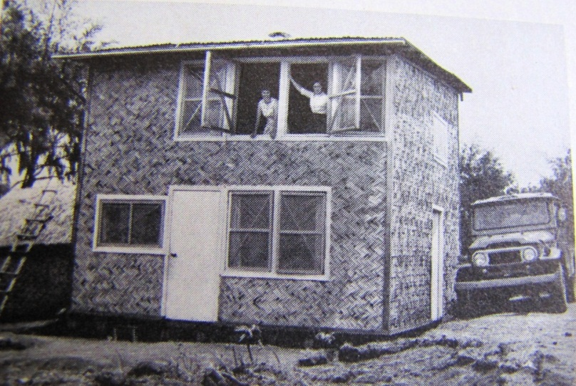
Joy and Gwen framed by the windows of their two-story village house

July 8, 1960 – Sunday about 6 PM, Lloyd, the Lutheran carpenter, arrived and stayed and listened to a tape with us for our “church” service. We think he has romantic notions for me! It was so funny, after he left we heard wailing at our door and there were several women. We said “What’s the matter?” “Oh, we are so sad Soipave is going to leave us and marry Lloyd.” We asked “How do you know it is Soipave?” They replied “Because Gwen does all the talking and Soipave just sits quietly.” The Kanite, like all cultures, interpret everything through their own grid and my silence obviously meant Gwen was arranging my marriage to Lloyd.
We began to learn the Kanite language by pointing at a tree and writing down what the people said in phonetic script; or running across the village and then writing down what they said to try and figure out the grammar. In our phonetic classes we had learned how to symbolize all the sounds found in all the languages of the world. We discovered one of the most common sounds in Kanite, was not recorded in this phonetic alphabet. It was this sound that made the neighbouring tribes people laugh and say that Kanite sounded like water going down a sink drain. Curiously enough it was this unusual and undiscovered sound that drew me to the window on the Kanite people.
Unlike many tribal areas in New Guinea, the Kanite people didn’t have government schools. In a total population of 15,000 there were only two mission schools teaching an average of 100 children a year. We realized that we would have to concentrate on literacy as there is no point in translating unless you have people who can read and this was a window we could construct for the Kanite.
Working in Kanite we had to solve the alphabet challenges and develop one. We ended up with 18 letters and began literacy experiments. Our first reading primer needed to be revised several times, finally into a syllable-teaching method instead of a word-teaching method. Just as we were about to begin trial classes, there was a land dispute fight with a neighboring tribe and eight men were seriously wounded. As a result most of our men were taken off to jail. There were only a few disabled men left in the village and we persuaded them to come learn to read.
The first person to learn to read in Kanite was a man with only one eye—an unkept, dishevelled-looking fellow we never would have chosen. But he learned to read and was genuinely changed by the Scriptures. By the time the other men returned to the village we were quite sure our literacy materials were useable and we began classes. Then we realized that we would never be able to teach all of the people ourselves. The answer was creating the window of training Kanite teachers to teach their own people how to read. What a different view the Kanite had as their own people became teachers, it was wonderful.
Interestingly enough, at this time, in 1970, the local government council became interested in literacy and offered to help pay salaries of any teachers we could train. This was a terrific incentive both for us to begin right then and also for the trained teachers to be willing to teach. In each village we generally found only one man who was able to read and thus to train as a teacher.
Jan. 15, 1970 – Imagine having 12 men come to class, which is really a Bible Study in John, every morning. All of a sudden the literacy fever has struck opening a new window! I had the men upstairs, Toni had 9 in the third primer downstairs in the peoples’ room and Gwen had 6 more in the kitchen. Six more girls are waiting outside for their class to begin!
March 1, 1971 – It’s wonderful to have this practical show of interest in Literacy. We applied to the District Council for a grant of $1,200.00 for teacher’s salaries to begin in July. It was granted and we paid them $4.00 per month for the first month, $5.00 for the second month and $6.00 for the months after that. This is 50% more than local road or plantation workers cash wage is presently. An instructor who has moved on to a second course is paid $8.00 per month.
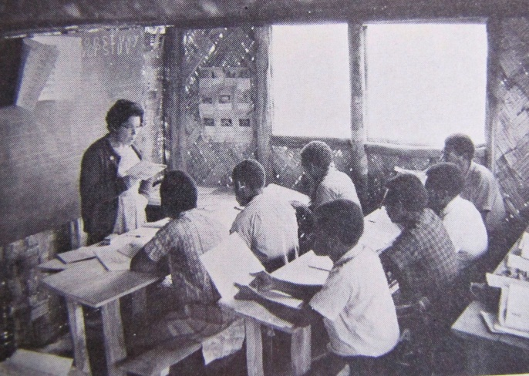
Joy McCarthy teaching Kanite men to read

April 25, 1971 –Just before 8:00 AM we heard the hum-chop-chop of the helicopter in the distance. In only four minutes it flew Gwen and Avopi into Hafinafa, a long four hour hike by trail. Then it returned to our village to pick up Toni and I for the three minute flight to have a quick look at the schools in Hafalu and then Ki’yo before flying us in to Yagonaga, a rugged five hour hike by foot.
Yagonaga is a beautiful village perched at 5,800 ft. right on a high ridge in the most rugged country. Imagine the excitement of these isolated villagers to see the helicopter land! Toni and I stayed here and read individually with the students while the pilot, Ken Wiggers, flew over to move Gwen and Avopi to their next village. And so it went on all day, checking schools in eight villages and reading with about 200 pupils. To our delight, most of them passed into the second primer.
I wish I could adequately picture in words the thrill it is to land in these isolated villages and there find teachers, gathering the people together into thatched roof buildings, which they have built themselves. They are doing an excellent job of teaching others to read. They begin each class with a Scripture reading, so, as God answers prayer, and the Holy Spirit works, we envision these classes turning into little churches as they read the scripture in Kanite and see the Word of God through this new window opening to them. May God make this vision a reality.

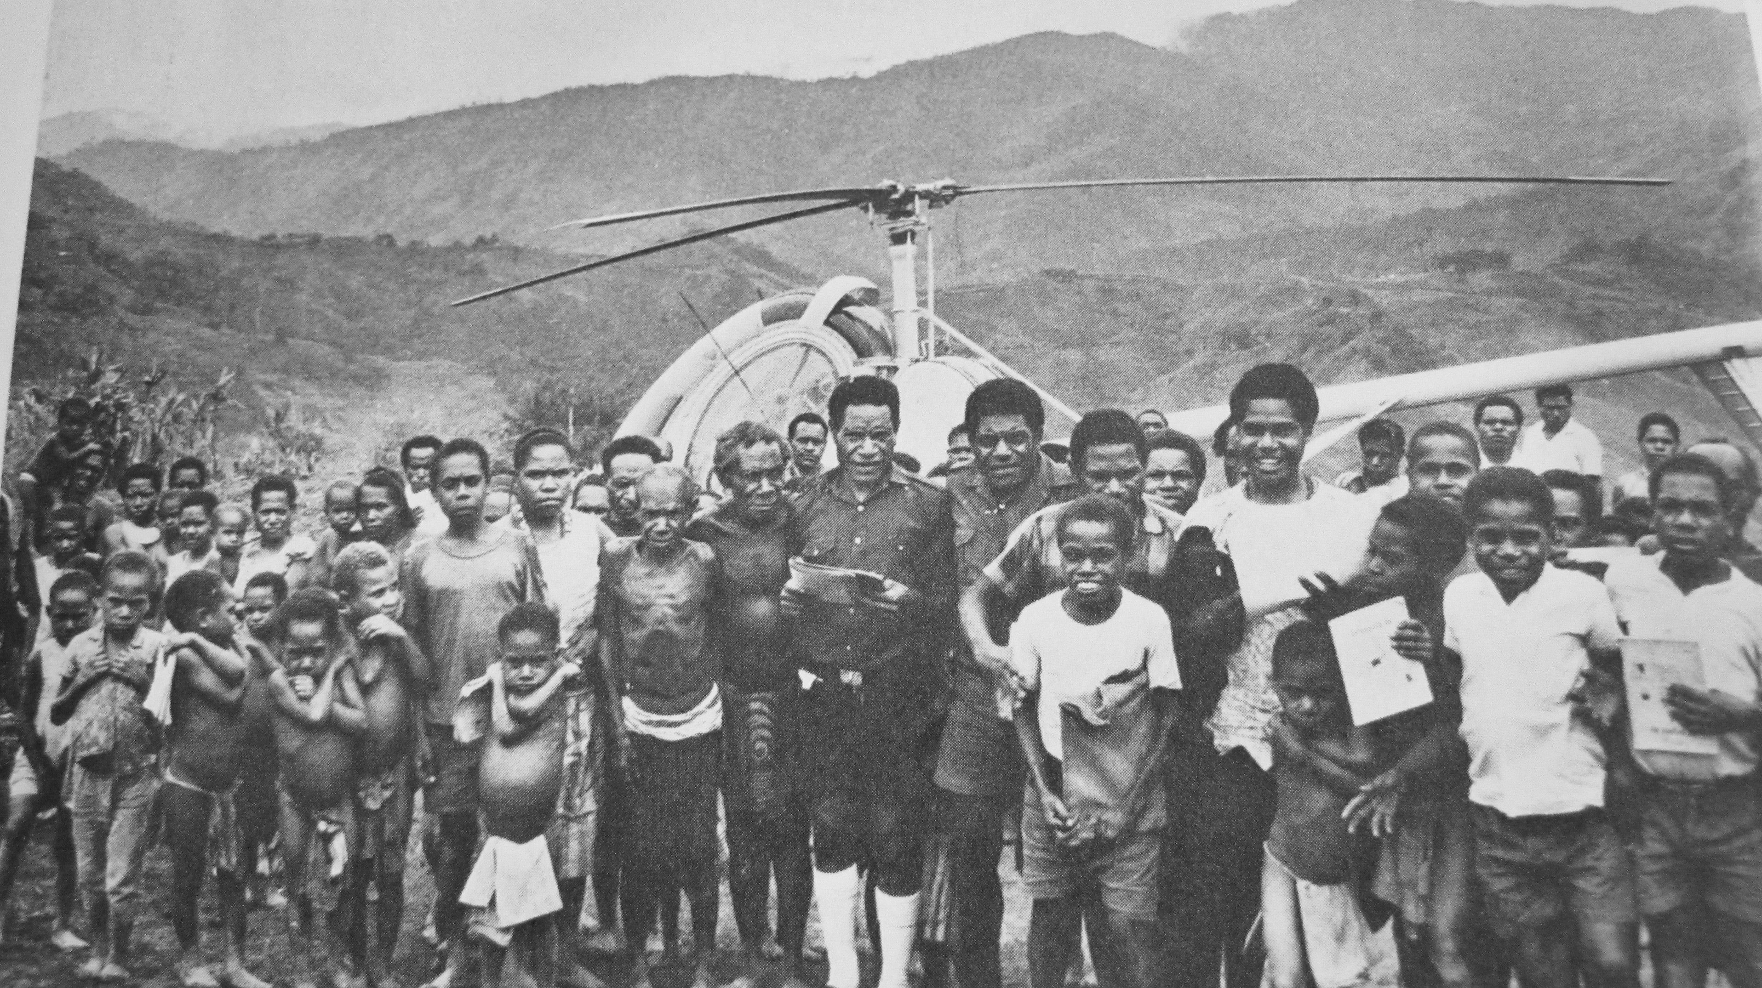
Kanite people gathered around the helicopter at a remote village

Without the helicopter this would have taken us at least four days of very difficult mountain climbing; four nights of sleeping in a local village hut and at least two days to recover. How we praise God for the dedicated pilot, who is giving his valuable time and skill; for Wycliffe’s Aviation Department that subsidizes flights for literacy so we pay only $10.00 per hour; and for those who have provided so that Wycliffe can have a helicopter in New Guinea. All so that New Guineans might have a window to the Word of God.
July 12, 1972 – Wednesday morning the helicopter dropped from the sky to deliver Cornell Capa, the famous photographer from LIFE magazine. He has been in New Guinea for a month collecting materials for a book on WBT. We were feeling relieved that we had not been included in his travels and yet here he was on our door step!
Cornell is a delightful person and wanted to focus on Toni and how God had changed and used him. He took many pictures. We had three more sessions with Cornell and as we were leaving he handed us his brand new stereo cassette recorder which he had just bought in Tokyo for $150.00. We could not believe his generosity and the recorder will be so helpful in the work.
After his wife died, Tony and his daughter Momo read a letter of comfort from Joy in July 2011

Furlough times for single women missionaries is much the same as for couples and/or families. However, many of us have the added responsibility of caring for elderly parents during those times of communicating with supporters, raising support needs, helping out in training programs for others training for missionary service, and seeking needed rest and refreshment. During a furlough in 1980, when my mother was ill, I was on a speaking trip to northern British Columbia, Canada and on the way spent a couple of weeks with an organization working among North American Native peoples, training candidates in language and culture learning. I had heard about the LAMP program, of course, but here were Betty Sue and Tom Brewster working with Dwight Gradin (Missionary Internship in Detroit) in the middle of nowhere teaching language acquisition.
In 1984, the year before Tom’s death, Brewsters came to Ukarumpa and did a week LAMP seminar with Wycliffe members in PNG. Their son was just a little five year old and stayed a couple of days with Gwen and I. One of the memorable conversations I had with Betty Sue was when she shared how as a young woman a college teacher had discouraged her from training to be a translator, I think she was told, “you don’t have what it takes to be a linguist!” I felt much in common with Betty Sue because of how we had proven the value of living right in a village for language, relationship and culture acquisition in reaching a group for Christ. The more I got to know her and the LAMP ministry the more thankful I was that she did not give in to that early evaluation and went on to be all the Lord had planned for her.

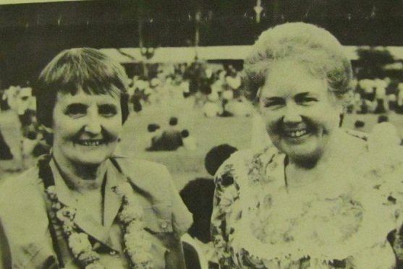
Gwen Gibson and Joy McCarthy at the dedication of the Inoke New Testament 1993

November 17, 1992 -There was unforgettable knock at the door at 11:00 AM. There stood five foot tall Timothy. He gave us a big hug and then, as he was overcome with emotion, said over and over again, “I and my village are so very pleased with what you have done for us!” He went on to share;
I have been reading the Inoke New Testament each Sunday in church and all the older people are so very thankful because now at last they can understand what is being said in church. Thirteen of those who can read some Pidgin English have come to my literacy class and now they can fluently read the Inoke New Testament themselves. Now everyone wants to learn to read. Here is the list of 27, and I’ve come in to attend the Teacher Training Course.

As Timothy continued explaining, I thought to myself, why had I been so discouraged at hearing about the lack of results from our course last May? God WAS indeed at work at this border village back in the mountains but the enemy had caused my eyes of FAITH to be clouded and now the light was shining through this open window.
At our invitation, Timothy came in and sat down. He showed us all the mud on his pants “The road is so bad,” he said. “I’d pay to get on a truck and then it would get bogged down and we would push and push to get it out of the deep mud. I left home on Monday and slept 3 nights by the side of the road but I had to come because my people so want to learn to read.” How our hearts burned within us as he shared for three hours. My heart is longing to share the deep wonders of God’s Word with Timothy and the other trainees who would soon arrive for literacy training.
Five years later, on March 22, 1997 there was another knock at the door. There was Pastor Smit, who said, “mi laik tok tok long liturgy” (I want to talk about ‘liturgy’) but to me it sounded like ‘literacy”. Later as we talked in Kanite, I learned that he was an ordained national Lutheran pastor, overseeing several churches in the Aiyura Valley. His main church was just across the river from the Training Centre where I was training literacy teachers. As we talked that day, I learned that he was interested in translating the Lutheran “liturgy” into Kanite (creating yet another Window). However, when I showed him the Kanite New Testament, he became very animated and said,
This talk is so good—it is MY language. We are tired of using the Pidgin English Bible. A lot of the children are not speaking our language anymore and I’m afraid it’s going to disappear. Our language is important; we can’t lose it to Pidgin English! Would you come out to my village and run a course so the people can use this New Testament instead of the Pidgin in our churches?

Would we, I thought! For 19 years we had been waiting for an invitation to come back to the Kanite people to help them use the Kanite New Testament they helped us translate. The Kanite translation took Gwen and I nearly 23 years before we held the precious book in our hands and were able to give to the people in 1981. Then we began work in Inoke, which was closely related to Kanite. Because the Kanite New Testament was on the computer many consistent changes could be made. This eased the time required for translation and the Inoke New Testament was completed in 1993. However, because of the high interest in literacy, the completion time was stretched out by the training of 115 teachers who taught in 59 villages between 1982 and 1992. A total of 2,724 students had attended classes and 1,256 of these could now fluently read the Inoke scripture portions.
After the completion of the Inoke New Testament, my involvement in literacy over the years led to my being appointed as PNG Literacy Coordinator. And, because of the need for more adequate training of Literacy Supervisors, my team and I developed STEP (Supervisor’s Tokples Education Program). This two year program included training in 4 courses and practical assignments and experience. The STEP Program has continued on steadily with 13 groups of graduates since 1994. It was renamed Strengthening Tokples Education in Papua New Guinea. Over the years, 228 students from most of the provinces of PNG have been trained and conducted Literacy Programs.
Then we undertook revising the Kanite New Testament in a slightly different dialect and completed the revision in 2002. In contrast to the first Kanite New Testament dedication there was a wonderful celebration and three weeks of the Biblical Education Leadership Training (BELT) conducted by Youth With a Mission. At the end of the course new windows were opened as many sincerely gave their lives to Christ. What a glorious closure to 46 years in PNG. Praise the Lord, only He knows the seeds that are yet coming to bud in the fertile PNG soil. We hold on to the promise in Malachi 3:10; “…test Me now in this,” says the LORD of hosts, “if I will not open for you the windows of heaven and pour out for you a blessing until it overflows.”

JOY MCCARTHY is retired from active service with Wycliffe Bible Translators Canada and resides in Abbotsford, BC. Joy finds great enjoyment and encouragement in teaching ESL (English as a Second Language) to international students and finds great delight engaging with students in the weekly WORD FOR ESL Program based on the Alpha Series.

Asthma would be a constant companion during my time in Papua New Guinea, sometimes even life threatening.
Dec. 1972 The Lutheran pastor came and asked questions about a part of John that had puzzled him. This is the first time any Kanite has asked us questions about spiritual things.
This team would last through our retirement in 2003 as we left PNG and I returned to Canada and Gwen to Australia.
This was our third house and the one that worked the best for living and working as we slept on the second level, but worked on the first level.
Toni became our right hand man and excellent co-translator over all our years in Papua New Guinea.
Lanugage and Faith 1972, a photographic essay published by Wycliffe Bible Translators. Because of this book, many people became aware of the need of PNG and especially the Kanite. It was a very useful tool for deputation and conferences back home in Canada and Australia.
While teaching a course in the Teachers’ College in Port Moresby a few years later our house was broken into, all of our clothes and other valuables stolen, but the worst loss for us was this stereo cassette recorder. In God’s amazing care the exact recorder was found and the students took up a collection to buy it for us!
Pidgin is the trade language (tok pisin) throughout Papua New Guinea.
Kanite was the first language we worked in from 1957-1982 when we finished the New Testament. We found that Inoke was a related language and finished translating the New Testament in Inoke by 1992.

