WINDOW B
LEARNING FROM PEOPLE ON THE MARGINS
In this window we focus on learning from people on the margins of society. Lisa Engdahl’s journey moves from the Midwest to Los Angeles InterVarsity to co-founding Servant Partners. Roberta Woodberry shares a personal experience at a refugee camp on the Afghan border while Sue Chung tells how she was instrumental in opening the Gospel message to Mongolians after the fall of Communism in that country. We journey from Kentucky migrant workers to Africa with Juanita Evans Leonard as she shares hope in action. The final article in this window is from Jude Tiersma Watson in which she shares her journey into Joy on the streets of Los Angeles.

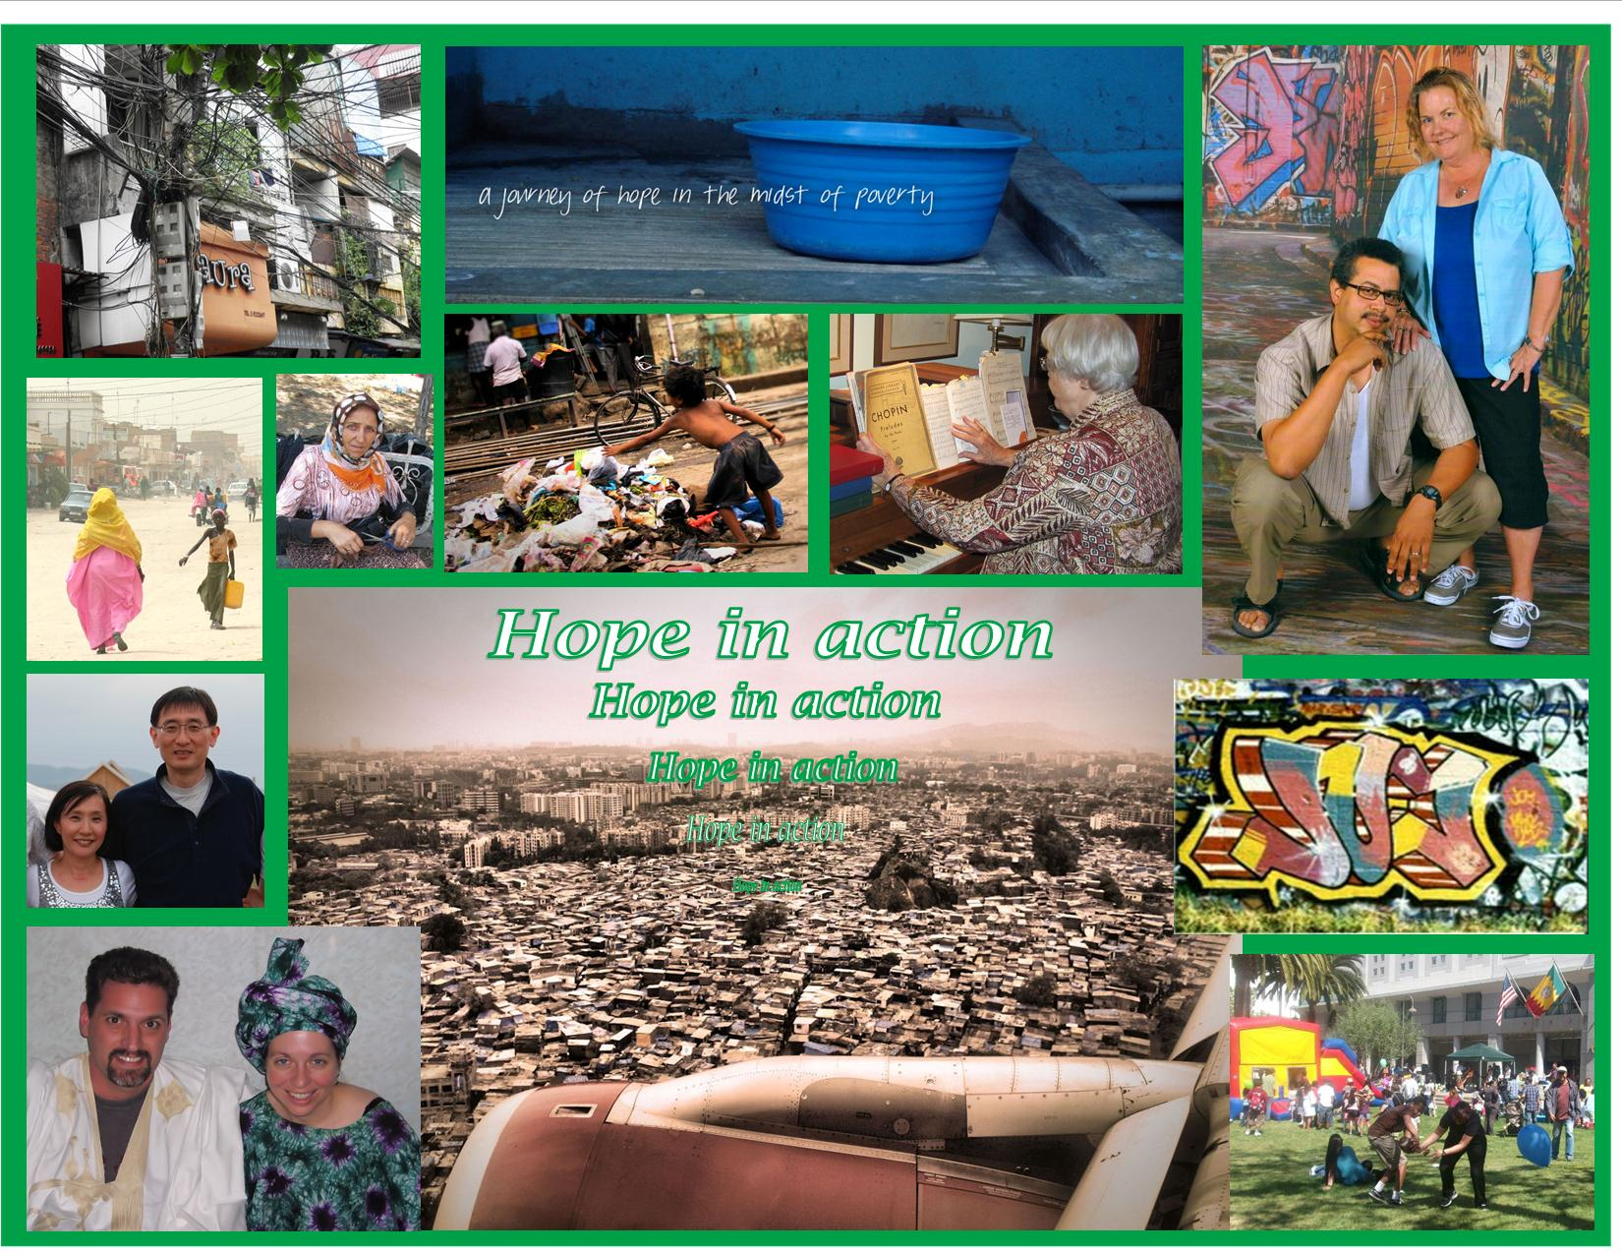

Fom top left: Hanoi Telicom 2012 by D. Bottrell, Servant Partners slogan, Jude and John Tiersma Watson; 2nd row: Servant Partners photo, street vender in Istanbul, Mumbai street child, Roberta Woodberry at her piano, 3rd row: Sue and Yun Chung, jet landing over Mumbai slums, graffiti in Los Angeles titled “Joy” by Christian artist Chris Albisurez, bottom row, Derek and Lisa Engdahl, and Easter in LA park 2012 by Robyn Cunningham.

