B2
Being the Hands of Jesus on the Afghan Border
- K. Roberta Woodberry
Published in Global Missiology, October 2012, www.globalmissiology.net

Born and raised in the Midwest I am the eldest of five children. My family finally settled in St. Paul, Minnesota where Dad (Dr. Bob Smith) taught at Bethel College. We were privileged to spend our summers traveling all over the United States and then internationally accompanying my Dad, who was a well-known preacher and teacher. My Mom, a teacher and musician, made a loving home for us all—even as we travelled and eventually spent time overseas.
It was during my junior year in college that our family moved to Beirut, Lebanon where Dad was teaching for a year and I attended Beirut College for Women. It was during that time I sensed the Lord’s calling to serve Him in the Middle East. It was there too that I met my future husband, Dudley Woodberry, who was studying at the American University. After our marriage, Dudley finished graduate school and we served together in Pakistan, Afghanistan, Saudi Arabia, Michigan, and California. Dudley taught at and was Dean of the School of World Mission, at Fuller Seminary for many years.
We were blessed with three sons, John, Bob, and David. As a stay-at-home Mom for 20 years, I was still able to teach, direct adult and children’s choirs at church and school and provide a home for our family in some difficult places.
When our two eldest sons were in college, I again returned to a full-time teaching position at Pasadena Christian School and then at Valentine School in San Marino. After taking early retirement, I went to Peshawar, Pakistan and then to Kabul, Afghanistan where I taught our grandchildren and others whose parents were serving there.
In 2011, Dudley and I moved from our home in Altadena, CA to Monte Vista Grove Homes, a wonderful Christian Retirement Community where we are settling in and feeling ‘at home’ again. Pictured here I am playing the Estey piano that was our first piece of furniture when we married in 1960. We knew a blind piano tuner who had a warehouse full of pianos which he allowed me to go through playing each one to find just the right piano for myself. Having lived in Lebanon I knew a piano must be a good one or it wouldn’t hold up.
This piano was part of many wonderful stories and is very precious to me as emotionally and spiritually I express myself best through music. You can only imagine the many times we had to move this piano and each time Dudley supervised the move and I went in the bedroom to pray. It has been transported by ship, old trucks, a water buffalo cart, train, and even on the backs of coolies through the mountain pass to Kabul.
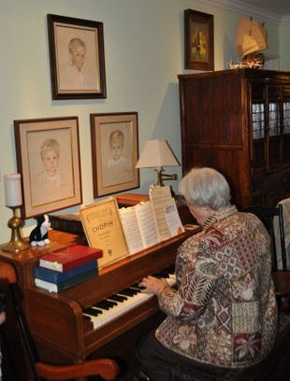
During our time in Saudi Arabia I was a member of the International Women’s Club and I remember once for a special event that included King Faisal’s wife, I was told the hall had a gorgeous piano that I could use. Again, having lived in the Middle East where things that look good don’t always play well, I insisted on playing it before the event. As I sat down to play, it did indeed look gorgeous, however, I discovered it didn’t have any pedals…so my piano was loaded on a truck and brought in for the event and it was a wonderful success.
When we left Saudi Arabia in 1979 we decided to give our piano to the church there because they didn’t have very much available for music. To our surprise when our freight arrived later in the States the first crate that came off was our piano. Friends had decided to send it to us as a gift, and I just cried for joy, for it was like seeing an old friend again.

Teaching on the Afghan Border

The year was 2000. I was teaching in a small school, not far from the Afghan border. Our son John, a pilot, and his family were working there. My two grandchildren were part of my classes. The Afghan refugee camps surrounding Peshawar, Pakistan were horrendous. They were located in places where no one else would live. They were usually in flood plains and places where the soil had been used for making bricks. It was way out from the city, so the refugees couldn’t even walk to try to find a day job in the city. The camps were teeming with people and I used to take my students there with supplies we had collected to give to the school children.
Our school was a house and the rooms were classrooms. We also had a walled-in yard where the children could play with lots of trees and flowers around. The paved driveway was a basketball court during school hours. However, the refugee camp school consisted of large white tents, provided by the U.N., where the children sat on the ground or on a straw mat—no desks, few books, no paper or pencils—just a small wooden board painted black where they did their writing and math with chalk, erasing it with a rag or their shirt sleeve. There were probably 50-60 children to a tent, but they all paid close attention, even in the almost daily scorching 120 + degree heat. I’m sure the tents were hotter, but the girls still covered their heads with scarves. If they misbehaved or complained, they were put out of school with nothing to do. Needless to say, the children tried hard. The teachers—usually not trained at all—but someone willing—taught mainly by rote. I noticed there was lots of chanting from the classrooms.
The families lived in small tents or shacks divided into sections by narrow alleys with sewage running down the middle. There were some latrines. Children waited in line with gas cans, plastic buckets and any other container they could find to collect water at either a well or a spot where the water truck would pull up. The dust was horrendous.
One group decided that it would be wonderful to provide sandals for as many as refugees as possible—especially since almost all the children were bare-footed. So they planned and purchased 2,000 pairs of shoes—but they didn’t want to just pass them out. They wanted to bless the people and their children. The father of one of my students was in charge, and he told me they had decided to do as Jesus did, and wash the feet of all who came. When I heard that, I thought “great idea—but impossible to implement.”
But it happened. They dug ditches for the water. They got benches that were put on either side of the ditch and had medical folks to help with blisters, sores, and other illnesses. They purchased soap and set the date. They had made a small compound in the middle of the camp surrounded by a chain link fence so folks could line up and be served in an organized way; the women and girls in one row, the men and boys in another. Everyone who could went out to participate in the week-long program, and we prayed. Our daughter-in-law; Corinne, was one of the volunteers.
Corinne said that at the beginning it was really hard for her. The feet were so dirty and revolting. And the faces of the women and girls were so suspicious. “What is this foreigner doing?” they seemed to ask. “But something happened as I greeted them and silently prayed for each one and then wiped their feet. Their faces softened and they smiled”, Corinne said. “I was being the hands of Jesus in this awful place—sharing His love with the poorest of the poor.” Each man, woman, and child was then given a pair of sandals (in their size) and a warm shawl. The people who went out and did the giving were the ones who seemed the most blessed.
But the story doesn’t end there. Several months later, in one of those school tents, one of the teachers asked her class of girls, “Who are the best Muslims?” One little girl raised her hand and answered, “The Kafirs! The Kafirs are the best Muslims!” The teacher was stunned. What did she mean? The little girl went on to explain, “The Muslims killed my father, but the Kafirs washed my feet and gave me shoes and a shawl.” My prayer is that our Muslim friends may experience, through all that we do, the caring heart of the Lord Jesus as this little girl did.

Then the righteous will answer him, ‘Lord, when did we see you hungry and feed you, or thirsty and give you something to drink? When did we see you a stranger and invite you in, or needing clothes and clothe you? When did we see you sick or in prison and go to visit you?’ The King will reply, ‘I tell you the truth, whatever you did for one of the least of these brothers and sisters of mine, you did for me (Matt 25:37-40).

My husband summarizes the desired results of this giving of sandals to these refugees in this way; “Ultimately, the future of missions to Muslims will be affected less by the flames of 9/11, or even the flames that started the Arab Spring, than by the inner flames that are ignited if we so follow our Lord, who modeled the basin and the towel.”

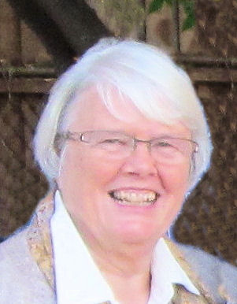
K. ROBERTA WOODBERRY is a retired missionary and school teacher and lives in Southern California with her husband Dudley.

Kafirs, meaning “unbelievers” often used as a derogatory word for Christians.

