WINDOW C
LEARNING FROM PEOPLE IN MINISTRY
This final window gives opportunity to learn from five more women in ministry, including graduate level teaching, music, counseling, leadership and writing. Marguerite Kraft shares lessons she has learned by doing ministry and then teaching others the ‘how tos’. Roberta King sings a different song in her story of how her musical pilgrimage in mission developed. Pictured below is Roberta singing with Hellen Mtawali from Daystar University in Nairobi, Kenya. Marit Landrø writes from Oslo, Norway of her journey in the Pentecostal church and the many doors the Lord opened for her to then open for others. Betsy Glanville shares her journey in education and the area of women in leadership. The final article is from Nancy Thomas, a Quaker missionary who became a trainer of writers in Bolivia.

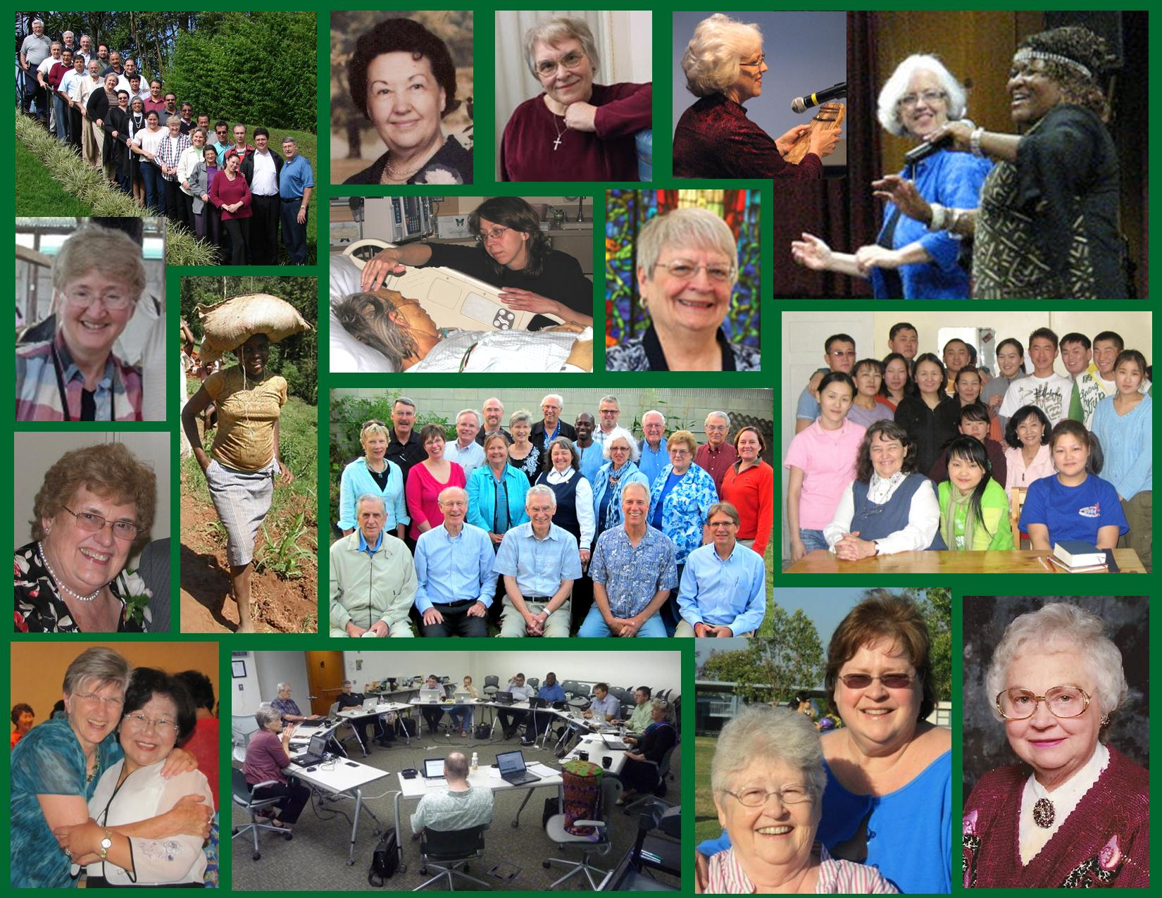

Photos from top left: PRODOLA session in Peru 2007, Betty Sue’s mother Martha Green, Marit Landrø, Roberta King playing the thumb piano and singing with Hellen, 2nd row; Nancy Thomas, Pathways Africa 2012 photo, Charlene Poulos in cancer hospital, Juanita Evans Leonard, Betty Sue with Mongolian SOD 2008. 3rd row; Marguerite Kraft, SIS faculty 2012, lower row: Betsy Glanville and Sarah Kim 2012, Betsy Glanville teaching a DMiss cohort 2012, Marilyn Clinton and Christine Cervantes, SIS staff, and Betty Wagner founder of Wayfarers, Inc. (deceased Aug. 2012).

