CONCLUSION:
LOOKING TO THE FUTURE
Published in Global Missiology, October 2012, www.globalmissiology.net

Now to him who is able to do immeasurably more than all we ask or imagine, according to his power that is at work within us, to him be glory in the church and in Christ Jesus throughout all generations, for ever and ever! Amen (Ephesians 3:20–21 TNIV).

Through these three windows, we have looked into the lives of fifteen women in various continents, settings and times. We have learned from different cultures, from those on the margins and from the lives of women in ministry. If we were to condense these stories to just one theme it would be a willingness to go to unfamiliar and unexpected places, beyond comfort zones, to serve and to be formed and shaped in other cultures and places. As these women listened and responded to the voice of God, they had the faith to let God write their stories. As a result, God led each of them to unexpected place, living lives beyond what they could have asked for or imagined. Each of these stories, like Betty Sue’s story, is a vivid example of what happens when we trust God, and let God write the story.
Our global world has changed and is changing much in the 21st Century. The center of gravity of world Christianity has shifted to the south, many countries are now involved in mission, and the traditional boundaries between sending and receiving countries are dissolving. Some of the narratives here have reflected back to mission in the 20th Century, some of the women having started in the 1950s.
Missiologists from around the globe are now asking how mission will look in the 21st Century. Dan Shaw sees the future of mission as “training and releasing those people to whom we took the Gospel message, to do culturally and lingistically effective mission in their own contexts. Rather than the colonial model we need a post–colonial perspective on mission to equip and enable leaders to be effective in whatever it takes for them to be missional.” Nancy Thomas illustrates this subtle change in her story; “…through the more than 27 years we lived in Bolivia, I gradually came to see that my role among my Aymara brothers and sisters was not as a writer. God was calling me to facilitate and encourage them to develop as writers in and for their own context.” Nancy experimented with a peer review model in the writing workshops and as a result a book of 26 stories is being published in La Paz and participants are leading new workshops. This is a new face of mission where, as Nancy puts it, “the ‘outside expert’ kept her mouth shut!” Our new role needs to be listen and learn, teach and release, and then train and refrain from controlling. Our hope is that women from many cultures will continue to be not only agents of mission but also leaders, shaping and forming transformative mission for the 21st Century.
A theme in this volume that will remain is “mission as relationship”. Our God is a relational God, calling us into relationship with the Trinity and each other, across national and cultural boundaries. There is great need to be multi–cultural bridge people. Betty Sue is such a person, and has shown the way for many others, including some of the women who have shared their narratives in this volume; Rie for the Japanese, Sue for the Mongolians, Aretta and Joy for Papua New Guineans, Roberta Woodberry for the Muslims, Lisa and Jude for the poor, Georgia for 1st Nation Peoples, and Roberta King and Juanita for Africa.
How do we conclude such a presentation as this and not diminish any of the stories presented? We turn to Robert Fulghum and the wonderful narrative he lays out about the building of the great Chartes Cathedral in France during the Middle Ages. A nobleman walks in just as the workers were finishing their day. He saw a stonemason and asks what he is doing, and the mason carefully explains his work. He asks a glass worker, who proudly shows him the stained glass window he has been crafting. The carpenter explains how the frame he is working on will support the entire structure. Finally he spots a peasant woman with her broom sweeping up the stone chips, wood shavings and glass shards. When the man asks her what she is doing, she pauses, leans on her broom, looks up toward the high arches and replies, “Me, I’m building a cathedral to the glory of Almighty God” (Robert Fulghum, It Was on Fire When I Laid Down on It. 1991, p73).
Betty Sue Brewster has kept this ‘peasant’ perspective in her life. Wherever she has gone, whatever she has accomplished, who she has become, is for the glory of God, for the building of the Reign of God. We are part of God’s big picture, his story. When we let God write the story of our lives, rather than needing to control our own destiny, God allows us to be a part of his big story. Betty Sue and the women in the volume have modeled this for us.
All who know Betty Sue know she is not retiring from life and ministry, only retiring from her role on the faculty at Fuller Seminary after 35 years. She will continue to be part of God’s big story.
Betty Sue, may you show us the way toward a retirement that continues to use the gifts we have been given for the glory of God and God’s reign here on earth “according to his power that is at work within us.”

BIOGRAPHICAL SKETCH OF BETTY SUE BREWSTER
– Georgia Grimes Shaw
Published in Global Missiology, October 2012, www.globalmissiology.net

Elizabeth Susan Brewster (better known as Betty Sue) was born the second of five children, into a missionary family in Cleveland, Ohio on May 31, 1943 during her parent’s first furlough. Her parents, Steve and Martha Green served with Baptist Mid–Missions (BMM) as pioneer church planters doing evangelism, church planting and leadership training for 30 years in Venezuela from 1939–1969, they taught in a Bible college on the island of Saint Vincent from 1971–74 and then church planting 1975 in Spain. Their missionary service was completed in 1976–1999 in the USA with the Theological Instruction and Missionary Enrichment Department of Baptist Mid–Missions.
From the age of six weeks Betty Sue was in meetings with her parents as they shared their ministry. Because of WWII their return to Venezuela was delayed until 1945 when Betty Sue was two years old. A defining moment for Betty Sue was at age three and a half when she prayed and asked Jesus into her heart. She loved being a missionary kid, in her words “I was part of something bigger than me”. She taught Sunday School starting around age 13 and was forever changed when a shy 8–year old girl came to her and said, “I want to receive Jesus” and prayed the sinner’s prayer with Betty Sue. A few weeks later in a house fire the child was severely burned and before she died of the injuries that precious new believer continually told the doctors and nurses about Jesus. “That is what I want to be about” was Betty Sue’s tearful comment. On another occasion Betty Sue found herself surrounded by a group of big guys taunting her about where Cain get his wife…with an immediate response, Betty Sue said, “It doesn’t matter where Cain got his wife, what matters is do you know Jesus?”
Life in Venezuela was simple and being home schooled was especially suited to Betty Sue’s personality as she organized her own schedule and usually got her school work done by noon and had the rest of the day free, even in high school. The family used the Calvert School materials for grades 1–8 because little else was available. Betty Sue remembers receiving personal correspondence of encouragement from various of the teachers who received and graded her assignments. Scripture memorization was a great joy to her and continues even to this day. Music was an important part of her early years and she played the folding organ and the piano as well as sang in various choirs. Betty Sue wrote reflections from her Bible reading and today says, If affective I write by hand, if cognitive I write on computer. I agree with the familiar statement, “I don’t like writing, I like having written!”

Steve, John, Betty Sue, Martha and Ethan Green 1949
In 1956 Betty Sue and her dad had been at a church youth conference where he was the missions speaker. They were driving home early in the morning and he fell asleep and the car went off the road and crashed. Betty Sue’s leg was broken and put in a full cast (thigh to toes) for about 3 months. As a young teenager she was going through a small growth spurt, so the left leg did not grow quite as much as the right leg leaving her with a slight limp. Her little brother Tim, who was 4 at the time, cried and cried because he thought that a broken leg, like a broken glass, would simply be thrown away.
While on furlough with the family, she attended public school for grades two and seven, and remembers the kids saying she was weird because she knew how to pace herself and quietly get her work done. Some responses were, “Poor you, your Mom was your teacher, this is going to be hard for you!” or “Well, of course you are getting A’s—your Mom is your teacher!” Basically public school was a waste of time for Betty Sue.
In 1960 Betty Sue began her undergraduate studies at Baptist Bible School (BBS) in Johnson City, NY, while her mother completed a degree of Bachelor in Religious Education at BBS in 1961. In 1963 after her junior year Betty Sue went home to Venezuela and met her adopted Venezuelan sister, Juanita, who learned to walk that summer and began talking in both Spanish and English.
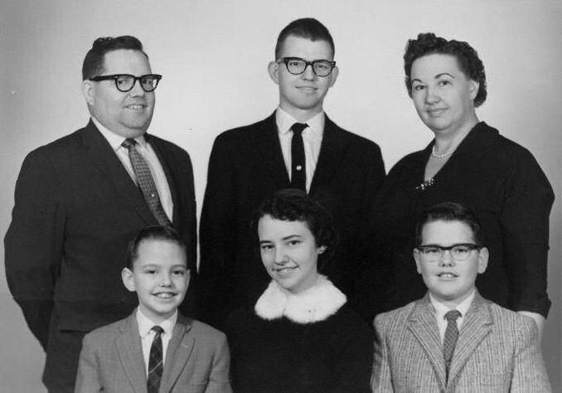
Steve, John, Martha, Tim, Betty Sue and Ethan Green 1961

Betty Sue knew she wanted to serve the Lord, maybe as a Bible translator in a remote tribe or as a nurse. However, as she was discussing her ideas with one of her college professors he responded, “I don’t think you have what it takes to be a linguist.” This was a response Betty Sue had not anticipated and she agonized in prayer over what to do. This experience helped guide her in the future as she listened to young people and prayed with them when they talked with her and asked for advice about their ministry direction. In her undergraduate program, she graduated Cum Laude and was made a member of the Alpha Gamma Epsilon honor society.
While at BBS in 1964 Betty Sue wrote a research paper for a Problems in Christian Education course, as a response to the results of the Evangelism in Depth (EID) program started by Latin American Mission. EID reported there were 17,000 converts in Venezuela as a result of the program, and determined the greatest need was for capable leaders in South American. Betty Sue is the kind of person who sees a problem and works at finding a solution. She learned that few people knew what training materials were available in Spanish, so she compiled a list of materials needed and wrote a letter to various publishers. Twenty replied to the letters, of those 14 had no leadership training materials and six reported that they did have such materials available in Spanish. Betty Sue ended the paper with a design for a three year training program. It is interesting to note that at this same time C. Peter Wagner was involved with EID in Bolivia.
After graduating from BBS, Betty Sue applied to the BMM board and was commissioned as a missionary in March 1965. As part of the acceptance process, candidates were given the Modern Language Aptitude Test, which she scored very high on, and that changed the course of her future. That summer she attended Summer Institute of Linguistics (SIL) in Norman, Oklahoma and of course loved it. However, the BMM board then decided because of the risks involved, they would not send single women out to do Bible translation in remote areas. Instead they requested she attend and evaluate a new language school that had just opened in Mexico, The Spanish Language School of Guadalajara. Betty Sue was fast learning that the Lord has ways of opening doors and making His way known for those who seek His will, so she went to Mexico, not really knowing what to expect.
On January 2, 1966 she was sitting in a car outside the school when another car drove up. She noticed a nice looking man sitting in the passenger seat and thought to herself, “There is the man I am going to marry.” Such a thought was totally out of character for Betty Sue and she checked it by thinking, “Oh, come on, you are getting to really be an old maid when you think that about every guy you see!” Then the driver got out and took a wheelchair out of the car and lifted the passenger into the chair…all Betty Sue could do was laugh at herself. That was the first time she set eyes on Tom Brewster.
After that first term at the language school Betty Sue had a couple of months before going back to SIL and she worked assisting Tom who was then assistant director of the language school (and he had also begun a small counseling center for missionaries). After her summer in Norman doing second year SIL, Betty Sue still didn’t know what the Lord wanted her to do, and the mission suggested she return to Guadalajara where she again assisted Tom and their relationship deepened until it came to the time Tom shared his heart and soul with her.
Truly the Lord had a plan, and they worked and prayed through the issues involved and agreed to announce their engagement. Somehow in the whirl of realizing they were in ‘love’ Betty Sue had not shared much about Tom with her family until they were engaged. Naturally they were surprised, here she was, twenty–three years old, getting engaged to a twenty–seven year old divorced “somebody” they had hardly heard of and he was in a wheel chair. “Come home” they urged, “let’s talk about it!” Finally her parents did consent to the marriage and her mother even took Betty Sue shopping for a bridal gown. They found a lovely one for $12 that was slightly in need of some cleaning and alterations. A friend made the adjustments and Betty Sue was very pleased with the finished dress.
Tom’s family and friends were a bit more skeptical and vocal. Some felt it would be too demanding for Betty Sue to care for Tom. At one point Tom took Betty Sue aside and very soberly said he would understand if she did not want to marry him based on what she had been told. True to her character Betty Sue said something like, “If you could live long term in a wheelchair, I’m sure I could live long term with the wheelchair.” So they were married in a Spanish/English ceremony on Valentine’s Day, 1967 (the total cost of the wedding was under $50).

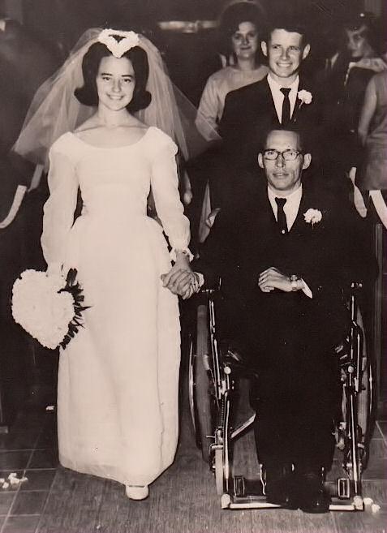
Valentine’s Day wedding Betty Sue and Tom Brewster 1967

The years 1967–1971 were formative in shaping a career that both Tom and Betty Sue would follow in language learning and missions strategy. They stayed in Mexico with the Spanish Language School of Guadalajara and soon began to realize they didn’t know what they were doing so they decided to go back to school.
The issue of accreditation caused problems for Betty Sue’s transcript from BBS and the University of Texas said she could only come as a freshman. The University of Arizona accepted her into a Masters program on probation, but she also qualified for a full academic scholarship. Tom enrolled in a Ph.D. program. They began their studies there in Tucson in the fall of 1968.
However, back in Mexico they read an ad about the Toronto Institute of Linguistics (TIL), “A unique one–month–long language and culture learning program for missionaries about to go overseas for the first time.” Betty Sue wrote TIL for a book list that they could use in Mexico, Don Larson, the principal, wrote back inviting them to come and “observe” during the coming month of June. Several creative minds such as Eugene Nida, Bill Reyburn, Bill Smalley, Don Larson and Charles Kraft had been involved in making TIL and innovative and stimulating environment for new missionaries.
Sharp thinkers such as Wayne and Lonna Dickerson, Ed Anderson, Dave McClure, Dwight Gradin, and the Brewsters made TIL a place bubbling with language and culture learning ideas, and a fertile place to experiment and test theory and practice. Larson had invited them to ‘observe’ but for him participant observation meant being part of the process, teach, experiment and challenge learners to face themselves and the realities of language and culture learning. TIL became one of the most significant building blocks for Tom and Betty Sue’s future ministry.
They became part of the team with Larson and the others in pioneering “relational” language learning approaches by having students go out into the ethnically diverse communities of Toronto, and learning introductory phrases in some of the many languages found there. That was the first of eleven consecutive summers for Tom and Betty Sue at TIL.
Tom worked on his doctoral dissertation at the U of A while Betty Sue completed her Masters. Eighteen months after the University of Texas had not accepted Betty Sue’s bachelor transcript, they accepted her Masters degree with no questions, and she enrolled in a PhD program.
1970 brought their five years of involvement in Guadalajara to a close. The leaving was traumatic and for a time they felt falsely accused by some in leadership and somewhat abandoned by the Lord. An old missionary man in Guanajuato, Mexico ministered to them and urged them to have an attitude of reconciliation and remember that the Lord was in control and not to allow a root of bitterness to remain (Heb 12:15). This wise counsel of trust became part of their thinking and was called on many times in the coming years.
Their experiences at the Spanish Language School and at TIL, led Tom and Betty Sue to begin thinking about establishing language schools in many parts of the world. As a result they established an organization they called Evangelical Language Institutes for Missionaries (ELIM). However, they realized that their emphasis needed to be on training learners how to learn, rather than just setting up schools, they wanted to work with mission organizations rather than compete with them.
Betty Sue pursued a PhD at Tom’s urging because he knew she would likely be a widow at a young age and he could not leave her a large monetary inheritance. But, if he helped her get a PhD he could leave an inheritance for her to be able to live and continue in ministry.
The research for Betty Sue’s PhD dissertation demonstrated that people who cultivate certain personality characteristics tend to learn languages better than persons who do not have those characteristics. This provided significant insights into the work and directions for their future ministry. She defended her dissertation on November 23, 1971 and the next day, they received a phone call from Bill Bright, the director of Campus Crusade for Christ (CCC).

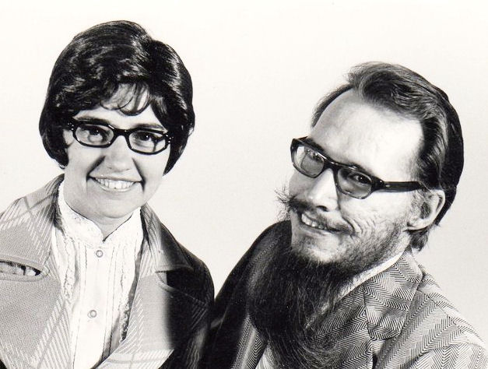
1972 Betty Sue and Tom Brewster

The challenge presented by Bill Bright was to see the Four Spiritual Laws booklet and other materials translated into all the languages of the world! Bill didn’t know how many languages that was but told them it was their business to find out and that began five years of Brewsters working with CCC and Agape. The visionary in Bright appealed to the visionary in Tom and this began the ‘translation’ phase of their ministry. Betty Sue has often said she was “the one who helped put legs on Tom’s ideas”, and he had a wealth of ideas that needed walking out. However, the CCC literal translation policy at that time raised serious concerns for Brewsters.
At a cross–cultural communications workshop for CCC, they met Don Smith, the founder and director of Daystar Communications in Nairobi, Kenya. Smith stressed that communication is much more than written and verbal messages—he talked about ten different “symbol systems,” with which we communicate. Don invited Tom and Betty Sue to Kenya. Neither Tom nor Betty Sue had been to Europe so they arranged a trip to Kenya through Holland, Greece and Israel. While in Kenya they learned Ken Taylor had formed Living Bibles International (LBI) to help translators all over the world create living translations in their own languages. Taylor arranged with Don Smith to have Daystar coordinate the recruiting, training and supervision of translators and testing of translations in projects all over Africa.
Brewsters worked closely Don Smith and the Living Bible people in Nairobi and split their time between work with CCC and LBI. Now, they were hooked on traveling and this first trip was the start of a traveling lifestyle that would take them to over 80 countries in the next thirteen years.
In the 1970s the prevailing understanding of “good translations” was to translate word–for–word and the various translation policies were not communicating the Gospel message. The summer of 1972 Brewsters attended a translation seminar led by Eugene Nida of the United Bible Societies, known as the giant in Bible translation in the 20th century. There they learned about ‘dynamic equivalence’ which expressed the principles they believed. Nida asked Tom and Betty Sue to “back–translate” as many CCC translations as they could find, to learn what the materials were really communicating. To do this task they often went to Fuller Seminary to meet with international students and there they met Chuck Kraft, Art Glasser, Ralph Winter and others who were later to have a significant influence in their lives.
The concept of dynamic equivalence was the tool they needed to convey the idea of being faithful to the meaning of the original materials while making whatever changes of the forms were required or appropriate in the new language. The back–translation work they did was proving their fears to be valid and that the meanings in the translated materials were definitely not dynamically equivalent. It was interesting work, because of the insights they gained into other cultures. However the result was a decision to re–write CCC translation policy.
The response from CCC national directors began almost non–stop traveling the world for Brewsters. They got ready for what they planned was a 3 month trip but they didn’t return for almost 36 months as they worked for both LBI and CCC in 70 countries. In 1973 they made trips to every major area of the world. They were encouraged and yet weary and the night before the 1974 Lausanne Congress on World Evangelization they prayed together and asked the Lord to show them if what they were doing was worthwhile. At the Congress they met scores of people from all over the world that they had trained or consulted with. Many shared their adventures in successful language and culture learning, translation, and ministry. Tom and Betty Sue felt reassured that God was indeed allowing them to make a difference in many lives and ministries throughout the world.
However, their time at CCC’s “Explo74” in Seoul, S. Korea was not nearly so affirming and as a result and with the invitation from Larry Poland, the Director of the new Agape program, Bill Bright agreed to release Tom and Betty Sue to work with Larry, training new Agape missionaries and that began their work with Agape.
During a language and culture learning workshop in Thailand and India, they had the opportunity to visit with missionaries working among the poorest of the poor, that stimulated their interest in and concern for the poor—the calling that consumed much of Betty Sue’s heart and energy for future ministry. Their first training workshop that included total immersion into a new community was in 1975 outside Nairobi in the Kamba town of Machakos. This was a perfect example of ‘de–schooling’ language learning and making it a social activity.
By late 1975 they finalized their tool for learners to successfully manage their own language learning experience and called it Language Acquisition Made Practical (LAMP). Tom and Betty Sue felt they wanted to supervise the publishing closely because of all the special phonetic fonts and cartoons and decided to publish it themselves. However, no publisher would accept LAMP because it didn’t fit any of their departments, not linguistics, not a text book, not a language curriculum. Brewsters often spoken motto was “find a way or make one” and they formed Lingua House as their own publishing company and in 1975 LAMP was the first book lingua House published. There were positive and some very negative responses to the book such as; “Don’t let any of our people purchase LAMP, you will ruin the language learning of the missionary enterprise.” However, it sold out quickly and was picked up by many mission agencies.
Just as LAMP was nearing delivery, Chuck Kraft invited Tom and Betty Sue to his home in Pasadena, CA for Thanksgiving dinner and asked them if they would be interested in teaching at Fuller. Tom was excited by the possibilities but Betty Sue was unsure, because in her thinking they were only in their early 30s, just ‘peons’ and Fuller was the ‘Big Leagues’. That night at home they discussed the issues for them of teaching at Fuller; Were they Fuller material? What about their travel plans and commitments? Betty Sue voiced her preference when she said, “I’m enjoying traveling, we are helping people wherever we go and I don’t want to quit yet.”
Tom seemed to thrive on change, and he needed challenges. As usual Betty Sue’s more introvert processing balanced Tom’s extreme extrovert visionary processing. He reminded her that she had expressed the desire to settle down and have a child. In 1994 Betty Sue wrote,
I had somewhere in the back of my mind figured that we had to have our first child before I was 30. The summer that I turned 30 (1973) was traumatic for me because I didn’t have a baby yet...things that really bothered me about turning 30, was that part of my self image was being young. I was the youngest person to do this and the youngest to do that and all of a sudden, here I was middle aged…perhaps it was time to think about a change. Not a sedentary lifestyle, but something more “normal”.

They accepted the invitation and agreed to begin teaching part–time in the Fall of 1976. The initial agreement with Fuller was to teach two quarters per year, leaving the other two quarters free for traveling. Their did more consultations with groups within the States including Missionary Internship (MI) in Michigan, The Southern Baptist’s Journeyman program in Raleigh, the LINK Care program in Fresno, Agape team training in Tijuana, and the Summer Institute of International Studies in Colorado, in addition to TIL.

School of World Mission photo 1978 front row from left: Tom and Betty Sue Brewster, Chuck Kraft, Fran and Paul Hiebert, Alice and Art Glasser, Mary and Donald McGavran, Doris and Peter Wagner and Lois and Dean Gilliland.

In 1978 Brewsters were in Cali, Colombia for what they called the “Language Exploration and Acquisition Project” (LEAP) and they were the coaches for the learners. It was while in Colombia they discovered they were pregnant and on Sept. 2, 1979 the birth of their son was attended by a ‘midwife’ in their home in Pasadena which started a new aspect of their journey. Given the challenge inherent in their traveling lifestyle, it could have meant the end of such traveling, but Betty Sue knew about missionaries traveling with babies and didn’t see it as a problem.
This birth also ushered in the concept of midwifery and language learning. They started talking about the similarities between child birth and language learning, and wrote the article Language Learning Midwifery. The second LEAP was with Wycliffe mission personnel in Guatemala and Honduras. This time Tom and Betty Sue went as ‘midwives’ to facilitate the natural process of language learning, rather than coaches.
Shortly after their son was born, late one evening they were settling down for the night and started talking about the similarities between infant bonding and missionary adjustment, and right then they began writing notes for an article on bonding. On a long vacation in Hawaii they met Loren Cunningham, the International Director of Youth With A Mission (YWAM) and had a creative time to write the article that became a signature piece, Bonding and the Missionary Task. The concept behind bonding was not new in missiology. What was new from Brewster’s teaching was the use of the analogy with infant bonding, and when bonding needed to be done. Shortly after that they also wrote “Language Learning is Communication—Is Ministry!” published in the International Bulletin of Missionary Research in 1982. Some people found Bonding very helpful, others very distasteful; “Don’t let our people buy or read your material. You will kill all the missionaries, or if they survive they will not stay.” Similar to the negative response to LAMP, Betty Sue was amazed that they, as only two people, could have such power.

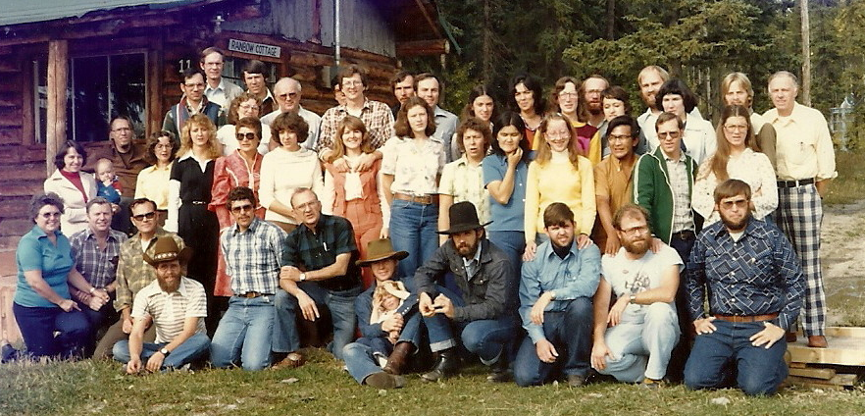
1980 IMCO training program using LAMP in Quesnel, BC.

In 1980 Brewsters were invited to do a two–week LAMP course in central British Columbia, Canada with a group of 5 mission agencies working together to train candidates for North American native ministry, Inter Missions Co–operative Outreach (IMCO). They invited Dwight Gradin from Missionary Internship (MI) to work with them and NAIM assigned me (Georgia ‘Pepper’ Grimes) to be their teaching assistant for the course. They were invited back the following year and after that Brewsters recommended in order to reduce expenses, IMCO should use their own members to do the language and culture learning.
To an extent, both Tom and Betty Sue knew about the poor, but it was the world travel that the extent of the world’s poverty, and God’s concern for the poor, began to be the motivating factor of their ministry. The 1974 trip to Calcutta had been the catalyst, along with the visit in 1982 to the Vietnamese refugee camp. Early in 1983, in South Africa they learned about the reality of spiritual warfare and the power of God in this present world and in their own lives. During this same time Fuller was experiencing a unique movement that was sweeping over the campus. The SWM course MC510 Signs, Wonders and Church Growth taught by John Wimber, became very popular and controversial in 1982–1985. This movement influenced Brewsters as well.

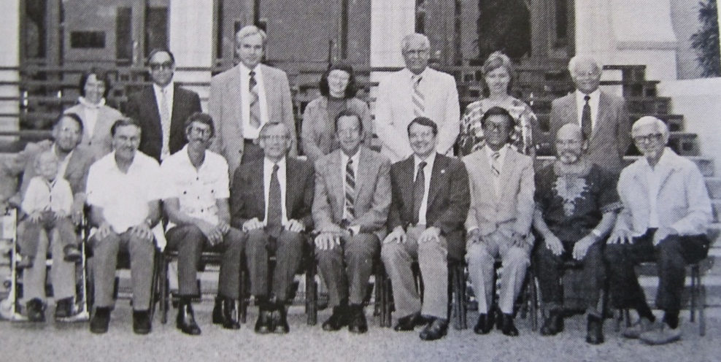
SWM faculty 1981, back row from left: Betty Sue Brewster, Viggo Søgaard, Carl George (adjunct), Pat Harrison (adj), Don McCurry (adj), Roberta King (adj), Edwin Orr. Front row: Tom Brewster, Chuck Kraft, Dan Shaw, Art Glasser, Paul Pierson, Bobby Clinton, CheBin Tan, Dean Gilliland and Peter Wagner.

In November, 1983 while teaching two one–week intensive seminars, in Auckland, New Zealand, Tom and Betty Sue met Viv Grigg, the founder and leader of Servants to Asia’s Urban Poor, a mission that sponsored teams for ministry in the slums of Manila and other Asian cities. That vision and model of ministry to the urban poor fit right in with Tom and Betty Sue’s thinking. Tom had the vision of forming a new mission that would exist for no more than 20 years and then dissolve to birth other grass root groups. Both Betty Sue and Tom had issues with modernity and the top heavy organizations that started as grass roots but evolved into large business. They dreamed of an alternative that would be fundamental theologically and missiologically relevant.
In the summer of 1984 Tom and Betty Sue taught a course on incarnational ministry at Fuller and threw out the challenge to the students to live among the poor. The reaction to incarnational living among urban poor varied, at first no mission board would consider allowing it as it was too dangerous, or their insurance wouldn’t allow it. One statement very similar to the responses of the LAMP and Bonding techniques was, “You will kill off all the missionaries who work among urban poor.” For a third time Betty Sue wondered how two simple people could carry such power.
People who heard about LAMP often stated that it was good theory, but would never work in practice. In the summer and fall of 1985 Brewsters worked on Community is My Language Classroom! This book contains first–person accounts of the language learning experiences of 16 missionaries who have learned a language though relationships with people of their new culture. Eugene Nida says, “For those who are sure they can never learn a foreign language, this book is an encouraging ‘must’….For a missionary, this system of language learning is particularly strategic for it teaches the central element of all Christian service—creative, interpersonal communication.” The book illustrates the way to view the people of a new language and culture group as friends rather than targets for evangelism.

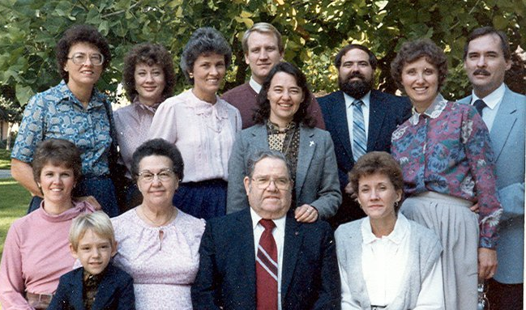
Brewster and Green families at Fuller after Tom’s funeral Dec. 1985
From left back row: Martha Brewster Moffitt, Ramona Brewster Tuma, Mary Brewster Anderson, Jerry Tuma, Betty Sue, Ethan Green, Alice and Dan Brewster, Front row from left: Hilda Green, Martha and Steve Green and Doris Brewster Douglas

In December 1985 Tom was scheduled for surgery and Betty Sue was allowed to stay with him in hospital. Tom’s brother Dan flew in from Colorado for the 2:00 PM surgery and was with Betty Sue to receive the news that Tom’s heart had failed during the surgery and they were not able to restart it. That of course began several very trying days for Betty Sue as she fought to carry out Tom’s wishes for a simple funeral, one that fit his style and his beliefs. She got the closest she could to a ‘pine box’ with no frills and when the funeral parlor insisted on the expense of a fancy hearse she offered to use her station wagon to transport the coffin to the church and cemetery (but it was against the law). So many details and attitudes of how to do it ‘right’. John Perkins sums it up so well: “I won’t ever forget the morning in Lake Avenue Congregational Church when it was time for Tom’s body to be brought into the sanctuary for the funeral. We were standing up and looking, and they were bringing Tom’s body down the aisle of the church in a plain, wooden box casket. I almost said, “Go, Tom, go!”…Tom lived with conviction and he was buried with a conviction. Thank God that Betty Sue had the courage to carry out Tom’s wishes.”
Betty Sue lists several defining moments in her life and two of these are, the birth of their son in 1979, and Tom’s death in 1985. Truly for her life would never be the same again and there was no getting back to normal. Her sorrow was doubled when ten months later her father died in September 1986.
During the past 26 years Betty Sue has joyfully persevered as a single mother, a trainer and midwife to language and culture learners at Fuller and around the world. She has been an active member of Lake Avenue Church since the early 1980s and a member of the 120 Fellowship Sunday School class started by Pete and Doris Wagner in the late 1970s.

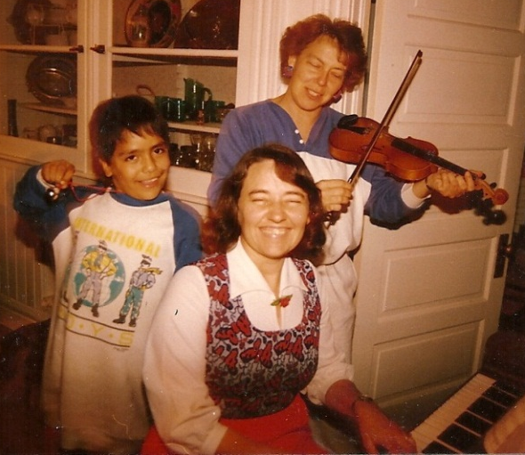
Betty Sue making music fun in 1989 with Pepper and neighbor Alex Chavez

Betty Sue’s mission in life has been to walk in close relationship with the Lord, glorify Him and help bring others to Him – by direct sharing, and by training others. She doesn’t really have a life verse, but as she says, she has more ‘season’ verses, for example; at the time of her cancer surgery and treatment in 1995,
Psalm 17:8 “Hide me in the shadow of Your wings” NIV.
Psalm 61:4 “I long to … take refuge in the shelter of Your wings” NIV.
Psalm 63:7 “Because you are my help, I sing in the shadow of Your wings”.
When her first grandchild was born after a very difficult labor and was reported dead at birth and needed to be resuscitated,
Psalm 71:6, “From birth I have relied on you; you brought me forth from my mother's womb. I will ever praise”.
Zeph 3:17 “The LORD your God is with you, he is mighty to save. He will take great delight in you, he will quiet you with his love, he will rejoice over you”.
Isa 50:4–5 “The Sovereign LORD has given me a well–instructed tongue, to know the word that sustains the weary. He wakens me morning by morning, wakens my ear to listen like one being instructed. The Sovereign Lord has opened my ears; I have not been rebellious, I have not turned away”.

After Tom died Betty Sue steadfastly refused to be full–time at Fuller. She wanted to continue spending half of each year in some other part of the world. In her words; “Being in the majority world keeps me alive and reminds me what this is all about. Seeing people trying to put it into practice, and trying it myself, gives me ideas of the realities and how to better help them. The traveling and seminars overseas bring a certain vitality to my teaching and a certain reality.” Chuck Van Engen senses she was about fifty years ahead of the curve with that decision.

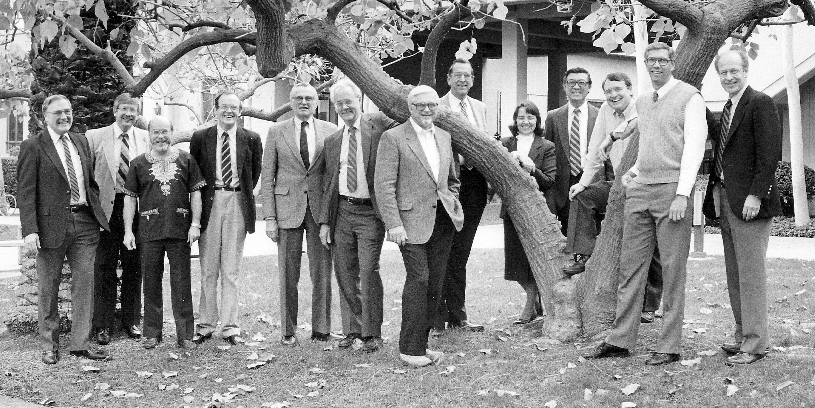
School of World Mission faculty 1988: Chuck Kraft, Eddie Elliston, Dean Gilliland, Eddie Gibbs, Art Glasser, Paul Hiebert, Peter Wagner, Paul Pierson, Che Bin Tan, Bobby Clinton, Dan Shaw and Dudley Woodberry (not pictured Saphir Athyal, Chuck Van Engen, and Hoover Wong)

Early in 1986 Betty Sue invited three young women to go on a survey trip with her to Tijuana, Mexico. Jude Tiersma, Linda Mitchell and I went with her for the weekend just to see how and where the Lord would lead us. It was healing for Betty Sue to be with the Spanish speaking poor again. Jude would later go on for her PhD at Fuller and fulltime ministry with InnerChange in Los Angeles, I continued working with Betty Sue, and Linda finished her Masters and returned to ministry in the Middle East.
It was in 1984 that Betty Sue and Tom had traveled with 18 young people into the poorest communities in Mexico City. Betty Sue describes this time as another defining moment in her life. While exploring the area and trusting the Lord to lead them, Betty Sue noticed a small yellow–front building that read, Iglesia Pentecostal Getsemani (Gethsemane Pentecostal Church). Betty Sue visited with the pastor’s wife and explained that they wanted to find out what God was doing among the poor in the area. They fellowshipped through the afternoon in the pastor’s home, learning about the needs of the families in the neighborhood. The team was served a meal by the church people that night and they stayed in the homes of the church members.
The pastor invited Tom and Betty Sue to stay in their home but it was too awkward to get the wheelchair in and out of the narrow doors of their two–room house, so it was decided they should sleep in the church. The couple gave them their one family mattress to sleep on. The next day Tom and Betty Sue tried to thank them for their kindness but the couple cried and said, “You don’t know what you have done for us. We were so discouraged and had no money. We asked the Lord to show us this month that we are to be here or we would have to leave this ministry.” They knew the Lord had sent this group in answer to their prayers and needs.
Betty Sue and her young son returned to that same area of Mexico City and the same people in 1986. The church members all cried when they learned of Tom’s death, then they laughed and said “That Tom, he has gone ahead of us to glory”. Then they cried again and laughed even more rejoicing together. This is the kind of relationship building that gives meaning to Betty Sue and empowers her to continue being good news to others. This is who Betty Sue is and others are touched by her sincere, gentle presence.
Betty Sue has made 7 trips to Mongolia since 1994 to teach for one of her former students who founded a School of Discipleship in the capitol city of Ulaanbaatar. These trips have been in the extremely cold winters. During these trips she teaches survey of Old and New Testament books and is always available to listen to the students, counsel, encourage and pray with them. The Mongolian students are inspired by her diligence and faithfulness, and her knowledge of and love for the Bible. She has also traveled in other parts of Asia to train Asians in cross–cultural ministry.
When Betty Sue was asked “If you could spend time with a Biblical person, who would it be and what would you talk about or do together”? she responded;
Wow! Lots! Jonah, why would you prefer ‘suicide’ to obedience? What was it like inside the whale? Did you get seasick? Did you feel like you were drowning? And Esther – questions about her emotions at having to marry the king rather than someone of her choice, emotions regarding Haman and the banquets, and becoming queen to serve her people. And the Widow of Zarephath – How did you have faith to believe Elijah was a prophet and not a madman? Did the flour and oil increase visibly and dramatically, or did every day you have to have faith that there would still be a little more for the next day.

Betty Sue hopes the future for her involves living in the 2/3 world (majority world) and ministering in some primary ministry. One goal Betty Sue wants to accomplish is to finish and publish her mother’s poetry book. Even now she is planning a ministry trip to Venezuela with her older brother John and his son in February 2013. Or she just might saddle up her yak and ride off into the hills of India.

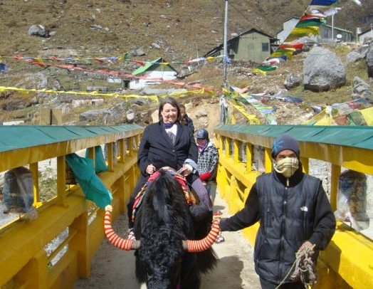
Riding a yak in the eastern Himalayan range, Tsongmo Lake in 2010

Betty Sue continues to listen to and learn from others. In her teaching for example she has expanded their 1982 roles of “learner, servant, storyteller” to include “friend and intercessor” two roles that are vital to who she is first in relationship to Jesus and then in relationship with others. If you are considered her friend, then you can be assured she is praying for you.
Betty Sue has a missionary heart and when asked what she sees as future mission challenges she responded:
I see multi–cultural teams moving to function more in the local culture, living at the support levels of the local community. I see and hear that majority world and western missionary teams do planned activities that always cost money rather than simple no cost get togethers, I envision this changing. Often the team language is predominately in English and this puts those not as well versed in English at a disadvantage, I see this needing to change. The whole area of ‘short termers’ can be excellent if tied into the work of long termers.

A convocation was held Thursday, April 5, 2012 at Fuller’s Pasadena campus to honor faculty and staff for their years of service to the seminary. Among staff and faculty, several were honored for 35 years of faithful contribution to Fuller including Betty Sue. “This is one of those wonderful days when things that have been invisible to us are suddenly made visible,” remarked President Richard Mouw in his opening comments, emphasizing the amount of important work done behind the scenes to contribute to Fuller’s success as a seminary. “This is a day in the life of Fuller Seminary when we stand and look back at everything that’s been accomplished and we say, ‘We thank God for you,’” continued Dr. Mouw. “And we press on because we know that what we celebrate are works God will bring to completion in Jesus Christ our Lord.”
Douglas McConnell, current provost and former dean of the School of Intercultural Studies wrote the following; “From the first day I met her, I knew that Betty Sue’s wisdom was a combination of God’s special gifting and the obedience of a special servant,” he notes. “She mastered the skill of combining intellectual discipline with practical application while leading students around the world to achieve more and better in their task of learning language and culture.”
When asked, “What have you learned over your lifetime that you’d like to share with the younger generation?” Betty Sue listed the following:
Know the Lord is a loving Father, He has your best at heart, He is utterly faithful.
Listen to the Lord and follow His leading.
Love the Scriptures and Scripture memorization.
I agree with Dr. Mouw when he said, “This is one of those wonderful days when things that have been invisible to us are suddenly made visible.” This e–book to honor Betty Sue is an attempt to make visible the mostly invisible formation pieces that have resulted in the contributions Betty Sue has made and continues to make, to the missionary community around the world. She began as a little bi–lingual missionary kid who wanted others to know Jesus and maybe translate the Bible for a remote tribe somewhere, but God had a much more grand scheme set in place. Never in her wildest dreams could she have imaged the places she would go, the organizations she would influence and the thousands of future missionaries she would touch just because she wanted to be about the Father’s business.
Thank you Betty Sue for staying the course even in the storms of life when you could have cut and run…and yes, I can hear you asking, “But where would I run?”

You’re blessed when you stay on course,
walking steadily on the road revealed by God.
You’re blessed when you follow his directions,
doing your best to find him.
That’s right – you don’t go off on your own;
you walk straight along the road he set
Psalm 119: 1–3, The Message.

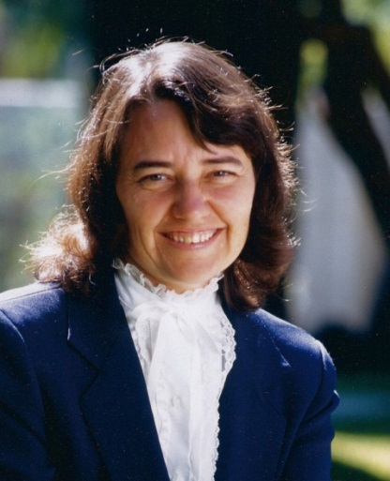

VITA
ELIZABETH SUSAN BREWSTER
Born: May 31, 1943
Parents and Siblings: Steve and Martha Green, John, Ethan, Timothy and Juanita
Marital and Family Status: Widowed (Thomas Brewster); one son, three grandchildren
Denomination CCCC
Ordained Commissioned by a GARBC Church

Education: Home schooled in Venezuela, grades 2 and 7 public school in USA
BRE Baptist Bible Seminary, 1964 in Missions, Christian Ed, Music and Language.
University of Oklahoma, SIL 1965-1966 summers
MA University of Arizona 1969, in Latin American Studies, Spanish Literature, and Linguistics
PhD University of Texas 1971 titled: Personality Factors Relevant to Intensive Audio–Lingual Foreign Language Learning

Professional Experience
1966–1968 Admin. Assistant, Spanish Language School, Guadalajara, Mexico
1968–69 Phonetics teaching assistant, University of Arizona
1967–78, 1990–93 Instructor, Toronto Institute of Linguistics (summer only)
1972–74 Directors of the Translation Dept, Campus Crusade for Christ
1974–76 Directors of Language Training for the AGAPE Movement of Campus Crusade
1973–76 Consultants for Living Bible International (translation dept) and for Daystar Communications, Nairobi, Kenya involving travel in over 70 countries.
1973–present Conduct Language/Culture Acquisition and Mission seminars around the world in 90 countries including Africa, Europe, Latin America, Middle East, Asia, Melanesia and North America
1976–2012 Associate Professor of Language/Culture Learning and Mission, SIS Fuller Theological Seminary.

Mentoring: Theses and Dissertations:
ThM Missiology
Duleep Janjanik Fernando, A Strategy for Mission Among the Poor in Colombo 1991.
Richard H. Gollings, Nuevo Nacimiento: A Revival Movement and Baptist Sodality Among Mexican Youth, 1992.
Tae Suk Kim, Mission to the Handicapped in Korea, 1994.
MA Missiology
Georgia R. Grimes, FARO: Learning Spanish in Community and School, 1988.
John Shorack, The Life History of an Undocumented Salvadoran, 1990.
MA CCSP
Martha Hollowell, Low–Income Housing: A Rationale for Christian Involvement, 1989.
DMiss
Rie Manabe–Kim, Strategies for North American Missionaries’ Regional Language–Culture Learning in the Japanese Context, 2012.
PhD Intercultural Studies
Jin Rag Son, Worldview Issues Underlying the Teaching of Tagalog to Korean Missionaries, 2002.
Jong Pyo Im, Incarnational Bonding Process in Relation to Effectiveness of Cross–Cultural Adjustment Through Field–Based Missionary Training Model: With Special Reference to Korean Ethnocentric Monoculturalism, 2007.
Publications:
Books
“Involvement as a Means of Second Culture Learning” in Practical Anthropology, January 1972.
Programed Translation Workbook. Campus Crusade for Christ, 1972.
Dynamic Equivalence: To Communicate Effectively. Campus Crusade for Christ, 1973 (also available in Spanish).
Crating a Living Translation with Dan and Alice Brewster, Daystar Communications 1975.
Language Acquisition Made Practical (LAMP) 1976.
Bonding and the Missionary Task, 1981
Language Learning is Communication—Is Ministry 1981.
Language Exploration and Acquisition Resource Notebook (LEARN!) 1983 (syllabus with 16 cassette tapes).
Community is My Language Classroom, editor. 1986.
Como Aprender Otro Idioma (How to Learn Another Language) 1993.
Names of God Calendar. 1989 and 1999 daily Scripture calendar.
Pronunciation Activities for Language Learners (PAL) 2007.
Articles
“Involvement as a Means of Second Culture Learning” in Practical Anthropology Jan. 1972: 19:27–44.
“Language Learning: Taking Time to Say, ‘I Care’ in Worldwide Challenge, January 1977.
“What it Takes to Learn a Language and Culture” (later reprinted as:“I’ve Never Been So Fulfilled in all My Life” in Evangelical Missions Quarterly April, 1978:101–105.
“Language Learning Midwifery” in Missiology April, 1980:203–209.
“Language Learning Is Communication–Is Ministry!” in International Bulletin of Missionary Research. Vol.6, No. 4 October 1982:160–164.
“Jesus’ Training Program” in World Christian Sept/Oct 1984:21–22, 27.
“Thinking Missions? Study Abroad!” in HIS Jan. 1985:21–22.
“As Poor Among Poor,” in World Christian Sept/Oct 1985:22–23.
“Culture Shock: California Style,” in The Semi Sept. 1994: 3 reprint 1995.
“Adventure in Words” in The Great Commission Handbook, 1994:170–171.
“Go Into All the World” in Decision Magazine Oct. 1997.
Entries: Evangelical Dictionary of World Mission, 2000.
Bonding, Home Schooling, Language Schools, Second Language Acquisition.
Chapter
“Preparing Life–Long Learners” in Helping the Missionary Language Learner Succeed, Ladonna Dickerson, ed. 1995.
Column in Today’s Mission/World Christian:
“The Mission Challenge” in Today’s Mission Jan/Feb 1982: 27.
“Language Learning vs. North Americans” in Today’s Mission Mar/Apr 1982: 17.
“Language Learning—How do They do It?” in Today’s Mission May/June 1982: 22.
“Language Acquisition Issues” in Today’s Mission July/Aug 1982: 22.
“Bonding and Language Learning” in Today’s Mission Sept/Oct 1982: 29.

Courses with Syllabi: Records from Spring 1995 – Summer 2012 teaching part–time for Spring and Summer sessions:
Course # enrolled
MB500 Culture and Transformation (campus and on–line)
MB 505/605 Serving Cross–Culturally
MB 530/660 Language/Culture Learning and Mission
MB 553 Teaching English to Speakers of Other Languages
MB 572 Cross–Cultural Min Practicum
MB 595/695/795 Training TESOL Teachers
MB 769 Methods 1; Research Design DMiss
MB 800 Tutorial in Behavioral Science
ME 500 Communicating and Serving Cross–Culturally: On–line
ME 516 Issues in Literacy
MI 530 Missiological Integration (in India)
MI 572 Practicum: Mission Integration
MI 770 Missiological Foundations DMiss
MI 792/892 Doctoral Seminar DMiss and PhD
MK 708 Language Culture Learning in Min. (Korean program)
MM 560/660/760 Women in Cross–Cultural Ministry:
MN 572 Practicum in Urban Mission
MN 576/676 Incarnation and Mission Among the World’s Urban Poor:
MH 800, MM 800 and MT 700 Tutorials

Honors and Memberships:
Undergraduate education Honors:
Alpha Gamma Epsilon honor society
Graduated Cum Laude
Member of the Planning Committee for and coordination of the International Congress On Language Learning (ICLL) at lease twice.
Keynote speaker at ICLL 1994.
Vice–Pres of Association of Professors of Mission 1996
President of Association of Professors of Mission 1997
Keynote Speaker for Association of Professors of Mission 1997.
Keynote speaker at “New Directions” in St Louis MO (Lutheran Church Missouri Synod – Conference on Refugees) – April 27, 2002.

This bibliographical sketch contains details from Dan Brewster’s 1997 book Only Parlayzed from the Neck Down, Charles Kraft’s 2005 book SWM/SIS at Forty and Martha Green’s 2008 book Pioneers in Pith Helmets.
See Wagner’s 2010 memoir book Wrestling With Alligators Prophets and Theologians.
Using concepts from linguistics, cultural studies, communication sciences and psychology, Nida developed a practical approach to translation he called dynamic equivalence or functional equivalence, the goal of which was to make the translation clear and understandable as well as accurate.
Larry Poland was the director of the Agape Movement, an international volunteer service organization under Campus Crusade for Christ, Intl. This movement trained more than 800 volunteers for service and opened 35 nations for volunteers during his eight years of leadership. He has traveled to 100 countries of the world.
This later became Perspectives on the World Christian Movement course under Ralph Winter. The Perspectives course is a dynamic 16–week accredited course that reveals God’s heart for the nations, helping believers see themselves and the world around them the way Jesus does. Those attending engage in analysis and discussion of biblical, historical, cultural and strategic views on the impact of the world Christian movement.
For future security Betty Sue and Tom’s son and family is not named or identified in this publication.
Betty Sue’s daughter–in–law is currently working on certification as a birth doula with Childbirth International.
IMCO was composed of Arctic Mission, Native Evangelical Fellowship, United Indian Mission, North America Indian Mission, and Northern Canadian Evangelical Mission.
The book came out the month after Tom’s death. This was most painful for Betty Sue to have worked so hard on it with Tom and then not be able to share the encouraging reception of it together.
John and Vera Mae Perkins were dear friend to Tom and Betty Sue. In 1982 they, founded Harambee Christian Family Center in Northwest Pasadena.
May be found at http://www.fuller.edu/About–Fuller/News–and–Events/News/2012/Faculty–and–Staff–Honored–for–Service–in–Convocation.aspx.
Faculty in Transition 7/19/2012 (http://www.fuller.edu/page.aspx?id=2147490443&terms=Brewster)

