Vulnerable Mission Strategies
Stan Nussbaum

Published in www.GlobalMissiology.org Jan 2013

No one has time any more to read an article arguing that mission should be contextualized and sustainable. The question remaining is how to achieve those goals not whether to attempt them. No one, least of all me, would dare to argue for the opposite—culturally imperialistic mission or manipulative mission.
It is time for a reality check. Contextualization and sustainability are widely preached; imperialism and dependence are widely practiced. Consider the state of the global church 100 years after Roland Allen.

Allen’s goal | Current buzz words about goal | Frequent realities
Self-governing | Contextualized | Foreign
Self-supporting | Sustainable | Money-driven
Self-propagating | Missional | Confusing

If we had arrived at Allen’s goal, missiologists would have quit writing and teaching about these things. They would be losing their jobs for being behind the times. But sadly they are not behind the times at all. The grand, correct concepts being taught are not yet being put into practice on a large scale. The need is still there.
As someone who lives and works mostly outside of academia, I will explain how a few of us are trying to address the gap between theory and practice. Then if you can help us work on it better or we can spur you on, perhaps we both can better influence mission practice so it brings less disgrace and more honor to our Magnificent Lord.
To signal that we are not just rehashing old truths about contextualization, we are using the term “vulnerable mission,” coined by the founder of our Alliance for Vulnerable Mission, Dr. Jim Harries. He is a British missionary in Kenya whom I have known for about 20 years. (See www.vulnerablemission.org.)
One reason we settled on the term “vulnerable mission” is that it directly challenges the triumphalism and the success mentality that is the default setting of Western cultures, especially American culture. According to the success mentality, the goal of a missionary and a mission agency is to plan carefully, start things, and see to it that they work (succeed). We get people to pray for success, and we write regular prayer letters to keep our donors posted on how well we are succeeding. If our programs don’t work, we add more resources or bring in another strategy or take a field research course from someone like me or enroll in a doctoral program until they do.
On the field we may agonize, individually or as a team, about whether to continue a program that is sputtering along, not working out the way we drew it up; however, we hate to write prayer letters about programs or projects that failed and were closed down. Our typical desire is to throw enough effort, money, and prayer at our projects that they will not be vulnerable to the many challenges besetting them. Occasionally this tenacity is fruitful and laudable but far too often it results in what is almost a pandemic across the mission world today—propping up of unfruitful programs and strategies that ought to have been allowed to die and would have died without another transfusion of their lifeblood, i.e., outside money and expertise.
A vulnerable mission strategy is one that allows things to die if they want to and if they should. It even allows them to die while the foreigners who started them are still on the scene, rather than shortly after they leave.
We advocates of vulnerable mission don’t aim to fail. If we did, every time we failed we would chalk it up as a success! We do, however, accept failure. We allow the weeds to die so they don’t keep choking the corn that has been trying to grow among them. If we have a slogan for the laborers, it is, “Don’t keep watering the weeds.” Let them die and see what grows up when they are out of the way. Don’t bundle financial advantages (salaries, gifts, favors, etc.) with ministry or project activities; compartmentalize your charity.
Failure is getting a little more acceptable in the secular world via books like Tom Peters’ Fail Forward Fast, or the latest one, The Wisdom of Failure: How to Learn the Tough Leadership Lessons Without Paying the Price (Weinzimmer and McConoughey) but even there the aim is either to learn from the mistakes of others or to take action quickly, keep the failures small, and get them out of the way as soon as possible so we can move on to success.
Vulnerable mission starts from different premises. We challenge three core assumptions of American culture which have been carried unquestioned into most American leadership books and most American practice of mission. We anchor these challenges in three rather unlikely places:
- Jacques Ellul’s view of what money is
- the “linguistic pragmatics” school’s view of what language is
- the orality movement’s view of what the gospel is
Here are these incredibly radical challenges to conventional wisdom.
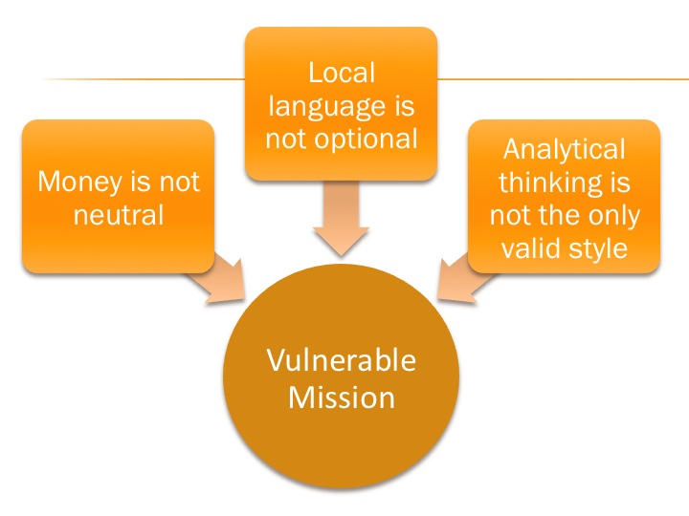
Conventional wisdom says money is a neutral object. Everything depends on how you use it. Jacques Ellul says this is a worldly perspective in direct conflict with a biblical one, where money is considered part of the “spiritual order” rather than the “moral order.” “When we claim to use money, we make a gross error. . . It is really money that uses us and makes us servants by bringing us under its law and subordinating us to its aims.” Biblical commands about money “have to do with relating to a power, and not with behavior toward an object.” Money is a power. It takes on a life of its own. It orients people’s lives. It gets people to think of life as a matter of buying and selling. Even today we hear it claiming to be the ultimate fact of life, “If you want to understand what is really going on, follow the money trail,” or, “It’s the economy, stupid.”
Secondly, conventional wisdom says that learning a foreign language is desirable but often not essential for cross-cultural work. The list of missionaries who have been sent home because they did not make enough progress in learning the local language is very short, and the list of excuses and work-around strategies for staying on the mission field without ever becoming competent in the local language is very long.
What conventional wisdom assumes is that meaning is detachable from language and context. In the field of linguistics, the school of “pragmatics” argues the opposite. It says that languages do not merely express thoughts; they shape them. Languages are very complex wholes, and until one gets quite far inside any particular language, many of the realities and dynamics of that language’s culture will be invisible and/or misinterpreted. A missionary without the local language will be “flying blind” much of the time, never realizing or having a feel for the local perspectives on reality, relationships, and propriety. Vulnerable mission says we need to stop kidding ourselves, putting up a brave policy about language learning but implementing it in a cowardly way.
Thirdly, we challenge conventional wisdom’s view that analytical thinking is the most accurate measure of intellectual maturity. On that view, schooling is designed to help people become more analytical, write good analytical essays, and draw solid analytical conclusions. Everything else is second-class thinking, and those cultures which are built around non-analytical thinking are seen as very backward indeed.
In mission work, the implication of this bias for analytical thinking is that “real” theology is “systematic theology” constructed by careful analysis of Scripture and that the “real” gospel is a series of abstract propositions that lead analytical thinkers to a conclusion.
The orality movement in mission takes a different approach, couching the gospel in the panorama of the biblical story instead of a series of propositions.
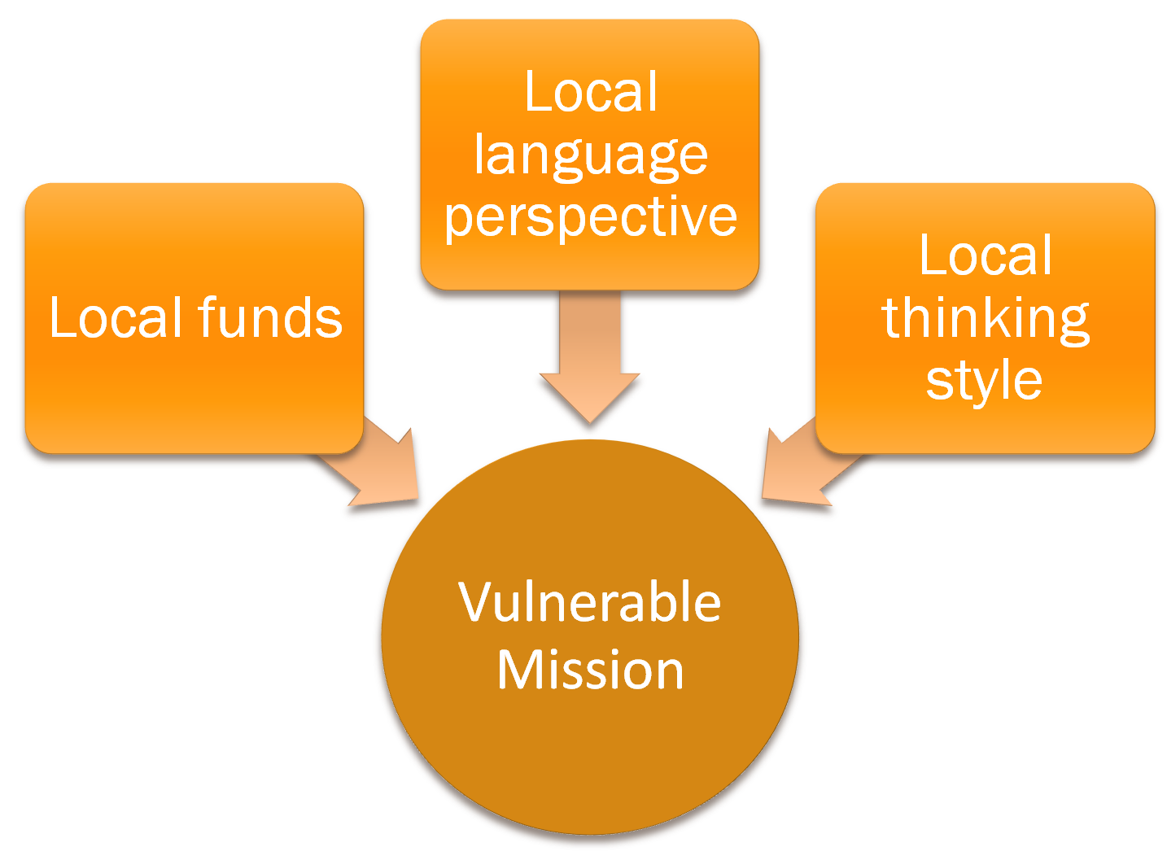
Vulnerable mission strategies bet more heavily on the local people. These strategies assume that locally appropriate things are going to survive because local people will see to it that they do. From the beginning, vulnerable missionaries rely on local resources, local language usage, and local thinking styles. They watch and learn what resources local people have and what they are good at. They gradually discover how the language works and how local people think deeply without analyzing everything to death. When they propose or begin ministry activities, they start small and see if local people gravitate to an idea or program. If and only if local people buy into, shape, and support an idea, it succeeds. Otherwise it fades away, and no outside money or expertise helps it survive in a vegetative state. In a nutshell, these are the ideas of what we call vulnerable mission.

Orality
The third point, orality, is the key to the whole thing because this is the point where we know we are lost. We kid ourselves about the other two points, excusing pump-priming and charity as well as treating language as a desirable but optional skill, but the instant we try to shift from analytical to oral thinking, we know we are off our turf and out of our depth. Local oral thinkers are the experts, we are in kindergarten, so we have to let them lead and learn from them as they do. When we ask them how to write a song, quote a proverb, hold a festival, or explain the gospel in an oral way, we know we don’t know!
After my first term of Bible teaching among oral learners in southern Africa, I came home to explain to my supporters what I was doing. I told them that contextualized Bible teaching in Lesotho meant, “Using parts of the Bible we don’t often read to teach truths we don’t understand to meet needs we don’t feel by using methods we don’t like.”
Unfortunately, this is not the usual approach of Westerners who teach the Bible in other cultures. They prefer analytical methods. They center everything on the most analytical book in the New Testament (Romans), which is also probably the most opaque book for oral thinkers. The result is an entire global system of theological education that was set up to turn oral thinkers into analytical thinkers rather than to capitalize on their natural strengths as oral thinkers.
Why? Because the vision of a “mature” church was fatally flawed in the beginning. It assumed that genuine theology must be analytical theology, genuine disciples must be analytical thinkers, and genuine church leaders must use analytical methods to help disciples grow. Consider the massive financial implications of our ethnocentric bias for analytical thinking.
Biases that go with assuming a mature church must be an analytical church
- Professionalization—the leaders are the best analysts; laity tag along
- That kind of leader needs special schooling for analyzing the Bible
- A congregation must be big enough to support a professional pastor
- That size of congregation will need a building
- Bottom line: The building, the schooling, and the pastor all require major funding
Alternative model if a mature church can be an oral-thinking church

- The laity can be involved in developing the theology of the group
- Special schooling not required for leaders; they can be apprenticed
- Congregations can thrive and sub-divide though too small to support a pastor
- Buildings are optional
- Bottom line: Little or no funding required for the whole system to work
It boggles the mind to think how much Western mission effort and funding have gone into things the alternative model does not need at all. It also makes one wonder how many of today’s Western missionaries are propping up the old model with time, energy, and money while missing golden opportunities for fruitful witness that would come if they could shift to an oral thinking style.
Here are a few examples of opportunities. These already have a few advocates but in my experience are usually regarded as somewhat quirky interests of a tiny minority.
- Ethnomusicology – music shapes the faith and life of emerging churches more than anything else. How can it be a sidelight of mission? A network of about 250 Christian ethnomusicologists is encouraging wider use of the kind of Christian music development that happened spontaneously in the churches that grew up using vulnerable mission strategies. Let this become a mainstream pursuit.
- Proverbs – proverbs are distilled oral thinking, masterful carriers of profound truth. How can these be incidental to preaching and witness? Why not routinely build them into mission work. For example, here is a paper topic I would love to assign to every international student at Asbury. “What are ten local proverbs that every missionary who comes to your language group should learn on arrival, and what would they know about your people if they really grasped these proverbs?”
- Festivals – how can festivals be so neglected? They are communal events celebrating the great acts of God in the biblical story, intriguingly and graciously open to outside observers, involving music and drama, processions, symbols, colors, and many layers of meaning. Westerners are festival-deaf and festival blind, but the rest of the world is fluent in festival. I would love to see us change the dominant paradigm for mission from a war to a festival, so that we automatically think of ourselves more as carriers of joy than agents of force. Might the festival be so effective that it would do even more for evangelism and discipleship than sermons do?
A shift to an oral thinking style would also go a long way toward helping us understand and utilize the shift that N.T. Wright, Willard, and McKnight are calling for—the recovery of the biblical “gospel of the kingdom” as opposed to an exclusive focus on the “gospel of salvation.” I cannot summarize that here. I only want to note that the “gospel of salvation” (our standard way of preaching and teaching the gospel in the West) is an analytical gospel, that is, it breaks the gospel into concepts and pieces, while the gospel of the kingdom is a narrative and is much more intelligible to oral thinkers.
Too idealistic?
If this is such a great idea, where is it working? A fair question, and the answer is hiding in plain sight. It is a lot bigger than Jim or any of the rest of us. Arguably the three most fruitful mission movements in the entire 20th century were three that operated almost entirely on vulnerable mission principles. The three movements are African indigenous churches, Chinese house churches, and (to a lesser extent) the charismatic movement in Latin America. Mainstream mission thinkers and leaders are fully aware of all three and generally admire them, yet they seem not to have grasped the implications of the fact that their low-budget evangelism was tremendously fruitful even though it involved no fringe benefits.
Consider this:
The AICs [African Instituted Churches] have shown how much mission can be done for free. It takes no money to retell the story of the calling of the founder or to tell people about one’s own walk with God. It takes no money to pray for someone to be healed. It takes no money to sing and dance or to write a new song that praises God. It takes no money to receive dreams or prophetic revelations from God. It takes no money for each member of a congregation to stand up and speak in a service. It takes no money to be freed from alcoholism, wife-beating, jealousy and witchcraft. It takes no money to become an honest, hard-working employee.
The massive success of vulnerable mission is not just a 20th century phenomenon. In our new century in India, Mongolia, the Philippines, and across the Muslim World, things are beginning to happen that look very similar to Africa 100 years ago and China 50 years ago. And the movements are typically working on vulnerable mission principles because they have no other options.
If it is true that in the 20th century God spread his kingdom most widely by vulnerable mission methods, and if it is true that he seems poised to do the same thing in the remaining “neglected corners” of the earth in the 21st century, then we in Western missions need to ask ourselves one huge question, perhaps the biggest question facing Western churches, the Western mission establishment, and the next generation of Western missionaries. Here it is: “To what extent does God want us to use our strengths (methods and resources) to complement the groups and churches who are using vulnerable mission by necessity, and to what extent does he want us to copy their vulnerable mission methods ourselves by choice, leaving our ‘strengths’ on the sideline?”
Complementing seems to be the obvious choice if we are thinking of the global church as a body where different members have different functions. But we have to recognize that every attempt to complement is an attempt to do mission from a position of strength. We want our strength to complement their effort in some area where they are weak. Vulnerable mission points out that the body is not working like it should when one member acts like Saul trying to help another “weaker” member, David, by offering some armor. I believe a great deal of what is interfering with the carrying out of the Great Commission today—the foreignness, the money-centeredness, the fuzziness of the message—is largely the result of many Davids accepting Saul’s armor and trying to fight while they wear it.
If we assume that our money and technology, which look like strengths from a human perspective, are what God is most likely to use to get his mission done and to bring glory to himself, won’t we forget to check with Jesus, the general director of the mission, whether he actually wants to use our money and technology in each particular case? A good book like Lederleitner or a good set of partnership guidelines like the Lausanne Standards (www.lausannestandards.org) show how easily money can sneak in and complicate or ruin partnership. In fact, they put so many qualifiers on partnerships involving money that one almost asks whether they should be attempted at all.
When we try to use money as our strength in so-called partnerships, are we not overlooking 1 Cor. 1 as the default setting for mission—God using the weak to confound the strong? Are we not relegating that “weak” and vulnerable method of mission to those who are too poor to be able to afford to do mission the way we do it? Are we not assuming that people do mission from a position of strength if they can and from a position of weakness if they must?
Conclusion
There is a very difficult choice for the next generation of Western Christians. I see no easy answer. Should we complement the “weak” vulnerable mission of the Majority World church with our strength, or should we forego our strength and copy the vulnerable mission that the Majority World uses by necessity?
If missionaries and mission agencies are so interested in bringing more glory to God, why would we not cut back on the mission methods that are failing to bring much glory to him? Why not replace them with a more vulnerable strategy, one that for its inspiration harks back to the cross, the resurrection, and Pentecost instead of the conquest of the Promised Land? Why not pay the prices of vulnerable mission and bring to God the glory that vulnerable mission in his name brings?
Options for further engagement with the ideas in this article:
- Join the “Pearl” listserve and/or subscribe to the monthly e-news at www.vulnerablemission.org. Jim Harries’ books are also available there, including Vulnerable Mission (Pasadena: Wm. Carey Library, 2011) and Theory to Practice in Vulnerable Mission (Eugene, OR: Wipf and Stock, 2012).
- Join the Facebook group, “Celebrating the Messianic Year,” or buy the printed version of the same weekly devotionals, Waking up to the Messiah, www.enculturation.org
- See “Stan’s Mission R&D Lab,” www.gmi.org/services/research/stans-lab, for more on the “Messianic Year,” including some new lyrics to “Auld Lang Syne” designed for welcoming New Year 2013 with Christian joy.

Adapted from a lecture at the E. Stanley Jones School of World Mission and Evangelism, October 17, 2012
Jacques Ellul, Money and Power (Downers Grove, IL: InterVarsity Press, 1984, English translation by LaVonne Neff; French 1954), p. 76. The entire chapter, “Money,” (p. 73-116) is relevant to our concern.
Jim Harries’ doctorate is in linguistics. See his Vulnerable Mission (Pasadena: Wm. Carey Library, 2011), p. 43-44 for an introduction to “pragmatics” as an alternative to “an oversimplistic understanding of language” which has hindered mission and development thinking in many ways.
See ION (International Orality Network) www.oralbible.com. There is no standard position in the network about the relation of propositions and narrative, that is, whether “real” theology and “real” gospel are in the narrative, the propositions, or both. What everyone agrees is that the narrative is a lot more important to communicating the gospel than most Westerners think it is, and unbelievers do not have to become analytical thinkers in order to understand and embrace the gospel.
Jim Harries has told me that one of his most consistent difficulties as he has traveled to make the case for VM on many campuses and at many conferences is that people affirm it and tell him they are doing it, but when they talk a little more, he discovers they are not understanding it at all in the way he presented it. They are reducing it to “partnership,” an elastic word if ever there was one.
For example, we neglect Leviticus and Hebrews, which were fascinating and engaging books for my students. They have many truths about holiness and purification which we do not delve into because we don’t think in terms of body-soul purification-health (I have to make up a clumsy English phrase to get somewhere near the idea that required no explaining in the Sesotho language). A method we don’t like is memorization, which oral thinkers routinely enjoy and excel at.
While giving some guest lectures in a Central Asian seminary a few years ago, I had my world rocked by a student’s question—“What is a paradigm?” Later it hit me that basically every lecture by a foreigner and every book in that seminary library except the biographies were structured for analytical thinkers (who like paradigms) and were basically lost on oral thinkers. Further I understood why a Scottish faculty member at the school had said, “We try to get them to answer the questions on an exam but often all they do is give testimonies.” The whole seminary system was at sixes and sevens with the natural strengths of the church leaders.
The International Council of Ethnodoxologists, www.worldofworship.org. “We facilitate online networking and provide resources for the development of culturally appropriate Christian worship, utilizing insights from ethnomusicology, missiology, worship studies and the arts.” For information on the Council’s forthcoming publication, Worship and Mission for the Global Church (James Krabill, ed.), see www.missionbooks.org/williamcareylibrary/pages.php?pageid=12.
An entire cultural profile can be sketched using proverbs as points for a “connect the dots” approach. This is what I have done on American culture in the book, American Cultural Baggage (Maryknoll, NY: Orbis Books, 2005).
I am currently making a personal attempt on this one, which you can see in my book, Waking up to the Messiah (Enculturation Books, 2011). The book sketches an annual cycle of festivals that together tell the whole story of Scripture. A two-page diagram of the cycle is downloadable from the “Stan’s Lab” page at www.gmi.org.
See A. H. Mathias Zahniser, Symbol and Ceremony: Making Disciples Across Cultures (Monrovia, CA: MARC, 1997). Note his definition: “Discipling is that ongoing set of intentional activities governed by the goal of initiating people into the kingdom of God through appropriate instructions, experiences, symbols, and ceremonies.”
They are not “two gospels” but two ways of presenting and explaining the gospel. McKnight clearly shows that the gospel of the kingdom is summarized in the same biblical passage that the gospel of salvation advocates claim as theirs, 1 Cor. 15:1-3. See Scot McKnight, The King Jesus Gospel (Zondervan, 2011), p. 40-43.
Thomas Oduro et al. Mission in an African Way, (Wellington, South Africa: BybelMedia, 2008), p. 159-160.
Mary Lederleitner, Cross-Cultural Partnerships (Downers Grove, IL: IVP Books, 2010).
We may note that 1 Cor. 1 does not entirely exclude the strong from mission. “Not many strong are called,” but a few are. I don’t think that means that the church really needs to thank God for those few strong ones and build its whole approach to mission around them and their strengths. I think it means rather that God’s preferred way and most common way of getting his mission done is the surprising way, through apparently weak people and groups. He does weave a few “strong” people into the tapestry but they are not the ones holding everything together.
Thanks to the influence of writers like John Piper and programs like the Perspectives course, there is increased attention to the connection of mission and the glory of God. Ralph Winter and Steven Hawthorne, Perspectives on the World Christian Movement, 4th ed. (Pasadena: William Carey Library, 2009), see especially Hawthorne’s article on p. 49-63 and Piper’s on p. 64-69.

