Canadian Speed Control being used in Canada..How's this for effective speed control?
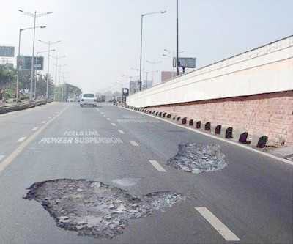
I don't know about you, but this would certainly slow me down! People slow down and actually try to "straddle" the hole.
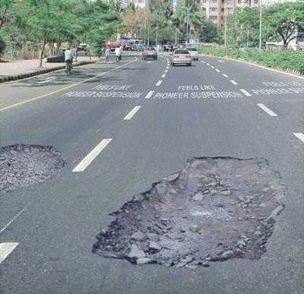
This is an actual speed control device that is currently in use. It is MUCH cheaper than speed cameras, radar guns, police officers, etc. Pretty clever -- especially when they move them around every day.
Isn't Art Wonderful

