ETHNIC RECEPTIVITY
AND
INTERCULTURAL MINISTRIES
1
ENOCH WAN
Chair, Division of Intercultural Studies and Director, Doctor of Missiology Program,
Western Seminary, Portland, Oregon, USA
Published in Global Missiology, Contemporary Practices, October 2004, www.globalmissiology.net
For past decades Canada had a leading role in sending missionaries into many countries of the world. Then came the 1980's, and many of those countries closed their doors to outside messengers (although Brother Andrew has maintained that there is no country you can't get into - just ones you can't get out of). Just when we are lamenting these hindrances, God seemed to be opening a new door of opportunity. Canada was inviting record numbers of immigrants to join us, many from countries which were closed to our missionaries.
We are now confronting a new mission field, yet in some ways are unequipped for facing this challenge. Donald McGavran has given us the necessary descriptive terms: "E-l evangelism," meaning that which reaches our own kind of people; "E-2 evangelism," which requires crossing some kind of barrier, usually physical, such as going into a new community; and "E-3 evangelism," which crosses cultural and language barriers as well as physical barriers, such as going to a new country. He says, "For E-3 evangelism, the church must have a corps of missionaries with special training." While we have trained our "foreign missionaries for crossing these barriers and are putting forth a great effort, particularly in Vision 2000, to equip for E-l evangelism, what may be lacking is help for E-2 evangelism reaching distant.”
Most of us would recognize that there needs to be a difference in strategy between E-l, E2, and E-3 evangelism. But as we confront the E-2 sphere of evangelism, is there anything that can help us to better relate the gospel? When we send our missionaries to other lands, we train them to look for ways that God has -prepared that culture -for the gospel, ways to look for receptivity that will affect strategy. We need to do the same, as we look at reaching these new cultures coming to our land. In fact, our strategy for evangelism will be deficient if this "cultural integration/variation" is not taken into consideration. There are factors of integration and receptivity that can help us better communicate the gospel to that culture.
In this chapter, we will look at informative cases or situations for contextualized evangelism of different ethnic groups, followed by the interpretive analysis of cultural integration/variation factors and concluded by instructive suggestions for our evangelism and church-planting strategies within these new Canadian cultures.
Informative Understanding of Cultural Integration/Variation:
Our mandate is clear. The church is to evangelize the nations or the people-groups (Mt 24:14; 28:19). Like the Christ Incarnate who in order to reach men, became a man and lived among the Aramaic-speaking Jews in the context of Greco-Roman culture, Christians are to evangelize different people-groups within the context of their cultures, which is "contextualized evangelism."
2
The general pattern of evangelization practiced by Anglophone Caucasian Christians needs to be contextualized when evangelizing other ethnic groups and modified according to their various degree of cultural integration/variation. Several simple but informative studies of contextualized evangelism will be presented to help us understand how this can be applied to various ethnic groups.
Means of Pre-evangelism
One of the characteristics of contemporary Canadian culture is the "impersonal informational" aspect. This may be the cumulative effects of industrialization, urbanization, technological revolution and information explosion, etc. consequently, the kind of pre-evangelism efforts that evangelicals use extensively involve mass media (e.g. telephone, radio, television, printed literature and published magazine). These are exclusively in English, predominantly informational, and very impersonal.
The usual means of pre-evangelism by Anglophone Caucasian Christians are inadequate and inefficient in reaching new immigrants who are functionally illiterate in English, relatively untouched by the mass media, and socially isolated from the Anglophone Caucasian Christians' social network (typically of middle-class, professional, suburban dwellers). Canadians of South Asian origin (mostly English- speaking, relatively more westernized professionals) may be touched by the impersonal-informational means of pre- evangelism. However, most Canadians who came as refugees (Vietnamese, Hispanic or Arab origin) are non-English speaking, non-professional immigrants. This group of Canadians will not be touched by the typical means of impersonal-informational pre-evangelism by Anglophone Caucasian Christians.
Method of Contact
First generation immigrants are culturally less integrated into the mainstream of Anglophone Caucasians culture than their local born descendants. They usually have frequent social interaction with their own people (i.e. extended family and kindred spirits) in their native tongues. Newspapers, videos and movies which are printed or produced in their native languages are the main media of communication and the sources of information. Being proportionately small in number, their social relationships are more personal and intimate. Thus, pre-evangelism is best done through personal contacts and private interaction, which better demonstrates the virtue of a Christ-like character than extensive reliance on mass media.
Message of the Gospel
3
Western culture has a Greco-Roman, politico-legal base and Judeo-Christian ethical foundation. The Greek social system of city-state, the Roman law, etc. has been well developed for "millennia" in the West. The influence of the Judeo-Christian value system and moral code has left its mark in the mind and heart of people in the context of western civilization, so much so that anthropologists who have conducted cross-cultural comparative studies have classified the western culture as a "guilt culture" in contrast to the "shame culture" of the East (e.g. Japanese, Chinese, Vietnamese, etc.).
The Protestant reformation had a strong emphasis on the doctrine of “justification by faith.” The favorite New Testament books of western evangelicals for reading and preaching are usually Romans and Galatians. Anglophone Caucasian Christians usually define “sinners” as “people violating God’s law” and the message of salvation is expressed in terms of “forgiveness of sin...the penal substitution of Christ...imputed righteousness.” The gospel is introduced in the form of “law-principle,” and in terms of “justification by faith in Christ as Saviour.”
Message in Culture
People of the East give a high priority to “honour” and avoid “shame” at all cost. For example, a Japanese would rather die than live in disgrace. To him wealth or health is dispensable and deniable in order to avoid shame or acquire fame. This is in contrast to the life-long quest for success as defined by material gain of the capitalist, entrepreneur in the West. Easterners, such as Japanese, Koreans, Chinese, Vietnamese, Indians, can better grasp the shameful state and severed relationship between God and man (Gen. 9:1- 11. 22), man and woman which was due to the fall (Gen. 3:16), and the need for salvation. They will be more willing to accept Christ as the “Blame bearer” (Gen. 3:7-8; Mk. 16:34), the mediator-reconciliator (Rom 5; 2 Cor. 5; Eph. 2; Heb. 9) for sinners who suffer because of severed relationship and the subsequent shameful state. If the message of the gospel, presented to relational people of the “shame culture,” was in terms of personal “reconciliation” instead of justification (as in the farm of the “Four Spiritual Laws”), it will be better understood and more gratefully received.
Of course, the “whole counsel of God” (Act 20:27) should be taught eventually in a discipleship program. But nobody should be alienated from the Kingdom of God because they are culturally unable to grasp the overemphasized “forensic” aspect of the gospel and therefore, unprepared to accept the “penal substitution of Christ” as presented by Anglophone Caucasian Christians in evangelism.
Message of Power
Most non-Caucasian Canadians from the third world take the spirit world very seriously. The presence and power of evil forces and demonic beings are readily recognized. Many have witnessed demonic manifestations or even personally experienced demonic oppression or possession. Their superstition and fear of the spirits would have prepared
them to receive the `good news” of a mighty but merciful Christ. The classical Christian view of Christ’s death and atonement (Col. 2; Heb. 2), setting us free from evil power, would be better appreciated than the rational, logical argument of the existence of God. They want to embrace Christ and experience His victory and love that could set them free from fear and fate (1 John 3:8; 4:4,18; 5:4- 6, 18-20).
4
The primary message of the gospel for these ethnic Canadians is not a hope to enter heaven `by and by” and deliverance from hell in the afterlife. They want to experience the deliverance from curse, fate, fear, etc. in the `here and now.” To these ethnic Canadians, the freedom and joy in Christ is a liberating message and life style. It is something that can be declared clearly, demonstrated powerfully and experienced daily.
In the context of western culture (Anglophone Caucasians of Canada, U.S.A., and Europe), the most popular and commonly used method of evangelism had been the well-publicized mass rally. Ideally, it is a well-organized operation, meeting in a public place (church building, public hall or arena), and featuring excellent programs. People are encouraged to make a personal decision and public profession of faith by raising their hand or coming forward.
This has been a very effective method of evangelism to reach Anglophone Caucasians who are relatively more individualistic in decision-making, more public in religious expression and more program oriented in their social gathering.
Method of Deciding
Most ethnics of non-western origin are not individualistic (self-directed) in their decision-making process. Whether it be Canadian Natives, East Indian Immigrants, Chinese, et cetera, they are more communal (family, clan-centered called `other -directed”) in social behavior, including decision-making. Their social gathering is usually more event, people-oriented (not program-oriented or time-conscious). They wait till the people are there, even though it is `late” in time accord ing to Caucasian standard.
Among many ethnic groups (e.g. Japanese, Chinese, East Indian, Africans, Hispanics, Moslems, Sikhs), children, wives, and unmarried young adults are to submit to the authority and ruling of their parents, husbands and the elderly males. Unlike Anglophone Caucasians, religious resolution (including acceptance of Christ as Savior) a private family matter. The general pattern of Anglophone Caucasians in thinking like public confession of faith, or making an instantaneous and personal decision, needs some rethinking before imposing it on the new converts of different ethnic origins.
Meaning of Grace
When evangelizing, ethnic Canadian evangelicals should modify their `felt need” approach of outreach often used with Anglophone Caucasians. Many times we give the promise of prosperity and problem solving, or the Gospel of health and wealth, success and happiness. We parade the newly converted movie star, the professional athlete or the
successful businessman in our evangelistic rallies, and in their stage show type of program, we call for a simplistic or emotional `acceptance of Christ.”
5
The problem is that it gives ethnic Canadians the idea of `cheap grace” and of superficial showmanship to the gospel. Many ethnic Canadians from Buddhist, Hindu, and Islam backgrounds take pride in their religious devotion, personal discipline, and ascetic deliberation of their ancestral faith. They despise and decline easy religious experiences as too shallow, superficial and simplistic. In fact, many of them will have to pay a high cost for the change of allegiance to the Lordship of Christ but would be willing to do so for the One who paid a costly price for their salvation (Eph. 1:17; 1 Cor. 8:19-20).
An extensive period of in-depth follow-up of these ethnic converts is necessary to deal with problems such as family opposition, carry over superstition and syncretism, social ostracism, lingering demonic entanglement, et cetera. The cost of discipleship (Mt 16:24; Lk. 14:25-35), personally and socially, as part of a well-developed evangelism program, is not to be underestimated. The fast-food mentality and quick-fix methodology of Anglophone Caucasians should not be assumed as valid when evangelizing ethnic Canadians
.
These factors were meant to inform as to the importance of `contextualized evangelism” among Anglophone non-Caucasian Canadians. We now need to interpret some of the cultural `integration/variation factors” that can help us in our evangelism and church planting.
Interpretive View of Cultural Integration/Variation
Canada, like the U.S.A., is an immigrant country. All Canadians, except the Canadian Indians, are either overseas-born immigrants or local born offspring’s. However, there is a dominant Anglophone Caucasian culture (or `host culture”) by virtue of its population size and duration of tradition. Although Canada is a bilingual nation, it has a multicultural population. There are many ethnic groups (East Indian, Chinese, Ukrainian, Italian) maintaining their subcultures in the cultural mosaic of Canada. The trend toward racial divergence and cultural variation in Canada is a fact reflected in the immigration policy of recent years.
The `host culture” of Canadian Anglophone Caucasians is a mixture of many cultures, such as British, Scottish, Irish, American, and yet is different from the origin of each. For example, Anglophone Caucasians usually have morning breakfast, noon lunch and evening dinner (with snacks or coffee breaks in between) in contrast to that of the British having morning breakfast, noon `dinner”, afternoon `tea” and night supper. Though there be regional variations, this is a distinctive of the `host culture” of Anglophone Caucasian Canadians. Both the non-English speaking, overseas-born-ethnic (`OBE”) and the local - born ethnic (`LBE”) will be gradually integrated into this `host culture.”
There are many factors contributing to the rate and extent of the cultural integration of ethnic Canadians, among them are English language skills, level of education, type of
occupation, residential pattern, place of birth, duration of stay, etc. Detailed discussion of these factors is beyond the scope of this chapter but two dimensions affecting cultural integration/variation are included in the following discussion.
6
The two major dimensions in the process of cultural integration are: objective predisposition (`the degree of resemblance of an ODE/LBE’s own culture to the host culture”), and the subjective preference (`an OBE/LBE’s personal choice in terms of motivation, emotion and volition towards cultural integration). These two can also be the deterrent factors against varying degrees (in intensity and extensiveness) of cultural integration with resultant cultural variation. (see the A---B scale in Figure #1.)
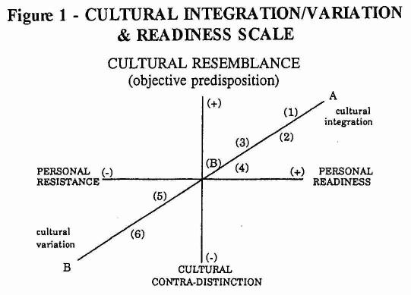
- ODE Canadian from the Philippines
- OBE Canadian from Pakistan
- LBE Canadian of East Indian parents
- ODE Canadian from India
- LBE Canadian Vietnamese (Buddhist from the countryside)
- OBE Canadian Vietnamese (Atheist from Bangkok) (B) Point of “acculturation” (s ee footnote 3)
For example, a Canadian Filipino (1 in Figure #1) comes from a cultural background with several centuries of Spanish colonization and decades of American domination. He, as compared to a Moslem from Pakistan (2 in Figure #1); can be culturally integrated into the “host culture” easier than the latter. The cultural resemblance of (1) to the “host culture,” contrasting to the culture contra -distinction of (2) from the “host culture,” would make shift of (1) to the “host culture” smoother and faster than that of (2).
On the other hand, though (3) and (4) are both from India, the lack of personal readiness of ODE (4) will restart the process of cultural integration as compared to LDE- (3) who has been born and raised in Canada. The ethnic background of (S) and (6) is Vietnamese, yet LBE- (5) has less cultural and religious barrier to overcome than OBE- (6); the latter most likely will prefer and remain to be more Vietnamese than the former.
This simple but basic understanding of cultural integration and variation provides the basis of the following discussion on evangelism and discipleship.
7
Integration/Variation re: Evangelism and Discipleship
If an OBE/LBE’s cultural background is more integrated with or similar to the “host culture,” then generally there is more opportunity for him or her to hear the gospel and more flexibility for that person to enjoy the freedom of accepting Christ. This leads us to a brief discussion of the two major dimensions of both the Christian’s conversion and maturity and the evangelization of non-Christians. (C--D of Figure #2 is an evangelism-discipleship scale).
For example, if all things are equal, a new convert to Christianity will grow to maturity faster and stronger (1 in Figure #2) if he experiences favorable circumstances and has a teachable spirit. If an individual (6 in Figure #2) does not objectively have the opportunity to hear the gospel and the freedom to accept Christ, nor does he personally show a willingness to embrace the Christian faith, he will not likely become a Christian. In fact, he might be strongly resistant to the gospel.
The following diagram illustrates the somewhat obvious, if both (2a) and (2b) of Figure #2 are born-again Christians with the same kind of teachable spirit, (2a) being from a Christian home will be easier to disciple than (2b) being from a Moslem home. Both (3a) and (3b) are born again Christians Catholic Filipino homes, (3a) with a teachable spirit will mature spiritually easier and faster than (3b) who is not receptive to spiritual things. Given that both (4a) and (4b) are unsaved and un-churched, if (4a) has less opportunity to hear the gospel and has to face strong opposition from Sikh parents, then he usually will be more difficult to be evangelized than (4b). If both (S) and (6) are non-Christian immigrants from Singapore, the churchgoing and less resistant (S) will more likely be reached by the gospel than un-churched and resistant person like (6).
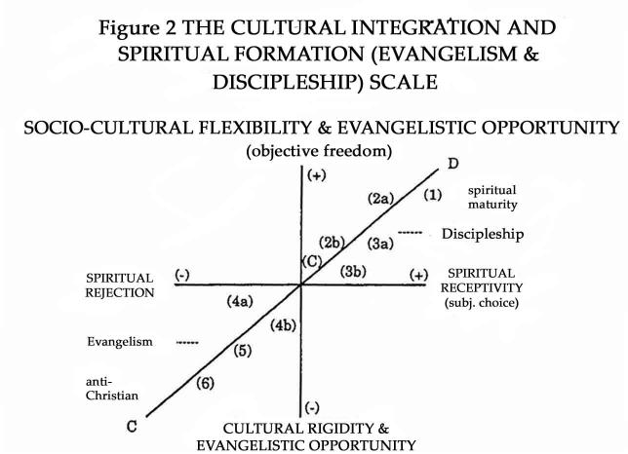
NOTES:
8
1. mature Christian (from Christian home, with teachable spirit)
- born-again Christian (from Christian home)
- born-again Christian (from Moslem home)
- born-again Christian (from Filipino home, with teachable spirit)
- born-again Christian (from Filipino home, without teachable spirit)
- unsaved, un-churched (of Sikh parents)
- unsaved, un-churched (of Catholic parents)
- unsaved, Canadian from Singapore (churchgoing, mildly resistant to the Gospel)
- unsaved, Canadian from Singapore (un-churched, strongly resistant to the Gospel) C. point of conversion
The cultural integration/variation and spiritual formation (evangelism -and discipleship) scale presented above is a useful conceptual tool for developing evangelism strategies to reach different ethnic Canadians, evaluating evangelistic efforts among culturally diverse groups, or planning for discipleship programs for ethnic converts. This basic understanding of the correlation between the objective and subjective dimensions of evangelism and discipleship (in relation to the cultural background, and personal preference of the target group) could cultivate the cultural sensitivity of Anglophone Caucasian evangelists and disciples, calm the anxiety of the hard-working soul winner, and encourage the disheartened Christian worker among the relatively difficult ethnic Canadians.
Instructive Suggestions of Cultural Integration / Variation for Church Planting
Local churches differ from one another in shape, size, polity, language, race, etc. Of these many different factors, the following discussion will deal with only ethnic diversity and congregational preference (in terms of cultural integration/variation).
After conducting successful evangelization and developing good discipleship programs among ethnic Canadians, a church planter (or the founding ethnic members) will have the option of forming a church that is not necessarily homogeneous or heterogeneous but somewhere on the continuum between the two. In other words, it may be a single-congregation of a homogeneous group, but there are options of being a single-congregation with subgroups making it a multi-congregation church as shown in the E---F scale of Figure #3.
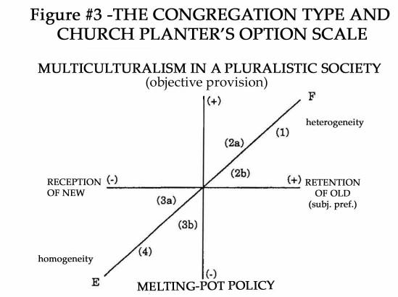
NOTES:
9
1. heterogeneous & multi-congregation church
- multilingual & multicultural church
- bilingual & bicultural church
- monolingual & monocultural church, ethnic but open (OBE + LBE + etc.)
- monolingual & bicultural church, ethnic but conservative (OBE dominant) 4. monolingual & heterogeneous church (only OBE or LBE)
It is natural and logical, and even expedient for ethnic Canadians to form a monolingual and homogeneous church as in example (4) in Figure #3. This is a common practice of OBE Canadian Christians, particularly seen in all early Mennonite churches. The opposite alternative is to form a multilingual, heterogeneous and multi-congregational church (i.e., 1 in Figure #3).
The operation of a multilingual and multicultural church (2a of Figure #3) would usually require a lot of mutual respect, careful coordination and Christian love to ensure the health and well being of such a heterogeneous church. For example, many Chinese and Vietnamese churches in the province of Quebec are multilingual using French for the local born ethnics (LBE), as well as the mother tongue of the overseas born ethnics (OBE), and also English.
Often there are members from several ethnic backgrounds joining Anglophone Caucasian churches in metropolitan centers. This type of church (2b of Figure #3) is usually English speaking but multicultural. This is a version of the “international church” found in major cities in the world (Bangkok, Manila, Hong Kong, Mexico, etc.).
Ethnic churches may begin with a monolingual immigrant congregation made up of OBEs. Later, when the new generation(s) of LBE or new converts from other ethnic backgrounds increase in number, the church may remain monolingual (of the mother tongue of OBE) yet become multicultural (3a of Figure #3).
The more conservative ethnic church dominated by OBE (without integrating other ethnic Canadians or accommodating the LEE) may remain monolingual (mother tongue of OBE) but bicultural (3b) of Figure #3.
10
In a pluralistic and multicultural society like Canada (and the U.S.A. in contrast. for example, to many Moslem countries), the E-F scale is a continuum of heterogeneity and homogeneity with many options for church planting. This is a good and healthy model especially when the population of Canada and the United States is changing towards greater racial diversity and cultural plurality.
Conclusion
Cultural integration/variation is an interesting and important aspect of Canadian life. Those who are committed to evangelism and church planting in Canada must take into consideration the multi-ethnic, multi-cultural trend of the population. The vision of the lostness of man and the mission of nationwide and worldwide evangelization require new efforts and cooperation on the part of Canadian Christians (Anglophone Caucasians, overseas-born ethnics and local-born ethnics alike) to share the gospel with the unsaved and un-churched, whatever their race may be. And as we are willing to be His witnesses, He has promised the power of the Holy Spirit, not only in our Jerusalem (E-l) or just to the far corners of the earth (E-3), but also in our `E -2 evangelism” -- our Canadian
`Judea and Samaria.”
Editor’s Note: Used by permission from China Alliance Press. Originally published as chapter 14 of a compendium volume, Missions Within Reach: Intercultural Ministries in Canada, edited by Enoch Wan, China Alliance Press: Hong Kong, 1993.

