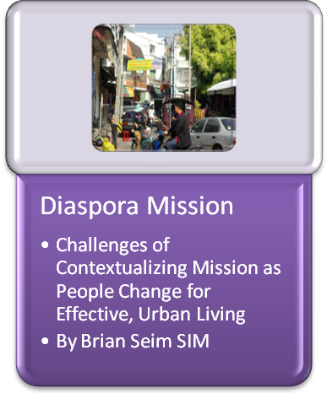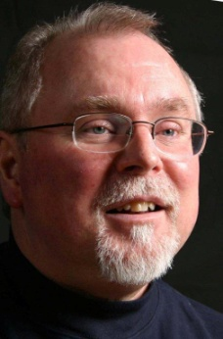
Brian Seim
Urban Centres Champion – SIM International
Published in “Featured Article” section www.globalmissiology.org July 2010

Learning Urban Culture

For an adult who has always lived in a rural village to enter and live in the city is a transition. But how does that person change? I wrote three separate analytical articles on this subject, then carefully placed them one-by-one, in that circular file sitting beside my desk. The subject needs a story. Meet Joseph as he walks through steps of techno-cultural adaptation, and transitions from a shame-based to a guilt-based response to morality. The story unfolds in equatorial Africa. But it’s similar in cities around the world. This is Joe’s journey to urban acculturation.

 Joseph climbed into a 4x4 with a local missionary, and bounced out to the highway that morning to flag down a bus. Jim wasn’t young but was well-loved. He got them an ice-cold pop in the petrol shop, picked up some fruit and a ball of manioc across the road and talked to Joseph about his next steps. The food tasted good, but Joseph’s 20 year old body needed more. He wasn’t listening as the old fellow encouraged him to learn from Robert, the man Joseph would stay with, who’d been in the city for nearly twelve years. Joseph enjoyed church the weekends that Robert was home to preach. He had a simple but real faith. Joseph thought he’d enjoy him.

He threw his bag onto the bus, dreaming he was joining the likes of Marco Polo. Each town they rolled into was more congested than the last. Many men wore what he thought of as chief’s clothing – rich cloths, long caftans and traditional hats. He heard new languages, as well as the trade tongue. He’d been an apt student of that melange of dialects. He was proud of his scholastic abilities. He’d scored very high, nationally on the high school exams. He was ready for the city, but as he spoke with different people along the way, they often asked him to repeat himself. Two girls, younger than him, snickered as he spoke with them. The bus moved slowly through the dust. For being a great adventure it was a disappointing day.
It was late in the afternoon. For the last hour they travelled on paved, multi-lane roads, moving at near walking speed. They shared the road with people on foot, carts drawn by horses and donkeys. But bicycles, buses, trucks, and cars crowded the road, too. He was bored and hungry. There were traffic lights, and as the sun set, electric lights came on in several shops. Large buildings surrounded the square in the central market and around them thousands of market stalls. Hundreds of buses of various kinds filled the station. A couple of fellows directed them to an open spot and the bus stopped. He stood, stretched his arms and climbed down, gathered his bags and looked around.
Mud seeped into his shoes and he found a drier strip dragging his bag with him. He paused, searching for his bearings. Bare light-bulbs hung from poles around the terminal. Market lights shone in every direction. He finally realized that in this big of a city, even if he knew where he was, he had no idea of where he was supposed to go. How would he reach Robert? He’d thought the challenge was to make it to the city. The pay-phone didn’t work. His heart fell lower. He shifted from one foot to the other, taking in what was around him with his bag in his hand.
He started to walk, unplanned steps toward uncertain goals. He noted traffic lights on every corner. Street lights shone on cracked sidewalks. Large and small neon lights curved colours onto flat-faced entrances of buildings and bare, incandescent bulbs hung above tables in open air cafes and bars. Young men watched You-tube videos on their phones. Bars had televisions and he watched from the street. Fifteen minutes later, his stomach growled. He looked up to get his bearings, but couldn’t see stars. There were street-signs on the corners but they meant nothing to him. There was a big sign for a hospital ahead and in the lights of a large green truck, a heavily armed squad of police walked down the street. He moved quickly beyond their presence. His eyes grew large as he saw a sign for a school. It was a block long with two stories of classrooms. Hundreds of adult students sat under bare fluorescent tubes. He wanted to be in that circle of light.
His heard someone hawking his tribe’s food. He smelled familiar smells of the village. With his enthusiastic response, the woman put a little more gravy and an extra chicken wing on his plate. She spoke his language, cooked his food. After finishing the savoury dish, he borrowed her phone to call Robert, only to hear twelve harsh rings. To calm him, she talked. She’d been here 15 years, proud of her own food stand in the main market and capable even with her husband’s passing a few years before. Mrs. Ndola was from the head chief’s village, across the valley from ‘home.’ Between customers she drew a crude map, and gave him the number of the city bus to the shanty town. With a wan smile, he thanked her, picked up his bag, and slowly walked back to the centre of town.
The city bus station seemed more organized than the national bus terminal where he’d arrived, three hours before. Cities made rules and controlled bus drivers, licensing, and their police controlled the traffic. The ‘A’ ‘B’ and ‘C’ buses each had their own platforms. Busses on ‘D’ and ‘E’ routes shared different sides of the same platform. He took the A-23. The driver said he’d let him know when he needed to change from bus to community van.
He’d entered the city from the north. They continued south, past blocks of large two and three story glass buildings. The grand, capitol building was on the left. Lights shone on it. Guards in full dress uniform stood at each side of the gate. He noticed a squad of soldiers in the shadows with sub-machine guns readied. They passed another hospital. A few blocks later, they turned east onto a rough, pot-hole covered road past blocks of concrete shops, mostly smithy’s and small engine operations. There was a team of men and a truck, collecting garbage from large bins along the road. Once more they turned south onto a broad avenue, separated from the opposing traffic by a green parkway, lined with walls, nice big houses behind some of the gates showing pale through the palm trees. There were not as many trucks and carts on the road. They moved faster here. The driver caught his attention and let him off to connect with the local van.
The street was lined with light industrial shops, but as directed, he turned the corner and there was a broad goat path, complete with, he was sure, some of the same goats he’d passed this morning out toward the highway. The van driver spoke his language and got him to the street where Robert lived. This ‘tin-city’ had about 3500 shacks that crawled up and down the hills between oil refineries and the harbour. By the time he arrived, he was seventeen hours - 315 kilometres from his home. People led him to the right house, but the kids wouldn’t let “a stranger” in the house.
It was midnight when Robert and his wife, Susanna returned from work. As they took him though the little door, it started to rain loudly on the tin roof, but they were dry as they ate a small meal under a single 40 watt bulb, a small TV blaring in the background. Robert had been married for thirteen years. He cleaned vegetables in the market and pastored a small church, while Susanna sold bananas and mosquito-zappers on the streets. They‘d moved to the city when their oldest was five. They finished grade nine in the village. Their three children crowded around the table and welcomed Joseph to his first home in the city.
Joseph would room with the oldest boy, Philip in a new bunk attached to the back of the main house. An old bed-sheet covered doorway. Robert said, “This is far more than we had in the village. There, we’d work all day, and weren’t sure if there would be enough to put in our stomachs at night.” He continued, “We lived in my father’s hut, because he couldn’t afford for me to take time off from fields producing nothing, to build something for us. My five brothers all worked the same fields with the same hope and the same return. There were too many people expecting food from overworked fields, too small to divide.”
“I have another hope now. I share a water tap with twenty-five other huts. By the way, Joseph,” he said, “Your first chore is to figure out how to bring water directly into the house. Philip will help you. Community leaders pocketed the money for the sewer, but that doesn’t mean Susanna needs to walk through sewage to get fresh water. We’ll have an urban house with running water. Today, I was put in charge of a team of vegetable preparers. We will make it.”
That might well be so, Joseph noted silently, but this one-and-a-half room shanty was crowded with six. Susanna, his hostess was weary, but gracious. By the end of the meal, Joseph knew this wouldn’t be his long-term residence. These people didn’t have space for him.
Robert took him to church the next day. Susanna and the two younger kids came later. Philip disappeared after breakfast. Twenty-five adults and children felt small in this huge city. He said, “It was a bigger church until three years ago. Key people moved to other parts of town.” The church looked small and shabby in the shadow of three new large homes. Robert commented, “These people just decided they were going to move into this area. (Land prices were reasonable.) They’re not even from our tribe.” He sat with the children because he wasn’t married. In the village there were other young unmarried men, but here it made him chafe.
Over the next months, life was a blur, frustrating and disorientating. Each morning he searched and applied for formal employment as an office boy in an accounting office. Robert criticised his attempts to get a desk job. During afternoon rush hour, he sold fruit, then phone cards on the street with Susanna. It helped pay for food and electricity.

Joseph discovered that if he was aggressive enough he could make 35% more selling cell phone-cards than he did selling vegetables, though both were sold on the street. No surprise, his first purchase was a cell phone. He was delighted. It could take pictures, play music and You-tube videos, and text-message. Why, come to think of it, he could even make a phone call!
The village school had taught two generations to read. But correction, encouragement and stories, often came by word of mouth. Most families had radios and two had gotten a television in the last few years. In a sense, Joseph thought, village education was really to enable them to read the Bible. The West had depended on a written culture for centuries, with a deep respect based on academics. In the city, he found that his reading was linked with symbols. Letters and numbers were connected to technology. He’d moved from an oral, (by-passing simple, written culture) to a techno-symbolic culture. Televisions and cell-phones were the tip of a technological iceberg that transformed culture every decade. He realized one night, as he listened to an auto ad on the radio that these word-images were far more carefully scripted to bring about change than any word he ever received from his mother or the village elders.
He pushed a button on his cell phone and an unasked-for, call-girl directly advertized her services. Funny, his cell-phone thought it had the answer for his loneliness in this swirling mass of people. Another time, as he restocked his phone-cards, the wide screen TV above the phone company desk broadcast a how-to-get-rich-quick scheme. A commercial came on, glove leather seats on a new 4x4, to go with a bigger (shinier) engine. There was noise; tool makers grinding, busses roaring by, taxies honking. Some morning he found himself actually loving the soft bleating of the goats. The sensory info that accompanied the symbols being shown on the gadgets had to do with the techno-info, not the goats. The speed of learning culture was nearly twice what it had been before these visual symbols started leaping at him. Without thinking about it, Joseph began to adjust the filing cabinet atop his shoulders. He found his way through the city. He filed new images among those he’d seen before, that seemed related.
One weekend he saw two young men about his age, one shaved head – the other with ‘locks. They had a large brown ball – larger even than a soccer ball. They wore short, flappy pants and sleeveless, loose shirts and laughed as they dribbled the basketball down the street. The next week, he followed them as they reached a black-topped court with a couple of hoops. They joined others, divided into teams and began to play basketball; totally new to Joseph. He looked at his own clothes and realized they’d probably just give him a bad time. The next month he took some of his hard earned cash and bought a basketball. The next week he bought a top and shorts.
Robert started calling him, “City-boy.” He didn’t care. He’d seen and reached for a new experience, It didn’t matter how good he was. It took him some real restraint, not to grab new immoral options. Joseph could tell the difference between this culture and village life and he now graded ‘village’ lower than ‘city.’ Robert said, “Though I’ve moved to the city, that doesn’t mean I’ll be tainted by it. I hate the trade language, (though he spoke it quite well.) He made fun of Joseph’s new sports and “city-boy clothes.”
Joseph sometimes responded. “It’s sin that taints you, not new sports, or styles of clothes,” (like, he thought, the ones Robert now wore to work.) Joseph struggled with his accent and was critical of himself and nearly everyone who spoke the patois. More frequently he used English. He decided Robert was either lazy, or had been hurt by criticism at some point in time and decided to quit learning. He certainly fought change. Joseph came to live in the city. Whining and cultural insularity were for others.
In every migrant’s life, intelligence, aptitude and initiative fight against ineffectiveness, cultural fear and discomfort. For some, the pain of failure will cripple them into apathy and despair. Some migrants seek outwardly easy solutions and end up caught in the underbelly of crime. Others, like Robert, make do and find a niche. For others the transition is eased through friendship, natural abilities and gifts. Joseph compared it to the games on his phone. You learned skills, went up a difficulty level, more skills and strategy. It seemed he had to reject twenty old ideas, to understand ten new skills. But he’d tackle the new challenges in order to get to the next level.
Joseph ‘got’ the people things. He analyzed many cultural differences. But he had to learn technology the hard way. Last night he hadn’t been able to remember how to work the remote control for the TV. This morning, as he delivered a job application to a new part of town, he travelled by bus and couldn’t remember how to ring the bell to signal his stop. So, he’d walked three kilometres. As he trudged, he thought technology would be the end of him.
Three rivers ran through the city. Busses would take very round-about means to find a bridge across a river. Bridges then must be an essential piece of the city puzzle, so why were there so few of them, he wondered? He took the question back to his friends from the pick-up basketball group. They talked about the cost of bridge construction and opportunity for corruption that kept their city from healthy development. One made it sound as if he was angry that it wasn’t him lining his pockets while another was just angry. There was widespread corruption everywhere, but their anger was reserved for where it dealt with bridges, sewer and electrical services. The city had eight bridges, raw sewage along the streets and four hours of electricity each day.
He noticed how old forms of transportation slowed down the city. A bicycle with four baskets often carried more than a horse-drawn-cart, took a quarter of the space and traveled six-times as fast. As cities developed, broad avenues were built around networks of alleys to facilitate mass-transit. Smooth infrastructure or not, Joseph decided, people are attracted to the pulsing energy, financial incentives, education and hope of the city.
Joseph wanted an accounting job. But with only a high school education, the job offers he got were physical labour. At city hall, he found his gold mine - job postings. There were book-keeping jobs in hospitals, school boards, bus stations, businesses, even restaurants. He found a seminar that taught him to develop a resume, what to wear and how to act in a job interview. His morning wardrobe and resume now looked quite different. But in the afternoons, as he sold phone cards, trucks and cars made their way past what looked like a village boy, just off the bus. His various looks matched the complexity of the city and the different roles he played. But he refused to clean vegetables. He would get an office job.
His teacher had told him he’d need to place a different value on time. This Global South, city had a different pace than the village, a structured flow. With financial competition being its highest reason for existence bringing that many people together, it wouldn’t work without planning and appointments. Joseph realized time connected the technical, infrastructural and cultural elements of the city. He was just one more migrant, with a hope for something more, moving to the city and facing the infrastructure with discomfort, loss of old life-patterns and general culture shock; the latest statistic to come to grips with the reality that if he didn’t learn to adapt to change, he wouldn’t succeed in the city. His worldview, his core inner values hadn’t altered yet, but Joseph was in the midst of radical change. He found a short-term job and realized that the work place required the same excellence on ledgers and personal work-space that had been required in school. He learned productivity by working harder and more focused. In one office, he had a woman for a boss. That took some getting used to.
Finally an accounting firm took him on. An older accountant, whose children had left home, took a shine to Joseph and invited him to rent a small apartment at the back of his home near the office. Robert was somewhat like an older brother. Peter became his mentor, his second father. On Saturday mornings he’d finish a few things in the office with Joseph, but in the afternoons he encouraged him to take a computer course. On Sunday, after church, Peter encouraged him to improve his English. Trade-languages are useful to street vendors, but office language is English, so he up-graded his skills. Computer was difficult, but with classes he moved beyond simple typing and using a number pad. He began to give, not just receive thought through a key-pad. The computer was more than a tool.

 Joseph began to understand Robert’s reaction against everything urban. He hated having to do another thing differently. Some mornings he’d wake and fight with himself about putting on a tie or leather shoes. Because of his language studies, he didn’t fight English like Robert did, but sometimes at night he’d sneak down for Fu-Fu at a shack like Mrs. Ndola’s and have village food. His resistance to cultural transition was at an all time high.
But he also experienced moral challenges through technology. Joe sat at his computer and looked at both sermons and pornography. Nobody looked at his actions. The shame-based culture in the village, had not prepared him for this. In the village, illicit sexual activity and accumulation of wealth at the expense of others had been veiled and shamed. He was thrilled with his new-found ability to make money, and was tempted to spend it on status symbols. He was amazed at his popularity among the young females at work and tempted by their come-ons and innuendos. He was often more tempted by a partially exposed limb, than by the casual nudity that was still part of village life. These sorts of temptations caused a quandary in a young man who loved his Saviour.
One night the temptation nearly drove him over the edge. His fear of the physical cost of such activity, gave him pause. But reflection mingled with his fear. In the village, he would wait for marriage. If he didn’t, the whole community would have judged and shamed him. In the city, nobody watched or cared about his personal actions or activities. As he thought about it, he realized that what he felt in the city was personal guilt. He knew God was there. His guilt was strong enough to offset the corporate shame in the village. He learned to manage his desires.
Peter understood a good deal about the incredible changes Joseph faced. He too had transitioned between community – shame-based culture – to urban – impersonal, morality, only exposed through guilt. He had become a Godly man through that and he encouraged Joseph to stand in his faith. Joseph re-committed himself to walk with God in his devotional life and allow that to provide the intimacy he so deeply craved.
When he became computer literate, Joe, as he started to be called, applied to university. He was re-directed to a two year college. His circle of friends included women. They did well, too. After class, they sat together and discussed their take on the city and world. A confidence might be shared of a frustrating cultural change and they`d thrash it out. Now his values, not just actions, started to change. He worked full-time, applying the auditing skills he learned in college. He’d been at it for three years, which was about average among his friends, but he graduated number one in his class of 5500 students. The university now welcomed him warmly. Senior partners in his firm had him accompany them to audit companies. He noticed differences in how they each thought and worked.
He stopped by Robert and Susanna’s new house. Joe was grateful for their hospitality and he loved Robert and Susanna’s simple, steadfast faith. They were the closest thing to family he had here. He enjoyed them and the kids called him uncle. The new house wasn’t far from the old one, but as with many older, better organised shanty-towns, tin-towns had become part of cement cities. Someone wanted to build a large house had offered Robert a good deal on the land. The original home had been three by four metres. Their new home was ten by ten metres with five rooms. Susanna’s brother lived with them and helped pay the bills. Though (or perhaps because) the neighbourhood had become tribally diverse, community groups banded together and developed proper sewage, and water supply.
Robert was still cautious of the steady transition he was going through. He’d become a manager at work, at times he even wore a suit. His English was improving, but he was tired of using it when he got home. They made him take night courses in accounting, and he often asked Joe how to do things. Joe taught him key-boarding, but insisted that he take computer at school. At this Robert resisted. He still acted like a big brother, even though he was the learner. He criticized Joe`s clothing constantly. He was upset because the only time Joe would speak the tribal language with them was in their own home. He criticized him whenever language came up.
Joe became an asset on the basketball court. His skills had improved, and though he was shorter than the rest of them, he had superb, hand-eye coordination, and was an outstanding guard. His defence was deadly. At times, because of his natural leadership, he also stepped in as centre. But the guys started to call him Village-Joe. He sent much of his money back to the village, to help his family, so his shorts and shirts were cheap, and he wore sandals, not expensive high-top basketball shoes. Criticism came from both sides, and it hurt.
Guilt, criticism, self image…. those were the things that drew Joe back to church. He wanted a group of friends, yes. But his real desire was Jesus Christ. Joe stopped going to Robert’s church when he’d moved to Peter’s. It wasn’t just the language. Robert’s little fellowship split. It was hard to listen to their bickering and think of them as spiritual leaders. The sermons were long, and had nothing to do with Joe’s current life. They only knew of bad behaviour through rumours and often disciplined the rumoured, not the rumour spreader. Tribal custom became the moral value-grid. Outsiders were not given opportunity to share their gifts. Children didn`t attend after they turned twelve. Neighbours would see or hear no good news from this church.
Peter invited him to his church. The service was in English, though there were various translation groups. Joseph felt uncomfortable with the language and diversity, but loved the welcome. The turning point came one day as they worshiped and he saw people of many tribes and classes standing with him. It dawned on him, “These tribes, his own tribe still hated. Yet in Jesus, they were one.” His needs were addressed in the messages. The pastors understood temptation in the city, loneliness in the midst of five million people, challenges of competition, pressurized acculturation and Christian character necessary to be godly in the city. They spoke from a broader base of scripture. Joe was once again in love with God, at home in the church and finally noticing his neighbour.
There was a college and career group on Sunday, various sports leagues, home fellowships, and at least once a month, a party, usually attended by over 300 young adults. The senior associate pastor oversaw the spiritual needs of the group, but, new, tribally diverse lay-leaders were always being developed. Even a young white businessman from London joined the leadership. Joseph organized the basketball teams, and invited his friends to smoother courts and better back-boards. It didn`t take them long to find faith in Christ and friends in the church. Others followed and Joe’s leadership was recognized by the pastor and he was invited to lead a committee.

Now, Joe reached a visible change-phase in his cultural adaptation. Much of the information that he’d been processing for the last five years started to fall into place and make sense. He did well in his courses at university and the arguments that followed his classes. Though he’d purchased them slowly, when they were on sale, he had enough city clothes to ‘look urban.’ He was respected at his firm and though personally unaware of it, was pushing many junior partners to work a bit harder. He still made finite, sometimes painful decisions to be urban, but the decision-making haze seemed to be clearing at times.
Many of his friends, both urban and migrant ‘dated.’ One said, “In the city, we don’t go near as often for arranged marriages. Our parents wouldn’t know which woman would make a good city wife. If she couldn’t get used to the city, their hopes for my success here would be wasted. My brothers went to smaller cities, maintained traditional lives. None of them have helped our family like me. Because of my success, I must make choices for myself. One night, Joe finally met a beautiful young woman he respected on the C&C leadership team. Beauty was from a different region and tribe than his own, but they found many things in common when they went to a café with other leaders after the meeting. Their first ‘date’ was with two other couples to a movie and dinner before a College and Career party one Saturday. Two months later, he met her parents. That went well. Then he took her to meet Robert and Susanna. Susanna welcomed her like a sister, but Robert was critical. “Have your parents even met? One should seek the elders for these decisions. Yes, you’ve grown spiritually in this new church, but a diverse family? It isn’t proper for you to embrace this woman from another tribe, a city-girl.”
His arguments rang hollow and repressive in Joseph’s heart. What was Robert trying to protect? A life they’d both fled? A tradition tied to that old life? His transition had its ups and downs. He understood the differences between the two cultures. He was choosing a person who could flourish with him in the city. Joseph would not be dominated by ‘village mentality’. He understood that there was more than one way to think about things, and he was angry at Robert for being unwilling to think on other planes. Peter, although he’d married from within his own tribal background, watched with delight as their spiritual and social relationship developed.
Joe brought his parents down to the city to meet his intended. They began the trip with fear, not only over Joe’s infatuation with a woman from another tribe, but their own journey to the city. But Joseph was a faithful son, who they loved and trusted. They were touched by his commitment to them as he passed on more than the rest of the family put together. They knew when he graduated from university next year he’d be an accountant. Beauty respected them as parents and she balanced Joseph. They recognized a deepening spirituality in the two of them, taking note of the changes in their son, how he thrived in this environment. People of her tribe had destroyed their village in 1979. But by then her parents already lived in the city. Beauty had yet to be born. They realized that though they never would have accepted this possibility in their rural, tribal region, for their Joseph, here in the city, they`d give their complete blessing – as long as the wedding took place here.
Until then, there was much to do. Joseph wanted to complete his studies, at which point he`d been offered a partnership in the accounting firm. Near Peter’s apartment, he’d noticed a run-down property and quietly purchased it when he had the money. After further saving, he carefully searched for an honest, capable builder, respected both in and outside the church. Joe took him for lunch and discussed different ideas on preparing the land. The builder had done some designing, and developed a plan for the home. It would begin with a large dining-living area, two small bedrooms, a kitchen, and a bath-laundry room. An addition of a large bedroom and office were planned for later. Joe loved one custom from the village. Outside his home, he built a porch where he could sit at the end of the day. As they built, Joe ran into the values and frustrations of the city. Both the building inspector and city electrical team stalled for a bribe. But the builder showed him quick solutions to that as he dealt with honest men at higher levels.

 While he built his own house, he’d met some fine Christian leaders in municipal government and became friends. Later, they’d invited Joe to sit on a new citizen’s council on education. He did well on that committee and at times spoke on their behalf. In a sense Joe and Beauty were a part of the city. They’d quietly return to visit family occasionally. When the church purchased land in a jungle region for a retreat centre Joe had enjoyed the physical challenge of felling the timber. He’d coordinated the effort to mill it. Using extra lumber he took five men up north on a mission trip’ to construct four huts and a meeting lodge.
He was comfortable in many cultures. He spoke five tribal languages, (often related) the trade patois, and English as well as French, because his firm did international audits across West Africa. They sent him on assignments to those areas. Others, not as gifted, or older when they moved didn’t acculturate as quickly or willingly. His language ability enabled him to succeed in the city in one generation, while many friends just got by.
They invited Susanna and Robert, their kids and Peter for village food, to celebrate seven years in the city. Robert had apologized to Joe, realizing his harsh behaviour. He was impressed with Beauty and how the two worked together. Robert was a grumbler, but he’d finally learned to use the computer and found that he had a flair for it. He now supervised an internet service team at the phone company. Susanna was home with the children. She smiled fondly at her grumpy husband and teased, “The more he grumbles, the more we know he likes his job.”
They talked about the ‘trade-language’ church plant Robert and Susanna were involved in with about thirty other families. The church he’d pastored had run out of steam two years before but over 200 attended the new church, and the kids came too. Though Robert had moved to the city to avoid starvation, he’d never liked the move. As his understanding grew, he was enjoying life more than he’d thought possible. He kept village customs he didn’t want to give up, and was becoming comfortable in the city. Phillip was college. Maybe he’d intern with Uncle Joe. Robert no longer thought of returning to the village. He’d been in the city for nineteen years.
Married life had given him limited learning opportunities from friends who understood the city. Spiritual responsibility for a tribal church had made him the cultural protector rather than cultural learner. His technology wariness meant he didn’t have the same stimuli that had sped Joe into new situations. Those twelve years before Joe had arrived only brought him through two stages of acculturation. He was disappointed in his progress. Now he was entering the emergence stage. Robert’s acculturation time was average. Joe had pushed him into trying things that he would never have done without the friendship. The market had been a good, if hard teacher for him tool. His internet job provided new and faster challenges of urban culture, as would his leadership in the community focused church. Robert would wrestle with culture for all his years.
Peter was 59 years old. His wife had passed away before he’d met Joe. He’d moved to the city, with her when they were 22. Education and being in a culturally inclusive church had stepped-up his acculturation into urban culture. He was lonely, but he had his children and grandchildren, as well as Joe and Beauty. He was a senior partner in the third largest accounting firm in the city, and he was pretty sure that Joe would follow in his path.
Joe was 27. His acculturation was assisted by education, technology, friends and a quick mind. Joe encountered the infrastructure of the city through a set of technologically sensitized eyes and took it in stride. In the village, he was not from a significant family, but because of his profession, here he had respect and ability to purchase and redirect monies. His changes would never be over, because the city always changes; much faster than rural life. He looked around the table at the group who celebrated his acculturation; his best friends. He said, “Listen up everyone, especially you kids. This is ‘village food’ night, with a twist. There’s a new shop that just opened up at the corner, specializing in ice cream. Let’s go down and get messy.” It wasn’t a difficult sell. Soon their faces were all just a little bit creamier than they had been.
The last surprise was Joe’s. Behind the counter was Mrs. Ndona, who’d helped him his first night in the city. She didn’t recognize him, but there was still a bit of street hawker in her and Joe would never forget that welcome voice, just as it had when he got off the bus. After finishing their cones, Joe went back in and introduced himself and thanked her. Now, her smile broke out and they slipped easily into reminiscence. He listened to her story and she his. It wasn’t so much that Joe had left his culture. It was that he now knew a few more. He went back out to the patio and brought in one of his friends. Then with a twinkle in his eye he said, “I want to introduce you to my good friend Peter.”
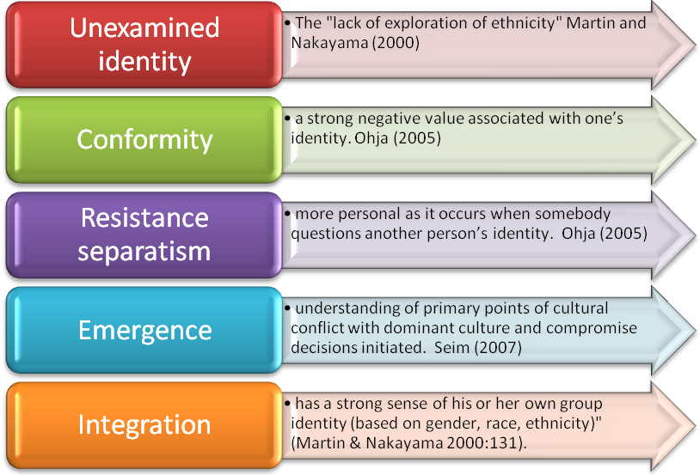
 A few years ago in Delhi, I spent an afternoon after church with some national and international Christians. They were playing soccer with their kids, and I (the old geezer) was just sitting around on the sidelines talking with one or two at a time as they took a breather. Many of them had day jobs that taxed their time and energy. All of them were serving Christ in ministry in one capacity or another. They did not share the same methodologies. Individually, they were faithful servants working with God’s gifts to initiate a small or large ministry to bring God’s Kingdom to that city. Together, these twenty couples were having a surprising, if piecemeal, spiritual impact on one of the largest cities in the world.
Joseph was from Accra, Ghana. Whether one works in Accra or Delhi, there are some questions that face the urban minister. How do urbanization, population density and diversity affectively bring continual change to the city? Why does that call for different ministry styles? Using Delhi as a case study, can you apply some of these issues to the city where your interests lie?

Urbanization

Urbanization brings Change
- Expanded transportation infrastructure
- Hydro
- Population projections
- City planning
- Industrial regionalization
- Residential regionalization
- Health clinics, hospitals
- Medical education
- Primary, secondary and graduate education expansion
- Employment development
- Communication
- Entertainment
- Water
- Sewage treatment
- The list goes on, and on …
The process of urbanization constantly changes a city. Although Delhi has been continuously populated since the Sixth Century BC, after having been back-watered for about 100 years by colonization, it was once again named as the Capitol Region of British India in 1911. On independence in 1947, it became the capitol of India. In 1950, the people of Delhi numbered about 1.4 million. In 1980, bursting at the seams with 5.6 million people Delhi created two satellite cities, with infrastructure that could manage transportation, hydro, education and population expectations. By 1995, with a population of 12.4 million they realized that in addition to further expanding the first two satellites they needed to enlarge their dreams and infrastructure to create at least two more satellite regions. City planning, lots of broad avenues, industrial and residential regions later allowed nearly 6 million more people to arrive in the city from the surrounding countrysides. Today, the city is over 18 million, and according to Wikipedia, is the eighth largest city in the world. Over the past 50 years Delhi’s annual rate of urbanization has been about 3%. That means that during any given time in the last half century nearly a third of the population has been in the city for less than ten years.

Population Density
Population density is a primary change agent. Because of the highly organized planning of India’s capitol city, the density is “only” 10,700 people per square kilometre. In central parts of an Asian or African city, that density may approach 70,000 people per square kilometre. Eight people may share two rooms measuring 4 m². Density demands that mass transit, sewage, water, roads and traffic patterns are much more highly regulated and centrally managed. The transient nature of people means that schools, traffic laws and hospitals need to be standardized within a city, so that they can be monitored and managed. A major city in North or South America (both of which are more than 80% urban) may have districts within them with more than 20,000 people per sq. kilometre, but that is in a centralized community, not the whole city.

The 5 most densely populated cities in the World
Rank | City / Urban area | Country | Population |  | Density  (people per sq Km)
1 | Mumbai | India | 14,350,000 |  | 29,650
2 | Kolkata | India | 12,700,000 |  | 23,900
3 | Karachi | Pakistan | 9,800,000 |  | 18,900
4 | Lagos | Nigeria | 13,400,000 |  | 18,150
5 | Shenzhen | China | 8,000,000 |  | 17,150

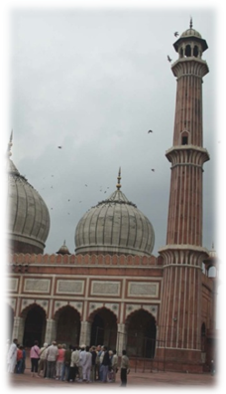
Diversity
India is the most diverse political administrative area in the world, with over 1200 languages and/or tribes. Some from each of those tribes have made their way to Delhi. The challenge of diversity was deeply felt at the infusion of Hindus and Sikhs from Pakistan in the partition of 1947. The sheer number of different ethnicities changes the city. Historic and new conflicts between them affect organization in the city. Those ministering there have to relate to the whole, as well as the parts.
The establishment, not wanting to release power, must offer basic services, boundaries, and justice. The moderating policies of pluralism require policing and mass transit to provide moderate levels of safety and access and prevent anarchy. Although I sensed that historic sections of Delhi remain divided in terms of religion, pluralism implies that ethnic peoples are not physically ghettoized. As I travelled through newer portions of the city, I saw that when a migrant first arrives, their home may be close to others of the ‘same culture and language.’ But subsequent moves are based on proximity to job and education opportunities, not ethnicity. Pluralism is working, at least for now.
While pluralism creates tolerance at a community level, diversity enhances economic development. Urban economist, Richard Florida looks at the current financial crisis and raises hopes for future sustainability, through the creative sector – which depends on diversity. The diversity-competition increases creativity and work ethic. My personal observations connect diversity at educational/ work environment levels. When different backgrounds of people work on the same product, new ideas are introduced to a process and that refines the product. As I loaded a new Adobe application onto my laptop recently, it was difficult not to note the diversity of the names on the design team. So, the city is a mixture of people, cultures and languages, in a complex, prescribed yet impersonal relationship, bonded together by the intense pressure of common needs and desires.
Those ministering in the city face a challenge. The context of Delhi or Accra is not a single tribe. Like Joseph and Robert or people I’ve met in Sao Paulo, Dakar, Delhi, or Chongqing, the migrant becomes part of urban culture. Oh, they are still warmed by a good homemade dinner from the old culture. They can converse in that language. Their children can often speak simply with their grandparents. But like you and I, they are people of more than one culture, making them more complex. Their new culture changes at an incredible rate, making them more flexible. The city is often more similar to another city’s culture a half a world away than the village from which they came. They are acculturating to the context of the city. We in missions have often focused on people group evangelism. I wonder if that is one of the reasons we resist mission in the city? But Jesus teaches that we are to love our neighbour, whoever they are. Peter writes about building a great architectural structure of many parts. Paul demonstrates that God’s desire is to deliver His message through us in ways that are understood in the smoggy, noisy, careening, transforming city.

As I travelled across Africa, Asia, South America, Europe and North America, I was seeking to understand the urban church. In order to encourage them, I had to know both the problems they faced, and the successes in which they were rejoicing.
The most consistent discouragement I found was that in each city, churches had been established by transferring many parts of their rural cultures to the city. Their welcome of others was culturally defined, and at the beginning, newcomers from the same area came. But most urban dwellers did not understand the welcome, so many urban neighbourhoods, although churched, were in no way evangelized. It set natural tribal or caste barriers between leaders, maintaining them as if Christ had left them up. But beyond Kingdom proclamation and unity, there are other, often hidden, health issues that this kind of church must face.
Hidden Issues of the Urban Transfer Church
Culture Freeze
- The transfer church culture ceases to change when they move into the new culture. It is frozen in time.
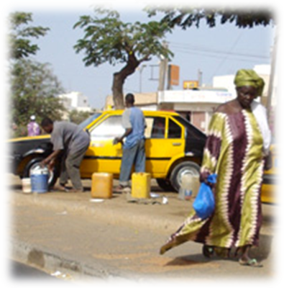
- Although the church culture does not change, these Christians do acculturate to the city. As they do, they face increasingly culturally-irrelevant messages from the pulpit.
- Migrants from that same culture, arriving 15 years later, don’t recognize the culture and can’t fit into it. They start new churches.
- When a church is focused on culture, they tend toward insularity.
Multiplying through Division
- Frozen cultures tend to divide easier.
- Leadership opportunities decrease in a new culture. Pastorship may often be hotly contested.
- Seminaries often focus more on scholarship rather than practical leadership theology, so pastors are uneducated in how to share leadership and lead equals.
- In a tribal context, their ‘next-door neighbours’ might have sold them into slavery, or in a national context, brutalized them in war. Historic divisions are still at work when different cultures, with a shared language, worship together.
Acculturation does happen. Are churches aware?
- We all need God’s reconciliation! Eph. 2:10-12.
Generational Juggles
- If a child spends his formative years in an urban setting, he won’t be asked to lead the transfer church.
- The migrating generation says they don’t share the same values – yet the values indicated are cultural - not biblical.
- We only pass leadership on to people who hold the same values that we do.
- As a result, 85-95% of youth are leaving these churches before the age of 18.
Limited good news
- Transfer churches don’t usually bring the gospel to those who are physically close but culturally distant.
- Transfer churches communicate in a different cultural context which may not be understood by others in their diverse neighbourhoods.
- Often, the transfer church limits God to the theological experience in their place of origin.
- Cultures, though always valuable, all need redemption. Transfer churches don’t evaluate that, so discipleship may not be fully biblical.
Reconciliation Blues
Migrant leaders often privately express a need from the established culture for:
- The rest of the body to befriend and mentor them as real leaders in a spirit of prayer.
- Grace. Those coming from a colonized culture face self-image problems as they acculturate alongside colonizers.
- Structures that include the 1st & 2nd generations and allow room for deeper integration.
- Financial help in the areas of leadership & missionary development.
© 2008, Brian Seim, “Mixing Colours Without Making Them Run”
Caught between Cultures
Recently, I received a call from two large immigrant churches. They had both been planted, to attract people from the culture and language of the tribe from which they’d come. They represent the majority of urban churches. Our English-dominant host culture churches are mostly transfer churches. Both of these immigrant churches were about 20 years old, had reached a significant population of their own people, but their communities were changing and were both interested in adapting from being transfer church. Cities were well churched, but little kingdom growth was happening.
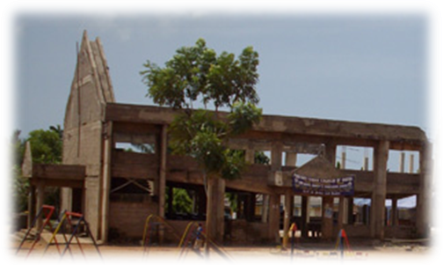
In Africa, I met with a church that was discovering, and dealing with these same issues. This church was changing their preaching to the national trade language. Yet people from other cultures would still find the welcome culturally defined, and there was no sharing of leadership outside the tribe. Others would sense a barrier. Most members had been in the city for 10-15 years. Few lived in that neighbourhood anymore. There were no young adults in the church. The only people sold on the old model were old people, who did not wish to give up control.
The pastor took me up on the unfinished roof, and asked if I might be able to bring a North American church to help them finish their building. He told me the dimensions and gave me a reasonable estimate of the general costs, and I asked him how I might inspire a church in the West to take on this kind of project.
In an urban transfer church the vision often doesn’t last long enough to complete its task.
I asked him the question, “What is your Vision?”
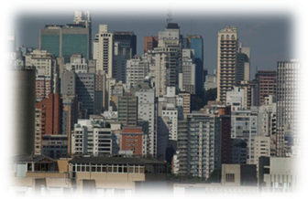
“We began by reaching people from our homelands,” he said. “But only three families have come this year, and of them, only one stayed. Those coming from our tribe now, are different than we seemed to be. On top of that, as families become more comfortable in the city, and they move from the neighbourhood, they are leaving our church as well. This neighborhood is becoming more upscale. It’s not a migrant community any more”
“So, what is your vision for reaching this neighbourhood?” I continued.
His face told me the rest of the story. It was as if he quietly said, “I know we need to reach all the people who live in this neighbourhood, but 1) we started off on the wrong foot to reach the neighbourhood, 2) now the lay leadership doesn’t want to change enough to do it, and 3) personally I’ve got a lot of my life and finances invested into this church. I’m caught between some pretty big forces.”
Forty cities – One major problem
21st Century cities are diverse, expect people to acculturate and demand tolerance. Culture-based churches are seen by city managers and urbanites as intolerant, because of their strong cultural bias. There is little emotional space or time for a frozen culture to flourish. In cities, distance to work and affordability of appropriate housing, not church, determines where people live.
We have set the missiological model in a rural context to focus on a tribe or language, but as people urbanize, the same methods don’t seem to work. Urban culture is diverse and tolerant. Urban churches will speak best by moving beyond tolerance in these cities to a genuine acceptance and value of others, with a truly supernatural love of the transforming character of Christ.
As in Nineveh, God’s call to the city in the 21st Century is a message of proclamation, redemption and transformation. Like Jonah, we all have our own biases, yet we need to learn God’s vital love for the city. The Lord’s concern for Nineveh mirrored Jesus’ toward Jerusalem. The whole city, from top to bottom, needs to hear a message of repentance that is not culturally defined, but God defined, with God’s heart intact. Then God will use it.

Acculturation is adopting the behaviour patterns of the surrounding culture. We began with a story of a new migrant’s acculturation, then looked at how urbanization changed cities. Migration and diversity in Global South cities including Accra and Delhi have increased new urban-dwellers by thirty to forty-five percent during the last ten years. Now, we’ll ask some, “what, why and how” questions, using urban slums as our visual lens. Only a portion of a city, they are often at the heart of acculturation: sometimes resulting in political unrest, but always in personal social change, affecting every urban citizen, not just the slum-dweller.

Influences - Environment, Creativity, Technology, and Globalization
Environment: In Kibera, a slum of a million in the middle of Nairobi, Kenya a cooker was built to burn uncollected garbage in the ‘world’s largest slum.’ Juma Ochieng of the Red Cross told Reuters the Community Cooker had benefits for health, sanitation and conservation, and would create employment for young people working to build and maintain the stoves. "It employs youth.... They would have been in trouble if we didn't have this cooker," said James Mokaya, 56, a member of the community that runs the prototype. The garbage-stoked, high-temperature system burner, with a complex chimney that burns plastic and destroys disease will impact many other slums. Out of that slum’s population, a few will ‘get’ the technology and begin to produce burners of their own. Leaders like Mokaya dream of communities where the burners might serve as centres of informal learning about hygiene, conservation, and environmental care, where citizens are learning and employed. Their environment has improved. So, they acculturate, accepting their urban reality.
Creativity: An Australian Arts Catalogue documents the impact of social-change media on health, culture and environment. Across the Global South video-makers took this technology and creatively moved from un-empowered peasants, to organized urban initiators. “Video empowers the poor with leadership and critical thinking skills and makes them partners in the development process. Even non-literates can learn to make videos in a matter of months.” Here are some NGO success stories:
- Bangladesh: Village women submitted video testimonies of experienced domestic abuse to avoid intimidation in the court.
- India: Rickshaw drivers made articulate video pleas that convinced local banks to give them loans for the first time.
- Mexico: Merely the site of a camera and fear of being caught caused police to withdraw from an illegal raid in Chiapas.
- Egypt: Women abandoned the practice of genital mutilation as community members' video interviews called for change.
Through these videos, they entered micro-industry and business, redeemed cultural practice and forced the hands of the powerful. Their identity grew from, “I am only a women/ rickshaw driver” to, “We demonstrate the value of our social status, activity and persons.” They re-shaped their character, a step in acculturation.
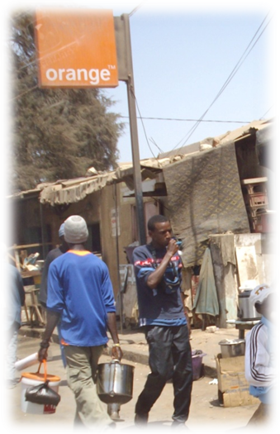
Technology: Columnist Dan Costa notes, “Globally, the mobile phone is now the primary communication tool. This shift has had a stunning impact on developing nations.”
- 4.1 billion People, subscribe to a mobile phone service. More than half of the world's people are connected.
- In 1990, there were 14,000 mobile phone subscriptions in Africa. Today, there are 280 million. (1 per 3.2 people)
- A 10 % increase in number of mobile phones increases GDP growth by as much as 6% in developing countries.
- 80% of adults in Africa have no access to secure banks. MAP International works with the country of Uganda, for citizens to get paid and pay bills through regulated banking via cell phone, significantly addressing corruption.
- Text messaging was recently used by citizen activists to monitor elections where media is government controlled.
- DataDyne.org, develops health-care solutions that take advantage of mobile infrastructures, including a data collection toolkit which collects health-care information, monitors infection patterns, and coordinates treatment.
A 12 year old acquires a cell phone with his wages, gathering garbage for the Kibera burner and learns his boss’s, girlfriend’s and ‘mate’s phone numbers. He also accesses storytelling, allowing learning in his illiteracy, and giving greater desire for literacy. WWW technology enhances leadership skills, comparing his people’s conditions with those around the world. He might avoid HIV-AIDS but is more likely to be addicted to pornography. It provides music and early exposure to rhythm and harmony now feeding into a healthy hip-hop culture in Nairobi. Technical stimuli travel through his social encounters of early childhood village stability, to the ever-changing power structures of Kibera. Cell-phone technology speeds transition to urban culture.
Selling phone cards in Dakar Senegal
Globalization; internationalizes trade, liberalizes government restrictions, universalizes objects and experience, Westernizes worldview and geographically reconfigures the space of social relationship. That levels the playing field in a city. Freidman, in The World is Flat, sites an American auto-parts manufacturer in China with an African proverb, translated into Mandarin, above the factory floor:
Every morning in Africa, a gazelle wakes. It knows it must run faster than the fastest lion or it will be killed. Every morning a lion wakes up. It knows that it must outrun the slowest gazelle or it will starve to death. It doesn’t matter whether you are a lion or a gazelle. When the sun comes up, you better start running.
The world is flat, so across the Global South those born in the old city acculturate to compete with slum dog millionaires and Kibera kids who got their ‘stuff’ the hard way. The establishment fights back with University of London MBAs or Sorbonne doctorates. The urban leader changes at nearly the same rate as the migrant. As suggested, when you wake up, you’d better start running.

Roadmap to Acculturation
Like a map, this section may help us get a better sense of orientation, distance and direction in acculturation process and its legend gives information on what we will see along the way.
Catalysts that precipitate or hasten acculturation include secularization, exposure to diversity and influence of the other. With any mass population, comes bureaucracy, which either changes people or they die, waiting in line. As colonial cultures dominated others, assimilation occurred. But migrants self-initiate re-location because of material need and as they build required proficiencies, these catalysts decrease their learning time.
Rural and urban cultures both value time – differently. Rural time is: geographical - wet and dry seasons, lunar cycles, sunrises and sunsets, biological - births and deaths, planting and harvest, relational - time for my son, or the village meeting. Urban time is: developmental – the connective tissue for trade between urban centres, business appointments to formulate partnerships and takeovers, mass education schedules adapted for children’s morning arrival and assignment due-dates. It is technical, an on – off switch in infrastructure; how confusing would it be if both directions of a traffic light were simultaneously green? Software developers use a single number to form hundreds of custom date and time representations to make hardware-devices speak the common dialect of time. A businessman in Dakar said, “you`ve got the watch, I`ve got the time.” But, in fact, he had no more time for relationship than anyone else in the city.
Social Science Analysis: As Polish journalist, Kapuscinski writes on meeting ‘the other’ from an urban anthropology view, he says, “A period of accelerated, increased (urban) migration has set in. The person we meet and get to know in the big cities of the Third World is already another, ‘other’ – the product of an urban, hybrid culture which is hard to define, descendent of various contradictory worlds, a composite creature of fluid, impermanent contours and features. Clearly, in order to reach the city we need to somehow understand this accelerating, urban hybrid culture and urban anthropologists often offer helpful insight.
Sociology also offers useful tools in its kit for grasping social change. As he watched intercultural relationships develop, sociologist Bennett noticed some systemically predictable reactions and created the “Developmental Model of Intercultural Sensitivity (DMIS) to describe steps to culture-change. He organized them into six stages of increasing sensitivity to cultural difference. As one’s experience of cultural difference becomes more complex and sophisticated, competence in cultural relations increases. The first three DMIS stages are ethnocentric, meaning one’s own culture is experienced as central to reality. The second three stages are ethno relative - one’s own culture is experienced in the context of other cultures. The DMIS radically helped re-write curriculum for cross-cultural training programs. Since Bennett’s publication, two more tools evolved from the model. Martin and Nakayama developed a ‘Majority Identity Development Model helping host cultures adapt to change.

Majority Identity Development Model
- Unexamined identity – is the "lack of exploration of ethnicity"
- Acceptance – is a complex stage of cognitive examination of the unconscious/conscious acceptance of being establishment. Specifically, it is the acknowledgement and expression of being the establishment.
- Resistance – is a move from blaming minority members for their condition to one that names and blames their own dominant group as a source of racial or ethnic problems"
- Redefinition – establishment begin to refocus on defining what it means to be host culture in non-tribal terms. Hardiman (1994) argues that Whites move into defining their own race as being more positive and downplay the negativity.
- Integration – is where individuals acknowledge that they are the establishment yet also see differences among minorities in a positive manner. The individual recognizes that s/he is different, but also is more accepting of minority groups.
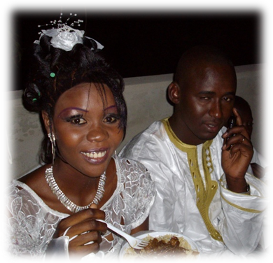
Ohja created the Minority Identity Development Model, observing how individuals construct identity when s/he is not part of the majority. Since host/emerging cultures live together in community, these two groups, he says, “must find ‘comfort’ in community through the two different processes.”

Minority Identity Development Model
- Unexamined identity - is the "lack of exploration of ethnicity"
- Conformity - In this stage, there is a strong negative value associated with one’s identity.
- Resistance and separatism - is more personal and occurs when somebody questions another person’s identity.
- Emergence - an individual begins to understand the foundational parts of their culture which are in conflict with the dominant culture and experimentation/compromise is initiated. (Seim [2007] building on adaptation [Bennett] added to Ohja’s findings)
- Internalization - Individuals develop a secure and self-confident minority identity and are also comfortable expressing preferences and interests for experiences from non-minority cultures.
We’ll minister in very messy situations if these social-change models are true. Christian leaders will resist change using rules created in the context of their cultures to maintain alleged ‘truth.’ Establishment and migrant will clash. They see threats and values in working together. Both resist change. Neither will remain the same. Yet, sociologists say the transition gave fuller identity to people (including researchers) who completed it. As one moves from their original culture, they never entirely leave it and often become wiser in assessing each culture. Educator, Jay Cross in, Informal Learning, agrees, “The emergent way of learning is more likely to involve community, storytelling, simulation, dynamic learning portals, social network analysis, expertise location … and co-creation.” His formulation of life-long learning is set in the classrooms and software of Cisco and IBM, but now streams through technology touching the Global South.
It’s counter-intuitive. In the diversity of the city, we are all becoming more similar. Our adjustments aren’t masks - put on and removed - though initially they feel like it. They truly affect how we adapt, act, think and process information. So, our city looks more like other cities around the world than the country of which it is part.
On Toronto’s airport expressway, a sign reads, “Life is change. Growth is optional.” Is growth optional for mission in your city? Are we too comfortable with tribal anthropology? What does an urban missionary look like? Does God want us to grow in urban mission? If so, we may need a new mission force, new ministry models, policies and best practices. Cities produce life change. In Acts, Paul grew the Church, by bringing God’s message to the city. Will we choose the same option for 21st Century mission?

 Working in Francophone cities around the world, Glenn Smith, asks, “What would a city look like if it was transformed by Christ?” He and his team at Direction Christien, working with one community in Montreal give us a holistic picture of desired outcomes that many can agree upon, and engage in contextualizing their city.
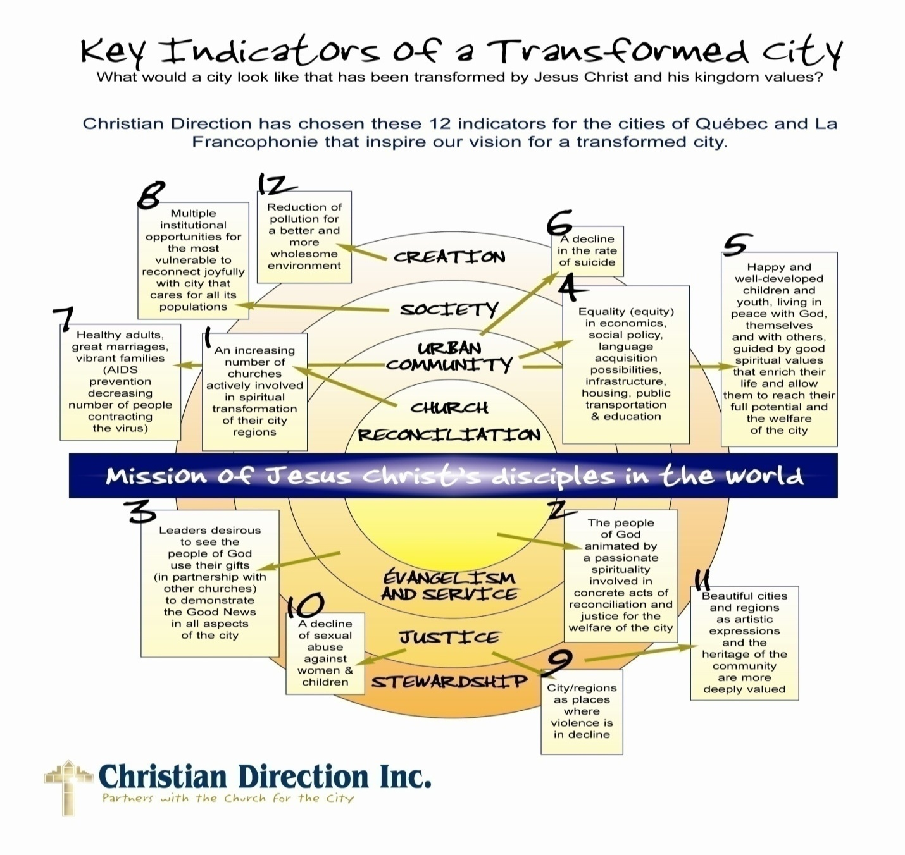
I’ve been reflecting as I wrote these last four articles – Journey to the City, Challenges of a Transfer Church, Cities and Change, and Urban Acculturation – “What difference is it going to make in how we focus on, and engage in mission?” Questions keep coming like Great Lakes black-flies in June. Smith’s diagram gave me something to inter-mesh those questions with; it heightened my awareness of what the city truly is.
Contextualizing involves awareness of others. If culture is a learned set of behaviors, becoming aware of others makes us more sensitive to differences. Paul describes his task as “a slave to everyone.” This doesn’t sound like cultural awareness, but fleshed out, he uses phrases like “become like the Jew, Greek, Roman, slave or free.” Educator, Richard Bucher, living in a diverse city, notes, “… developing multiple, cultural awareness must be our goal, the ability to adopt multiple cultural perspectives or lenses regardless of the situation.” Smith says, “To pursue this ethnographic analysis, the urban ministry practitioner will need to bring:
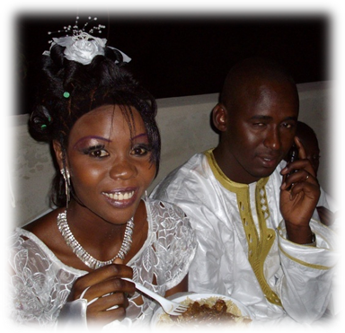
- a high sensitivity to the local specifics and to micro details in the context.
- a concern for the larger worldview influences (understood as the macro issues).
- a synthesis beyond a simple homogenisation of the data.
- a true appreciation of the differences between cities, regions, and even neighbourhoods so that one can appreciate the specifics of the area in the light of mission of the Church in the situation.”
So, we must somehow be aware and relate with the diversity of a city at every level. This kind of awareness forces us to mark the penetration of Christianity in the ‘old city.’ It begs us to ask, “Do culturally diverse migrants at various stages of acculturation have hope of being embraced by God’s people or, if they respond to our message will they become a ‘level ii Christian’ in my city?” Basil Davidson observed, “The Europeans came and assumed command of African History; and the solutions they found were solutions for themselves, not for Africans.” The value of Smith’s tool is that we can merge ‘our’ questions in contextualizing ‘our’ city. Please evaluate questions of your own as well, but my global, urban questions about contextualization include:
- How fast is Diaspora urban acculturation taking place in my city? How often do the migrants visit the village? If a child goes to school s/he adapts at a different speed than her mother who sells vegetables on the street or at the market, who still must interact with other tribes working parallel tasks. Techno-feeds like TV and cell-phone hasten acculturation by depending on common language, explaining change and why it must happen.
- Are we empowering migrants to function, communicate and succeed in cities so they grow in success as well as faith?
- What does an urban environment do to a given rural culture? Is a different discipleship needed? Diversity in most cities require systems of pluralism. That secularizes the general culture because diverse spiritual thought unvalued, becomes unshared. Privatized faith creates a guilt-based culture. Rural missiology has worked in shame-based culture.
- How do we meet ethno-specific needs, as cultures enter a city (0-12 years maximum)? Are there ministries that are oriented to seasonal urban dwellers? Is there commonality in theology between the rural ministry of which they are also a part, thus avoiding confusion and distrust?
- What needs ought urban Christians’ meet, both immediate and long-term? How can we facilitate discipleship that produces true Christian character to help meet these needs? Do churches need mobilized to meet needs in their neighbourhoods?
- Do we reflect Jesus in his declared mission? Have we included the Great Commandment in our application? How do loving God fully and loving neighbours deeply relate? How do we disciple Christians to love (all) their neighbours without having to ask, “Who is my neighbour?”
- Does our relevant message include celebrating the arts and advocating for social justice?
- Some urban problems are systemic. What systemic ministries need shaped to meet these challenges?
- Does the ‘old city’ call for more reaching than the new? What layers and niches are not being touched by God’s kingdom? Which City-leaders need help in addressing these issues and how will we engage them in the task?
- How do we help urban Christians examine their faith for syncretistic elements coming from tribal, local and global world views? Can we read Scripture for an urban context rather than the rural cultures from which we’ve come?
- Is there ‘space to search for truth with post-modernity’ rather than demand answers at the outset?
- Is there a place for the ‘meta-church and the house-church’ in our missiology?
- Are we creating faith communities that accept brokenness, class and cultural diversity, and disciple for significant healing or planting churches in which people must look as if they are already successful?
- In the loneliness of diversity, can we enfold the diverse, embrace ‘the other’ into our midst, and celebrate their cultural roots? How do we teach churches, who though not specifically called to be culturally uncomfortable with one-another, are called to love the other –“especially those of the ‘household’ of faith.”
- Have we acknowledged these issues, trends and pace of change as we create strategic goals for ministry in our city?
Understanding context shows us challenges. A denominational leader recently told me of one of their major regional churches. He said, “The church has maintained its numbers over the past several years, which in essence, means it’s growing.” I agree. Twenty-five percent of the population leaves that city every 5 years. Christians divorce at the same rate as non-Christians in that city, after which, they often switch churches. 80% of youth seem to be leaving the church before age 18. So, if the church maintains attendance, it does so in the face of all these losses. That church has done well. But, urban churches in general, are often decimated by those same trends.
The Church is already at worship in almost every city in the world, so both missionaries and churches ought to engage in this contextual exercise. (How about together?) There are huge pockets, both cross-cultural and un-reached, in each city which seem the natural task of mission.
A recent magazine headline says, “It’s a Wonderful World” The world is still open to wonderfulness and now more than half its population live in cities. Yet, in one meeting last week we discussed how cities are testy, complex, crowded and noisy places to live and minister. Those are the contrasts; a world looking for solutions of hope, living in a place where it’s tough to see, hard to get to and tricky to hear. Who needs touched by Christ in our cities? what special needs do the Diaspora have in the urban transition? What special gifts do Diaspora Christians offer in the transformation of the city? What are the greatest challenges of tranformation – not to bring people to a common culture or economic bracket in the the city, but to help them resemble Christ. What does God’s message look like in that kind of place?
What kinds of ministries must be present in a city, to insure that all might respond to Christ?
Engaging with Community
Neighbourhood involvement
Intervention in at-risk communities
Intervention in systemic problems
Listening to God
Leadership development
Reflect on effects of urban acculturation
Reflect on spiritual interactions in community

In the church orientation
Church planting
New mission opportunity
Churches embracing classes & cultures

End Notes

http://www.sia-acp.org/acp/download/wa_sccw_brief_7_-_urbanisation_migration.pdf This is a fascinating paper covering West African Migration, given in Dakar, Senegal in 2003. It summarized the roles of urbanization as, - The modification of rural life in areas close to urban sites. - Stabilization of demographic trends by incorporating important flows of migrants from rural areas. - Reduction of pressure on the land, allowing remaining rural populations to develop viable production. - Process considered as the first form of the beginning of a middle class. - Concentration of economy in the urban sectors. It addressed some primary issues for government intervention in the city; - Increase in jobs, especially in the ‘informal’ sector. - Upgrading education for the formal employment sector which requires skilled workers. - Remaining a refuge for the poor. - Challenges including diversity, difference in living space, educational requirements. - Acquisition of a new ‘trade language without literacy capabilities in their original language. - Financial destabilization. - A dependence on different leadership structures (chief to bureaucrat.)
Demografia World Urban Areas: Population and density, 2008.08, http://www.demographia.com/db-worldua.pdf
http://www.citymayors.com/statistics/largest-cities-density-125.html This is the intermediate or metro measurement of the cities, not the full agglomerate population.
http://en.wikipedia.org/wiki/Delhi
Richard Florida, Who’s Your City? 2008
From WordNet (r) 2.0 [wn]: http://define.com/acculturation
Kenya: Slum cooker protects environment, helps poor, Barry Moody, Reuters, April 2, 2009, http://www.climateark.org/shared/reader/welcome.aspx?linkid=123418
Drishti is a collective of film & documentary makers in India. directed by Stalin K. and produced by Drishti. http://www.aliak.com/category/category/social-change
One Cell Phone Per Child, Don Costa, PC e-zine March 31, 2009, http://www.pcmag.com/article2/0,2817,2344283,00.asp
Smith, M. K. (2002) 'Globalization and the incorporation of education' the encyclopedia of informal education, www.infed.org/biblio/globalization.htm, http://www.infed.org/biblio/defining_globalization.htm
The World is Flat, Thomas Friedman, 2005, Douglas & McIntyre, ISBN 978-1-55365-175-8
The Collaborative International Dictionary of English v.0.44 [gcide]: [WordNet 1.5 +PJC] http://define.com/catalyst
The Other, Ryszard Kapuscinski, Instytute Ksiaski, 2006,ISBN 13: 978-1-84467-328-5
Milton Bennett and Mitchell Hammer, 1998 Bennett, M.J. (1986), Developmental approach to training for intercultural sensitivity
Martin & Nakayama 2000:133.
Ajay K. Ojha ajayojha@hotmail.com Journal of Intercultural Communication, ISSN 1404-1634, 2005, issue 10. Editor: Prof. Jens Allwood URL: http://www.immi.se/intercultural/,
http://www.csupomona.edu/~jsmio/325/powerpoints/identity.html
Mark 3:4 then Jesus asked them, “Which is lawful on the Sabbath, to do good or to do evil, to save life or to kill?” But they remained silent, 7:9, “You have a fine way of setting aside the commands of God in order to observe your own traditions,” 9:33-35… “what were arguing about on the road?” But they kept quiet because on the way they had argued about who was the greatest. Sitting down, Jesus called the twelve and said, “If anyone wants to be first, he must be the very last and servant to all.”
Informal Learning: Rediscovering the Natural Pathways that Inspire Innovation and Performance, Jay Cross, John Wiley and Sons, 2006, ISBN 0787981699, 9780787981693
Smith, Glenn, 2006, Key indicators of a transformed City, The Church in dialogue with its context – observations from Montréal, p.16, Direction Chrétien
I Corinthians 9:19-23, Though I am free and belong to no man, I make myself a slave to everyone, to win as many as possible. To the Jews I became like a Jew, to win the Jews. To those under the law I became like one under the law (though I myself am not under the law), so as to win those under the law. To those not having the law I became like one not having the law (though I am not free from God's law but am under Christ's law), so as to win those not having the law. To the weak I became weak, to win the weak. I have become all things to all men so that by all possible means I might save some. I do all this for the sake of the gospel, that I may share in its blessings.
Richard D. Bucher, Building Cultural Intelligence, Nine Megaskills, 2008, Pearson Prentice Hall
Smith, Key Indicators, p.9
Gugler, J. and Flanagan, W, 1978, Urbanization and Social Change in West Africa, and Cambridge University Press, ISBN 0 521 29118 6
Luke 4:18-19 "The Spirit of the Lord is on me, because he has anointed me to preach good news to the poor. He has sent me to proclaim freedom for the prisoners and recovery of sight for the blind, to release the oppressed, to proclaim the year of the Lord's favor." (Jesus seems to have an ‘identity-recovery mission’ as well as a ‘salvation mission.’)
Matthew 22:37-40, Love the Lord your God with all your heart and with all your soul and with all your mind.' This is the first and greatest commandment. And the second is like it: 'Love your neighbour as yourself.
Wells, David, 2008, What I See, The Pentecostal Assemblies of Canada National Office
Readers Digest Magazine Canada Ltd, Cover page, April, 2009 Picture of the author Heather Morgan All other photographs by Brian Seim

