New Year Greetings

The Lord Bless You and Keep You

Deborah Ko (Soprano) Peter Tang, M.D. (Tenor)

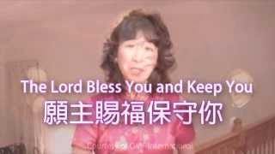

Watch the Video

