China's Next Generation: New Church, New China, New World

Luis Bush, Brent Fulton &
A Christian Worker in China
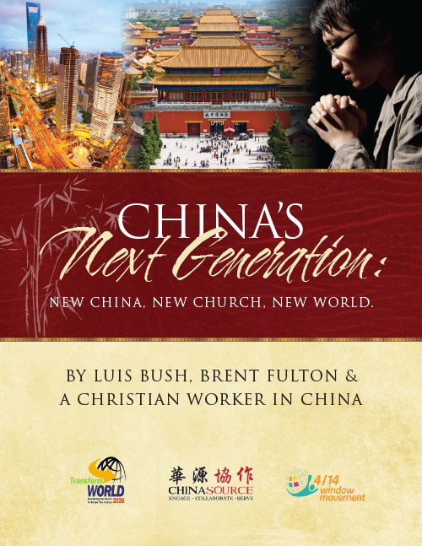
Download

