Do you want to get checked out to make sure you're healthy and will be around longer? If so, please take the following tests.

MEDICAL TEST:

STARE INTO THE CAT'S EYES FOR 10 SECONDS
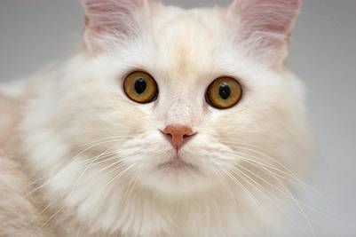

Then Scroll Down

NOW STARE IN THE PUPPY'S EYES FOR 10 SECONDS ..
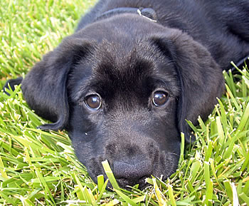
Scroll Down


Your CAT SCAN and
LAB TESTS are now
Complete.

