A Profile of North American Messianic Jews: A Study Conducted by Jews for Jesus

Andrew Barron and Beverly Jamison

Published in Global Missiology, April 2015 @ www.globalmissiology.org

Acknowledgements
This report could not have been developed without the assistance and expertise of a large team. We are especially appreciative to Meghan Jimenez, who did the artwork and layout.

We are grateful to David Brickner, Susan Perlman, Aaron Trank, Jeff Millenson, Toby Weiss, Rich Robinson and Stephen Katz. Many others gave advice and guidance.

Thank you.

Andrew Barron
Beverly Jamison
October 2014

© 2014 Jews for Jesus
Additional copies of this publication are available from: Jews for Jesus, founded in 1973, is dedicated to bringing the gospel into places where a Jewish testimony is needed.

Table of Contents
Acknowledgements 1
List of Tables 4
Introduction 7
Key Findings of Comparative Data 8
Abstract of Findings 9
Section I Quantitative Results 12
Family Background 12
Location 13
Marital Status 17
Intermarriage 18
Age Group 20
Gender 21
Occupation 22
Education 23
Age When First Heard Gospel 25
Context And The Gospel 26
Nomenclature 33
Nomenclature By Decade 34
Activities And Worship 35
Section II Qualitative Analysis 51
Introduction 51
Questions on pressure 51
Conclusions 61
Authors 66
References 66

List of Tables

Table 1 Family Background 11
Table 2. Location of respondents by state 12
Table 3. Location of Respondents by Region 13
Table 4 Major Jewish Population Centers 14
Table 5 Marital Status 15
Table 6. Intermarriage 16
Table 7 Intermarriage with Decadal Comparatives 17
Table 8 Age Group 18
Table 9 Gender 19
Table 10 Occupation 1983 vs. 2013 20
Table 11 Occupation and U.S. General Population 21
Table 12 Education 22
Table 13 Age and the Gospel 23
Table 14 Context and the Gospel 24
Table 15 First Heard the Gospel 25
Table 16 Initial Attraction to the Gospel 1983 26
Table 17 Nature of Response when you first heard the Gospel 27
Table 18 What Actions did you take after you heard the Gospel? 28
Table 19 What helped to convince you of the Truth of the Gospel? 29
Table 20 What Book or Movie influenced you? 30
Table 21 Nomenclature Comparing 1983 to 2013 31
Table 22 Nomenclature by Decade 32
Table 23 Celebration of Holidays Comparatives 33
Table 24 Celebration of Holidays Decadal Before and After Becoming a Messianic Jew 34
Table 25 Activities 35
Table 26 Synagogue Attendance 36
Table 27 Shabbat Candles 37
Table 28 Observing Shabbat Customs 38
Table 29 Study Hebrew 39
Table 30 Joining Campus Groups 40
Table 31 Jewish Media 41
Table 32 Keeping Kashruth 42
Table 33 Tikkun Olam 43
Table 34 Jewish Community Center 44
Table 35 Giving to Jewish Causes 45
Table 36 Going to Israel 46
Table 37 Fellowship Affiliation 48
Table 38 Source of Pressure 51
Table 39 Type of Pressure 52
Table 40 Internal Pressure numbered 53
Table 41 Internal Pressure as a Percentage 54
Table 42 Changes in Relationships 55
Table 43 Changes in Relationships 56
Table 44 Relationship Changes 57
Table 45 Relationship Changes 58

Introduction
There are Jewish people in North America who have come to faith in Jesus as Savior of the world and as the Messiah of Israel. Our interest is in surveying a group of these people in order to understand their lived experience.
From June 1, 2013, through December 1, 2013, Jews for Jesus carried out a broad study of Messianic Jews in North America. This study was a follow-up to a similar study conducted in 1983. The 2013 study involved a sample of 1,567 respondents and, like its predecessor, covered a variety of aspects through quantitative questions covering age, family background, education, religious observance and vocation.
The purpose of this study is to aid those of us involved in the wider messianic community. Our challenge is to critically understand our evolving movement; to provide resources and stimulate strategies for outreach, fellowship and edification.
Through this study we explored:
- The representation of the experiences of a group of Jews who believe in Jesus
- How this group of Jewish people experienced cultural influences during their decision to follow Jesus
- How one generation’s experience compares with another
Qualitative questions covered observance of religious traditions, Jewish and general beliefs and values, and Jewish identity. A new section of analysis covered the respondent’s experiences as they heard and responded to the gospel. The distinguishing range of this study and a comparison of its findings were made with those of the previous study (Jews for Jesus, 1983) the Pew study (Portrait of Jewish Americans, Pew Research, 2013) and the Steinhardt study (American Jewish Population Estimates, 2012).

Key Findings of Comparative Data
The Pew Research Foundation published their report on American Jews, which contains valuable comparison data for the American Jewish community and, where appropriate, the general U.S. population.
American Jews say they are proud to be Jewish and have an awareness of belonging to the Jewish people. Nevertheless, Jewish identity is changing in America, where one in five Jews (22%) now describe themselves as having no religion. The percentage of U.S. adults who say they are Jewish when asked about their religion has declined by about half since the late 1950s and currently is a little less than 2%. The number of Americans with direct Jewish ancestry or upbringing who consider themselves Jewish, yet describe themselves as atheist, agnostic or having no religion, is rising and is now about 0.5 % of the U.S. adult population.
The changing nature of Jewish identity stands out sharply when these results are analyzed by generation. Ninety-three percent of Jews in the aging generation identify as Jewish on the basis of religion; just 7% describe themselves as having no religion. By contrast, among Jews in the youngest generation of U.S. adults, 68% identify as Jews by religion, while 32% describe themselves as having no religion and identify as Jewish on the basis of ancestry, ethnicity or culture.
This shift in Jewish self-identification reflects broader changes in the U.S. public who increasingly shun religious affiliation. The share of U.S. Jews who say they have no religion (22%) is similar to the share of religious “nones” in the general public (20%), and religious disaffiliation is as common among all U.S. adults ages 18-29 as among Jewish Millennials (32% of each). Sixty-two percent say being Jewish is mainly a matter of ancestry and culture, while 15% say it is mainly a matter of religion. Even among Jews by religion, more than half (55%) say being Jewish is mainly a matter of ancestry and culture, and two-thirds say it is not necessary to believe in God to be Jewish.
Compared with Jews by religion, however, Jews of no religion are not only less religious but also much less connected to Jewish organizations and much less likely to be raising their children Jewish. More than 90% of Jews by religion who are currently raising minor children in their home say they are raising those children Jewish or partially Jewish. In stark contrast, the survey finds that two-thirds of Jews of no religion say they are not raising their children Jewish or partially Jewish–either by religion or aside from religion. (Pew, 7-8)
The Steinhardt Social Research Institute (SSRI) produced an expansive study of the Jewish population in North America in 2012. There are an estimated 6.8 million Jewish adults and children in the United States: 4.2 million adults self-identify as Jewish when asked about their religion. Nearly 1 million adults consider themselves Jewish by background and other criteria. There are an estimated 1.6 million Jewish children among adults who self-identify as Jewish by religion. Just over 1 million (24%) are aged 65 years and older. They are more than twice as likely as other Americans to be college graduates. The portrait of American Jewry described by the 2012 SSRI findings is of a population, at least numerically, in ascent. (SSRI, pp 7-8)

Abstract of Findings
The statistics from this survey have been compared with the previous survey of Messianic Jews in 1983 as well as other available demographic data. Messianic Jews in North America have a wide-ranging Jewish temperament. Messianic Jews say they are proud to be Jewish and have an awareness of belonging to the Jewish people. A majority consider themselves part of the Jewish people, based on nomenclature preferences and lifestyle. More than 90% feel an association with Jewish tradition, observe some Jewish practices and life-cycle rituals, and mark at least some of its festivals.
We see in Tables 10, 11 and 12 that Messianic Jews are overrepresented in our survey in education credentials and professional and specialized vocations. Respondents are underrepresented in the Northeast and overrepresented in the South, Midwest and West. Seventy-five percent of respondents married people who are not Jewish.

Respondents in Tables 14, 15 and 16 are hearing the gospel in the marketplace. As expected, the most common way for someone to hear the gospel in the Jewish community is in direct conversation. However, there has been growth in the numbers who hear the gospel in a church, a Messianic congregation, and in conversation with a relative.
We see a consistent representation of the influence of the Bible, New Testament and prophecy across age groups. The Late Great Planet Earth by Hal Lindsey is not significant among responders under 50. CS Lewis is the most well-represented author of influence across all the age groups.
An equal number of respondents responded positively and negatively when they first heard the gospel. The median age that Jews hear the gospel is 17 and the median age of becoming a Messianic Jew is 22. Across the age group we see this five- year period as typical. We can see that older responders responding to the gospel trended in a negative way whereas younger respondents exhibited similar but less severe reactions. Jews who hear the gospel confront issues of loyalty to community, culture, family, and friends. They think about the Holocaust and are afraid of change. As these people think about Jesus and his relationship to the Jewish people, they read the Tanakh and the New Testament. They confront the words of our prophets. They read books and they talk to God and their friends. They are convicted of sin.
Lifestyles, values, and identity of most of our respondents reflect efforts to maintain a connection to Jewish distinctiveness and tradition, on the one hand, and choice, on the other. The results show a broad consensus that reflects a representative commitment to the wider Jewish character, culture and continuity.
“Jewish identity is complex and fluid.” (SSRI, 24) We see Messianic Jews and their families express their Jewishness in a variety of ways. The relationship of the Messianic Jewish community to the North American culture at-large and the Jewish community in particular is a reflection of these myriad of options.
Socio-psychologist Bethamie Horowitz is a research assistant and Professor of Jewish Education at NYU. She has conducted research about major issues and problems facing the Jewish people for more than two decades. Horowitz says that “Jewishness unfolds and gets shaped by the different experiences and encounters in a person’s life. Each new context or life stage brings with it new possibilities. A person’s Jewishness can wax, wane, and change in emphasis. It is responsive to social relationships, historical experiences and personal events.” (Horowitz, 2000 p. viii).
Messianic Jews, orient themselves in new and refreshing ways to their Jewish community. We see increases in various Shabbat activities and observances, interest in Hebrew, Israel and participation in Jewish issues that affect Jews around the world. They become more generous in their attention and resources to issues of Jewry. Most significant is the increase in awareness in their interest in giving to Jewish causes, going to Israel and tikkun olam. This Hebrew phrase that means "repairing the world" (or "healing the world") advocates our common responsibility to heal, repair and transform the world.

Section I Quantitative Results

FAMILY BACKGROUND
The survey opens with a question about the background that defines the respondent as Jewish. More than 75% of those in the fifty and older decades report both parents Jewish. For those born after 1980 we report just under one-third of them came from households with both parents Jewish. This is likely influenced by the larger number of second generation Messianic Jews in the youngest respondents, reflecting mixed marriages of Messianic Jewish parents

Table 1 Family Background
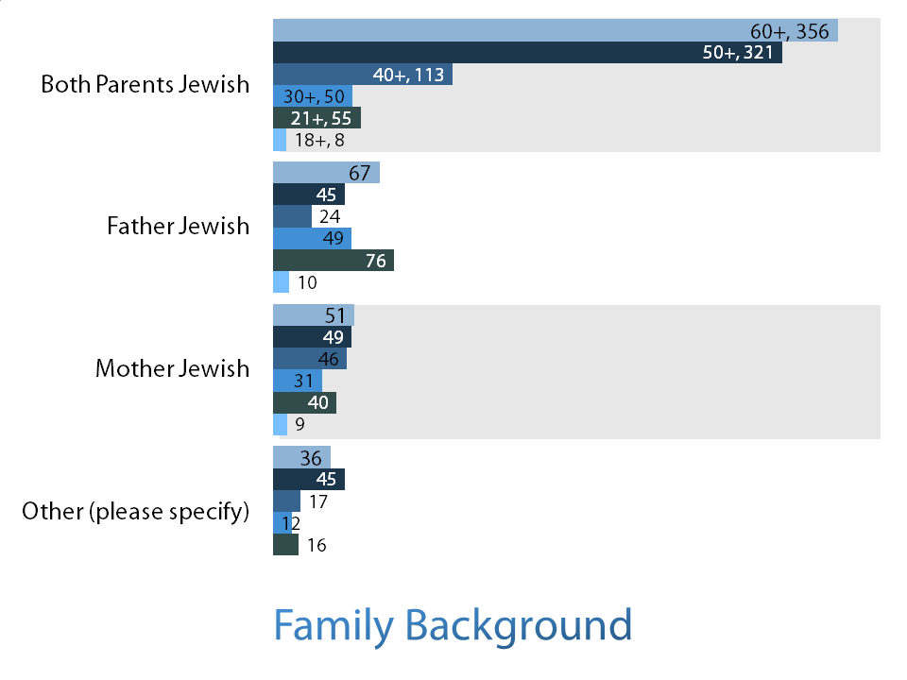

LOCATION
These questions involve the location of the respondents. The larger states and larger Jewish population centers have the highest number of Messianic Jews. California and New York have the largest communities, followed by Texas, Illinois, and Florida. The DC metro area also represents strongly. The Brandeis study (SSRI, 16) provided population estimates for the major population centers. We see Messianic Jews overrepresented in the West and Midwest and South and underrepresented in the Northeast.
Table 2. Location of respondents by state
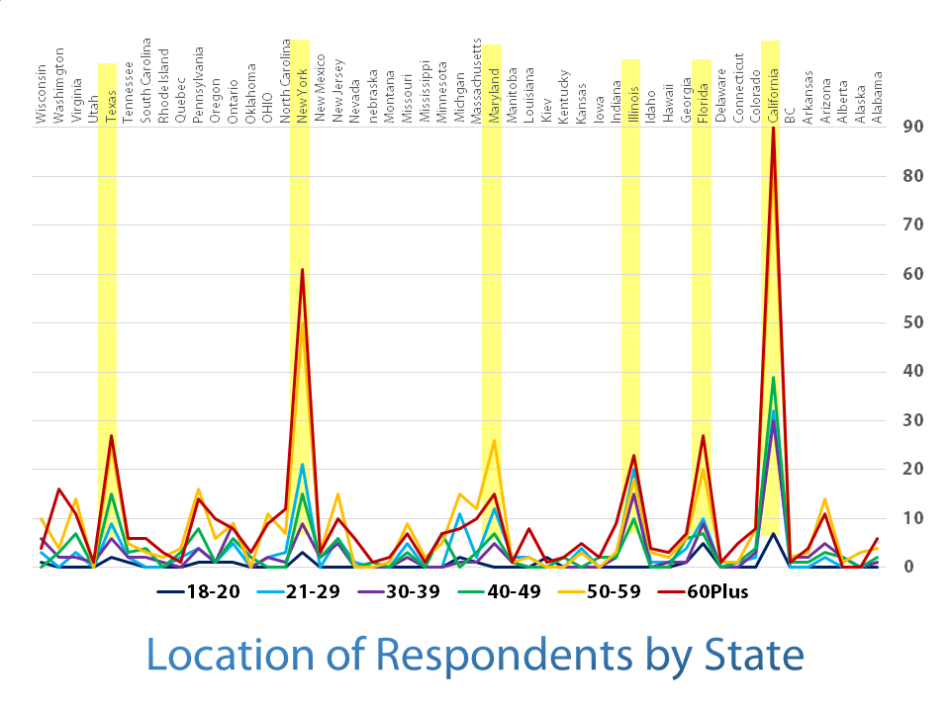

Table 3. Location of Respondents by Region
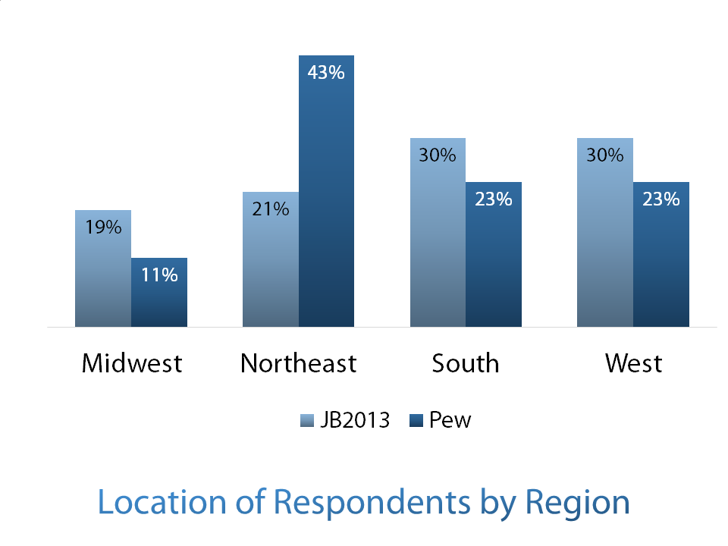

Table 4 Major Jewish Population Centers
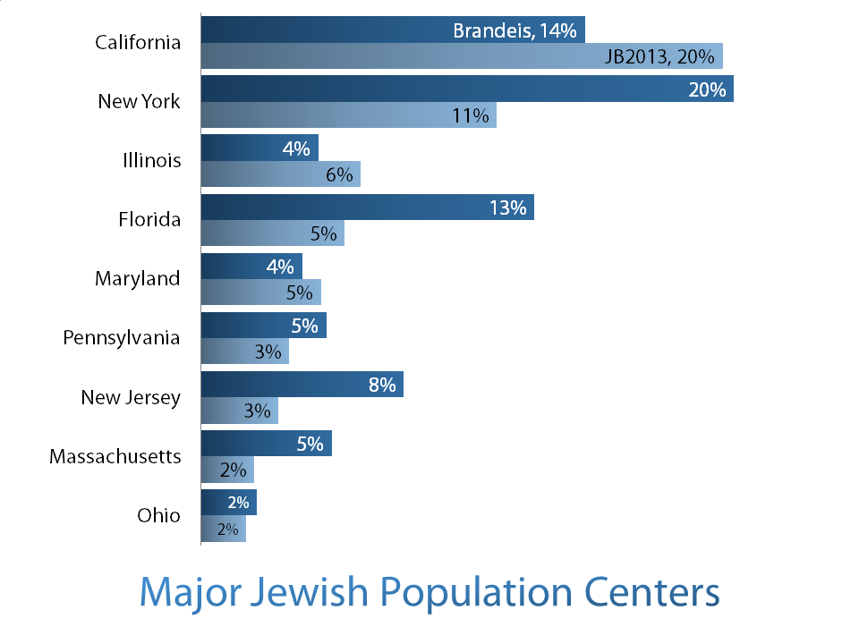

MARITAL STATUS
The variation between married and single reflects the expected larger number of never-married among the 29-and-under populations. The small numbers of widows / widowers is also a reflection of the age categories on the whole.

Table 5 Marital Status
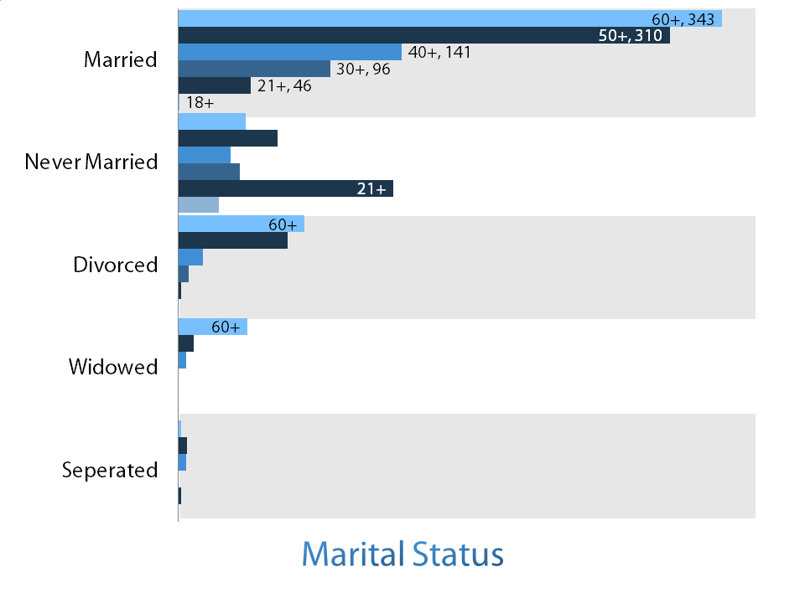

INTERMARRIAGE
These results show that the intermarriage rate is higher in the Messianic Jewish community than in the categories listed in the Pew study. There was a slight increase from 1983 to 2013, though not as much as in other categories in the general Jewish population. Table 7 indicates a small change in the intermarriage trend among second generation Messianic Jews.

Table 6. Intermarriage
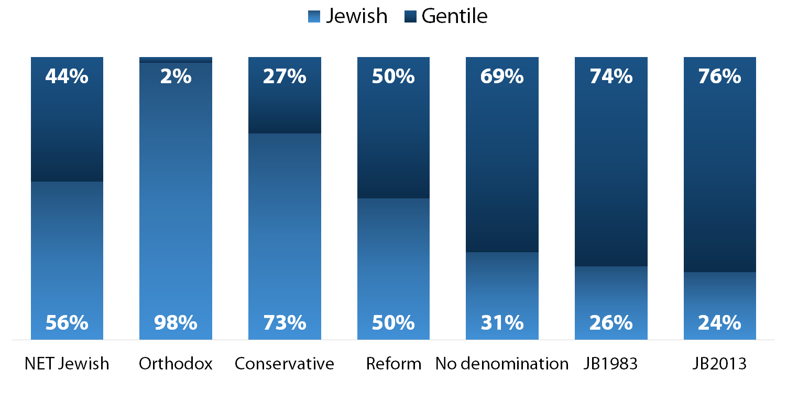

Table 7 Intermarriage with Decadal Comparatives
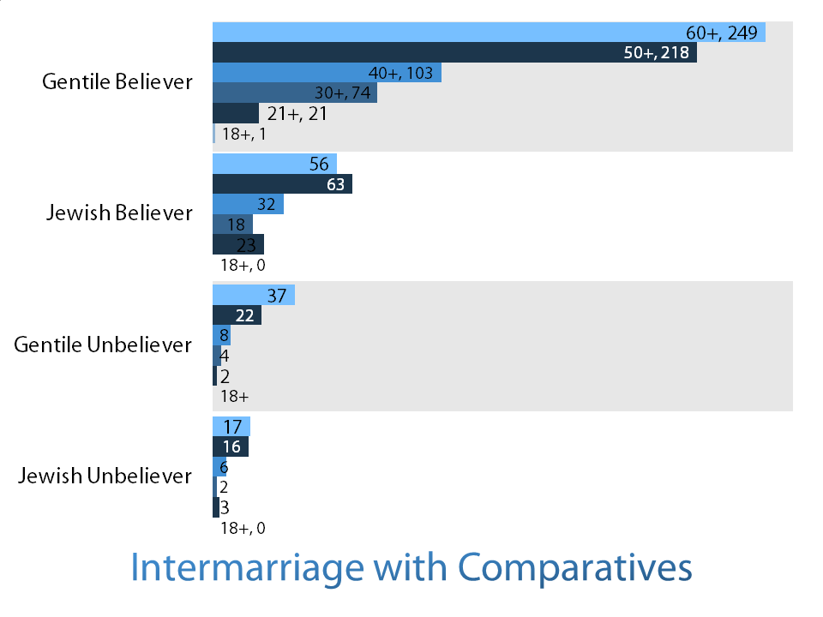

AGE GROUP
The majority of the respondents were in the older decades, though there is still a reasonable representation of the younger groups as well. The Pew study has a more even distribution across their chosen age categories, while the 1983 and 2013 surveys reflect the evolution and growth of the movement, with more pronounced spikes in each survey.
Table 8 Age Group
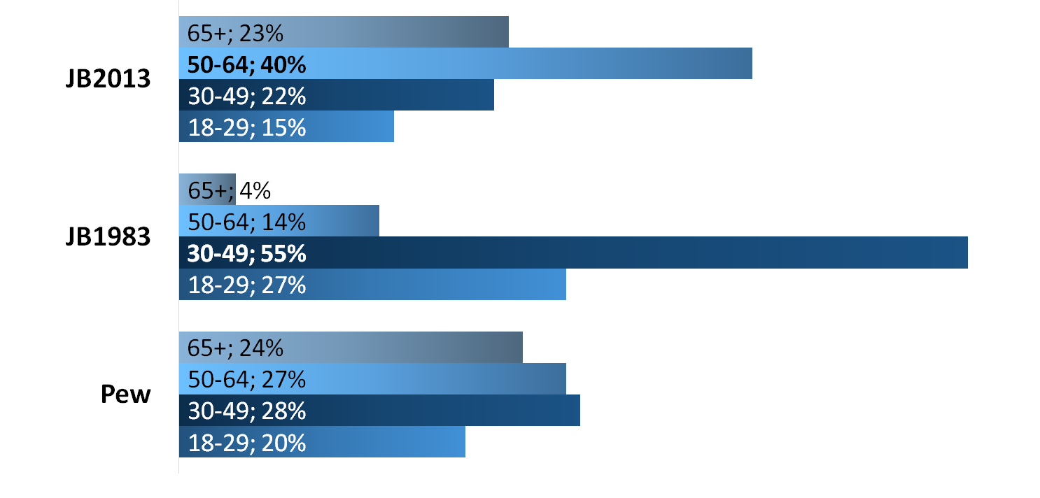

GENDER
The gender of the respondents was evenly distributed, with 52.4% female and 47.6% male. The ratio varied slightly with the decades. 49% of American Jews are male, 51% female, the same as the total U.S. population
Table 9 Gender
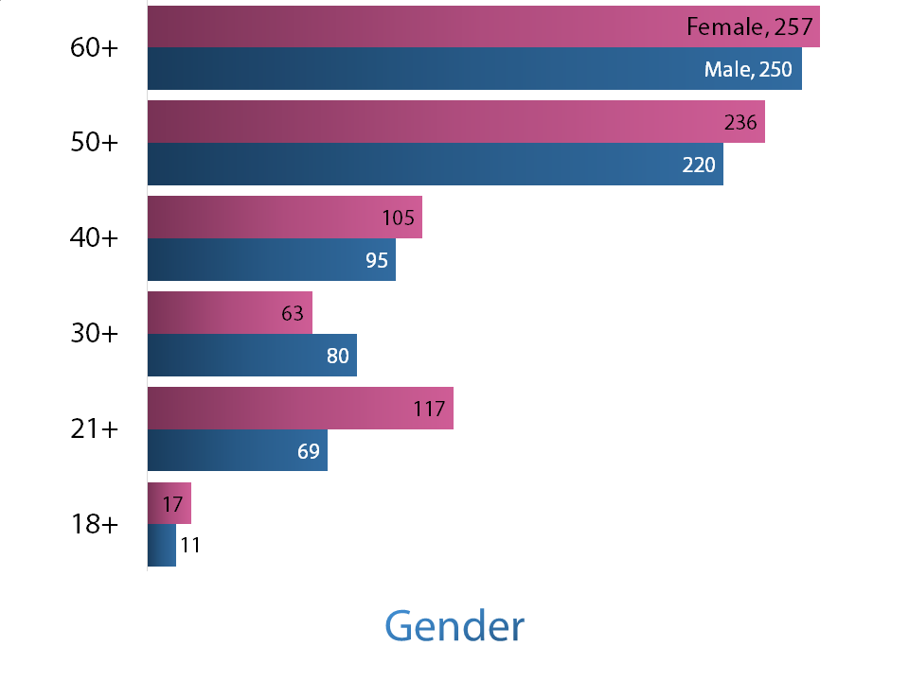

OCCUPATION
We compared 2013 with 1983 results. A wide range of options were given. The first graph uses the categories provided in the Jewish Believer surveys. The Jewish Believer population has a higher representation in the Management, Science, Business, and Arts categories than the general population, with an additional increase from the 1983 study to the 2013 one. The second graph normalizes the responses in order to compare them with categories used in a survey by the U.S. Census Bureau. Some of this additional increase probably reflects career path growth due to the increased representation in the higher age brackets.
Table 10 Occupation 1983 vs. 2013
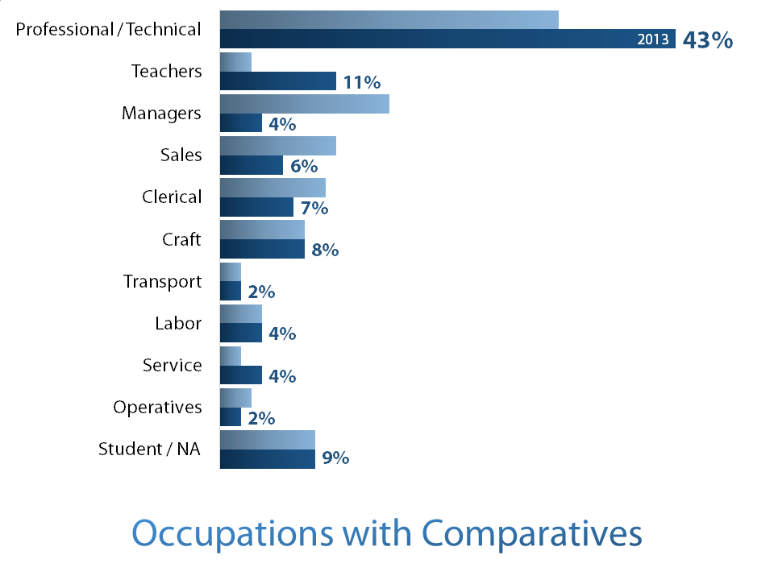

Table 11 Occupation and U.S. General Population
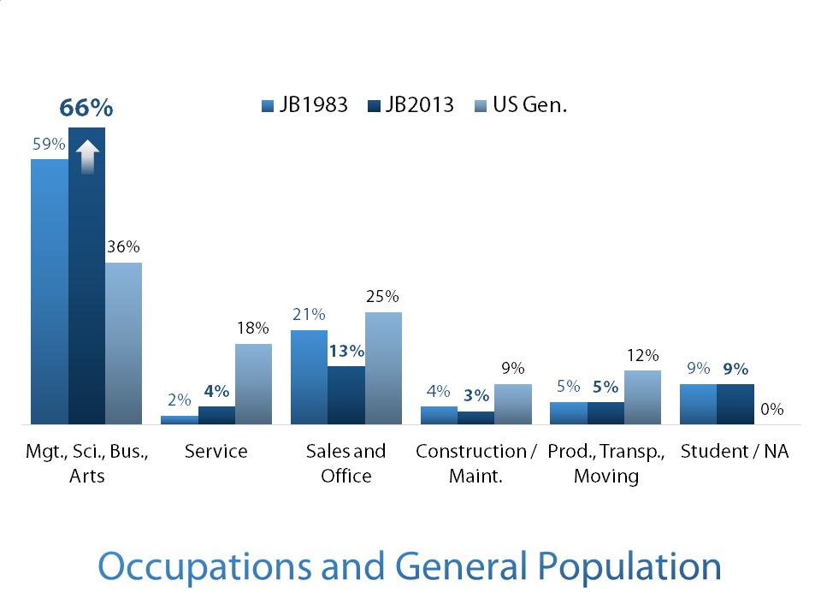

EDUCATION
There is a commitment to education by Messianic Jews that is more significant than in the general population and at par or greater than the wider Jewish community, as shown in the following graph. We compare the Pew survey with the 1983 survey, the most recent survey and US General population.

Table 12 Education
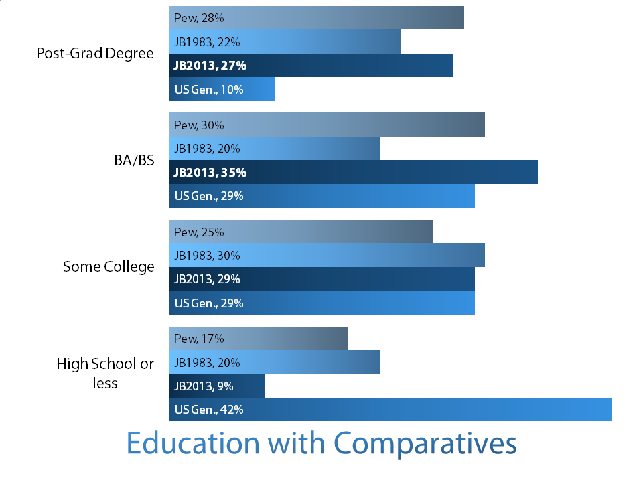

AGE WHEN FIRST HEARD GOSPEL
Overall population: Median age is 17 for first hearing the gospel and 22 for becoming a Messianic Jew. Table 12 breaks the age down by decade. As expected the average age rises with each decade, but across all decades, most people had heard the gospel by age 25, though there were still a number of respondents who did hear the gospel later in life. And while the medians were 17 and 22, the averages were significantly higher, indicating that people do respond to the gospel even when hearing it for the first time at much later ages.
Table 13 Age and the Gospel
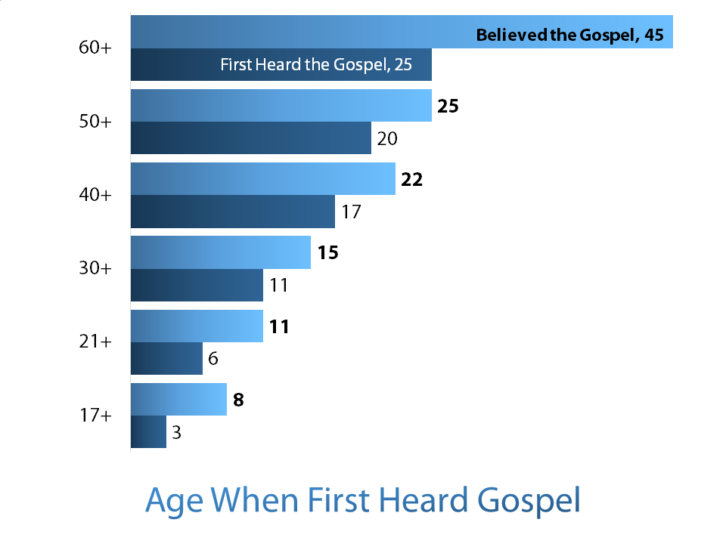

CONTEXT AND THE GOSPEL
These questions ask the source and context in which the respondent first heard the gospel broken down by decade. As expected, the most common way for someone to hear the gospel in the Jewish community is in direct conversation. However, there has been growth in the numbers who hear in a church, a Messianic congregation, and in conversation with a relative.
Table 14 Context and the Gospel
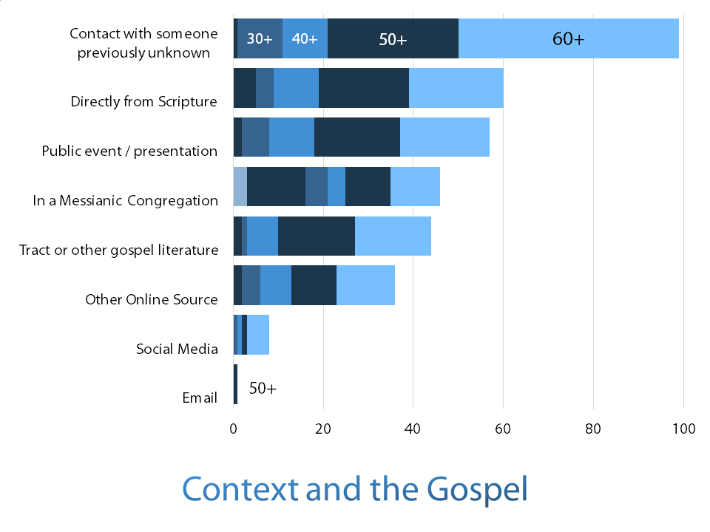

Tables 15 and 16 ask the same question of source and context in different ways. Although the question was asked differently in the two surveys, the importance of personal interaction around the topic of the gospel was very important, with respondents in the 2013 survey indicating the conversation with friends, relatives, or strangers accounting for the majority of the means of hearing (with a congregational setting, Messianic congregation or church being the next most prevalent). The 1983 survey indicated that people were the strongest influence.
Respondents were asked to provide narrative here as well. We can see that older responders responding to the gospel trended in a negative way, whereas younger respondents exhibit similar but less severe reactions.
Table 15 First Heard the Gospel
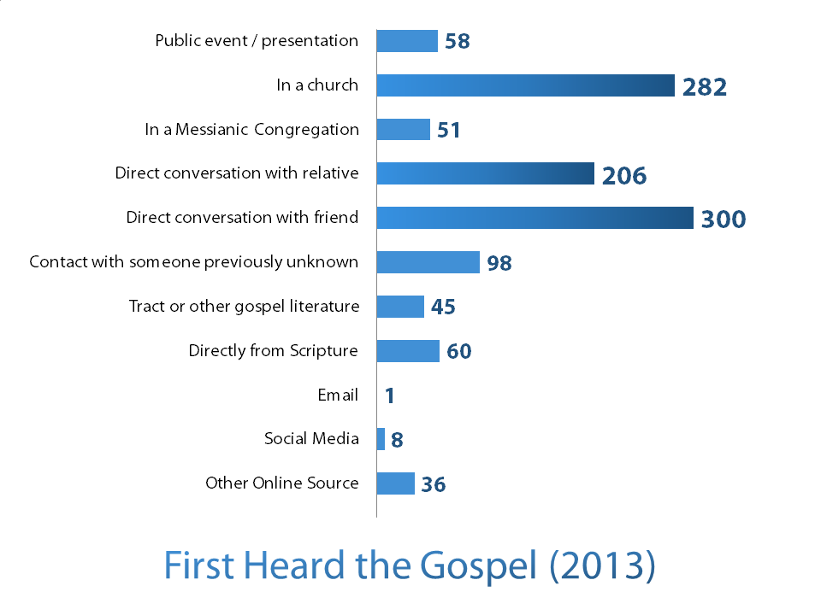
Table 16 Initial Attraction to the Gospel 1983
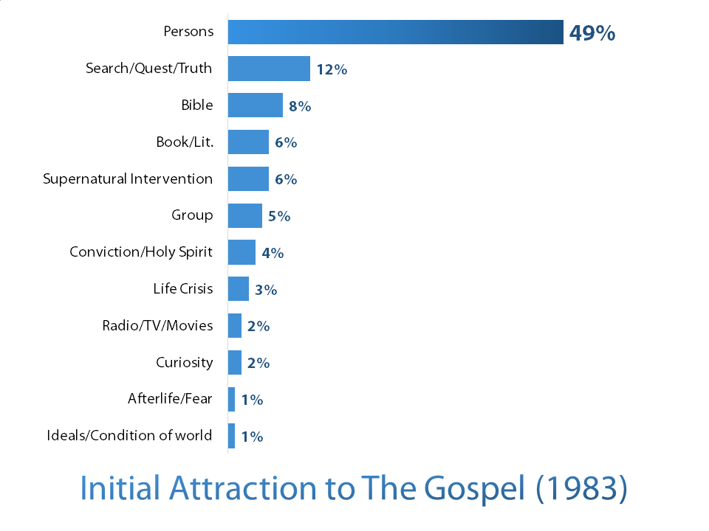

Table 17-18 look at the nature of the response, actions taken and convincing. These are categories that were applied to narrative responses. We tried to capture the essence of the reaction. There is a mixture of positive and negative responses across the age groups.
Table 17 Nature of Response when you first heard the Gospel
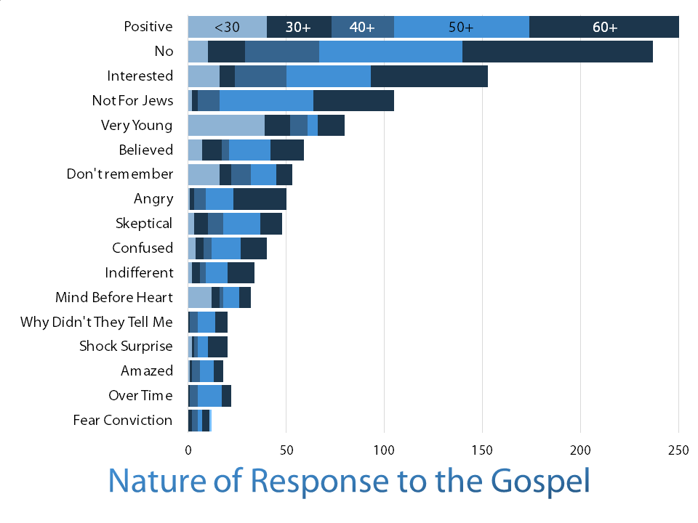

Table 18 offered respondents multiple options with regard to actions taken after hearing the gospel. The trend indicates respondents attempting to refute or confirm, using the Bible and friends as resources. Each response was well represented across the age groups.
Table 18 What Actions did you take after you heard the Gospel?
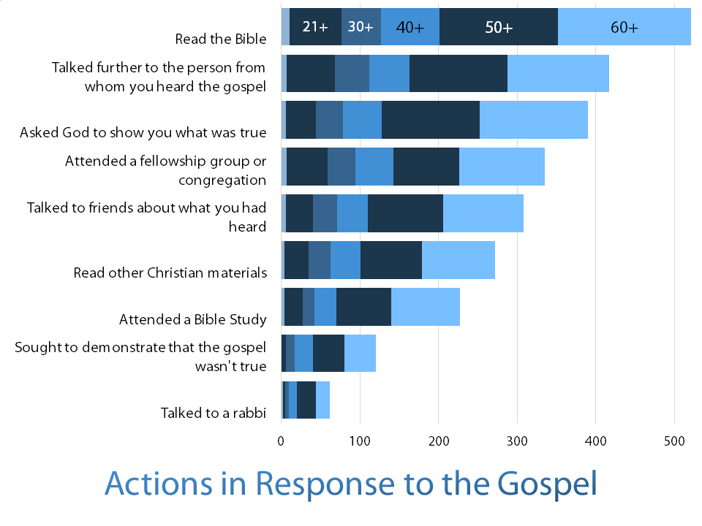

Respondents for Table 19 were able to select multiple options. We see again as in Table 18 that responses were well represented across the age groups.
Table 19 What helped to convince you of the Truth of the Gospel?
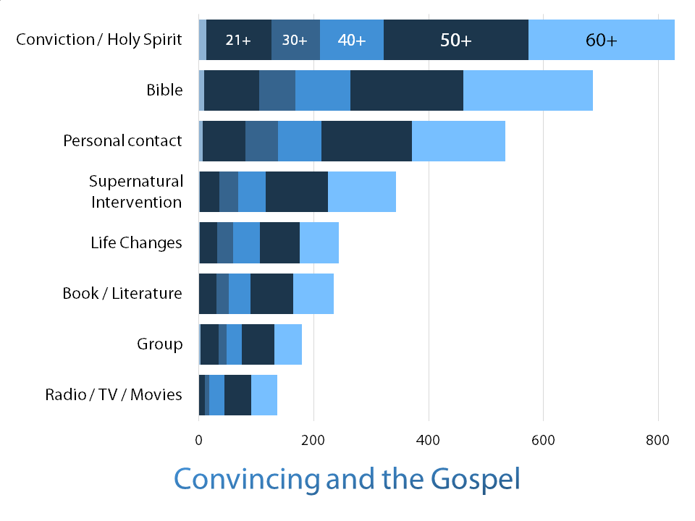

Table 20 indicates a consistent representation of the Bible, New Testament and prophecy across age groups. The Late Great Planet Earth is not significant amount responders under 50. C.S. Lewis is the most well-represented author across the age groups.
Table 20 What Book or Movie influenced you?
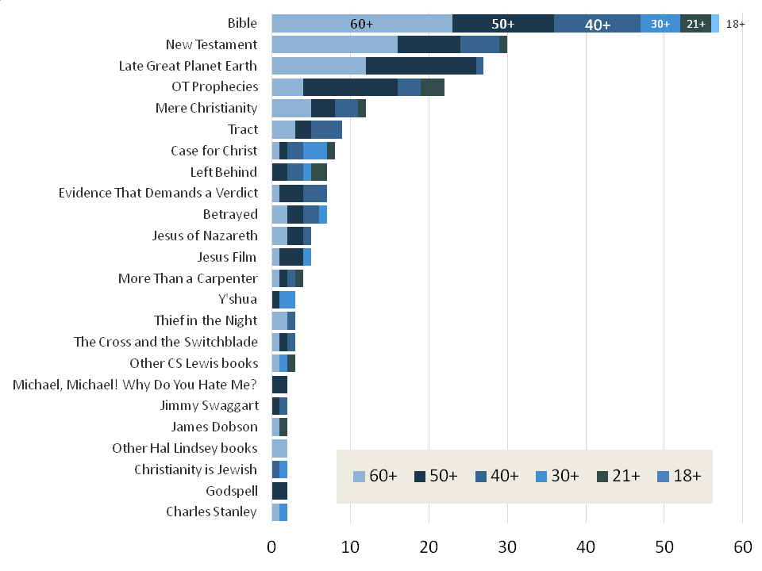

NOMENCLATURE
This graph answers the question how Jewish believers in Jesus identify themselves. There has been some significant trending in the last three decades away from “Hebrew Christian” and with an increase in identification as either “Jewish believer” or “Messianic Jew.” Respondents were allowed to choose more than one option.
Table 21 Nomenclature Comparing 1983 to 2013
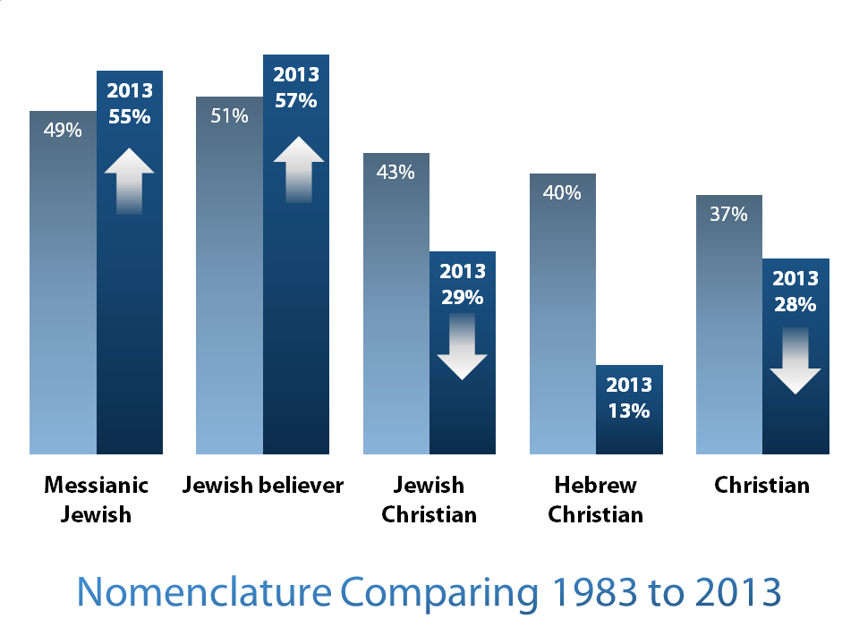

NOMENCLATURE BY DECADE
These results across the decades show a consistent pattern of some label that maintains Jewish identity. Respondents were able to select multiple options.
Table 22 Nomenclature by Decade
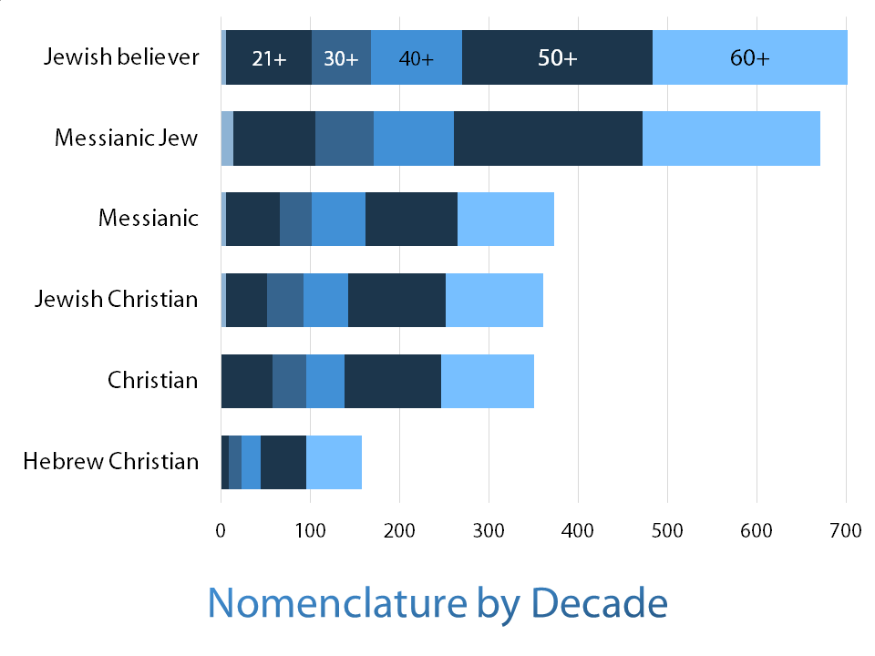

ACTIVITIES AND WORSHIP
The next section attempts to show the wide variety of ways that Messianic Jews participate in the Jewish world. We see a consistent pattern of respondents taking a renewed interest in participating in and relating to their Jewish world in a variety of ways and with a variety of commitments. We see diversity and choice in patterns that reflect a commitment to the Jewish world in the face of the pressures of modernity. More than 90% feel an association with Jewish tradition, observe some Jewish practices and life-cycle rituals, and mark at least some Jewish festivals. Before and After questions endeavored to show if any orientation and participation in the Jewish world changed. We also attempted to see if commitments to the Jewish world were altered after their decision was made.
We see in Table 23 respondents in 1983 and 2013 say that they are oriented to and participating in Jewish life in a more substantial way than respondents to the Pew study.
Table 23 Celebration of Holidays Comparatives
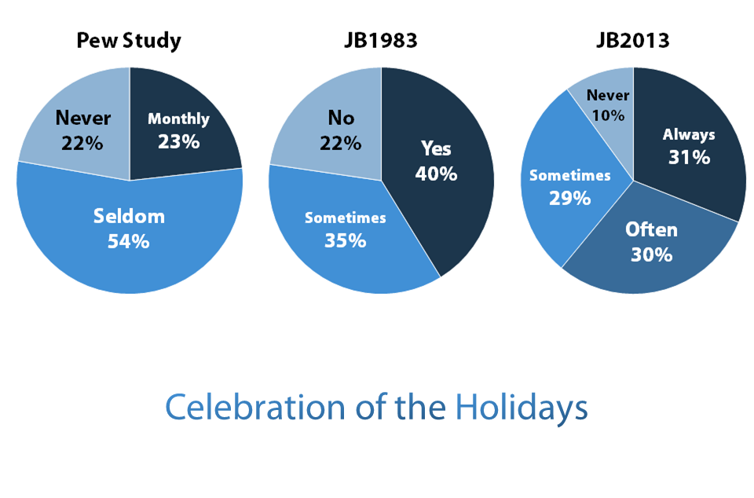

Table 24 respondents show by decade how celebration of Holidays was impacted after becoming a Messianic Jew. We see a trend across age groups towards a participation in Jewish life
Table 24 Celebration of Holidays Decadal Before and After Becoming a Messianic Jew
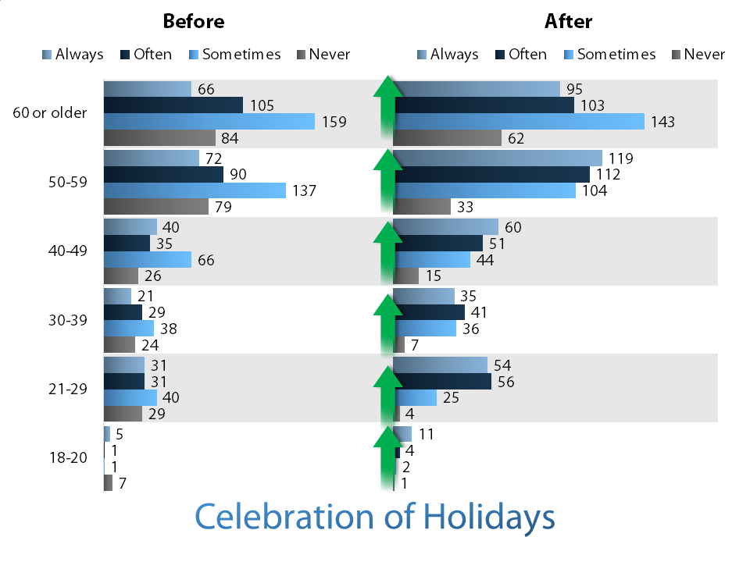

Table 25 asks the respondents to list what activities they participate in on a regular basis in their Messianic Jewish life. There is an even response across age groups, and respondents were able to choose more than one activity.
Table 25 Activities
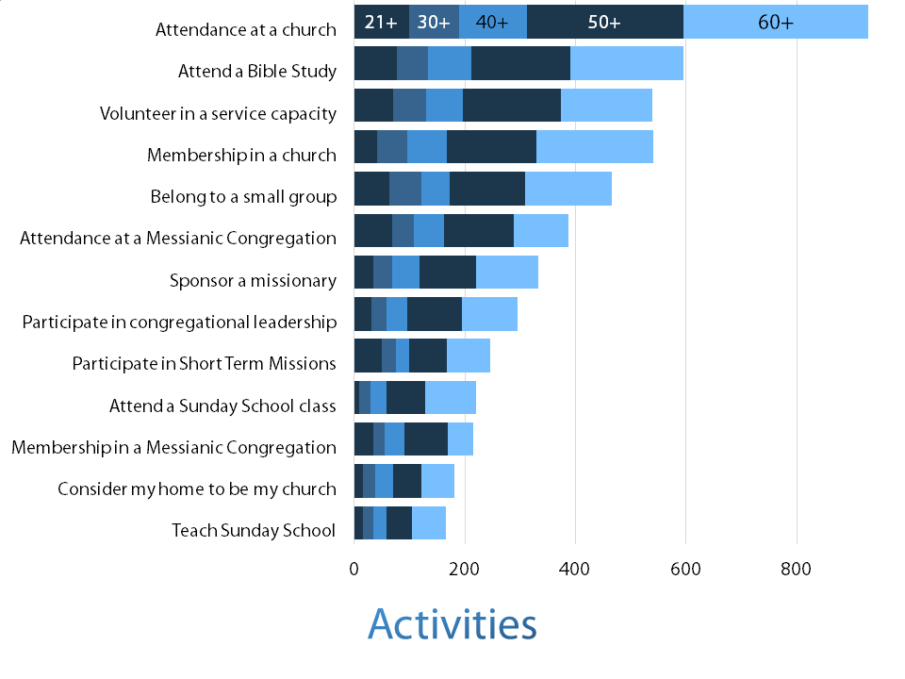

Respondents here and below indicated participation in and orientation to a variety of activities, interests and causes before and after becoming Messianic Jews.
Table 26 asks the respondents to speak to their participation in synagogue life outside the Messianic Jewish community. Patterns indicate an orientation, especially in older respondents, away from this practice. We do see, however, a consistent pattern of Messianic Jews in all age groups participating in and worship at local synagogues.
Table 26 Synagogue Attendance
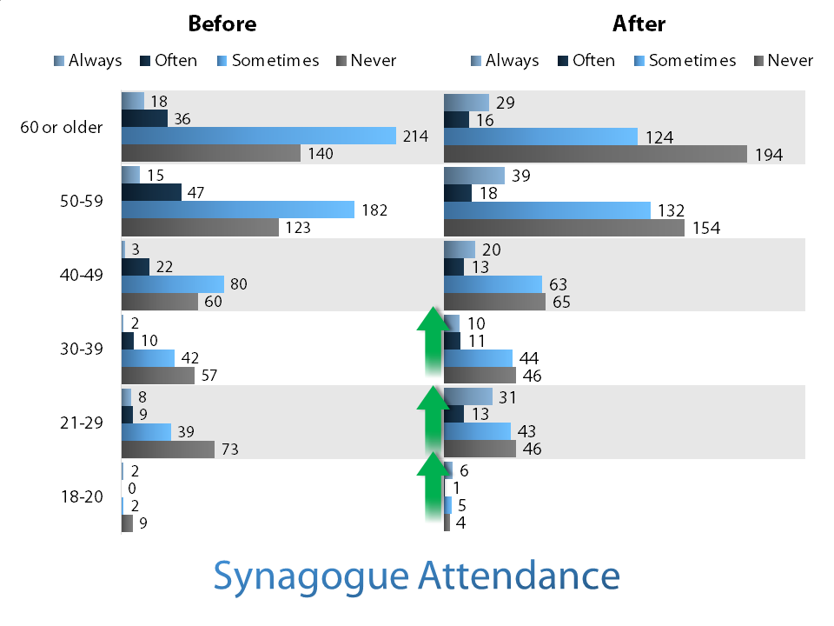

Table 27 asks respondents if Shabbat is recognized in the home through the lighting of Shabbat candles. We see a consistent increase in orientation across age groups towards this practice.
Table 27 Shabbat Candles
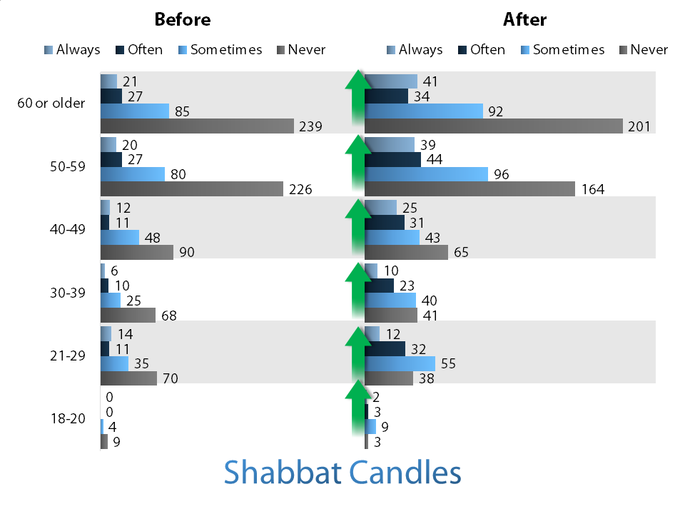

With regard to the general observance of Shabbat, and without providing specifics, we see again a consistent increase in orientation across age groups towards this practice.
Table 28 Observing Shabbat Customs
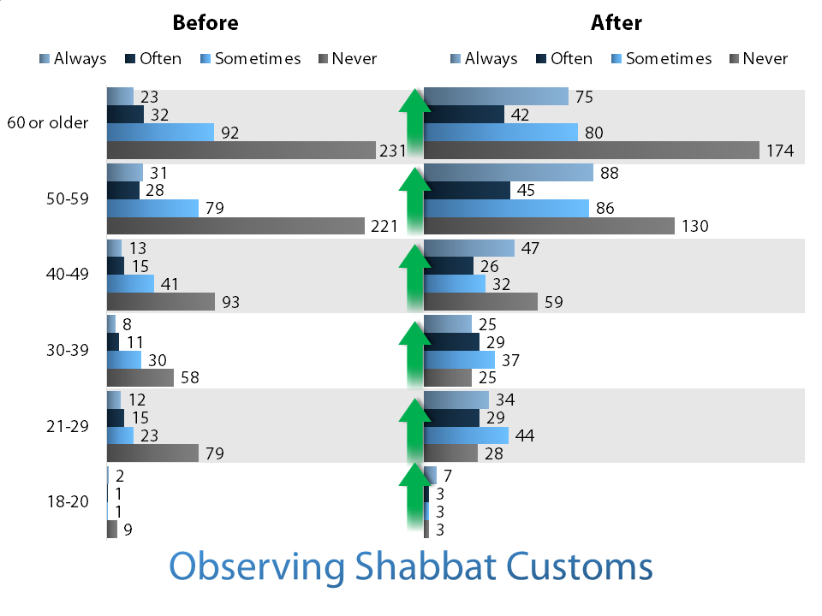

With regard to the study of Hebrew, and without providing specifics, we see a consistent orientation across age groups towards this practice.
Table 29 Study Hebrew
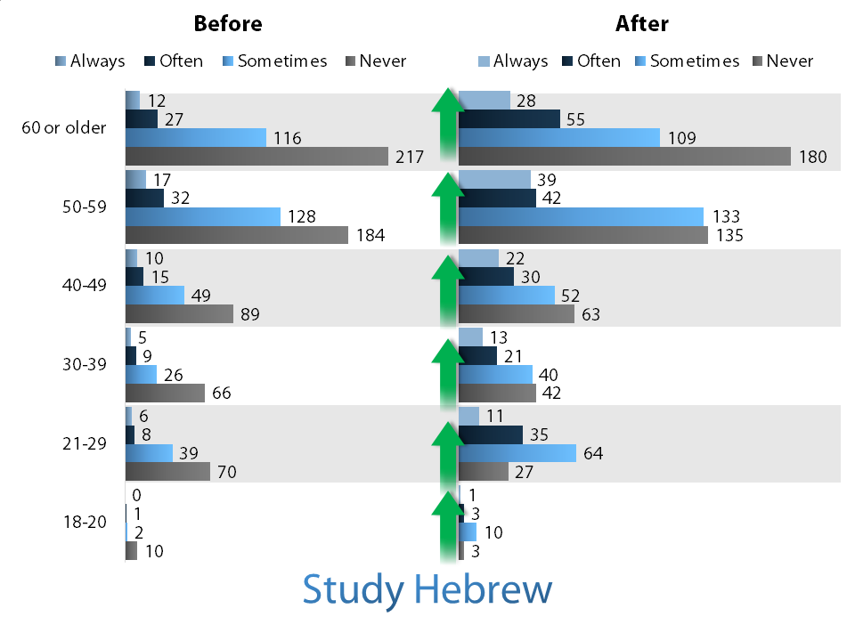

Table 30 respondents show a consistent pattern of participation in older and younger ages. We speculate that these groups were not available to older respondents or that the older groups participated in more extemporaneous and impromptu groupings. We note respondents under 30 trending towards participation in campus groups.
Table 30 Joining Campus Groups
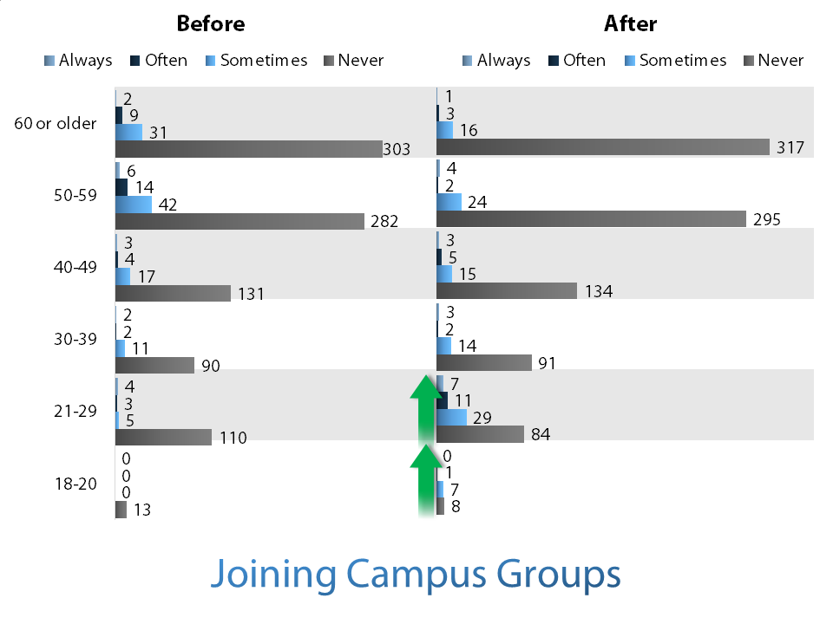

With regard to accessing and reading Jewish media, and without providing specifics, we see a consistent increase in orientation across age groups towards this practice.
Table 31 Jewish Media
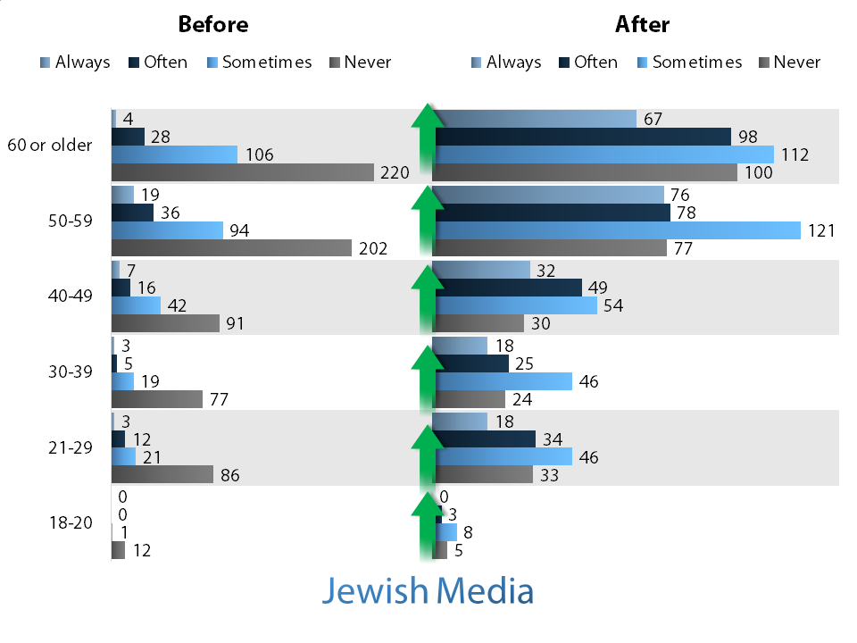

With regard to traditional Jewish food observances, and without providing specifics, we see a consistent increase in orientation across age groups towards this practice.
Table 32 Keeping Kashruth
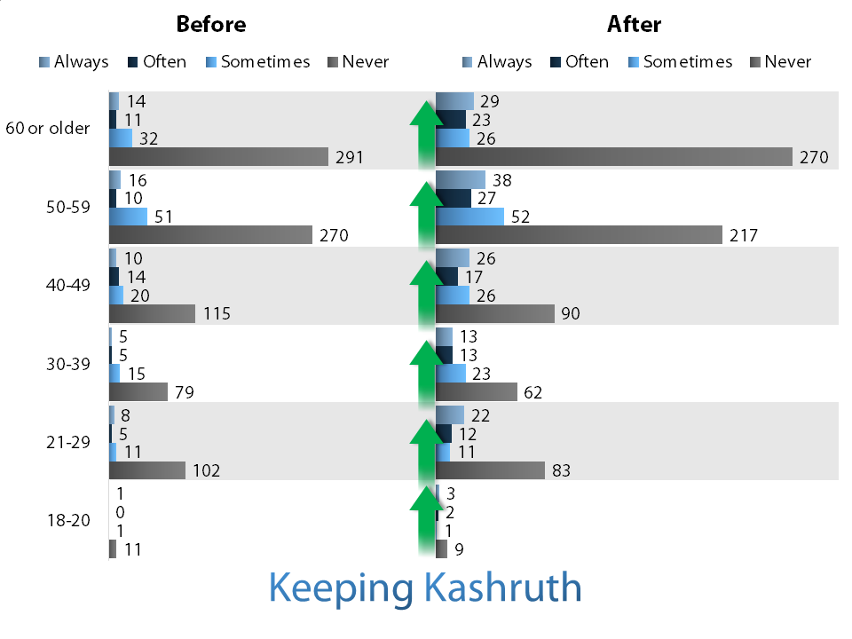

With regard to the Jewish value of tikkun olam (repair of the world), and without providing specifics, we see a consistent and very significant increase in orientation across age groups towards this practice.
Table 33 Tikkun Olam
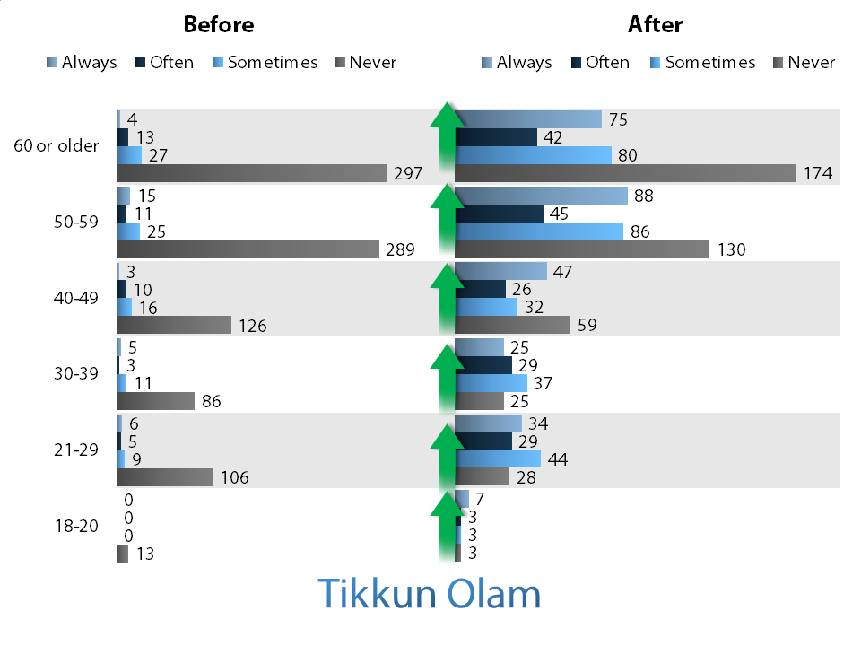

With regard to participating in Jewish community centers, and without providing specifics, we see some decrease across age groups towards this practice.
Table 34 Jewish Community Center
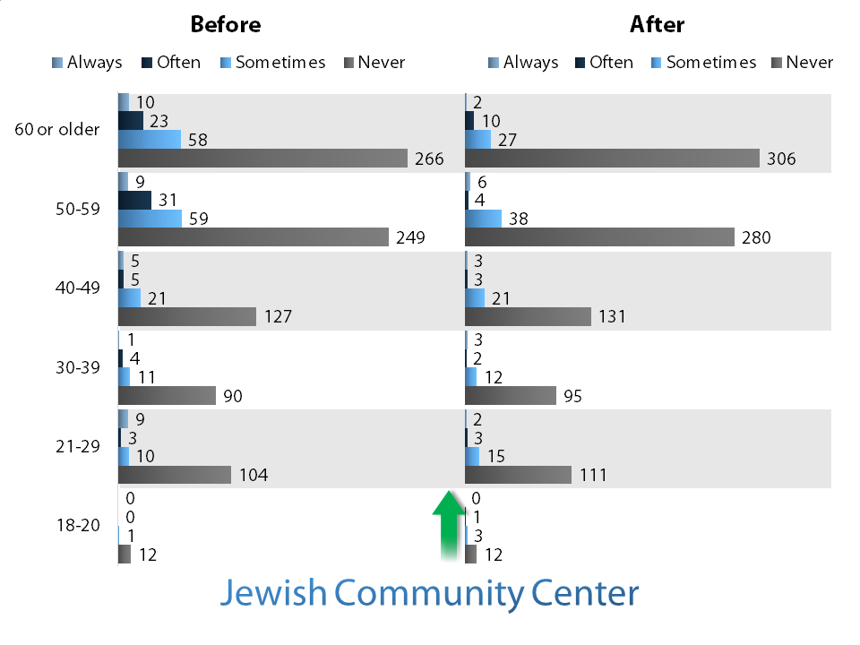

With regard to giving to Jewish causes, and without providing specifics, we see a consistent and significant increase in orientation across age groups towards this practice.
Table 35 Giving to Jewish Causes
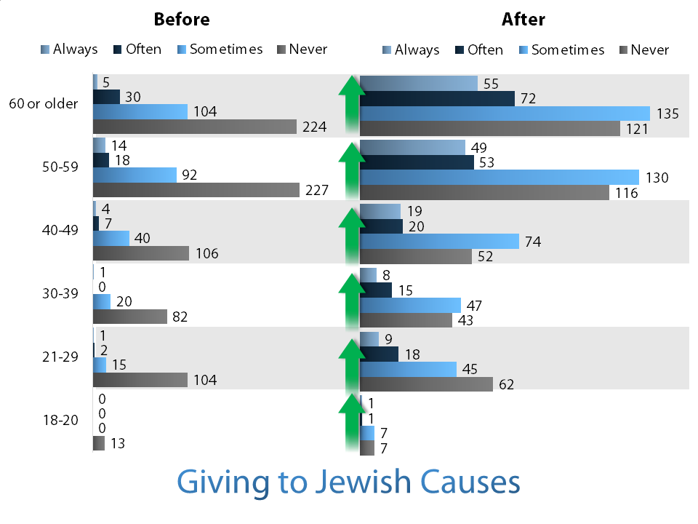

With regard to traveling to Israel, and without providing specifics, we see a consistent and significant increase in orientation across age groups towards this practice.
Table 36 Going to Israel
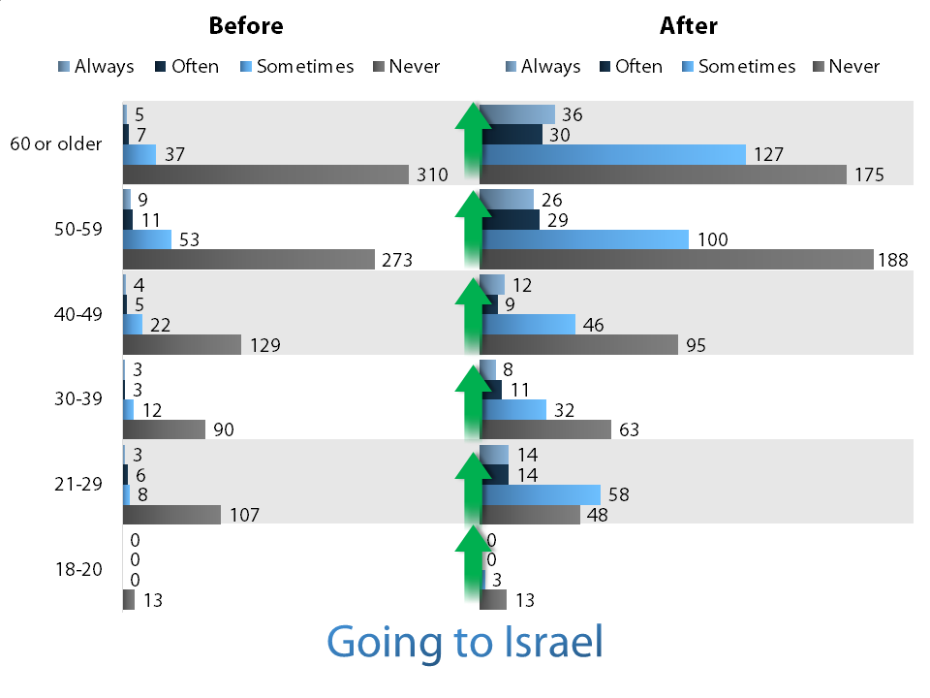

Table 37 asks the respondents to list the churches or congregations they attend. This was asked in order to get a more concrete sense of congregational affiliation and present attachment to fellowship. We then grouped the responses in order to make a more meaningful comparison. In most cases, the type of church or Messianic congregation was reasonably clear.
Five percent of respondents indicated attendance at both a Messianic congregation and a Christian church of some other denomination.
In most cases, the denomination was reasonably clear from the name, but in some cases we made some assumption about the category. Messianic congregations, Baptist churches, and charismatic churches were each grouped into their own category. The Traditional category included Roman Catholic, Episcopal, Methodist, Lutheran, Presbyterian, and similar denominations. The community category includes community churches, non-denominational churches, and some of the more recent “movements” in which non-denominational churches have emerged as affiliated congregations in multiple cities.
Table 37 Fellowship Affiliation
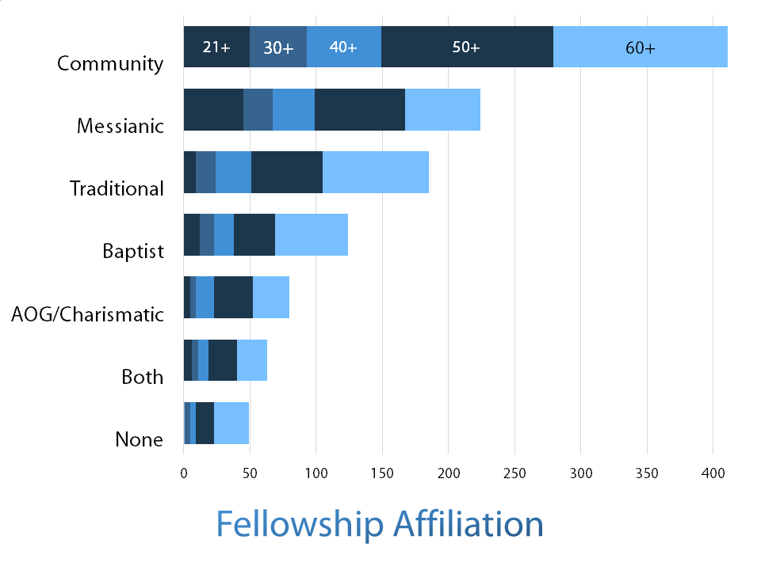

Section II Qualitative Analysis

Introduction
Qualitative results are more elusive. Narrative responses were broken down by common themes and significant statements which yielded patterns that were sometimes easily and sometimes more difficult to discern. In assessing and analyzing this part of the research, we examined narratives that show patterns of experiences in relationships and pressures related to the decision-making experience. We tried to develop categories of information that would lead to an understanding of the common experience of the participants.

Questions on pressure
The comments on family rejection covered several types of internal pressure. Some of the following comments represented common themes weighted across age groups but clustered in the above 50 group.
Loss of important relationships: ‘It became a battle between the comfort of my life and a good relationship with my family or choosing Jesus.’ ‘ “My dad and I were already in a strained relationship; this most likely would make it worse.”
Direct rejection: “When I first went to church, mom kicked me out of the house and made me choose to either leave church or leave the house...” “Since I come from a very powerful family, I was concerned they would try to have my children taken out of my care through legal channels, but I was prepared to face any judge since freedom of religion is our right”. “My family cut me off and mourned my death. They wanted nothing to do with me for a while, then after eight months or so they accepted it, but not happily.”
Fear of telling family: “Had a huge fear of my dad finding out” “Was afraid to tell my parents, family members.”
Fear of disappointing family: “My dad was always rich in his Jewish beliefs and I feared disappointing him, but what I felt in my heart was true. My mom was raised Jewish but she went into this New Age belief that borders on cultish like..” “I only knew of one family that were Jewish believers while growing up. They were considered the ‘weird family’ in the neighborhood. I felt like I would be considered the black sheep of my family and that they would be disappointed in me..” “I didn't want to disappoint my parents.”
Ridicule from family: “When I finally got the courage to tell my dad, he laughed at me and said that belief in Messiah and heaven is like being on drugs. My family thinks I am nuts, but they are still my family.”
As expected, family rejection was the most often-cited item, with related items of community rejection, cultural pressures and disloyalty. Also, the most frequent mention of the Holocaust was among the age groups for children of Holocaust survivors, with a smaller incidence in the age groups of their grandchildren.
There was an increased incidence (particularly proportionately) of those who knew of the gospel from an early age among the youngest two categories, representing the increase in second-generation believers.
Conviction of sin ranked high. This was followed by those who indicated they were challenged by the gospel in various ways.

Participants were involved in a complex pattern of relationships that were affected by this decision making process. Respondents were able to cite multiple sources of pressure. We would define community as the formal Jewish community and family of the respondents. Based on the number of responses, we still see similar patterns in all age groups.
Table 38 Source of Pressure
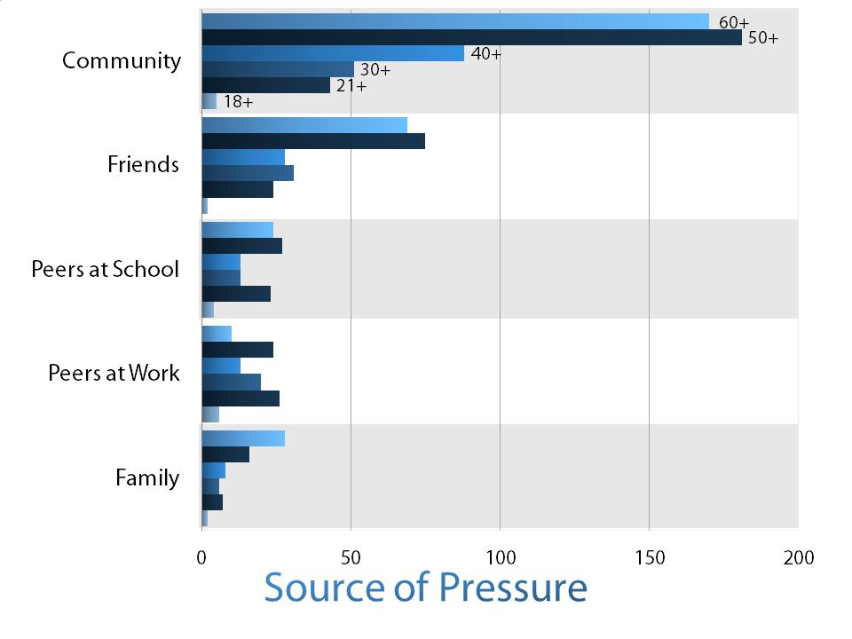

Table 39 was multiple select. There is a consistent pattern of experience in all age groups.
Table 39 Type of Pressure
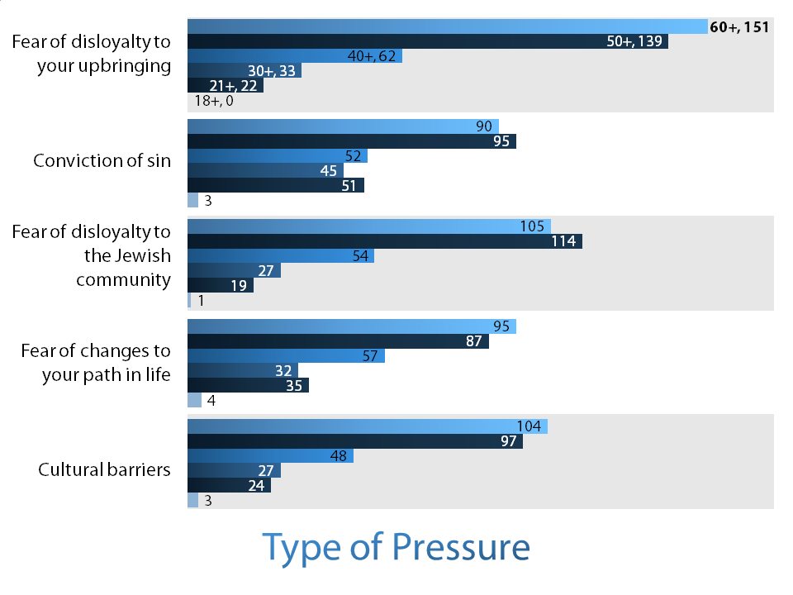

Table 40 asked respondents for a narrative response. Family reaction and conviction of sin were the most prevalent expressions seen in the stories.
Table 40 Internal Pressure numbered
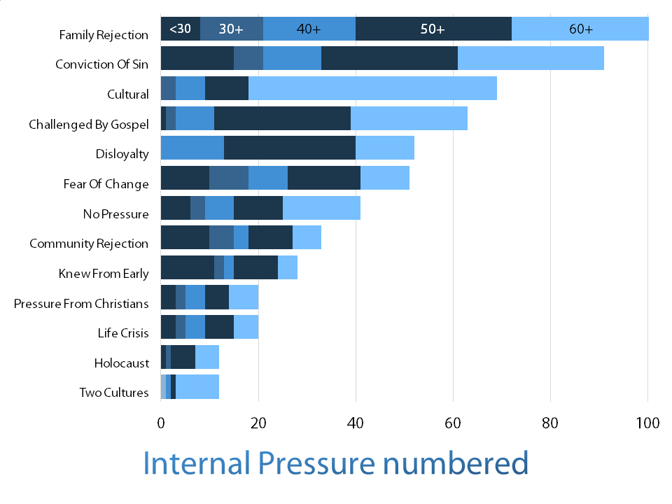

Table 41 asked respondents for narrative response. Older age groups indicate the largest percentage response to being pulled between a variety of social and cultural values.
Table 41 Internal Pressure as a Percentage
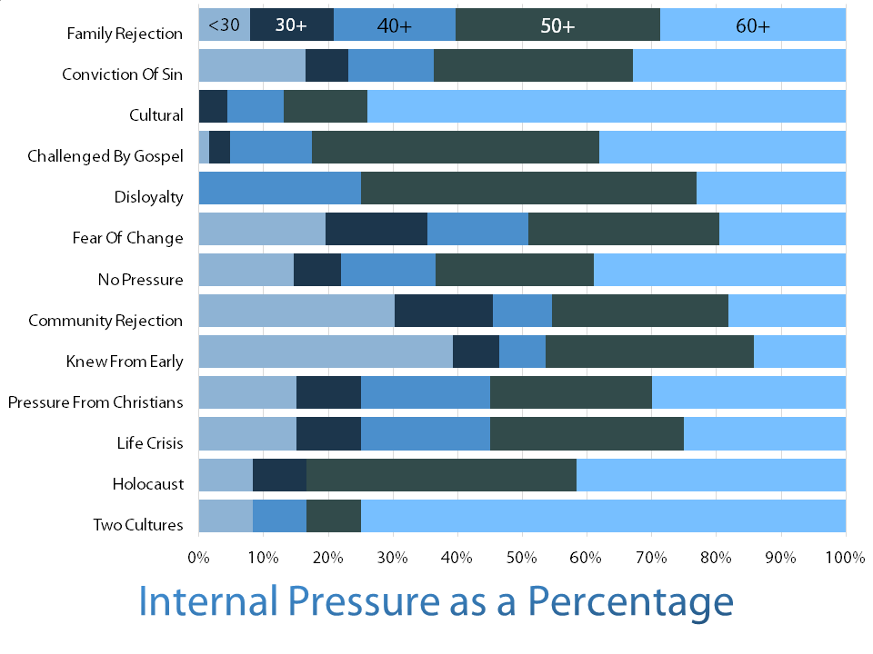

Table 42 provided respondents multiple choices. They were able to choose more than one selection. There is an even distribution among age groups in these expressed changes
Table 42 Changes in Relationships
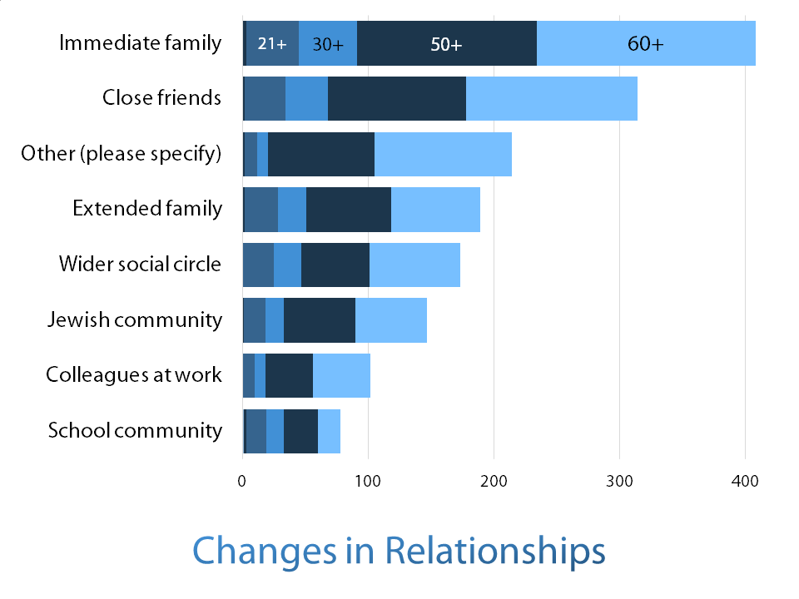

Table 43 shows the same data as 42 in different format. Across age groups we see a consistent pattern based on the number of responses. Responses varied based on the closeness of the relationships.
Table 43 Changes in Relationships
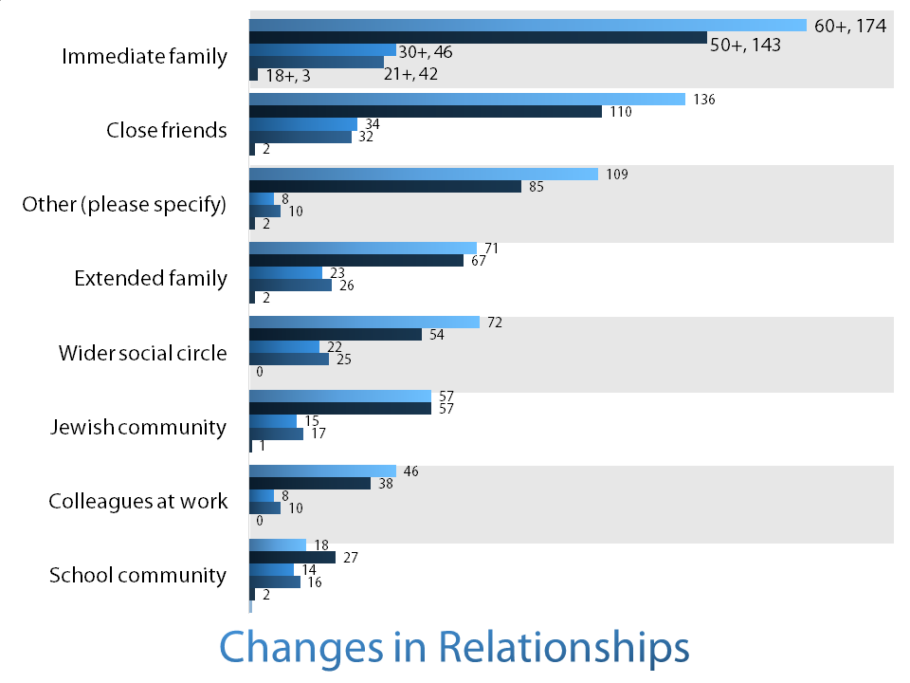

Table 44 asks for a narrative response. We see a more significant pattern in older respondents with regard to family and orientation to community. Respondents categorized as new perspective not only sought to change old relationships, but make new ones. They looked at existing relationships differently.
Table 44 Relationship Changes
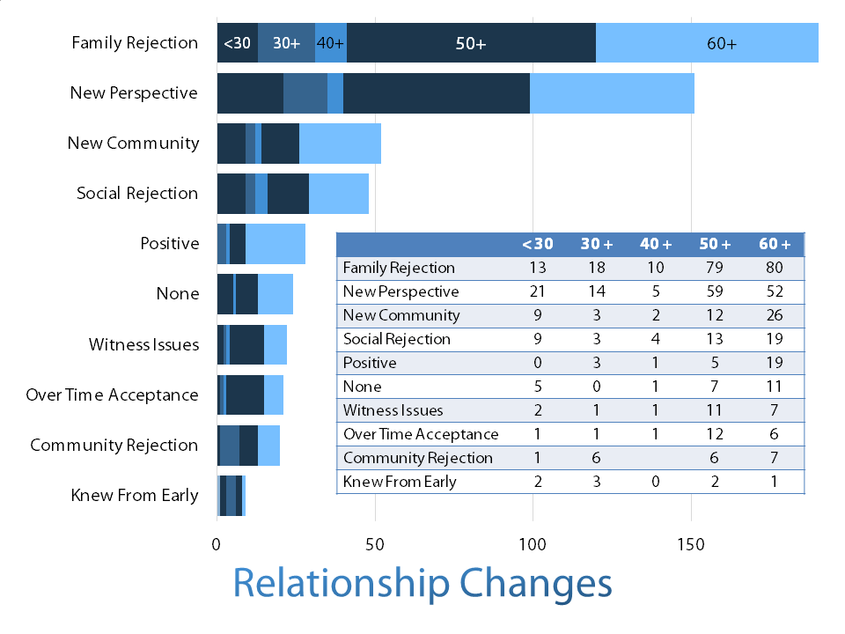

Table 45 is the same question presented in different form.
Table 45 Relationship Changes
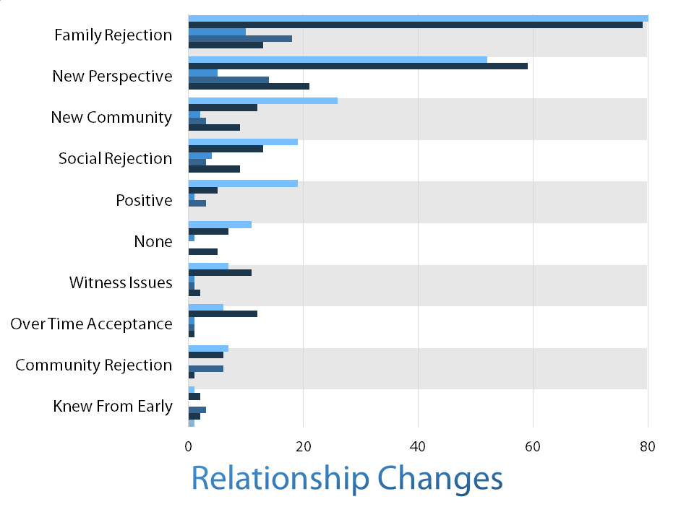

Conclusions
Our data addresses a wide range of complex phenomena. Our aim is to improve critical thinking on strategies, practices, and knowledge of the environments in which we work. We hope that this study will stimulate conversation and new efforts to understand the attitudes and behavior of North American Messianic Jews. Qualitative questions on peer and community pressure are open to competing narratives. We hesitate to conclude that Messianic Jews are either not welcome or not interested when it comes to continuity with family and institutions or how one affects the other. It is clear that both these forces are at work.
Through this study we explored three matters:
- The representation of the experiences of a group of Jews who believe in Jesus.
- How this group of Jewish people experienced cultural influences during their decision to follow Jesus
- How one generation’s experience compares with another

- Assimilation and Communication
Our results indicate that the Messianic Jewish community in North America is assimilated and accommodated into 21st century culture, but has not acculturated itself.
This means that Messianic Jews see Jewish religious and cultural forms as an important means of identification. Many want to participate in them while still being part of the wider culture. Jewishness and identification with the wider religious, social, and cultural characteristic Judaism is important, but most want choice. The statistics show us that being Jewish and identifying with Jewish values and causes is important, but so is being part of the wider culture of choice.
We would say these results show that resources must be brought to bear in these areas that respect a significant cross cultural approach. This approach attempts to look at things from the point of view of the receptors. The doctrine of sociocultural adequacy – of focusing on the receiver’s cultural perspective – helps us appreciate the essential validity of other peoples’ ways of life, and their basic assumptions and worldviews.
Charles Kraft is an apologist, anthropologist and linguist. He is Professor Emeritus of Anthropology and Intercultural Communication in the School of Intercultural Studies at Pasadena. Kraft sees sociocultural adequacy as an anthropological restatement of the Golden Rule; it advocates granting the same respect and appreciation to another’s culture as we would wish them to grant to us, were we in their place. In practicing this anthropological Golden Rule, Kraft asserts that human well-being is a value that transcends every culture. Thus, he affirms that we ought to look beyond the validity of specific cultural matrices toward what we might assume those cultural structures to be providing – genuine quality of life in material, spiritual and interpersonal and personal areas (Kraft 1996, 509).
The majority of our respondents are members of the “baby boom” generation. There are broad cultural similarities, and the historical impact of this generation is ubiquitous. The term has gained widespread popular usage. Baby boomers are associated with a rejection or redefinition of traditional values. We associate this generation with the birth of the modern messianic movement. We acknowledge and pay respect to the many thousands of Messianic Jews of previous generations on whose shoulders we stand.
David Baron was born in 1855 and cofounded the Hebrew Christian Testimony to Israel missionary organization, in London He was a leader in the Hebrew Christian movements of the Haskalah (Jewish Enlightenment) period in Europe. He wrote in 1893:
What we continually press upon Jews is that we believe Jesus is the Son of Man and Son of God, not in spite of, but because we are Jews. We believe that Jesus is the King of our people, the sum and substance of our Scripture, the fulfiller of our law and Prophets, the embodiment of the promises of our covenant. Our Testimony is that of Jews to Jews.

- Worldview Clash and Ethnic Cohesion
Messianic Jews find truth that is consistent and coherent with the Scripture. They do not find this same coherence in their culture.
This worldview clash is a maze of underlying presuppositions that lie at a deep and often unseen level of thought. This worldview is a necessary intellectual arrangement that encompasses both knowledge and viewpoints. We assume this worldview to be true; it offers coherence and a model of reality, and functions as a protective mechanism against other worldviews (Hiebert, 2008, 28). Worldview serves important social and cultural functions by providing answers to our deepest questions; it yields emotional security, validates norms, and offers psychological reassurance (Hiebert 2008, 29-30).
The Pew study indicates that most Jewish people are attracted to Jewishness and choice. Many are ambivalent about faith and already admit to the existence and tolerance of competing world views. Given this ambivalence, how do we explain this constant and consistent pressure within and without on Messianic Jews from the Jewish community?
Ethnic cohesion is an elusive factor, perhaps made up of some combination of pride in one's cultural heritage and a determination to survive. Its presence often keeps a people struggling to maintain their sociocultural existence, even in the presence of great pressure to change. The breaking of such cohesion results in the loss of the will of a people to continue living as a viable social entity. Tampering with this cohesion leads to, in the language of Jewish culture, a kind of confusion. To reject the gospel is to be accepted within this culture and, likewise, to accept the gospel is to be rejected by the culture. We see the rejection of Jesus and the culture we assume He represents as part of Jewish worldview and part of security, norms and reassurance.
- Messianic Jews and Conventional Jewish Values
Even with the minor differences in how the questions were framed across the various studies, these results show that the Messianic Jewish community in North America is more similar to the American Jewish community than to the general U.S. population in demographics such as Jewish dispositions, education and occupation. The nomenclature preference and religious observance levels among these Messianic Jews indicate a continuing identification with the Jewish people. The diversity of the Messianic Jewish community is the diversity of the larger Jewish community. We are, in our temperaments, dispositions and activities, part of this wider community. Messianic Jews seek ways to be part of the wider Jewish community.
- Hearing the Gospel
Responses to the questions about how Messianic Jews first heard the gospel and what attracted them to the gospel underline the significance of individual interaction. The more recent study also indicated that churches and Messianic congregations have an emergent impact.
- Intermarriage
There is a need for critical thinking in the area of intermarriage. If, as suggested by NJPS (Kosmin et al., 1991), approximately half of the general Jewish population marries non-Jews and three fourths of Messianic Jews marry non-Jews, how many of the children of these families will claim Jewish identity? The intermarriage situation is dynamic. In the general Jewish community, Taglit-Birthright Israel is altering marriage and family patterns (Saxe & Chazan, 2008; Saxe et al., 2012). Taglit, which brings young Jews to Israel, changes the course of participants’ deportment with regard to Jewish life. Messianic Jewish leaders must understand who these individuals are and how they are involved with their religious-ethnic identity. We are seeing as well, in the Messianic Jewish community, congregations and ministries making new and dynamic efforts to provide fellowship and service opportunities to young Messianic Jews which alter marriage and family patterns. We see this in our intermarriage statistics.
- Pressure
These qualitative results show that the older group of messianic Jews experienced quite a bit more external pressure than younger respondents. This older age group compromise second generation North American’s whose immigrant grandparents and parents lived in a more secure social and cultural dynamic.
This survey is a snapshot of a dynamic process. Because the Messianic Jewish community is changing so rapidly, the problem of relevant communication and generational change develops with it. Can we measure successful communication in less obvious and less quantifiable but equally important categories? People are to be treated as people, not as things; they are to be respected and consulted, not simply dominated. Potential innovations are to be politely advocated, not rudely mandated, even when the power of the change agents is considerable.
For us, the key is communicating Jesus as the fulfillment of the destiny and the hope of Israel. The promise to Abraham comes true in His person, work, and mission. What is clear is that a new narrative of contemporary Messianic Jewish life is needed: one that concedes the changing space, size and structure of the Messianic Jewish community and attempts to understand how Messianic Jewish life is evolving in the 21st century.

Authors
Andrew Barron, MA, is the director of Jews for Jesus Canada and is presently a D Min student at Wycliffe College University of Toronto.
Beverly Jamison, PhD, holds a BSc in Mathematics and a PhD in Computer Science. She has served as a reviewer in mathematics, statistics, and technology in the healthcare sector and presently works in information technology and academic publishing.

References
Guttman Center of the Israel Democracy Institute, "A Portrait of Israeli Jewry." Jerusalem, 2000.
Hiebert, Paul. 2008. Transforming Worldview. Grand Rapids: Baker Books.
Horowitz, B. (2000). Connections and journeys: Assessing critical opportunities for enhancing Jewish identity—Executive Summary. New York: UJA Federation of New York
Jews for Jesus. Jewish Believer Survey. San Francisco: Jews for Jesus, 1983.
Kraft, Charles. 1996. Anthropology for Christian Witness. Maryknoll: Orbis Books.
National Jewish Population Survey 2000-01 (NJPS; Kotler- Berkowitz et al., 2004)
Pew Research, Religion and Public Life Project. "A Portrait of Jewish Americans" October 1, 2013.
Saxe, L., & Chazan, B. (2008). Ten days of Birthright Israel: A journey in young adult identity. Lebanon, NH: Brandeis University Press/ University Press of New England.
Saxe, L., Shain, M., Wright, G., Hecht, S., Fishman, S., & Sasson, T. (2012). Jewish Futures Project: The impact of Taglit-Birthright Israel: 2012 Update. Waltham, MA: Cohen Center for Modern Jewish Studies.
Steinhardt Social Research Institute. American Jewish Population Estimates: 2012. Boston: Brandeis University
United States Census Bureau, American Fact Finder, Report DP03, "Selected Economic Characteristics, 2012 American Community Survey 1-Year Estimates".

