Review
Global Dictionary of Theology: A Resource for the Worldwide Church
Edited by William A. Dyrness and Veli-Matti Kärkkäinen
Downers Grove, IL: InterVarsity Press, 2008.
Reviewed By Rev. William W. Ki, D. Min.

Published in Global Missiology, Review & Preview, April 2009,
www.globalmissiology.org

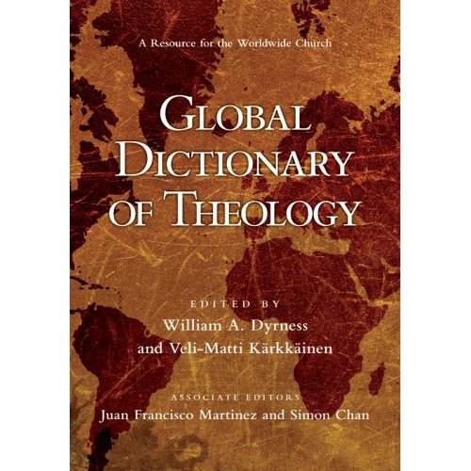

I believe in gaining access to more tools and resources for the servant leaders of the global church. Considering the subtitle, the Global Dictionary of Theology seems to be a welcomed addition to one’s library.
William A. Dyrness is a professor of theology and culture at Fuller Theological Seminary and was formerly a missionary to Thailand. Veli-Matti Kärkkäinen is a professor of systematic theology at Fuller. The two editors have solicited two associate editors to bring in international and intercultural experience. Juan Francisco Martinez is an associate professor of Hispanic studies and pastoral leadership at Fuller and has served in a seminary at Guatemala. Simon Chan, representing Asia, is the Earnest Lau Professor of Systematic Theology at Trinity Theological College in Singapore.
This five-year project is a compilation of 250 articles from over 100 international contributors. Extensive cross-references and bibliography can be found at the end of each article. The volume concludes with indexes categorized by Scripture, persons, subjects, and articles.
According to the editors, this dictionary is “to provide a general overview of theological reflection and practice throughout the world,” with seminary professors and students, missionaries, pastors, and lay church leaders comprising its target audience. The stated working framework is “evangelical and ecumenical,” but it does not suggest “a single methodology or particular theological slant.” Features of the book are threefold. (1) There is no entry of individual theologians. (2) Instead of having many shorter entries, they reserved the space for longer entries, many of which are parallel to journal articles. (3) The longer entries are usually coauthored by two or more theologians from various locations and traditions.
A common but significant editorial problem in dictionaries of theology is the balance between breadth and depth. The selection and length of articles reflect editorial intent. While this book seems to favor depth over breadth, the average article is no more than four pages.
As expected of a dictionary of theology, it contains traditional topics like, “revelation and Scripture”, “doctrine of God,” “justification,” “theodicy,” and “eschatology.” Sub-divisions within major topics such as African Theology and Latin American Theology are given their own entries. The longest article, topping 20 pages, is “Christology.” “Trinity” occupies 14 pages and “theology of missions,” 13. “Ecclesiology,” “salvation,” “Hinduism,” “poverty,” “pneumatology,” “sin,” “social ethics,” and “theological method” each takes up at least 10 pages.
There are atypical theological articles as well, including “theology of the city,” “Anabaptist theology,” “black theology,” “narrative theology,” “postcolonial theology,” “postliberal theology,” “Caribbean theology,” and “mujerista theology.” Other unusual entries include “land,” “space,” “time,” “discipleship,” “face,” “shame,” “animal rights,” “green theology,” and “preferential option for the poor.”
Theology can essentially be studied from three perspectives: theme, time and space. Theme falls under the realm of systematic and biblical theology. Historical theology traces the development of theology through time. The spatial aspect is the variation of theology in geographical locations. The emphases of Global Dictionary of Theology are local theologies and social issues of the contemporary world.
I find it strange to see entries of two books: “The Divine Comedy” and “Imitation of Christ,” as well as an article for “Our Lady of Guadalupe.” Among the extensive subjects of theology, these relatively small entries appear out of place. Similarly, Ordo Salutis (Order of Salvation) was, for some reason, chosen to be a separate entry, among numerous sub-topics of soteriology.
The editors state that “Christianity is moving from the Global North (Europe and North America) to the Global South (Africa, Asia, Latin America)” (p. ix). Conspicuously confusing in this broad description is China; though it is geographically situated in the North, it is associated with the South. This book includes only two short entries related to China, the place where the most Christians in the world reside today: “Chinese religions” and “Chinese theology.”
Clark Pinnock wrote a one-page article on “Open Theism.” I was disappointed at the lack of a counterpoint to complement the discussion of such a contemporary and crucial subject.
In terms of the challenges and limitations of the project, the editors said,
A further challenge that was in some ways surprising was the number of scholars from the Global South who tended to do theology in the manner of their Northern teachers. Occasionally, entries drafted by theologians from Asia, Africa and Latin America did not differ significantly from entries that would have been written by their European or North American counterparts (p. xi).

The editors attribute this limitation to the “long history of Euro-American theological traditions and the unequal distribution of resources in publications and theological education.”
However, I would challenge such presuppositions. It is quite plausible that for certain theological topics, there are few variations among all theologians, regardless of their location. May be theology around the world do not differ that much after all!
Global Dictionary of Theology takes bold and successful efforts, assuming the risk of publishing authors who are “newly minted PhDs and younger scholars in the beginning stages of their career. The multiple-author approach in many articles and their conversational dialogs are refreshingly effective.
The GDT is not an entry-level resource as a dictionary of theology. Though this volume is more complete than the Dictionary of Third World Theologies by Fabella and Sugirtharajah, it is far from being comprehensive.
One drawback of GDT may be that it attempts and assumes too much. Treatment of systematic and historical theologies is insufficient, giving way to contemporary and global theology issues. As mentioned above, the emphases and praxes of theology differ geographically, but the core doctrines do not. One can find the universal truths in the traditional theological themes in this dictionary. If stripped of everything but the local theologies and current social issues, GDT could be titled Global Dialog of Theology.
The GDT would best be supplemented with other similar references: New Dictionary of Theology (Sinclair B. Ferguson, David F. Wright and J. I. Packer, eds.), and Dictionary of Mission Theology: Evangelical Foundations (John Corrie, ed.), both of which are also published by InterVarsity, and Walter Ewell’s time-tested Evangelical Dictionary of Theology, published by Baker.

