GENTRIFICATION: IMPACT AND OPPORTUNITIES
FOR URBAN DIASPORA MISSIOLOGY

By Johnathan W. Bryson

Published in www.GlobalMissiology.org April 2017
ABSTRACT

The United States is currently the world’s top destination for global diaspora. The overwhelming majority of these people groups will make their new homes in the city since for many the city represents the place where practical resources and opportunities seem most plentiful. Many cities across the United States are experiencing not only an influx of global newcomers but also the return of and the expansion of indigenous populations. The latter occurrence often manifests in the form of gentrification. This “first to the cities meets back to cities” intersection is also a crossroads for urban diaspora missiology. Gentrification presents some unique challenges to and opportunities for urban diaspora missiology. This paper will briefly examine current scholarship on the issue of gentrification and include a brief history of gentrification. Also included will be an evaluation of the primary challenges and opportunities that gentrification presents to urban diaspora missiology, along with some conclusions and recommendations for dealing with this emerging missiological controversy.

INTRODUCTION

Since as early as Egypt and Rome and likely even before, as Diasporas head to the cities, the biggest question they face is whether there will be adequate resources there to meet them (Lambin & Meyfroidt 2011). North America represents the number one destination for diaspora groups (Pew Research Center 2013). Major cities in the United States are already bursting with new faces and increasing needs. What is more troubling is that smaller cities are feeling the pressure to accommodate growing numbers as well, creating a domino effect of sorts that impacts even the smallest cities and towns and eventually dissipates in rural and outlying areas. Many see gentrification and its impact as the catalyst behind this explosive growth (Maciag 2015). Those in favor of this idea point to the appeal of once blighted neighborhoods that are now trendy and chic. Neighborhoods that once offered housing options to low-income families now favor the upper-to-upper-middle class. Even economically stable neighborhoods where housing is affordable for middle-class are now the target of gentrification because of their proximity to amenities and resources. As opposed to other global gentrification movements gentrification in the west and in particular in the United States, does not seem to be concerned with absorbing the poor or accommodating the influx of diaspora groups who perhaps cannot pay the premium prices that accompany gentrification. Thus, many groups who rely on paired or bundled resources such as affordable housing and public transportation, but find themselves economically barred or displaced from the city will miss these centralized resources.
There is still much debate regarding the degree to which displacement due to gentrification occurs. Some say the impact is minimal while others naturally say that the impact is great; others argue that due to the pervasive nature of the issue it is really too early to tell. Data exist for every argument and in some cases researchers have amended their stance or changed it altogether due to the steady stream of emerging results (Freeman 2008). What is abundantly clear is that this is a discussion about two things: cities and people. Whenever the discussion turns in this direction, it becomes imperative that the church listens and engages. Urban diaspora missiologist already have their collective antennae tuned to many of the issues and discussion that by default relate to the gentrification debate. This essay attempts to unpack gentrification and its potential outcomes to the ongoing discussion on urban diaspora missiology and to the list of seriously overdue conversations that the church at large needs to have. Such a proactive approach can only serve to benefit the body of Christ in the long- run.

GENTRIFICATION IN RECENT LITERATURE

Research on the impact of gentrification on urban missiology or urban diaspora missiology is still limited. Sammy Campbell in The New Urban Missions briefly discusses gentrification and displacement (Campbell 2010). Alessandra Ram writes about the impact of gentrification on the Black Church (Ram 2012). Urbanization, which many confuse gentrification with, or lump gentrification under, emerges in discussions relating to urban missiology and diaspora missiology. John Fuder (2005) in A Heart for the City: Effective Ministry to the Urban Community discusses the impact of urbanization on urban ministries, as do Gary Fujino, Timothy R. Sisk, and Tereso C. Casiño (2012), in Reaching the City: Reflections on Urban Missions for the Twenty-first Century. Gentrification is distinct from urbanization and for the last few decades, it has steadily been the focus of debate and scholarly research.
Indicators that point to gentrification having an impact on urban diaspora missiology come from studies done on the impact of gentrification on low-income residents and those who may or may not have been displaced by gentrification. For example, Raphael Bostic and Richard Martin (2003) examined the impact of gentrification on Black homeowners during a two-decade period, while Neil Smith (1979) examines the catalysts behind gentrification. Jackelyn Hwang’s study of the impact of Asian and Latino immigration on gentrification reveals pertinent data in relation to diaspora studies (Hwang 2014). Much of what is missing in terms of literature is partly attributable to two factors.
The first involves the pervasive nature of gentrification. In some cases, it is simply hard to track using current methodologies. Researchers like Ingrid Ellen and Katherine O’Regan (2011) rely on aggregate data in their studies while others like Terra McKinnish, Randall Walsh, and Kirk T. White (2010) rely on Census long form data. There is also still great debate as to what exactly qualifies as gentrification. The second issue revolves around the age of the primary data that exists. Much of the literature written purely about gentrification is decades old and represents the beginnings of gentrification awareness. After a hiatus of sorts, the issue has reemerged and new research is emerging, however some of the results may take several years or even up to a decade or more to come in.

GENTRIFICATION EXPLAINED

The term ‘gentrification’ has been around since at least the mid 1960’s. British sociologist Ruth Glass is credited with creating the term when in 1964 she noticed significant changes to London’s urban landscape. Glass stated, "One by one, many of the working class quarters have been invaded by the middle class - upper and lower ... Once this process of 'gentrification' starts in a district it goes on rapidly until all or most of the working class occupiers are displaced and the whole social character of the district is changed" (Glass 1964 p. xvii). Standard definitions of gentrification define it as, “The process of renovating and improving a house or district so that it conforms to middle-class taste (Oxford 2015)” and “the process of renewal and rebuilding accompanying the influx of middle-class or affluent people into deteriorating areas that often displaces poorer residents (Merriam-Webster 2015).”
Gentrification is by nature a long-term perpetual process. We can safely regard the process as perpetual because it is at its basest level, economically driven and constantly looking for the next opportunity to “buy low and sell high.” In fact Neil Smith, who some consider to be the father of Gentrification Theory, writes,

Consumer sovereignty hypotheses dominate explanations of gentrification but data on the number of suburbanites returning to the city casts doubt on this hypothesis. In fact, gentrification is an expected product of the relatively unhampered operation of the land and housing markets. The economic depreciation of capital invested in nineteenth century inner-city neighborhoods and the simultaneous rise in potential ground rent levels produces the possibility of profitable redevelopment. Although the very apparent social characteristics of deteriorated neighborhoods would discourage redevelopment, the hidden economic characteristics may well be favorable (Smith 1979).

Some view gentrification, especially in the hands of governments and private industry, as little more than classic urban revitalization/redistribution (Milloy 2014). Opponents of government-initiated gentrification argue that at the heart of process is a desire for an increased tax base at any cost (Atkinson n.d.). The length and pervasive nature of gentrification make it difficult at best to say conclusively what gentrification’s final impact is on people and neighborhoods. Lance Freeman (2008) whose work is used by both proponents and opponents of gentrification has stated that much of the critical evidence is “thin” and in some cases “inconclusive”.
The immediate results are clear, that is, suddenly blighted neighborhoods seemingly become more aesthetically and economically appealing. Neighborhoods also initially become more socially and economically diverse. In the hands of private citizens, gentrification appears to some to breathe new life into dying neighborhoods to the exclusion of only a few if any existing residents. As a result, two schools of thought emerge--one that celebrates all that gentrification accomplishes, and another that rejects all that gentrification represents.

IMPACT ON URBAN MISSIONS

Gentrification could affect the effectiveness of the church’s urban missions in both positive and negative terms. Positively, gentrification may promise affordable housing, centralization of resources, new employment opportunities, as well as new age, gender, and economic demographics within urban congregations. Many middle-class families who have been priced-out of more established neighborhoods view gentrification as an opportunity to maximize their home-buying dollars by getting in on the ground floor of up and coming neighborhoods. Thus in one way gentrification could serve to increase the number of urban missionaries by increasing the number of Christians in the urban setting.
Negatively however, gentrification could perpetuate the gap between the haves and the have-nots, class inequalities, marginalization of the underprivileged in urban societies, and forced transitions. The greatest impact that gentrification is thought to have on the communities impacted by it is the reduction in affordable housing for existing low-income residents. Quality affordable housing will always be a challenge as long as the responsibility for ensuring and providing for it falls solely to governments. While not as bad as in the city, even in rural areas quality affordable housing presents a challenge. According to the Department of Housing and Urban Development (Affordable Housing 2015), housing is unaffordable when it exceeds 30 percent of a family’s income. The economic downturn of the last decade has created more demand than supply of subsidized housing and Housing Authorities now have waiting list years long. The National Low Income Housing Coalition states that the average wait-list time for low-income housing is two years and had this to say about the impact of this fact on rural areas:

The lack of decent, affordable housing is not solely an urban issue. Inadequate and substandard affordable housing is an issue that remains all too common in low- income rural communities. And in spite of lower housing costs, rural Americans are increasingly facing a cost burden. Between 2000 and 2010, the number of cost burdened rural renter households increased by ten percentage points, largely caused by the lack of affordable rental units in rural areas. Many rural and tribal communities have minimal resources devoted to the development of new rental housing. And rural affordable housing developers face unique challenges, such as limited access to capital financing (NLIHC Out of Reach 2013).

The following graph from Benjamin Landy of The Century Foundation (Landy 2012) shows how even in the most affordable states, low-income housing and the average cost of rent requires a person making the minimum wage to work in excess of a forty- hours per work. While this graph deals with the reality of affordable housing or lack thereof, it also speaks to the affordability of goods and services for the person making the minimum wage if housing costs alone require excessively long hours of work. With only so many hours in a day and legal limitations on how many hours can be worked on one job per day, how can someone making the minimum wage have a sustainable quality of life economically?

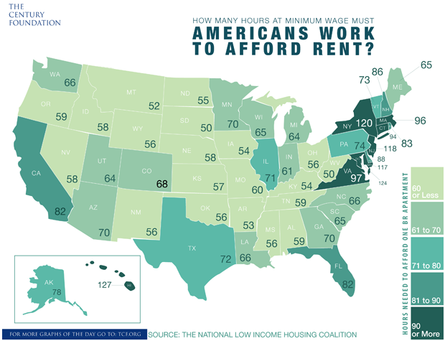

Again, as studies show (Feldman 2014), the question is not one of whether gentrification leads to displacement but a question of the extent to which it does and the long-term implications of such. What we know for sure is that in many cities impacted by gentrification, the one thing that has yet to change is the centralization of resources. Human services and public transportation in many instances remain centralized within the city. Dante Perez notes that proximity to affluent neighborhoods can severely reduce access to resources utilized by neighboring low-income residents (Perez 2014). Those displaced by gentrification into more affordable rural areas are in many cases left to figure out how to gain access to the resources that they have come to depend on. For example, in cases where there is a dependence on public transportation by a family over multiple generations, there may not be aptitude present or personal resources available to begin the process of utilizing privately owned vehicles.
Diaspora groups hoping to making urban areas their home may find themselves priced out of areas that as little as a decade ago would have been readily accessible. The quest for affordability comes at a premium. Often rural areas are not equipped to meet the social needs of diaspora groups. Besides access to resources, there are language and education barriers unique to rural areas. Most institutions of higher learning are located in cities along with interpreters and a host of other ESL resources. Much discussion is occurring regarding the increasing size of cites worldwide due to rural-to-urban migration (Fujino & Cheong 2012), but at a minimum equal consideration needs to exist for diaspora groups that transition from urban areas to urban areas (Berg 2012).
If when arriving to the United States certain diaspora groups find themselves priced out of urban markets and forced to establish themselves in a rural setting, are we willing to assume that their urban worldview will automatically and positively reset to a rural worldview? If we are not willing to make such an assumption then we should give careful consideration to the psychological impact of forced transition from an urban to rural settings. This is true not only for diaspora groups but for local populations displaced by gentrification as well (CDC Gentrification 2013). The impact of gentrification on the city’s poor and the subsequent displacement that likely occurs as a result does not have to be a bad thing if handled proactively and deliberately. The church can certainly assist to ensure that this is the case.

OPPORTUNITIES FOR DIASPORA MISSIOLOGY

The primary impact of gentrification on urban diaspora missiology is that gentrification carries with it the potential to extend the urban mission field beyond traditional urban borders. If the focus of urban diaspora missiology is to reach those who are first to the cities and those who are returning to the cities, then it must take into consideration those who are conceptually in the city by virtue of their worldview but relegated to rural and outlying underserved areas for economic reasons. In addition, gentrification has the potential to expand how we conceptually understand diaspora by expanding our understanding of people groups and thus allowing us to to include those displaced by gentrification. What all of this potentially creates is a wonderful opportunity for urban diaspora missiology. If we focus our attention toward diaspora impacted by gentrification then we find that we have the opportunity to reach them and help them by concentrating on mission to, mission through, and mission beyond the diaspora (Lausanne Committee for World Evangelization 2010).
Mission to the diaspora in light of gentrification could be two-fold consisting of identifying and reaching diaspora groups inside the city as well as those from corresponding rural settings. Mission through the diaspora could naturally follow the first step by equipping diaspora groups identified in urban and corresponding rural settings to engage their fellow diaspora missionally. Mission through the diaspora alleviates many of socio-cultural barriers that may be present as part of mission to the diaspora. Both of the aforementioned corresponding strategies should ultimately lead to mission beyond the diaspora or cross-cultural diaspora-led mission. Diaspora who carry not only the gospel but also a personal message about the challenges of social and economic marginalization, displacement, or transitional hardships are powerful witnesses to those experiencing any part of the same. The most practical way to engage diaspora as well as anyone else negatively impacted by gentrification is to focus our individual or collective efforts on three primary areas: housing, transportation, and education (Bryson 2014). There are within these three areas numerous opportunities for the church, civic organizations, or committed individuals to form partnerships and mobilize resources to meet the needs created by gentrification.

Community Planting

Churches must consider becoming property owners in cities and rural areas. Mobile homes, mill houses, abandoned city blocks, crime-ridden areas, former commercial sites, and other locations provide churches with affordable and unconventional opportunities to respond to an undeniable affordable housing need. In fact rather than planting a church in an existing community, the church can plant a community and already be an integrated part of it. Community planting will require partnerships. Urban churches and rural churches must share the vision of providing quality affordable housing to those who need it most. Investing in affordable housing options also creates the potential for residual income for churches that could be used to fund other programs within the church. Now is the time to act while real estate prices and interest rates are at historic lows. The graph below from Dr. Mark Perry’s blog Carpe Diem (Perry 2012) shows the affordable opportunities the last few years have produced as opposed to decades past.

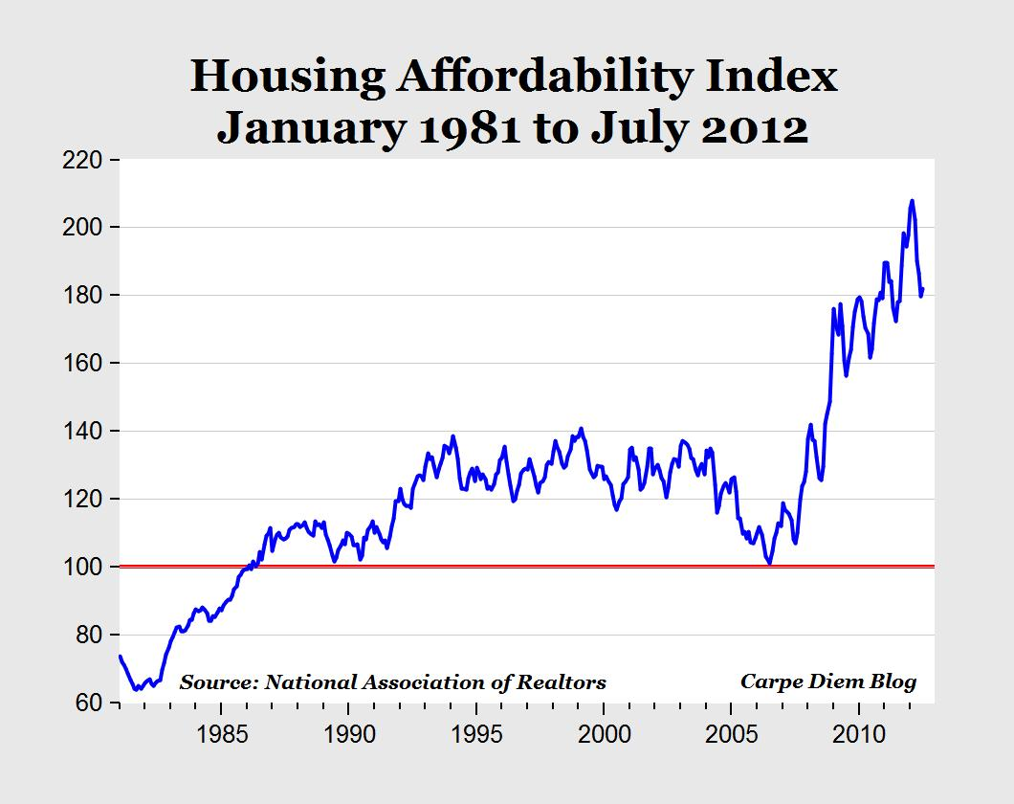

Transportation

The cost of transportation far exceeds just the purchase of a vehicle. One must consider insurance, maintenance, taxes, and other annual fees such as inspections and license and license plate renewal. For example in Singapore the cost of owning a car exceeds $60,000 (Goodman 2012) and while that is not the case in the United States, to someone who can barely afford housing cost any additional cost may as well be just as high when you do not have it. Even cities that receive federal assistance for public transportation wrestle with the cost of transportation. Some cities even forego establishing or expanding their public transportation infrastructures in an effort to avoid attracting the poor. Yonah Freemark of The Transport Politic had this to say:

The provision of transit for impoverished people is a redistributive service, and there is considerable theoretical support for the argument that redistributive public functions should not be funded by local governments. Cities that choose to aid their poor, scholars like Paul Peterson have argued, will simply attract more of the needy into their city limits; other municipalities without such aid will be able to escape with lower taxes and no aid to the poor (Freemark 2011).

In addition one is required to (on paper at least) have mastered the skill of operating a motor vehicle within the laws of one’s state. It is incorrect to presume that diaspora or displaced groups who once enjoyed public transportation and now find themselves without it can simply and easily transition to privately owned vehicles. Poverty rates in many cases are directly tied to public transit funding. Freemark illustrates this with the graph below and when he writes:

Comparing statistics across this group of cities indicates that by requiring operating funding to be assembled at the local level, people living in poorer metropolitan areas are likely to be denied the quantity of transit services that their peers in wealthier regions are offered. This will only increase the transportation costs faced by people living there. This indicates that there is a strong equity argument to shift operating funding of transit services away from the local level and towards the federal government, which would be more likely to spread resources equally across metropolitan areas, regardless of local incomes.

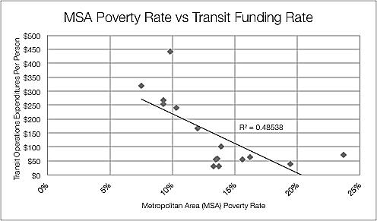

Lack of adequate transportation can severely limit one’s ability to survive and thrive in urban and especially rural areas. Churches can respond by canvasing urban and rural areas in an effort to determine where they can maximize their resources such as church buses, vans, and privately owned vehicles in helping diaspora gain access to needed resources. Attacking this epidemic does not have to be the sole responsibility of one church or denomination. Churches could transport people to the nearest bus stops or public transportation hub as little as once a day, week, or month, through inter-denominational, inter-faith, or inter-organizational collaborations. Churches could also look at lobbying for expansion of the public transit system to cover underserved areas.

Education

Throughout history, education has improved the quality of life for people around the world. Without access to education and the technology associated with it, many will never escape the captivity of their current circumstances. Many educational institutions remain centralized in the cities with the exception of primary schools such as elementary and high schools. Many poor are consumed with meeting the most basic needs and often do not have the time or money to invest in education.
Just as churches located in private homes provide people with greater access to the gospel, home schools or community schools can provide diaspora or the displaced with expanded educational opportunities. Again, partnerships are key. Educational institutions and churches must collaborate to bring educators into communities to teach practical courses aimed at improving quality of life. Churches should also be deliberate about identifying people from within their own ranks to teach practical and vocational skills to those in need.
Distance education is already an established medium of learning. Many churches already serve as centers for gaining Adult Basic Education credits. An expanded version of this existing paradigm could include churches that serve as satellite campuses for obtaining a formal college or vocational education in disenfranchised areas. When there may be a conflict of interest between churches and existing educational institutions, churches should look at creating their own educational institutions to meet the needs of their community.
Naturally, these efforts will require a deliberate redirection of resources and a willingness to maximize existing partnerships while forming new ones. It will also require churches and individuals in the west to engage diaspora as partners or co-laborers rather than seeing them as voiceless recipients of western assistance. Given the opportunity, diaspora can lead the effort to lessen the impact of gentrification on their given group. What is most necessary is a willingness to accept the theory that unchecked gentrification carries with it the potential to negatively impact the lives of people everywhere, and a willingness as believers to be proactive in our efforts to counter the potentially negative effects of this growing issue.

CONCLUSION

This integrated, urban-rural, cross-cultural model is not new. We see this demonstrated in the early days of Christianity where one group went to the Jews and the other went to the Gentiles. Those reached carried the gospel intra-culturally from there, and then beyond, internationally cross-culturally engaging others. This strategy, born out of persecutions, marginalization, and hardships has proven very effective for over 2000 years. If we accept that whenever people move, the gospel moves, then we should become better able to see how the implications of this early paradigm are extremely relevant to the discussion surrounding gentrification and urban missiology.
Urban diaspora missiologist can advocate for and teach relevant strategies for maximizing outreach to, through, and beyond diaspora populations directly or indirectly impacted by gentrification. Strategies involving outreach to the displaced are of the utmost importance if the displaced populations are to get or remain connected to Christian networks. Rural and urban churches can form partnerships and mobilize to assure that displaced groups continue to have access to centralized resources. The key to success is to be proactive in our approaches to dealing with the impact of gentrification. To wait is to limit the scope of our effectiveness and to in many ways, fail in our stewardship of resources.
While it is still too early to determine the long-term effects of gentrification and thus determine to what extent it is truly a missiological issue it is never too early to begin anticipating paradigm shifts and planning strategies. The question on our collective minds should be this: Can we afford not to discuss gentrification and its implications? If we are genuine in our desire to be light to the nations then the answer is no. The gentrification discussion outside evangelical circles is alive and well. As evangelicals, we do not seek to dictate the conversation but we certainly have a responsibility to take a seat at the table and offer the guidance that is unique to our worldview.

REFERENCES

Atkinson, R. (n.d.). “Displacement through gentrification: How big a problem?” Radical
Statistics. Available from: http://www.radstats.org.uk/no069/article2.htm.
[Accessed: 01 March 2015].
Berg, N. (2012, February 27). “Tracing America's Urban-to-Urban Migration Through
the Recession,” From The Atlantic City Lab. Available from: http://www.citylab.com/housing/2012/02/tracing-americas-urban-urban-migration-through-recession/1338/. [Accessed: 01 March 2015].
Bostic, R., & Richard, M. “Black Home-Owners as a Gentrifying Force? Neighbourhood
Dynamics in the Context of Minority Home-ownership.” Urban Studies. 40 (12/2003). pp. 2427-2449.
Campbell, S. (2010). The New Urban Missions: Local Breaching for Global Reaching.
Crossbooks, Bloomington.
Centers for Disease Control (2013, August 21). Health Effects of Gentrification, Available
from: http://www.cdc.gov/healthyplaces/healthtopics/gentrification.htm. [Accessed: 01 March 2015].
Department of Housing and Urban Development (2015). Affordable Housing. Available
from: http://portal.hud.gov/hudportal/HUD?src=/program_offices/comm_planning/affordablehousing/. [Accessed: 01 March 2015].
Ellen, I.G. & O’Regan, K.M. (2011). “How Low-income Neighborhoods Change: Entry,
Exit, and Enhance,” Regional Science and Urban Economics. 41. (2/2011). pp. 89-97.
Feldman, J. (2014, August 15). “Gentrification, urban displacement and affordable
housing: Overview and research roundup,” Journalist’s Resources. Available from: http://journalistsresource.org/studies/economics/real-estate/gentrification-urban-displacement-affordable-housing-overview-research-roundup#. [Accessed: 01 March 2015].
Freeman, L. (2008). “Comment on ‘The Eviction of Critical Perspectives from
Gentrification Research’,” International Journal of Urban and Regional Research. 32 (1/2008). pp. 186-191.
Freemark, Y. (2011, December 28). “Local Funding for Public Transportation Operations:
Producing Inequitable Results?” The Transport Politic. Available from: http://www.thetransportpolitic.com/2011/12/28/local-funding-for-public-transportation-operations-producing-inequitable-results/. [Accessed: 01 March 2015].
Fuder, J. (1999). A Heart For The City: Effective Ministries to the Urban Community.
Moody Press, Chicago.
Fujino, G. & Cheong, J. (2012). “Emerging Global Mega-Regions and Globalization:
Missiological Implications, “In G. Fujino, T.R. Sisk, and T.C. Casiño (Eds.), Reaching the City: Reflections on Urban Ministry for the Twenty-first Century. William Carey Library, Pasadena.
Fujino, G. & Sisk, T.R. & Casiño, T.C. (eds.) (2012). Reaching the City: Reflections on
Urban Ministry for the Twenty-first Century. William Carey Library, Pasadena.
Glass, R. (ed.) (1964). London: Aspects of Change. MacGibbon & Kee, London. p. xvii.
Goodman, W. (2012, June 04). “Singapore Family Sedan Matches Cost of a U.S. Home,”
Bloomberg Business. Available from: http://www.bloomberg.com/news/articles/2012-06-04/singapore-family-sedan-matches-cost-of-a-u-s-home. [Accessed: 01 March 2015].
Hwang, J. (2014, September 26). “How “Gentrification” in American Cities Maintains
Racial Inequality and Segregation,” SSN Scholars Strategy Network. Available from: http://thesocietypages.org/ssn/2014/09/26/gentrification-in-american-cities/. [Accessed: 01 March 2015].
Landy, B. (2012, June 03). “Graph: Where Can You Live on Minimum Wage?” What We Work
On: The Century Foundation. Available from: http://www.tcf.org/work/detail/graph-where-can-you-live-on-minimum-wage. [Accessed: 01 March 215].
Lambin, E. & Meyfroidt, P. (2011). “Global land use change, economic globalization,
and the looming land scarcity,” PNAS Proceedings of the National Academy of Sciences of the United States of America, [Online] PNAS Database 108 (9/2011). pp. 3465-3472. Available from: http://www.pnas.org/content/108/9/3465.full. [Accessed: 01 March 2015].
Lausanne Committee for World Evangelization (2010). Scattered to Gather: Embracing
the Global Trend of Diaspora. LifeChange Publishing, Manila. pp. 24-27.
Maciag, M. (2015). “Gentrification in America Report,” Governing the States and Localities,
Available from: http://www.governing.com/gov-data/gentrification-in-cities-governing-report.html. [Accessed 01 March 2015].
McKinnish, T. & Walsh, R. & White, T.K. (2010). “Who gentrifies low-income
neighborhoods?” Journal of Urban Economics. 67. (2/2010). pp. 180-193.
Merriam-Webster (2015). Gentrification. Available from: http://www.merriam-
webster.com/dictionary/gentrification. [Accessed: 01 March 2015].
Milloy, C. (2014). ‘Initiative to revitalize Barry Farm is little more than an urban
dispersal plan,’ The Washington Post 28 October. Available from: http://www.washingtonpost.com/local/2014/10/28/a5641e80-5ec7-11e4-91f7-5d89b5e8c251_story.html. [Accessed: 01 March 2015].
National Low Income Housing Coalition (2013). Out of Reach 2013 Introduction. Available
from: http://nlihc.org/sites/default/files/oor/2013_OOR_Introduction.pdf. [Accessed: 01 March 2015].
Oxford Dictionaries (2015). “Gentrification,” Oxford University Press. Available from:
http://www.oxforddictionaries.com/us/definition/american_english/gentrification. [Accessed: 01 March 2015].
Perez, D. (2014, September 16). “How rich enclaves affect nearby municipalities’ policies
and low-income residents,” Journalist’s Resource. Available from: http://journalistsresource.org/studies/government/municipal/wealthy-enclaves-municipal-policies-low-income-residents. [Accessed: 01 March 2015].
Perry, M. (2012, September 17). “Housing Affordability is Historically Very High,” Carpe
Diem: Professor Mark J. Perry's Blog for Economics and Finance. Available from: http://mjperry.blogspot.com/2012/09/chart-of-day-housing-affordability.html. [Accessed: 01 March 2015].
Pew Research Center (2013). Changing Patterns of Global Migration and Remittances: Top-
10 Destination Countries of International Migrants, 2010–2013. Available from: http://www.pewsocialtrends.org/2013/12/17/changing-patterns-of-global-migration-and-remittances/sdt-2013-12-17-global-migration-02-02/. [Accessed: 01 March 2015].
Ram, A. (2012, October 12). “In Changing Neighborhoods, Black Churches Face an
Identity Crisis,” The Atlantic. Available from: http://www.theatlantic.com/national/archive/2012/10/in-changing-neighborhoods-black-churches-face-an-identity-crisis/263305/. [Accessed: 01 March 2015].
Smith, N. (1979). “Toward a Theory of Gentrification a Back to the City Movement by
Capital, not People,” Journal of the American Planning Association. 45. (4/1979). pp. 538-548.

Lambin and Meyfroidt discuss the increasing scarcity of land due to globalization highlighting the increased scarcity in urban areas and residual effects of such. Scarcity of and diminished access to goods and services are among the residual effects they note. Lambin and Meyfroidt identify four areas that perpetuate this scarcity writing, “The displacement, rebound, cascade, and remittance effects—that are amplified by economic globalization accelerate land conversion.”
Maciag uses census data to identify population increases in gentrified areas across the nation. Census data used by Maciag points to a 6.5% increase in population where gentrification as occurred.
Freeman responds to the argument by Slater, that more critical gentrification research is needed and that researchers are trending toward a less critical view. Freeman’s 2005 study is used by both pro and anti-gentrification proponents to argue for and against a connection between gentrification and displacement. While Freeman acknowledges that, his findings revealed only a slight increase in displacement due to gentrification he warns that the results should not be used to declare gentrification as harmless. Freeman notes that more research is needed and that the issue is complex and multifaceted.
Campbell in his section, The Benefits of a Nonprofit Organization to the Church, discusses re-gentrification and displacement by church-based nonprofits seeking to work in low-income neighborhoods (174).
Jackelyn Hwang. How “Gentrification” in American Cities Maintains Racial Inequality and Segregation. 2014. Hwang’s study looks in part at the disparity between Asian in-migration and Latino in-migration as it relates to gentrification and positive outcomes.
The Department of Housing and Urban Development States that anything over a 30 percent threshold threatens a family’s ability to afford food, transportation, and medical care. HUD states this in regard to affordable housing,” An estimated 12 million renter and homeowner households now pay more than 50 percent of their annual incomes for housing. A family with one full-time worker earning the minimum wage cannot afford the local fair-market rent for a two-bedroom apartment anywhere in the United States.”
Benjamin Landy. Graph: Where Can You Live on Minimum Wage? 2012. Landy’s graph focuses solely on the average cost of rent and raises questions about the viability meeting basic individual economic needs on a minimum wage salary.
Feldmen points to the higher aggregate levels of displacement noting the residual effects such as higher rents for less space, overcrowding, and even homelessness.
Perez examines the long-term political effects of gentrification noting the trend toward reduced spending on public services among municipalities consisting of affluent and low-income neighborhoods existing within close proximity of each other.
In Reaching the City: Reflections on Urban Mission for the Twenty-first Century, Gary Fujino and John Cheong in their chapter, Emerging Global Mega-Regions and Globalization: Missiological Implications discuss the trend toward urbanization and cite United Nations data that indicates that by 2050 the world population is predicted to be 70% urban.
Nate Berg in his article, Tracing America's Urban-to-Urban Migration Through the Recession uses data collected from MetroTrends, The Internal Revenue Service, and Census data to track internal urban to urban migration in the United States. Berg notes that the United States has an 80% urban population, which is significant considering that the United States is the leading destination for global diaspora.
Organizations such as the Centers for Disease have begun to examine the physiological and psychological impacts of gentrification. Their initial findings include correlations between those displaced by gentrification and increased stress levels, violence and crime, and compromised mental health. The CDC reports the following, “Where people live, work, and play has an impact on their health. Several factors create disparities in a community’s health. Examples include - socioeconomic status, land use/the built environment, race/ethnicity, and environmental injustice. In addition, displacement has many health implications that contribute to disparities among special populations, including the poor, women, children, the elderly, and members of racial/ethnic minority groups. These special populations are at increased risk for the negative consequences of gentrification. Studies indicate that vulnerable populations typically have shorter life expectancy; higher cancer rates; more birth defects; greater infant mortality; and higher incidence of asthma, diabetes, and cardiovascular disease. In addition, increasing evidence shows that these populations have an unequal share of residential exposure to hazardous substances such as lead paint.”
In Scattered to Gather: Embracing the Global Trend of Diaspora (pp. 24-27) the Lausanne Diaspora Development Team unpacks the rationale behind, “mission to, through, and beyond the diasporas.” This model offers a viable means for connecting rural and urban diaspora displaced through gentrification.
In an unpublished paper I wrote entitled, Rural Diaspora, Challenges and Solutions: Exploring the Impact of Gentrification, I unpack multiple partnership opportunities as well as mobilization strategies aimed at meeting potential housing, transportation, and educational needs connected to gentrification.
Perry discusses the historic affordability of housing as compared to decades past and encourages buyers to take advantage of the historically low prices. It is worth stating however that historically low home prices are beneficial only to those economically able to purchase a home, and in no way implies that there is not truly a need for increased affordable housing options for those unable to purchase homes and thus must rent.
Wes Goodman. Singapore Family Sedan Matches Cost of a U.S. Home. 2012. Goodman discusses the exorbitant cost of owning a vehicle in Singapore and compares it with the average price of a home in the United States. Goodman also notes the potential negative impact that this policy aimed at the wealthy has on Singapore’s poor.
Yonah Freemark. Local Funding for Public Transportation Operations: Producing Inequitable Results? 2011. Freemark discusses how poorer regions are more likely to spend less on public transportation and how this increases transportation cost for the poorer residents of those regions.

