COMMUNICATING AND EVANGELIZING RUSSIANS BY AMERICANS
BASED ON HOFSTEDE’S CULTURAL ANALYSIS
Enoch Wan
Published in www.GlobalMissiology.org July 2017

Introduction
Communicating with and evangelizing Russians by Americans generally speaking is a difficult endeavor wrought with challenges. This exploratory study is just a personal attempt to take on the challenge.
“Relevance principle” (though it is not the focus of this study) is known in communicative science and the following is a simple explanation for it:
“Proponents of relevance theory say that in communication, the communicator gives evidence of her thoughts and intentions through her use of language. She expects her recipient to infer her meaning not only from the language that she uses but also from the context of the communication and what he already knows about her thoughts and attitudes. Using all of this information, the recipient infers what she intended to communicate. Relevance theory emphasizes that much of what the recipient infers comes from these sources that are in addition to what is actually said.”

There are various ways of understanding and practicing evangelism and quoted below are just two samples:

- “Evangelism is “that dimension and activity of the church’s mission which, by word and deed and in the light of particular conditions and a particular context, offers every person and community, everywhere, a valid opportunity to be directly challenged to a radical reorientation of their lives, a reorientation which involves such things as deliverance from slavery to the world and its powers; embracing Christ as Savior and Lord; becoming a living member of his community, the church; being enlisted into his service of reconciliation, peace, and justice on earth; and being committed to God’s purpose of placing all things under the rule of Christ.”
- “Evangelism is inviting people to come to Jesus, sharing the good news ‘that Christ died for our sins according to the Scriptures, that he was buried, that he was raised on the third day according to the Scriptures (1 Corinthians 15:3-4).”

Purpose of the Paper
The purpose of this study is to present suggestive ways for Americans to communicate and evangelize Russians by employing Hofstede’s cultural analysis. This study is delimited by choice to use Hofstede’s cultural analysis as a basis for cross-cultural communication and evangelism by Americans.

Definition of Key Terms
In order to have better communication, several key terms are defined below:
- communicating: interaction between personal beings by which information/message being conveyed/transferred among them.
- evangelizing: interaction between personal beings by which the Gospel message being conveyed/transferred from one to another.
- American: the cultural heritage with the following characteristics: “low power distance, high individualism, high masculinity, low uncertainty avoidance, low long-term orientation, and high indulgence.”

Duane Elmer’s “Cultural Differences that Affect Communication”
The following introduction of Duane Elmer’s approach is based on two sources: Elmer, Duane. Cross-Cultural Connections: Stepping Out and Fitting In around the World. Downers Grove, Illinois: IVP, 2002. And Elmer’s. “Cross Cultural Relations and Communications,” International Multicultural Institutes, August 2014 http://www2.isu.edu/fsen/InformationItems/FacultyStaff_ParticipantHandout_AL%208-11d.pdf

Time and Event (Russian = Event-Oriented)
Western cultures tend to be time oriented, whereas many non-Western cultures are event oriented. Westerners often focus on how long a meeting or worship service lasts, whereas non-Westerners often focus on the quality of the event and whether it is a good experience for the people attending it.

Task and Relationship (Russian = Relationship)
Some cultures emphasize getting jobs done, projects completed, and deadlines met. Other cultures emphasize developing and maintain interpersonal relationships even if the task gets done more slowly.

Individualism and Collectivism (Russian = Collectivism)
Individualism is a value associated with the cultures of Europe and North America, but with globalization it is spreading. Slogans like “Follow your passion” and “Be true to yourself” express individualism’ emphasis on each person’s autonomy in decision making and seeking success or fulfillment. Collectivism emphasizes the importance of the group more than the individual. At work, collectivist cultures emphasize being a loyal employee, fitting in, and working for the group’s success and recognition, not individual awards. In sports, the team is far more important than any single player.

Categorical and Holistic Thinking (Russian = Holistic Thinking)
Some cultures see life as consisting of elements that can be separated from one another, whereas other cultures see life as a single tapestry woven into a unified whole.

Logic: Straight or Curved (Russian = Straight)
Some cultures, especially in the West, value communication that is direct and to the point, moving step by logical step. Other cultures prefer “curved” approaches to communication and process. Their communication about an important matter like a spiral that begins wide and gradually moves in an ever-tighter curve until it gets to the central concern.

Achieved Status and Ascribed Status (Russian = Somewhere in the middle)
In many of the world’s cultures, individual statuses come from relationships and roles that the culture attributes to each. In contrast, other cultures emphasize the possibility of improving one’s status by achievements in school and work, becoming affluent, “marrying up,” gaining power, moving into desirable neighborhoods and joining prestigious groups.

Guilt and Shame (Russian= Somewhere in the Middle)
To generalize, shame cultures look to external sources of approval to determine whether a person’s conduct is acceptable. In guilt cultures, which are typically also more individualistic cultures, people are expected to internalize laws or the rules of a moral code and obey their conscience.

Hofstede’s cultural analysis

Background of Hofstede’s Cultural Analysis
“Geert Hofstede has defined “culture” as “the collective programming of the mind that distinguishes the members of one group or category of people from others”. In 1980 he published his book, Culture’s Consequences: International Differences in Work-Related Values. As the title suggests, this book was entirely devoted to the study of culture at the national level, in which values played a major role. The book’s main innovation was its use of the concept (paradigm) of dimensions of culture: basic problems to which different national societies have over time developed different answers.
Using research data from a multinational company (IBM) with subsidiaries in more than 60 countries, he identified four largely independent dimensions: Power Distance (large versus small), Uncertainty Avoidance (strong versus weak), Individualism versus Collectivism and Masculinity versus Femininity. The relative positions of 40 countries on these four dimensions were expressed in a score on a 0-100 point scale. Replications by Hofstede and other researchers have extended the number of countries covered to 76.
The dimensions concept was widely adopted by other researchers, and is presently the leading paradigm in cross-cultural research. Nearly all major research projects since the 1980s are using the concept, sometimes called axes. Researchers differ in their choice of the number and names of dimensions, but the results of different studies tend to show significant correlations. Results are also, not surprisingly, influenced by the nationality and professional background of the chief researchers. This was a reason for Hofstede’s cooperation in the 1980s with Michael Bond, a Canadian established in Hong Kong, in administering a “Chinese Value Survey”, using value questions from the Chinese tradition. Results from this study across twenty-three countries led Hofstede in 1991 to add a fifth dimension: Long Term versus Short Term Orientation.
In 2010, using the massive database of the World Values Survey, Michael Minkov succeeded in extending the number of countries with scores for this dimension to ninety-one. Simultaneously with this extension of the fifth dimension, Hofstede added a sixth dimension also based on Minkov’s exploration of the World Values Survey: Indulgence versus Restraint. Scores for this dimension are also available for 91 countries.”

Explanation of Hofstede’s Cultural Analysis

Power Distance
This dimension deals with the fact that all individuals in societies are not equal – it expresses the attitude of the culture towards these inequalities amongst us. Power Distance is defined as the extent to which the less powerful members of institutions and organizations within a country expect and accept that power is distributed unequally.

Individualism
The fundamental issue addressed by this dimension is the degree of interdependence a society maintains among its members. It has to do with whether people´s self-image is defined in terms of “I” or “We”. In Individualist societies people are supposed to look after themselves and their direct family only. In Collectivist societies people belong to ‘in groups’ that take care of them in exchange for loyalty.

Masculinity
A high score (Masculine) on this dimension indicates that the society will be driven by competition, achievement and success, with success being defined by the winner/best in field – a value system that starts in school and continues throughout organizational life. A low score (Feminine) on the dimension means that the dominant values in society are caring for others and quality of life. A Feminine society is one where quality of life is the sign of success and standing out from the crowd is not admirable. The fundamental issue here is what motivates people, wanting to be the best (Masculine) or liking what you do (Feminine).

Uncertainty avoidance
The dimension Uncertainty Avoidance has to do with the way that a society deals with the fact that the future can never be known: should we try to control the future or just let it happen? This ambiguity brings with it anxiety and different cultures have learnt to deal with this anxiety in different ways. The extent to which the members of a culture feel threatened by ambiguous or unknown situations and have created beliefs and institutions that try to avoid these is reflected in the score on Uncertainty Avoidance.

Long term orientation
This dimension describes how every society has to maintain some links with its own past while dealing with the challenges of the present and future, and societies prioritize these two existential goals differently. Normative societies. which score low on this dimension, for example, prefer to maintain time-honored traditions and norms while viewing societal change with suspicion. Those with a culture which scores high, on the other hand, take a more pragmatic approach: they encourage thrift and efforts in modern education as a way to prepare for the future.

Indulgence
One challenge that confronts humanity, now and in the past, is the degree to which small children are socialized. Without socialization we do not become “human”. This dimension is defined as the extent to which people try to control their desires and impulses, based on the way they were raised. Relatively weak control is called “Indulgence” and relatively strong control is called “Restraint”. Cultures can, therefore, be described as Indulgent or Restrained.

Strength and weakness of Hofstede’s cultural analysis

Strengths
Simple tool for comparison between two cultures. The bar chart is easy to see and compare.

Much research has already been done by the Hofstede team and continues to expand. Every year a new national culture or category is added to the website.

Widely adopted framework in missiological and sociological circles. The Hofstede study is well-cited and recognized.

Applicable to organizational culture as well as national culture, since the Hofstede tool is now being applied to organizational culture analysis as well.

Weaknesses
Cultures transform constantly and cannot be accurately measured numerically at any given time.

Be careful to avoid the generalizing tendency and stereotypes. What’s true for a group may not be true for an individual and vice versa

Not necessarily comprehensive, since obviously culture consists of more than just 6 categories but give credit to the Hofstede team for continuing to expand the scope of the research as the tool expands every year.

Implications of Hofstede’s Analysis for Communicating and Evangelizing Russians by Americans
Below is a helpful way of visually using Hofstede’s cultural analysis to compare US and Russian cultural traits for our study in communicating and evangelizing Russians.

Figure 1 Compare US and Russian Cultural Traits baSed on Hofstede’s Cultural Analysis 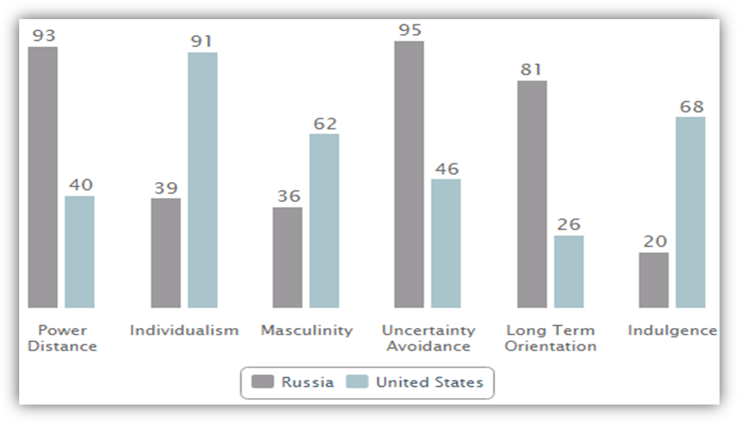

Results

Power Distance = 93
Russia, scoring 93, is a nation where power holders are very distant in society. This is underlined by the fact that the largest country in the world is extremely centralized: 2/3 of all foreign investments go into Moscow where also 80% of all financial potential is concentrated. The huge discrepancy between the less and the more powerful people leads to a great importance of status symbols. Behaviour has to reflect and represent the status roles in all areas of business interactions: be it visits, negotiations or cooperation; the approach should be top-down and provide clear mandates for any task.

Individualism = 39
If Russians plan to go out with their friends they would literally say “We with friends” instead of “I and my friends”, if they talk about brothers and sisters it may well be cousins, so a lower score of 39 even finds its manifestations in the language. Family, friends and not seldom the neighborhood are extremely important to get along with everyday life’s challenges. Relationships are crucial in obtaining information, getting introduced or successful negotiations. They need to be personal, authentic and trustful before one can focus on tasks and build on a careful to the recipient, rather implicit communication style.

Masculinity = 36
Russia’s relatively low score of 36 may surprise with regard to its preference for status symbols, but these are in Russia related to the high Power Distance. At second glance one can see, that Russians at workplace as well as when meeting a stranger rather understate their personal achievements, contributions or capacities. They talk modestly about themselves and scientists, researchers or doctors are most often expected to live on a very modest standard of living. Dominant behaviour might be accepted when it comes from the boss, but is not appreciated among peers.

Uncertainty avoidance = 95
Scoring 95 Russians feel very much threatened by ambiguous situations, as well as they have established one of the most complex bureaucracies in the world. Presentations are either not prepared, e.g. when negotiations are being started and the focus is on the relationship building, or extremely detailed and well prepared. Also detailed planning and briefing is very common. Russians prefer to have context and background information. As long as Russians interact with people considered to be strangers they appear very formal and distant. At the same time formality is used as a sign of respect.

Longterm orientation = 81
With a very high score of 81, Russia is definitely a country with a pragmatic mindset. In societies with a pragmatic orientation, people believe that truth depends very much on situation, context and time. They show an ability to adapt traditions easily to changed conditions, a strong propensity to save and invest. thriftiness and perseverance in achieving results.

Indulgence = 20
The Restrained nature of Russian culture is easily visible through its very low score of 20 on this dimension. Societies with a low score in this dimension have a tendency to cynicism and pessimism. Also, in contrast to Indulgent societies, Restrained societies do not put much emphasis on leisure time and control the gratification of their desires. People with this orientation have the perception that their actions are Restrained by social norms and feel that indulging themselves is somewhat wrong.

Challenges:
In nearly every category, American culture and Russian culture are on opposite sides of the spectrum. As a result, it is important to note that communicating with and evangelizing Russians by Americans will prove to be a challenging task, requiring Americans to think differently and empathetically.

These cultural differences and tensions will be exacerbated by societal and political biases on both sides, especially considering the historical distrust between the two countries.

Opportunities:
Due to the cultural disparities and especially the long term oriented non-indulgent nature of Russian culture, diaspora missions might be more of an effective method for communicating and evangelizing Russians, than traditional forms.
Diaspora Missions: “Christians’ participation in God’s redemptive mission to evangelize their kinsmen on the move, and through them to reach out to natives in their homelands and beyond. There are four types of diaspora missions:

    - Missions to the Diaspora – reaching the diaspora groups in forms of Evangelism or pre-evangelistic social services, then disciple them to become worshipping communities and congregations.

    - Missions through the Diaspora – diaspora Christians reaching out to their kinsmen through networks of friendship and kinship in host countries, their homelands, and abroad.

- Missions by and beyond the Diaspora – motivating and mobilizing diaspora Christians for cross-cultural missions to other ethnic groups in their host countries, homelands, and abroad.

    - Missions with the Diaspora – mobilizing non-diasporic Christians individually and institutionally to partner with diasporic groups and congregations.”

Figure 2 Diaspora Missiology
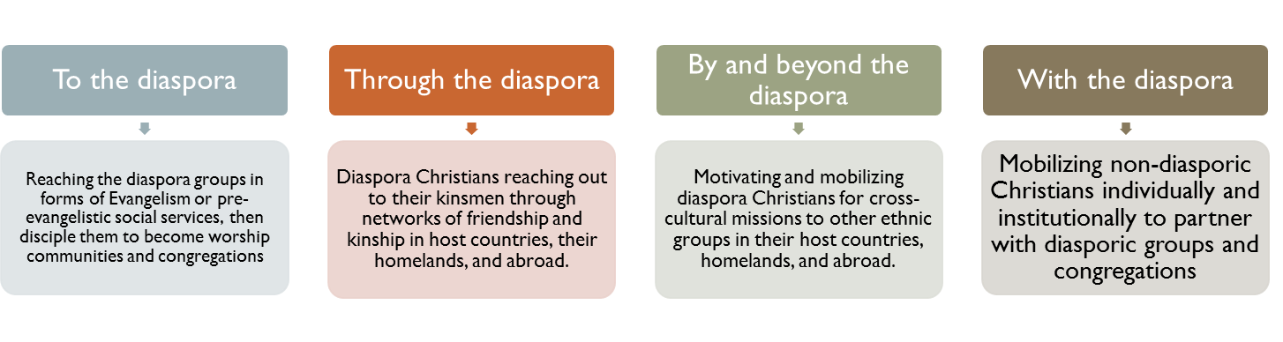

Figure 3 Diaspora Missiology and Diaspora Missions
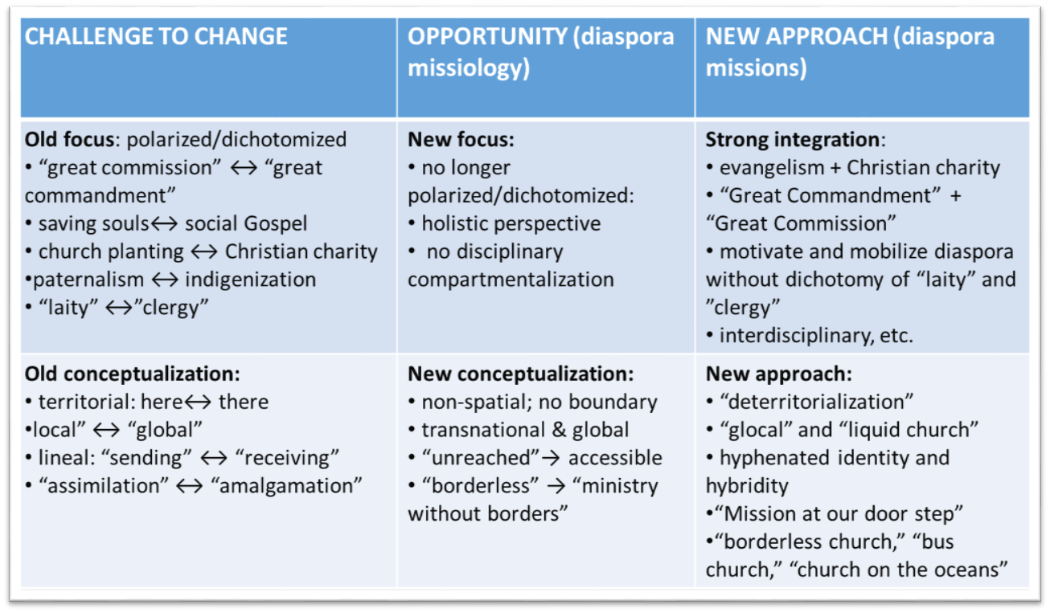

Application of Hofstede’s Analysis for Communicating and Evangelizing Russians by Americans

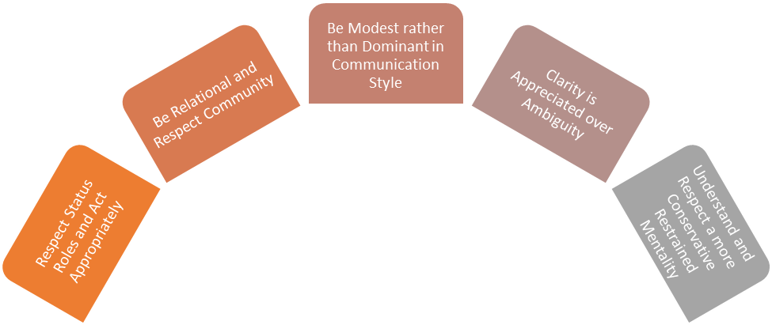

Figure 4 - Application of Hofstede’s Analysis

Respect status roles and act appropriately (affected categories – power distance, individualism, indulgence)
Limitations placed on relationships must be honored in a power distant culture. One must be careful not to challenge the authority of those with higher status roles, or force a peer-type horizontal relationship to those who feel more comfortable viewing themselves at a lower status.

Be relational and respect community (affected categories: individualism, masculinity)
Relational paradigm approach over managerial missiology practice

Managerial missiology practice: “Ways and means of practicing Christian mission in the same manner of secular management in business that might be ‘biblical’ and secularly contextual; but definitely not ‘scriptural.’”

Relational paradigm approach: The relational paradigm provides a way to rediscover relationship in Christianity – the essence of Christian faith and practice. If Christianity is likened to “chicken soup” and “relationship” is the genuine chicken, then the contemporary Christian church and individual believers have often settled for chicken soup that only has a resemblance to the chicken in canned chicken soup.

“The source of human being and understanding is relationship.”

Vertical relationship with God and horizontal relationship with each other

Be modest rather than dominant in communication style (affected categories: masculinity, indulgence, power distance)
Humility is a respected quality in Russian culture. Avoid Ugly American syndrome, in which Americans tend to seem arrogant or dominant.

Clarity is appreciated over ambiguity (affected categories: ambiguity, long term orientation)
Russians do not like uncertainty or ambiguity. Suspicion of motive can become an issue if you seem misleading, manipulative, or have ulterior motives, such as using friendship to evangelize. Evangelism must be done with more clarity, but also with patience.

- Understand and respect a conservative restrained mentality (affected categories: indulgence, long term orientation.)

Americans are about “now now now!” Russians are less reluctant to accept change without thinking things through more thoroughly. Heavy pressure to change may have unintended outcomes, such as backlash. Communication and evangelism must be engaged in sensitively for these reasons.

- Here are insights gleaned from Mark J. Harris who has rich experience engaging in cross-cultural ministry to Russians and serving as missionary in Russia.

Mass Evangelism

Qua-lities | Mass Evangelism | Church Evangelism | Small Group Evangelism | One-on-One Evangelism
Advantages | Large meetings in rented halls became associated with visiting Western evangelists in Russia in the 1990s. The primary advantage is that a neutral setting can be arranged where many people can be invited to hear the gospel. Advertising can be used to attract people and gifted speakers can be utilized. | An Evangelical worship service provides a setting where the visitor can observe a large group of believers together and see what they do. The site will more likely remain the same for future visits, unlike those rented for public meetings. The message of the gospel is combined with singing, prayer, and other forms of worship. In addition, bringing the young person to become a living part of a church is the goal of evangelism, so this step must necessarily happen sometime. | A small group, usually meeting in a home, provides a more natural setting for a young Russian who can see how believers interact with each other, care for each other, and pray together. A visitor can see that believers are normal people, with a living faith that exists outside the four walls of the church. A visitor to a small group is much more conspicuous than in a church service, aiding in follow-up. | This method has the advantage of being the most flexible. It can occur anytime, at any place. The person doing this kind of work is able to focus attention on one person, allowing for more particular probing into the person's special needs and questions. This is the only method that can be used with the many people who will not accept any invitation to a group. A loving, wise believer can take the time and build trust, being careful not to rush youth into something for which they are not ready.
Disadvantages | The main disadvantage relates to the misuse of this method by many Evangelical groups. Many Russians have responded to a public gospel invitation by performing the required step (raising hands, coming forward, praying a prayer, filling out a response card, etc.) but only a minute fraction of these have ended up in churches. Russians are often seen to respond due to the actions of the group around them, but with no deep understanding. A speaker cannot respond to the particular questions and problems of each listener in a mass group and the large numbers who respond in various ways make follow-up problematic. | The church can be an intimidating place for a young person to visit and may be too strange for an initial exposure to the gospel. The pulpit messages are less likely to be directed to the visitor and may be hard to understand. | The small group may be the most susceptible to being considered a cult, and this fact will frighten many away. It also may be less likely that a person will be there with adequate training to properly communicate with a visitor with particular needs. Visitors may feel conspicuous in a small group and thus be intimidated. | In Russia one person evangelizing another is a very strange thing. Young people will likely feel that this is not a normal person talking to them. The fear of cults will also be a factor because this is the common approach of cults in Russia. The young person may be very reluctant to open up, so the method is often limited to close acquaintances or gifted personal evangelists.
Primary Usage | This method is best used when the main goal is general exposure to the gospel. Those listeners who are serious will come to further meetings in various kinds of neutral venues or give a trained believer the opportunity to visit them. They will be much less likely to take the big step of visiting a church. | This method is best used when the main goal is exposure to worship. Visitors not only hear the gospel, but also see it being demonstrated corporately. The life of the body need not be described, because it is in fact experienced. A trained member has more freedom to follow up by conversing with a person who has visited the church. The resulting personal relationship is a more fruitful method of evangelism, especially in Russia. | This method is best used when the main goal is exposure to fellowship. The life of a church is best seen in the lives of its members and godly fellowship is the most important expression of that life. | This method is best used when the main goal is exposure to personal counsel. Young Russians can see how this one person cares enough to take time and deal with their personal life problems. When church members are trained to do this kind of evangelistic ministry sensitively, it can become the most important way to give people first exposure to the gospel.

Figure 5 – Advantages, Disadvantages, and Primary Usage of Evangelism Types in Russia

The following are some observations from Figure 5:

Advantages - Large meetings in rented halls became associated with visiting Western evangelists in Russia in the 1990s. The primary advantage is that a neutral setting can be arranged where many people can be invited to hear the gospel. Advertising can be used to attract people and gifted speakers can be utilized.

Disadvantages - The main disadvantage relates to the misuse of this method by many Evangelical groups. Many Russians have responded to a public gospel invitation by performing the required step (raising hands, coming forward, praying a prayer, filling out a response card, etc.) but only a minute fraction of these have ended up in churches. Russians are often seen to respond due to the actions of the group around them, but with no deep understanding. A speaker cannot respond to the particular questions and problems of each listener in a mass group and the large numbers who respond in various ways make follow-up problematic.

Primary Usage - This method is best used when the main goal is general exposure to the gospel. Those listeners who are serious will come to further meetings in various kinds of neutral venues or give a trained believer the opportunity to visit them. They will be much less likely to take the big step of visiting a church.

CHURCH EVANGELISM
Advantages - An Evangelical worship service provides a setting where the visitor can observe a large group of believers together and see what they do. The site will more likely remain the same for future visits, unlike those rented for public meetings. The message of the gospel is combined with singing, prayer, and other forms of worship. In addition, bringing the young person to become a living part of a church is the goal of evangelism, so this step must necessarily happen sometime.

Disadvantages - The church can be an intimidating place for a young person to visit and may be too strange for an initial exposure to the gospel. The pulpit messages are less likely to be directed to the visitor and may be hard to understand.

Primary Usage - This method is best used when the main goal is exposure to worship. Visitors not only hear the gospel, but also see it being demonstrated corporately. The life of the body need not be described, because it is in fact experienced. A trained member has more freedom to follow up by conversing with a person who has visited the church. The resulting personal relationship is a more fruitful method of evangelism, especially in Russia.

Small Group Evangelism
Advantages - A small group, usually meeting in a home, provides a more natural setting for a young Russian who can see how believers interact with each other, care for each other, and pray together. A visitor can see that believers are normal people, with a living faith that exists outside the four walls of the church. A visitor to a small group is much more conspicuous than in a church service, aiding in follow-up.

Disadvantages - The small group may be the most susceptible to being considered a cult, and this fact will frighten many away. It also may be less likely that a person will be there with adequate training to properly communicate with a visitor with particular needs. Visitors may feel conspicuous in a small group and thus be intimidated.

Primary Usage - This method is best used when the main goal is exposure to fellowship. The life of a church is best seen in the lives of its members and godly fellowship is the most important expression of that life.

One-on-One Evangelism
Advantages - This method has the advantage of being the most flexible. It can occur anytime, at any place. The person doing this kind of work is able to focus attention on one person, allowing for more particular probing into the person's special needs and questions. This is the only method that can be used with the many people who will not accept any invitation to a group. A loving, wise believer can take the time and build trust, being careful not to rush youth into something for which they are not ready.

Disadvantages - In Russia one person evangelizing another is a very strange thing. Young people will likely feel that this is not a normal person talking to them. The fear of cults will also be a factor because this is the common approach of cults in Russia. The young person may be very reluctant to open up, so the method is often limited to close acquaintances or gifted personal evangelists.

Primary Usage - This method is best used when the main goal is exposure to personal counsel. Young Russians can see how this one person cares enough to take time and deal with their personal life problems. When church members are trained to do this kind of evangelistic ministry sensitively, it can become the most important way to give people first exposure to the gospel.

Conclusion
Effective communication and evangelization of Russians by Americans will be
difficult; but possible with patience. For Americans to reach Russians, we are to embrace a new orientation, be prepared to bridge the cultural divide, to overcome language barriers and to integrate the Great Commandment and the Great Commission relationally approach.
For an extensive study on relational approach in Christian missions, the following new publication is recommended:
Enoch Wan & Mark Hedinger, Relational Missionary Training. CA: Urban Loft Publishers, 2017 also
@ , https://www.amazon.com/s/ref=nb_sb_noss?url=search-alias%3Dstripbooks&field-keywords=Enoch+Wan+%26+Mark+Hedinger%2C+Relational+Missionary+Training

BIBLIOGRAPHY
Bosch, David J. Transforming Mission: Paradigm Shifts in Theology of Mission
(American Society of Missiology) Maryknoll, NY: Orbis, (2004) 2011.
Elmer, Duane. Cross-Cultural Connections: Stepping Out and Fitting In around the
World. Downers Grove, Illinois: IVP, 2002.
___________, “Cross Cultural Relations and Communications,” International
Multicultural Institutes, August 2014
http://www2.isu.edu/fsen/InformationItems/FacultyStaff_ParticipantHandout_AL%208-11d.pdf
Harris, Mark. J. “Evangelism in Russia: What Works and What Doesn't,” East-West
Church & Ministry Report, Vol. 8, No. 1, Winter 2000:5-6.
http://www.eastwestreport.org/articles/ew08103.htm (access June 20, 2017)
Hofstede, G. Culture's Consequences: Comparing Values, Behaviors, Institutions, and
Organizations Across Nations. Beverly Hills, CA: Sage Publications. 2001.
http://www.enochwan.com/english/articles/pdf/Relational%20Theology%20And%20Relational%20Missiology%20-%20Orig.pdf https://geert-hofstede.com/russia.html
Plueddemann, James E. Leading Across Cultures: Effective Ministry and Mission in the
Global Church. IVP, 2009
Terry, John Mark (Editor), Missiology: An Introduction, (2nd edit) TN: Broadman &
Hollman Publishers. 2015.
Wan, Enoch. Diaspora Missiology: Theory, Methodology, and Practice. Portland,
Oregon: Institute of Diaspora Studies – USA, 2014.
________ & Mark Hedinger, Relational Missionary Training. CA: Urban Loft Publishers, 2017

David J. Bosch, Transforming Mission: Paradigm Shifts in Theology of Mission. (American Society of Missiology). 2011:420.
James E. Plueddemann, Leading Across Cultures: Effective Ministry and Mission in the Global Church. IVP, 2009:52.
According to Grant Lovejoy, communication is: “Speaker’s message → encoded → transmitted → decoded → message understood” (Terry, ed., Missiology, 2015:256).
Duane Elmer, “Cross Cultural Relations and Communications,” International Multicultural Institutes, August 2014 @ http://www2.isu.edu/fsen/InformationItems/FacultyStaff_ParticipantHandout_AL%208-11d.pdf See also Terry, ed., Missiology, 2015:254.
https://geert-hofstede.com/russia.html
https://geert-hofstede.com/russia.html
https://geert-hofstede.com/russia.html
Wan, Diaspora Missiology, 6.
Wan, Diaspora Missiology, 6.
http://www.enochwan.com/english/articles/pdf/Relational%20Theology%20And%20Relational%20Missiology%20-%20Orig.pdf
Harrris, “Evangelism in Russia: What Works and What Doesn’t,” 5-6.

