Cross-Cultural Humor:
English Speakers’ Gaffes in Japanese
Compiled by J. Nelson Jennings
Published in Global Missiology, www.globalmissiology.org. October 2018
From personal acquaintances and experience:
- Ordering “circumcision” (katsurei) in a restaurant instead of the intended breaded deep-fried pork and egg on rice (katsudon).
- Pregnant (ninshin) woman in hospital: “I’m a carrot” (ninjin).
- Next-door neighbor (in Nagoya) politely inquires, “Is your wife at home (miemasu ka)?”
Answer: “Yes, she can see (miemasu kedo), but why do you ask?”
- Confusing chopsticks (hashi) and bridges (hashi).
- Misunderstanding polite refusals (ii desu) as enthusiastic acceptances (ii desu).

From “50+ Funny and Embarrassing Japanese Language Mistakes”:

Calling babies and children “scary” (kowai) instead of “cute” (kawaii).

Calling people carrots (ninjin) instead of “human beings” (ningen).

Preacher commends “sexual” (seiteki) experience, not “spiritual” (reiteki) experience.

Saying, “My stomach is a watermelon” (onaka suika) instead of “I’m hungry” (onaka suita).

Actually discussing “earthquakes” (jishin) while assuming the topic was “confidence” (jishin).

When making a cold-call visit, misunderstanding “Go home!” (Kaere) as “Come on in!” (Haire).

Asking a woman to marry you (Oyome ni narimasu ka) while intending to ask her to read something (Oyomi ni narimasu ka).

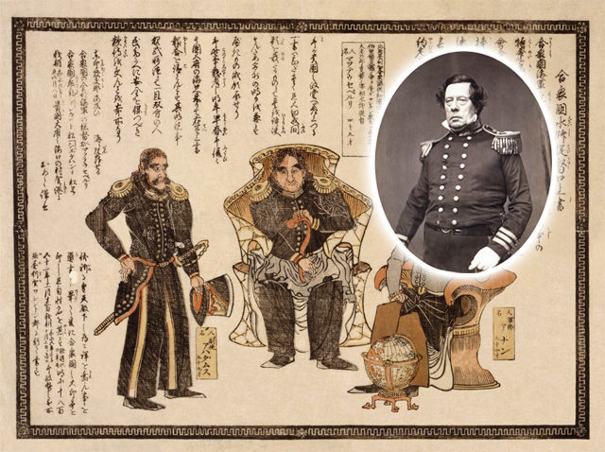
Asking, “How are the eggs?” (Tamago-tachi wa dou desu ka) instead of the intended “How are your grandchildren?” (Omago-tachi wa dou desu ka).
https://www.therisingwasabi.com/new-evidence-suggests-commodore-perry-used-gaijin-smash/

