Language and Translation in China’s Historical Protestant Missions:
Sharing the Word(s) of God in the Far East
James W. Ellis
Published in Global Missiology, www.globalmissiology.org. January 2019

Abstract
The European and American Protestant missions to China (1807-1953) were one of history’s greatest cross-cultural encounters. By 1850, only a few dozen (mostly male) missionaries had been sent to China. Five decades later, the number had grown to approximately two-thousand-five-hundred men, women, and children. During this period, Protestant missions spread the gospel message to the Chinese populace, translating and otherwise communicating God’s Word through Chinese languages and regional dialects. This essay compiles secondary accounts of how missionaries used language and translation to accomplish their evangelistic goals. Bringing together these associated accounts will inform readers who may be unfamiliar with Protestant missionaries’ translation projects in the nineteenth and first half of the twentieth centuries in China.
Key Words: China, Protestant, Mission, Translation, Bible, Hymn
-----------
Introduction
The Protestant missions to China were one of history’s greatest cross-cultural encounters. Never before had so many Europeans and Americans lived on the Chinese mainland. This essay examines how the Western Protestant missions tried to spread the gospel message to the Chinese populace, and how the missionaries used Chinese languages and regional dialects to accomplish their evangelistic goals.
Robert Morrison: The First Protestant Missionary to China
Robert Morrison (1782-1834), an Anglo-Scottish Presbyterian, was the first Protestant missionary to China. He arrived in the Portuguese port of Macau in 1807. Morrison was both a devoted missionary and a devoted linguist, and he mastered the Chinese language. He completed a Chinese translation of the New Testament in 1813 and, with assistance from his colleague William Milne (1785–1822) and a team of new local Chinese converts, translated the entire Bible. Morrison published his complete translation in 1823. In 1818, Morrison and his team of Chinese assistants also produced the first Protestant hymnbook in China, which was entitled Sacred Odes to Nourish the Mind (Hsieh 2009a:7-8). Chinese Bible translations and Chinese hymns will be discussed in depth later, but it is important to note that the Protestant missions focused on spoken and written language from the outset (Barnett and Fairbank 1985).
Western Missions, Eastern Languages
The greatest formal challenge facing Western missionaries in China was learning to convey the gospel message in Eastern languages and dialects. This was a prerequisite to effective evangelization. Today, approximately seventy-five percent of mainland China’s residents are reasonably fluent in Mandarin, China’s official spoken language. Mandarin is known as pǔtōnghuà, or “the common language.” Since 1949, the Communist Party of China has aggressively promoted the general use of Mandarin, which was originally Beijing’s regional dialect. However, before the mid-twentieth century most ethnic Han Chinese people (historically ninety percent of China’s population) spoke only their own local language or dialect. There are more than half a dozen major spoken dialects, including Mandarin, yuè (Cantonese), wú (Shanghainese), mǐnběi (Fuzhounese), and mǐnnán (Fujian). Hakka people speak a distinct language, which shares many characteristics and words with Cantonese.
Newly arrived missionaries spent their first few weeks in China studying for five to ten hours each day with local tutors. They first studied the regional vernacular (or everyday spoken language), and then proceeded to reading and writing classical Literary Chinese. Western missionaries often expressed frustration with their language instruction because their Chinese tutors placed great emphasis upon recitation and little emphasis upon content (Forsythe 1971:14-15). Chinese tutors also tended to overlook missionaries’ mistakes as a matter of courtesy, to show respect and help the students to save face. Tutors taught the stronger missionary students about Chinese literature, proverbs, and idiomatic expressions to enhance communication.
The British Methodist Wesleyan Missionary Society sent William Scarborough to China in 1865. A few years later, he published A Collection of Chinese Proverbs in Shanghai. Scarborough believed that an extensive acquaintance with Chinese proverbs was important for missionaries, because “a proverb will often serve to rouse the flagging attention of a congregation or to arrest it at the commencement of a discourse” (Scarborough 1875).
A few missionaries became linguistic scholars, like Robert Morrison. They mastered classical Chinese and regional dialects, compiled English-Chinese and Chinese-English dictionaries and collaborated with indigenous communities to translate the Bible’s written text into new languages and dialects. Scholars were typically university graduates, who were ordained and committed to spreading Christianity. Many scholars arrived in China with negative preconceptions about a heathen nation, but found a society of “good, moral people” operating under philosophical traditions they knew little about (Lodwick and Cheng 2005:4-5). The scholars learned about Confucianism and China’s religions and were among the first to explain Chinese customs, Buddhism, and Taoism to Western audiences.
In recent decades, secular anthropologists have criticized the ethnographic and language research of mission scholars, because they set out to “crack a foreign cultural code” expressly for the purposes of evangelization (Van der Geest 1990:590). Judith Shapiro, for example, faulted Protestant missionaries for learning “native languages” and dialects expressly so they could translate the Bible into them. According to Shapiro, missionary scholars were part of a Christian conspiracy: they were “in the service of God’s Central Intelligence Agency, learning to intercept messages in a foreign code so that they can use that same code to transmit messages of their own” (Shapiro 1981:147). Unfortunately, Shapiro confused the tools of temporal political imperialism with the tools that were necessary to accomplish the Great Commission (The Gospel According to S. Matthew 28:16-20, KJV). Jesus told his disciples, “Go ye therefore, and teach all nations … [t]eaching them to observe all things whatsoever I have commanded you.” This mandate often requires mastering new languages.
Romanized Colloquial and Bible Women
During the early nineteenth century, only a small number of male missionaries ventured from Europe and America to China. However, after The Treaty of Nanking [Nanjing] (1842), which ended the First Opium War between the United Kingdom and the Qing dynasty, Western men and women were permitted to proselytize in five official treaty ports: Shanghai, Canton [Guangzhou], Ningpo [Ningbo], Foochow [Fuzhou], and Amoy [Xiamen]. The Protestant missions began setting up boys and girls schools in and around the treaty port cities as soon as it was possible. Missionaries believed that “education as intellectual enlightenment would lead to rejection of idolatry, conversion to Christianity, and the eventual elimination of social evils” (Chiu 2015:47).
In China’s traditional society, children of wealthy families might have private tutors; however, poorer children often received no formal education. At mission schools, Chinese students learned to read the Bible as translated from Hebrew and Greek into either classical Chinese, vernacular Mandarin, or a regional dialect in romanized form. Romanized colloquial translations borrowed letters from the Latin (or Roman) alphabet to represent the pronunciations and speech patterns of Chinese languages and dialects (figure 1). The fusion created new scripts. Romanization, of course, is not a pure science; exact transcriptions are often impossible. Written languages cannot perfectly represent spoken languages and certain Chinese pronunciations and intonations have no written European equivalent. The process had mixed results, but, according to a missionary writing in 1907, “in regions where romanized is used there is no doubt; if [a student] has learned to read, [he or she] can read the whole Bible” (Benham 1907:140).
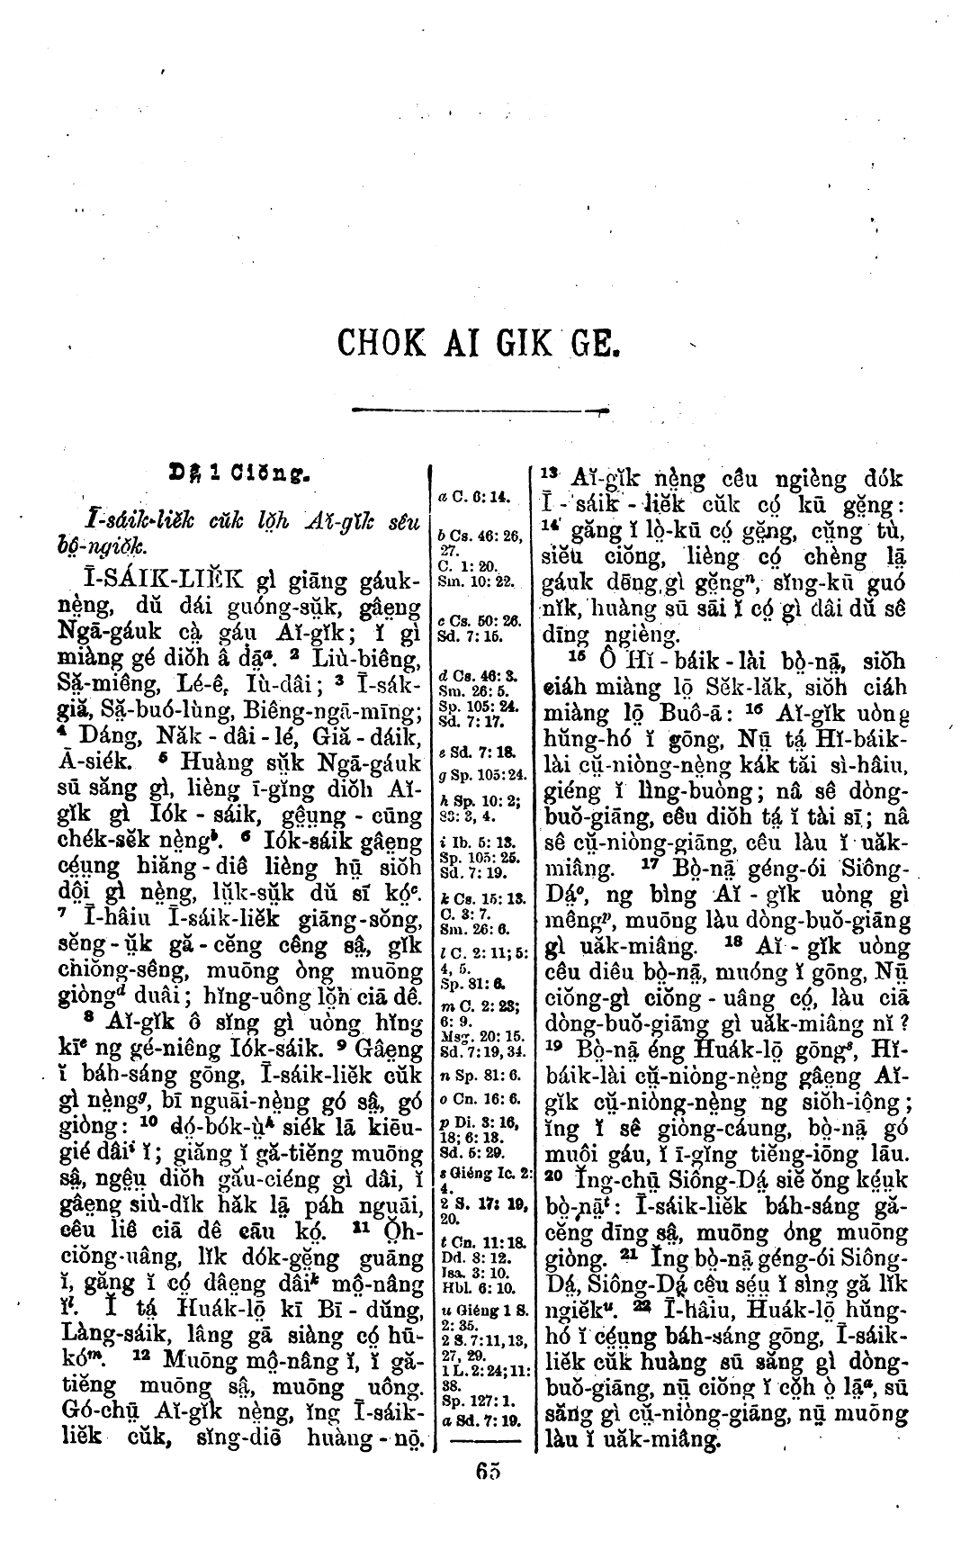
Figure 1. The First Chapter of Exodus in Foochow Romanized, 1908, The British and Foreign Bible Society, Public Domain.
Over time, older Chinese women also began coming to mission schools to learn about Christianity. Female missionaries and student-translators helped the older women learn to read romanized colloquial, so they could better understand theology and read the Bible to others. After sufficient training, they “began to go about among the women to read the Bible and teach them the way of salvation” (Davis 1886:35). Missionaries referred to these women as “women evangelists” (Hamilton 1900:5), Bible readers, or Bible women. By the early twentieth century, there were training schools for Bible women across mainland China and in Hong Kong, some with four-year curricula and dozens of full-time students.
The Wordless Book
Although mission school students and Bible women could read romanized colloquial Bibles, most Chinese people could not. In fact, illiteracy was common in China during the nineteenth and early twentieth centuries (UNESCO 2005:192). Mission evangelists used many methods to reach illiterate audiences.
During the Middle Ages and later, glass painters and artisans used the pictorial language of stained glass to teach Christian doctrine to largely illiterate European congregations. To medieval Europeans, who mostly spoke regional languages and dialects, the Catholic Church’s Latin services would have been incomprehensible. Western missionaries in China also spoke languages and published Bibles that were incomprehensible to local people and they often relied upon purely visual teaching tools to convey Christian doctrine. The London Baptist minister, Charles Haddon Spurgeon (1834-1892) popularized one such visual aid called The Wordless Book (figure 2). Spurgeon discussed its use and symbolism in a sermon entitled The Wordless Book, which Spurgeon delivered at London’s Metropolitan Tabernacle in 1866 (Spurgeon 1866). Members of the China Inland Mission began using The Wordless Book during the eighteen-sixties in open-air sermons.
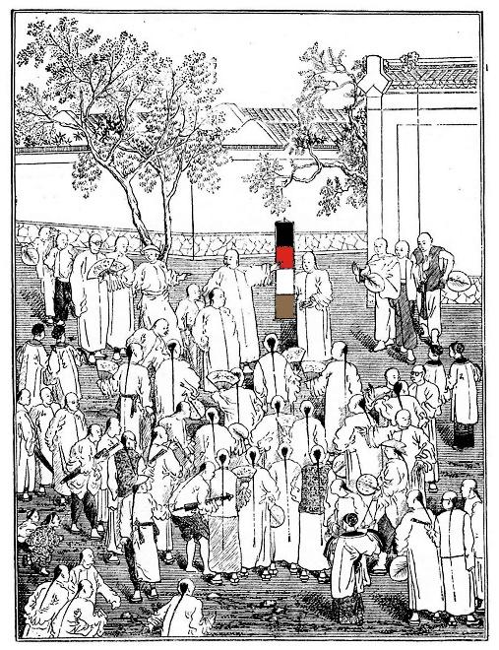
Figure 2. “The Wordless Book” (with modern color added), from China's Millions, 1892, China Inland Mission, Public Domain.
The Wordless Book was not an actual book. Rather, it was (and is) a pedagogical tool, a series of colored pages that symbolize fundamental Christian principles and the stages of Christian conversion. Spurgeon’s Wordless Book had three colors: black, red, and white. The first, black page represents man’s sinful state; the second, red page represents the atoning blood of Jesus Christ; the third, white page represents the Christian’s pure redeemed soul. Local Chinese translators helped missionaries explain these concepts to congregants at mission compounds and outdoor meetings. Many Chinese people were familiar with Taoist color cosmology (or wǔxíng) and understood how different colors relate to universal, spiritual concepts. In 1875, American evangelist Dwight Lyman Moody (1837-1899) added a final, gold page that represents the splendor of Heaven. Of course, missionaries wanted Chinese people to know more about Christianity than could be conveyed by The Wordless Book; they wanted the people to read the Bible.
Early Bible Translations
As soon as they arrived in China, Catholic and Protestant missionaries began translating the Bible into classical written Chinese. The first translations were unpublished sixteenth century Catholic manuscripts. Protestant translations appeared three centuries later. British Baptist missionary Joshua Marshman (1768-1837) was the first to translate the Bible into classical Chinese. India’s Serampore Press published Marshman’s translation in 1822. As previously mentioned, the Western Protestant era in China began with Robert Morrison’s arrival in Macau in 1807. Morrison and William Milne produced one of the first Protestant Bible translations (1823), with the assistance of local Christian-translators, Cai Luxing, Cai Gao, and Liang Fa. Morrison’s Bible was the most widely used version in China during the mid-nineteenth century.
Unfortunately, many Chinese people could not understand the written characters used in the Morrison Bible, and similar early translations. Furthermore, their formal literary style, which was most appropriate for well-educated scholars, was difficult to understand when read aloud. During the second half of the nineteenth century, Protestant missionaries traveling the Chinese mainland realized the vernacular, spoken Mandarin dialect was becoming a lingua franca among Han Chinese, and they fought for its use in Bible translations. In 1878, the first Bible translation into the Mandarin dialect was published, The Peking Version. In 1919, The Chinese Union Version was completed, in both classical Chinese and vernacular Mandarin versions (Zetzsche 1999). This became the most commonly used Protestant translation in China. A Chinese New Version was published in 1992 and a Revised Chinese Union Version was published in 2010. The Studium Biblicum Version, which was completed in 1968, is the standard Bible for Chinese Catholics.
Proper Terms
Matteo Ricci (1552-1610), an Italian Jesuit priest and missionary to Macau, and his associates designed Portuguese-Chinese and Chinese-Portuguese dictionaries in the fifteen-eighties and nineties. Robert Morrison and the Scottish missionary and scholar James Legge (1815-1897) created similar English-Chinese and Chinese-English dictionaries, using romanization systems, in the nineteenth-century. Morrison’s voluminous Dictionary of the Chinese Language, in Three Parts (1815-1823) included both Chinese characters and romanization to indicate pronunciation.
In each case, the translators encountered inherent problems finding Chinese equivalents for Christian terms and translating certain Western concepts into an Eastern language system. For example, various Chinese terms were used to translate “God.” Protestant Bibles often used shàngdì (or “highest emperor”) or shén (a term for Chinese folk gods). Matteo Ricci’s Bible translations and The Peking Version used tiānzhǔ (or “Lord of Heaven”). Each option conveyed a distinct meaning in Chinese culture (Cummins 1985). Imprecise communication was the root of many difficulties, and missionaries were reliant upon multilingual indigenous converts to explain orally the subtleties of Christian doctrine to local communities. However, Western missionaries’ attempts to convert the Chinese people to Christianity faced more challenges than differing languages. Missionaries and potential converts had radically different world-pictures. Whereas the Chinese mind-set was “rooted in concepts from the Sino-Tibetan family of languages,” the missionaries’ Christian ideas evolved from the Greco-Roman-Judaic “mental world” (Cummins 1985). Even as missionaries “attempted to accommodate to Chinese culture [and languages] and engage in dialogue,” they were often seen as propagating a strange, foreign religion (Wickeri 2015:1).
Absalom Sydenstricker
Absalom Sydenstricker (1852-1931), a Southern Presbyterian from the United States, arrived in China in 1880. Sydenstricker was a linguistic scholar who set out to learn the Chinese language and translate the Bible. During the decade before Sydenstricker’s arrival, Protestant missionaries learned that Mandarin was understood by many people throughout China and had begun using the dialect as an effective tool for evangelism. Sydenstricker believed a primary reason for “ignorance” and illiteracy in China was that books were written in traditional, literary Chinese but most people only understood their local dialect (Buck 1936:217). Sydenstricker used Mandarin to translate books of the Bible, hymnals, and tracts. Late in his mission service, he advised newly arrived missionaries to study with local teachers to master correct pronunciation, grammar, and colloquial idioms (Sydenstricker 1889).
In 1880, the year Sydenstricker arrived in China, H. A. Tupper, leader of America’s Southern Baptist Foreign Mission Board, wrote that Christian theology must become indigenous and develop “its own nomenclature and phraseology” (Tupper 1880:133). Chinese Christians, Tupper asserted, would naturally develop their own interpretations of the Bible based on their own experiences, “not by acquiring theology secondhand from foreign missionaries” (Tupper 1880, 133). Absalom Sydenstricker agreed. Pearl Buck, Sydenstricker’s daughter and Pulitzer Prize winning author of The Good Earth, wrote that the great frustrations of her father’s Christian life were imprecise translations of biblical texts, in English and Chinese (Buck 1936:49). Sydenstriker was convinced that the “Word of God” could be found in the original Hebrew and Greek texts and his life’s work became communicating God’s word into a comprehensible Chinese form. He translated the New Testament into Mandarin book-by-book and published the four Gospels in one volume (Sydenstricker and Zhu 1913). He chose a “clear, somewhat compressed, plain style, without allusion or furbishing” that corresponded somewhat to James Moffat’s contemporaneous edition of the English Bible (Buck 1936:217-18).
Translation Methods
Bible translators in China had an enormous opportunity: to present the Christian message to vast unreached populations. However, they also had a very difficult, cross-cultural task. The Chinese languages and dialects differ greatly from European languages, and translators needed to situate the Bible authors’ messages and “communicative intentions” within the linguistic parameters and cultural expectations of Chinese audiences (Bühler 2002). However, in doing so, they risked becoming Bible interpreters; they risked becoming the “source writers for the [Chinese] target readers” (Bassnett 1996:11). Traditionally, translators were responsible for translating the Bible and individual readers and hearers were responsible for interpreting the messages of the original Bible authors.
It proved impossible to translate the Bible from English, or German, or Portuguese into Chinese using an inflexible formal equivalence approach. The formal equivalence approach to Bible translation attempts to retain the precise lexical and grammatical features of the Bible’s earliest texts. Western and Eastern languages, however, often do not share direct lexical or grammatical equivalents. In such cases, where word-for-word translations were impossible, Bible translators resorted to the dynamic equivalence (or functional equivalence) approach and translated ideas and incorporated neologisms (newly coined terms or concepts). Their goal was not interpretation, but rather finding new ways to help readers of both the source and target languages understand meanings in similar ways (Nida and Taber 1969). By necessity, Bible translators in China often employed the dynamic equivalence approach.
Minority Translations and Missions: Language as Liberation: The Lisu, Hua Miao, and Hakka
The Lisu
Christian missions attracted members of ethnic minorities living in remote provinces through evangelizing and by improving communication. The China Inland Mission’s James O. Fraser (1886-1938), for example, spent nearly thirty years living among the Tibetan-Burman Lisu people in China’s mountainous southwestern Yunnan and Sichuan provinces. Around 1915, Fraser collaborated with Sara Ba Thaw, a Burmese preacher, to construct a Lisu script (the “Fraser alphabet”) in order to translate the New Testament. This resulted in impressive church growth and enhanced community cohesion.
Most of the world’s Lisu people live in Yunnan province. They are concentrated in Yunnan’s Nujiang Prefecture. In 1997, seventy percent of people in the Fugong County of Nujiang Prefecture identified as Christian, the highest percentage of Christians in any Chinese county (Chan and Yamamori 2000). Even during China’s current communist era, the Lisu Church is prospering. The Yunnan Christian Council printed thousands of Lisu Bibles in Fraser’s alphabet during the nineteen-eighties and nineties. Recently, ethnic Lisu missionaries have planted churches in even more remote and underdeveloped minority communities, including the community of the Dulong (or Drung) people living in the Dulong River Valley of Yunnan province (Chan and Yamamori 2000).
Hua Miao
British Methodist missionary, Samuel Pollard (1864-1915) arrived in northern Yunnan province in 1888 to serve the Hua Miao people. The Hua Miao are indigenous to China’s southern mountainous provinces and related culturally and linguistically to Hmong communities living in northern Myanmar and Vietnam, Laos, and Thailand. Around 1914 Samuel Pollard and Miao teachers and evangelists completed an entirely new Miao phonetic system and script and translated the New Testament. Hua Miao tradition credits Christian missionaries with bringing literacy along with religion (Diamond 1996:141).
The Miao of southern China had serious conflicts with the Qing dynasty’s Han Chinese majority since at least the eighteenth century, which led to armed conflicts and Hmong migrations to Southeast Asia. Translating the Bible into the language of Hua Miao people had religious and social effects. Formulating and disseminating a new written language represented a self-realization, oppositional strategy for ethnic minorities, ways to assert distinctive religious and social identities and resist the cultural categories imposed by China’s Han majority. After the introduction of Pollard’s script, the Hua Miao’s network of village schools strengthened and Hua Miao men and women achieved a relatively high rate of literacy compared to neighboring groups of Han Chinese. Pollard and Miao evangelists became bearers of both a Christian message and a flexible literacy system “that was not patently ‘foreign’ and that circumvented the problems of learning Chinese ideographs or another language” (Diamond 1996:149).
Hakka
For many centuries, the Hakka people have lived in China’s southern Guangdong, Jiangxi, and Fujian provinces, and in Hong Kong and Taiwan (Lutz 2008). Although the Hakka are also Han Chinese, they have unique socio-cultural customs and have their own spoken language, which is distinct from the Han majority’s Mandarin dialect. As a result, like the Lisu and Hua Miao, the Hakka people have collectively been historically marginal to Chinese power structures. Ironically, although as a group they have existed on the margins of Chinese life, many prominent figures in Chinese history have had (at least partial) Hakka ancestry, including Sun Yat Sen and Deng Xiaoping (Erbaugh 1992).
During the eighteen-forties, German Lutheran missionary Karl Gützlaff (1803-1851) convinced the Basel and Rhenish mission societies to send their first missionaries to China: Theodor Hamberg (1819-1854) and Rudolf Lechler (1824-1908) (figure 3). Hamberg and Lechler were among the first Protestants to evangelize among the Hakka people. Although they had difficulty reconciling their Han, Hakka, and Christian identities (Lutz and Lutz 1999), the Hakka people converted to Christianity in proportionally greater numbers than other Chinese groups.
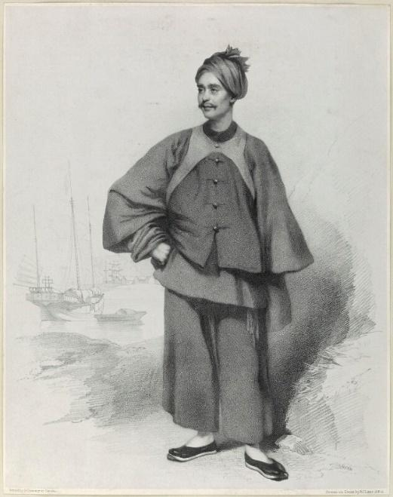
Figure 3. Karl Gützlaff in Fujian Clothes, ca. 1835, print. Public Domain.
Gützlaff also founded an organization of Chinese evangelists called the Chinese Union that he hoped could spread the gospel message from the coastal cities into the Chinese interior, through itinerant preaching and the distribution of translated Bibles and tracts. By the mid-eighteen-forties, Gützlaff’s corps of evangelists reported converting over two-hundred-fifty people, primarily Hakkas, in the area around Hong Kong (Schlyter 1946:98). The Basel Mission began Christian services in the Hakka language in Hong Kong in 1851, a tradition that continues today in the form of the Tsung Tsin Mission. European missionaries and Hakka converts worked together to formulate a standard Hakka dialect. A complete romanized Hakka translation of the New Testament was finished in 1883, and a translation of the Old Testament (with Chinese-styled Hakka characters) was published in 1916.
Mission Literature - Tracts
Missionaries in China used many evangelistic methods: preaching in weekly church services, instructing children in mission schools, delivering open-air sermons, conducting Bible studies during home visits, and distributing religious tracts on the streets (figure 4).
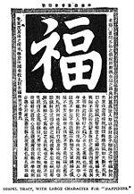
Figure 4. China Inland Mission Tract, ca. 1900, Public Domain.
Religious tracts are brief pamphlets that can effectively disseminate foundational Christian doctrine to a cross section of a society. Christian tracts have been around since the thirteenth century. Martin Luther and other Reformation theologians produced the best-known early tracts during the sixteenth century, after Johannes Gutenburg created his famous printing press.
The London Missionary Society was formed in 1795 to financially support and coordinate overseas missions, primarily in the Pacific islands, Africa, India, Australia, and the Far East. In 1799, the founders of the London Missionary Society established the Religious Tract Society (RTS) to send tracts to missions worldwide. The RTS began printing tracts in classical Chinese and Chinese regional dialects in 1824, and supplied the majority of tracts distributed by missionaries in China (Jones 1850; Gützlaff 1846; Su 1996). The RTS was interdenominational, and “to avoid doctrinal conflicts between members of different denominations, the subject matter of every tract was strictly restricted to the essential gospel truth agreed upon by every Protestant denomination” (Lai 2007:41). David Bogue (1750-1825), a Scottish minister and one of the founders of the London Missionary Society and RTS, outlined the characteristics of a successful tract in his Address to Christians, Recommending the Distribution of Cheap Religious Tracts (1799). According to Bogue, Christian tracts should convey “pure [biblical] truth,” give an “account of the way of a sinner’s salvation,” and be “plain, striking, entertaining, full of ideas, and adapted to various situations and conditions” (Lai 2007:42).
The leadership of the RTS was generally convinced that translating Bible passages into Chinese literally, or word-for-word, could communicate the full gospel message. However, not every missionary agreed, including William Milne, Robert Morrison’s colleague and the second person the London Missionary Society sent to China (after Morrison). Although Milne agreed complete Bible translations should remain faithful to the original texts, he had a much more flexible attitude about individual Bible scriptures mentioned in tracts. Milne encouraged tailoring specific scriptures to suit the cultural background of Chinese readers, by means of omission, addition, explanation of terms, and even changing compositional forms (Lai 2007:53). In this, Milne was an early advocate of free translation: translating biblical ideas without being constrained by the original words.
Tracts were one of the early missionaries’ favorite evangelistic tools. In 1825, the American Tract Society (ATS) was formed in New York based on the RTS model. However, the ATS operated on a more modest scale. They supplied Chinese-language tracts to American missionaries beginning with Elijah C. Bridgman (1801-1861), who was ordained by The American Board of Commissioners for Foreign Missions. Bridgman was the first American missionary to serve in China. When he arrived in Canton in 1830, Bridgman established his own press and began printing his own tracts. In 1844, the Shanghai Tract Committee was founded, China’s first indigenous producer of Christian tracts. A few missionaries self-produced tracts, independent of the Western societies or the patronage of specific denominations. For example, Karl Gützlaff wrote and distributed approximately fifty tracts in the classical Chinese language during the eighteen-thirties and forties.
Chinese Language Hymns
When early missionaries introduced Chinese audiences to Christian “psalms and hymns and spiritual songs” (The Epistle of Paul the Apostle to the Ephesians 5:19, KJV), they quickly realized they would be a popular and effective evangelistic tool. With the assistance of Chinese converts and tutors, missionaries began translating Western hymns and compiling Chinese-language hymnbooks. Mission schools in the treaty ports taught local students about Western music, including instruction on reading musical notation and singing hymns in chorus and in unison. Because each port city had its own spoken language, hymnbooks were originally translated into regional dialects. Around 1912, the newly formed Republic of China adopted Mandarin as the nation’s official language, and many hymns were then retranslated from the various dialects into Mandarin.
Robert Morrison published the first Chinese hymnbook, Sacred Odes to Nourish the Mind (1818), which contained thirty translations of hymns that were in common usage in England and Scotland. Morrison and his Chinese assistant and co-evangelist, Liang Fa (1789-1855), published a second hymnal in 1833 entitled Prayers and Hymns. Liang Fa was one of Morrison and William Milne’s earliest Chinese converts and he became the first Chinese evangelist and an important apologist. Liang’s 1832 essay entitled quànshì liángyán (roughly translated as “Good Words to Admonish the Age”) was an important early statement of Protestant doctrine written in the Chinese language.
During the early Western Protestant missionary era, Western hymns were selected for translation; original Chinese compositions came later. In 1895, G. F. Fitch of the American Presbyterian Mission recommended some criteria for selecting and translating mission hymns. Fitch suggested a proper hymn must be: (1) devotional, so people may sing with spirit and understanding, (2) expressed in colloquial Chinese, and (3) set in proper rhythm and rhyme (Fitch 1895:470).
Western missionaries often studied the nuances of Chinese dialects and the features of classical Chinese poetic styles for many years before attempting to translate hymns. As with Bible translations, the greatest challenge was finding the proper Chinese term to convey Christian themes and concepts. For example, missionaries had heated debates over which terms best captured the meanings of Heaven, spirit, sin, and redemption. The formal equivalence (or word-for-word) approach to hymn translation, proved to be as problematic as the formal equivalence approach to Bible translation. Translators also confronted other serious challenges. The forms and styles of traditional English and Chinese poetry are quite different, and difficult to reconcile. In addition, Chinese languages are tonal; however, Mandarin uses four tones, Cantonese uses eight tones, and other dialects have other systems. Distinct tonal inflections alter the meanings conveyed completely. Oftentimes, the melodies of translated hymns were disharmonious and the lyrics failed to reflect the original messages (Hsieh 2009a:25).
Henry Blodget (1825-1903) and Chauncey Goodrich (1836-1925), of the American Board of Commissioners for Foreign Missions, produced the Mandarin Chinese Hymnal in Peking [Beijing] in 1872. It was republished in 1912. The hymnal included two hymns by Chinese Christians: Ch’ao-hai Jen’s Christmas song entitled “God of Heaven Whose Boundless Love,” which was based on the Chinese folk tune “Peking,” and a song written by En-P’u based on the mission hymn “O Save My Country Lord.” Blodget and Goodrich’s 1912 republication was very popular in Mandarin-speaking churches and was widely used until the nineteen-thirties (Hsieh 2009a, 80-81, 83). In the nineteen-thirties, a small group of Chinese Christians began translating hymn texts from English into Chinese following the phrasing and rhyming schemes of classical Chinese poetry.
True contextualization of Chinese hymnody began with the collaboration of the prominent Chinese theologian Zhao Tze-ch’en (“T. C. Chao”) (1888-1979) and the American Methodist Episcopal missionary and composer Bliss W. Wiant (1895-1975). Chao translated Western hymns using Mandarin words and phrases that could be understood within broad Chinese cultural contexts, sometimes “departing from the meaning of the originals by paraphrasing the texts or writing his own” (Hsieh 2009a:2). Wiant composed tunes based on traditional Chinese folk melodies to match Chao’s new paraphrases. Their first contextualized Chinese hymnals were Hymns for the People and Christian Fellowship Hymns, of 1931. The texts and tunes followed the styles of famous ancient Chinese poems, traditional folk songs and even borrowed from Confucian and Buddhist chants.
Since the end the Western missionary era in China, compilers of Chinese hymnals have often retranslated earlier Chinese versions of Western hymn texts, to ensure they reflect sound Christian doctrine and suit traditional Chinese poetic and musical styles. Western hymns are still prominent in Chinese hymnals, because they are considered an important part of the Chinese church’s heritage (Hsieh 2009a:8).
Conclusion
China’s Protestant missionary era, which began when Robert Morrison arrived in Macau in 1807, ended when the Communist Party of China expelled the last Western missionaries (Arthur Matthews and Rupert Clarke of the China Inland Mission) in 1953. The early Protestant missionaries faced many of the same challenges that face contemporary missionaries, such as adapting to new cultures and finding ways to spread the gospel message in understandable terms. There is much to learn from the early missionaries. They translated Christian texts into the majority language but they also recognized the need to communicate in regional dialects and minority languages. In addition, they understood the power traditional local cultural forms, including poetic and musical styles, have to inspire potential new converts. The early Protestant missionaries’ effective use of translation helped bring God’s Word to millions of previously unreached people in China.
References
Barnett, Suzanne Wilson, and John King Fairbank, ed. (1985). Christianity in China: Early Protestant Missionary Writings. Cambridge, MA: Harvard University Press.
Bassnett, Susan (1996). “The Meek or the Mighty: Reappraising the Role of the Translator,” in R. Álvarez and M. C. A. Vidal, eds., Translation, Power, Subversion. Philadelphia, PA: Multilingual Matters, 10-23.
Benham, Edith (1907). “Women’s Work: General,” in China Centenary Missionary Conference Records. Shanghai: American Tract Society, 140.
Buck, Pearl S. (1936). Fighting Angel. Bath: Chivers Large Print 1993 version.
Bühler, Axel (2002). “Translation as Interpretation,” in A. Riccardi, ed., Translation Studies: Perspectives on an Emerging Discipline. Cambridge: Cambridge University Press, 56-74.
Chan, Kim-kwong and Tetsunao Yamamori (2000). “China’s Christian County: The Lisu of Fugong” ChinaSource, https://www.chinasource.org/resource-library/articles/chinas-christian-county#footnote-marker-1-1, accessed November 13, 2018.
Chiu, Patricia P. K. (2015). “Female Education and the Early Development of St. Stephen’s Church, Hong Kong (1865-1900s),” in Philip Wickeri, ed., Christian Encounters with Chinese Culture: Essays on Anglican and Episcopal History in China. Hong Kong: Hong Kong University Press, 47-64.
Cummins, J. S. (1985). “A Conflict of Cultures, A Review of Jacques Gernet’s China and the Christian Impact” Faith and Culture Today, https://transformingmission.com/2013/01/13/china-and-the-christian-impact/, accessed November 13, 2018.
Davis, John A. (1886). The Chinese Bible Woman: A Sequel to “The Chinese Slave-girl.” Philadelphia, PA: Presbyterian Board of Publication.
Diamond, Norma (1996). “Christianity and the Hua Miao: Writing and Power,” in Daniel H. Bays, ed., Christianity in China: From the Eighteenth Century to the Present. Stanford: Stanford University Press, 138–157.
Erbaugh, Mary S. (1992). "The Secret History of the Hakkas: The Chinese Revolution as a Hakka Enterprise" China Quarterly 132 (December): 937–968.
Fitch, G. F. (1895). “Hymns and Hymn-Books for the Chinese” The Chinese Recorder 16 (October): 470.
Forsythe, Sidney A. (1971). An American Missionary Community in China, 1895-1905. Cambridge, MA: Harvard University Press.
Gützlaff, Karl Friedrich August (1846). Visit to the Chinese Coast, and Other Books for the Young. New York: The American Tract Society.
Hamilton, W. B. (1900). The Chinese Bible Woman. New York, NY: Women’s Board of Foreign Missions of the Presbyterian Church.
Hsieh, Fang-Lan (2009a). A History of Chinese Christian Hymnody: From Its Missionary Origins to Contemporary Indigenous Productions. Lewiston, NY: The Edwin Mellen Press.
Hsieh, Fang-Lan (2009b). “Introduction,” in Chinese Hymns in Chinese Baptist Hymnals-Colloquium on Baptist Church Music. Waco, TX: Baylor University.
Jones, William (1850). The Jubilee Memorial of the Religious Tract Society. London: The Religious Tract Society.
Lai, John T. P. (2007). “Institutional Patronage: The Religious Tract Society and the Translation of Christian Tracts in Nineteenth-Century China” The Translator 13:1: 39-61.
Lodwick, Kathleen L. and W.K. Cheng, eds. (2005). The Missionary Kaleidoscope: Portraits of Six China Missionaries. Norwalk, CT: Eastbridge Books.
Lutz, Jessie Gregory (2008). Opening China: Karl F. A. Gützlaff and Sino-Western Relations, 1827-1852. Grand Rapids, MI.: William B. Eerdmans.
Lutz, Jessie Gregory and R. Ray Lutz (1999). “Karl Gützlaff’s Approach to Indigenization: The Chinese Union,” in Daniel H. Bays, ed., Christianity in China: From the Eighteenth Century to the Present. Palo Alto: Stanford University Press, 269-291.
Nida, Eugene A. and Charles R. Taber (1969). The Theory and Practice of Translation. Leiden: Brill.
Scarborough, William (1875). A Collection of Chinese Proverbs. Shanghai: American Presbyterian Mission Press.
Schlyter, Hermann (1946). Karl Gützlaff – als Missionar in China. Gleerup: Lund.
Shapiro, Judith (1981). “Ideologies of Catholic Missionary Practice in a Post-colonial Era” Comparative Studies in Social History 23: 130-149.
Spurgeon, Charles Haddon (1866). “The Wordless Book” The Spurgeon Archive, http://www.romans45.org/spurgeon/sermons/3278.htm, accessed November 13, 2018.
Sydenstricker, Absalom (1889). An Exposition of the Construction of Chinese Sentences, as Found in Colloquial Mandarin. Shanghai: American Presbyterian Mission Press.
Sydenstricker, Absalom and Zhu Baohui (1913). Si Fuyin [Four Gospels]. Shanghai: Presbyterian Mission Press.
Tupper, H. A. (1880). The Foreign Missions of the Southern Baptist Convention. Philadelphia, PA: American Baptist Publication Society.
UNESCO (2005). Education for All Global Monitoring Report 2006: Literacy for life. New York, NY: The United Nations.
Van der Geest, Sjaak (1990). “Anthropologists and Missionaries: Brothers Under the Skin” Man 25:4 (December): 588-601.
Wickeri, Philip L. (2015). “Introduction,” in Philip L. Wickeri, ed., Christian Encounters with Chinese Culture: Essays on Anglican and Episcopal History in China. Hong Kong: Hong Kong University Press.
Zetzsche, Jost Oliver (1999). Bible in China: The History of the Union Version or the Culmination of Protestant Missionary Bible Translation in China. London: Routledge.

