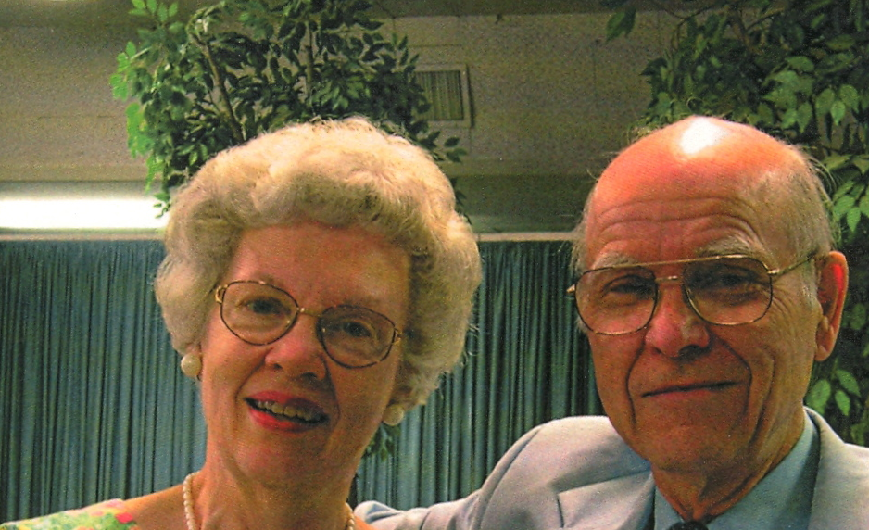

RALPH D. WINTER December 8, 1924 - May 20, 2009
Ralph spent his boyhood years in South Pasadena and was nurtured in the Christian faith by devout parents and from 1938 at Lake Avenue Church where he was active in Christian Endeavor. Later he joined the Navigators. He pursued a degree in civil engineering at Caltech, joined the navy and was training as a pilot when WW II ended. He earned an M.A. at Columbia University in teaching English as a second language and a Ph.D. at Cornell University in structural linguistics, with minors in cultural anthropology and mathematical statistics. While in seminary at Princeton, he served as a pastor of a rural New Jersey church.
He married Roberta Helm in 195l while at Cornell. Roberta's expert help in research, writing and editing, among many other gifts, made her a valuable partner. Following her death in 2001 after nearly 50 years of marriage, Ralph married Barbara Scotchmer, July 2002, who brought him much joy and facilitated his continuing ministry.
After Ralph's ordination in 1956, the Winters joined the Presbyterian Board of Foreign Missions working for ten years in Guatemala among the native Mayan people (Mam). Along with the development of 17 small businesses for bi-vocational pastoral students, Ralph joined others to begin an innovative, non-residential approach to theological studies known as Theological Education by Extension (TEE), which has since been reproduced in countless mission contexts around the world.
In 1966 Dr. Donald McGavran invited Ralph to join the faculty of the new School of World Mission at Fuller Theological Seminary. Between 1966 and 1976 he taught more than a thousand missionaries, but he claimed to have learned much more from his students. During these years he founded the William Carey Library, a specialized publisher and distributor of mission materials, and the Presbyterian Frontier Fellowship (PFF). He also co-founded the American Society of Missiology, helped in starting Advancing Churches in Mission Commitment (ACMC) and inaugurated what is now the Perspectives Study Program (first called the Summer Institute of International Studies).
Many of the accomplishments of Ralph Winter's long career as a missionary, mission professor and "mission engineer" stemmed from his conviction that Christian organizations accomplish more when they cooperate in strategic ways. It was at the Lausanne International Congress on World Evangelization in 1974 that he presented a seminal address with his innovative analysis and advocacy that has redirected evangelical mission energies ever since. Building on McGavran's emphasis on people groups while gleaning insights from his interaction with students and faculty, Ralph underscored the necessity of pioneer, cross-cultural missionary outreach to thousands of "hidden peoples," later known as "unreached peoples." His statistics and careful reasoning stunned all who had previously assumed that "near-neighbor evangelism" by existing churches would be sufficient in world evangelization.
To facilitate creative outreach to unreached peoples, Ralph and Roberta founded the U.S. Center for World Mission (USCWM) in 1976, and in 1977 the related William Carey International University (WCIU), mobilizing evangelicals to pay for the acquisition of the $15 million campus through a series of campaigns that culminated in 1988 and that emphasized mission vision more than fund raising. A community of workers in Pasadena and other locations, now known as the Frontier Mission Fellowship (FMF), has grown to sustain an array of cooperative mission projects. Ralph served as General Director of the FMF until two weeks before his death.
At 84 Ralph continued to work full time, finding satisfaction in addressing a wide range of new challenges and perplexing questions. He was busy dictating into his last days believing that retirement is not Biblical.
Ralph is survived by his wife, Barbara; by his and Roberta's four daughters (all of whom are active in Christian mission), Elizabeth Gill (Brad), Rebecca Lewis (Tim), Linda Dorr (Darrell) and Patricia Johnson (Todd); by 14 grandchildren and one great-granddaughter. He is also survived by his older brother, Paul H. Winter (Betty), a graduate of Caltech and a well-respected structural engineer; by his younger brother, David K. Winter (Helene), former president of Westmont College for more than 25 years; by nephews, nieces and numerous friends and colleagues worldwide.

''TO GOD BE THE GLORY---GREAT THINGS HE HATH DONE."
Barbara R. Winter - Friday, June 19, 2009

***************************************************************************************************************
Memorial gifts may be made to the Roberta Winter Institute, c/o Betty Leung, 1605 Elizabeth Street, Pasadena, CA 91104.
You may read about the Institute at http://www.uscwm.org/rwi/index.html.

Published in the July 2009 issue of the multi-lingual online journal www.GlobalMissiology.org

