Dr. Ralph D. Winter
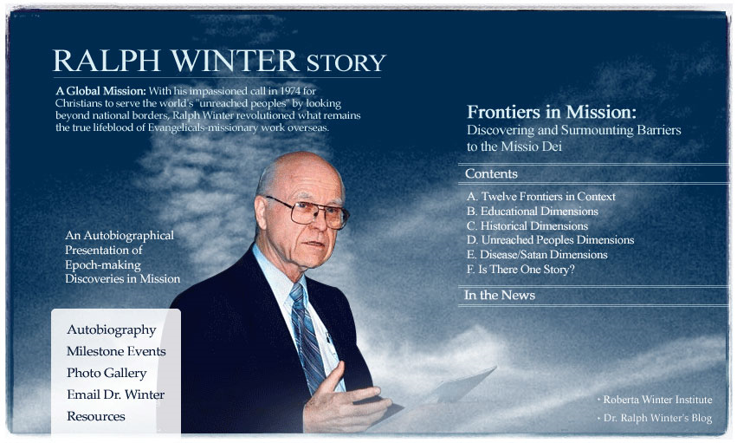

(www.GlobalMissiology.org, Editor - Enoch Wan)

With his beloved four daughters, his wife Barb, and a few friends by his bedside, Ralph D. Winter entered into the presence of his Lord and Savior at his home in Pasadena, CA on Wednesday, May 20, 2009 at 9:05 p.m.

He celebrated life joyfully and ministered to God and others faithfully as a visionary, missionary, researcher, strategist, professor, publisher, etc.

Like King David, “after he had served God's purpose in his own generation, died and was buried with his ancestors, and so he experienced decay” (Acts 13:36 NIV)

- For obituary of Ralph D. Winter - click here.
- For the comprehensive bibliography of Ralph D. Winter - click here.
- For Mission Frontiers - click here
(Ralph D. Winter served as the senior editor, 1979-2008)

- For information on the Roberta Winter Institute - click here.

