A TRIBUTE TO DR. RALPH WINTER

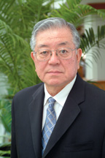

Tetsunao Yamamori

What can I say about Ralph Winter? My dear friend of 50 years was a missiological genius who, in brief articles and editorial columns, could suggest innovative ideas and course corrections of great importance for missionary endeavors.
He was also a missionary statesman who helped engineer a paradigm shift from going to all the countries of the world to people groups without which the Great Commission mission would not be accomplished. Ralph was all these things and more.

He was a soft-spoken gentle person who always found time for you as though you were the only person that mattered. He will be greatly missed.

Tetsunao Yamamori
President/CEO, WorldServe Ministries
and
Research Consultant, PCRI
John Templeton Foundation and Center for Religion and Civic Culture at the University of Southern California

Published in the July 2009 issue of the multi-lingual online journal www.GlobalMissiology.org

