A Tribute to Dr. Ralph Winter

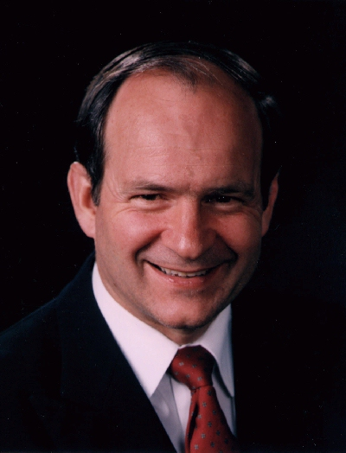

Luis Bush, former director of AD 2000 and Beyond

Ralph Winter has served us all
by providing mission perspectives
that not only made those of us
who seek to follow Christ think,
but also,
to act.
Luis Bush
His friend
Published in the July 2009 issue of the multi-lingual online journal www.GlobalMissiology.org

