A Tribute to Ralph Winter

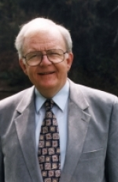

Roger S. Greenway
I came to know Ralph back in the 1960s when he and Roberta were serving
in Guatemala. In many ways Ralph was a genius.
But what made him stand out most was his unwavering passion for introducing people to Jesus Christ.
To that end he dedicated his talents and energy, and by it he left an indelible
mark on missions.

Roger S. Greenway
Prof. of World Missiology, Emeritus
Calvin Theological Seminary

Published in the July 2009 issue of the multi-lingual online journal www.GlobalMissiology.org

