My Tribute to Dr. Ralph Winter

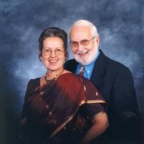

Roger E. Hedlund

Professor, Mylapore Institute for Indigenous Studies, Chennai (Madras), India

My earliest interaction with Ralph Winter was at Fuller Seminary in 1969-70 when I was doing an M.A. in the School of World Mission (as it was then known). Ralph was assigned as my mentor. At our first weekly meeting Ralph announced, “In the SWM we’re not really interested in a thesis, we want a book — something people will read....” From then on we got along famously. Eventually weeks later Ralph said, “You know, you really ought to be turning in something for me to read.” Which I did a chapter or section at a time. Then Ralph would proceed to scribble furiously all over the margins, interesting stuff which I would incorporate into the text. Well, that became my first thesis—yes the Fuller Librarian accepted it as such—which was published in 1970, my first book.
There is more, but how much to tell? Once that I know of, Ralph Winter forgot about our final exam. We were assembled in the lecture hall, but no professor (or exam questions) until someone went to get him. I’m sure he thought up the questions as he came up the back stairs....
Another time I turned up at Ralph’s office to find him in an extensive house-cleaning project, books getting shelved, papers and files made to disappear: “I’m really not supposed to be running a publishing house out of my faculty office....” Ralph was expecting a visit from the provost or some other august officialdom representative.
And more. He is missed. But his creative works remain and follow.

Published in the July 2009 issue of the multi-lingual online journal www.GlobalMissiology.org

