Do Mission Events Really Have a Long-Lasting Impact
On the Younger Generation?
Evi Rodemann
Published in Global Missiology, www.globalmissiology.org, April 2020
Abstract
Thousands of dollars are spent on Christian events and mission conferences globally. Very little has been researched on their impact. If results are discussed, they are often short-term goals. This article examines the long-lasting impact that mission events for young people can produce, what should be measured, and tools to measure desired impact and outcomes. Data will be drawn from four European youth mission conferences called Mission-Net, including findings from conference surveys.
Key Words: Europe, events, impact, Lausanne Movement, missions, Mission-Net, young generation
Introduction
Whether held at global, continental, national, or other levels, Christian and youth mission conferences seek to mobilize Christians to live out their faith, be the hands and feet of Jesus, and follow Jesus wholeheartedly. Each conference has its own vision and agenda. Some conferences clearly portray their vision and agenda on their websites and in their brochures, while others might require more concerted effort to understand what their purposes and goals are all about.
This article seeks to describe what is meant by “impact” and the difference events can make in the lives of young people. In order to determine the kind of impact that conferences actually have and potentially can have, consideration must be given first to how “impact” can be measured.
When Do Young People Come to Faith?
Barna’s research on young people in the U.S. finding faith in God reports, “The probability of someone embracing Jesus as his or her Saviour was 32% for those between the ages of 5 and 12; 4% for those in the 13-18 range; and 6% for people 19 or older” (Barna 2003:34).
Summer Madness, a significant yearly event in N. Ireland, seems to be one of the first events in Europe to conduct research and numerical data (Kee 2015). In their survey of 1,000 Christians, a total of 74% said that they came to faith before the age of 18, and a further 11% between the age of 18-25. Together, these two groups total 85% of the participants (Kee 2015:7).
For young and old, events play an important part in their spiritual journey. The study by Summer Madness highlights the importance of camps in the spiritual journey of a young person under 17 years of age. Thirty-four percent of those surveyed indicated that a residential camp or other Christian events made the difference for them (Kee 2015:8).
These statistics will vary from nation to nation and only suggest that the majority of people who become involved in church and in missions make a decision for Christ sometime during their teens, with a few more during their university years.
How do Mission Events Seek to Call Young People into Missions?
To mobilize the younger generation for missions, various missions conferences worldwide offer a unique opportunity for young people to hear global stories, be invited to participate in the Great Commission, and be offered concrete opportunities. Such conferences are surely only one way of creatively of engaging with young people, but they play an important role by having hundreds or even thousands of them in one place rallied around the same vision. During these events, young people are invited to commit their lives to God and missions - often with life-long implications.
Regional missions events include CIMA conferences, organized by Movida and held throughout Latin America since 1990 (Movida n.d.), and the many TEMA (The European Missionary Association) congresses held in Europe for 28 years (1976-2004). European-wide, new-year’s congresses were held four times by Mission-Net from 2007 to 2016, with a new Revive new-year’s congress, sponsored by IFES Europe, beginning in 2019-2020 (IFES Europe n.d.).
The largest gathering is the Urbana student missions conference in the United States, drawing more than 12,000 students every three years. Urbana (Urbana n.d.a.) started in 1946 and was instrumental in establishing TEMA and later Mission-Net. CIMA was inspired by TEMA. There are surely more overlaps and inspiring relationships unknown to the author. Their legacies might only be completely known in heaven. Informal discussions with individuals reveal the significance of these events in their mission journeys.
What Effects Do Event Organizers and Proponents Hope Will Occur?
Youth events need to break even financially, and often strong sponsorship is needed to maintain financial viability. Finances often determine whether events can continue, although profitis not the end goal. Christian events have a deeper level of meaning unique for a religious event, the spirituality factor. This factor is by far the most challenging to measure, as it can only be deduced from less tangible realities: how young people have heard a message, responded in their hearts, and then taken action.
Urbana states on its website that God has used previous congresses to challenge nearly 300,000 young people “with their responsibility and privilege in global missions” (Urbana n.d.). MaryKate Morse describes on her blog the significance of Urbana in her life and why she thinks that large Christian conferences make a difference:
Yes, I believe that large conferences can be catalytic and Spirit-led, like Urbana. This is especially true when they are bathed in prayer and scripture from beginning to end, have a true multi-cultural platform of presenters and topics, not just token ones, and are willing to be prophetic and honest about the real lived spiritual and physical experience of all people despite the cost, and then lives are changed (Morse 2016).
Offering a different perspective, Kara Powell encourages young people to move from mission trips to missional living, implying that mission is not only a one-off intercultural experience or event but is a lifestyle. Powell stresses that event and daily life need to go together (Powell 2009).
Huber developed the Centrality of Religiosity Scale (CRS) to help identify religious aspects of human personality. The scale measures five theoretically defined core dimensions of religiosity: public practice, private practice, religious experience, ideology, and the intellectual dimension. Observing these five dimensions helps to analyze the religious life of a person (Huber 2012). No research paper has yet tied this measurement scale to spirituality and events, but certainly CRS could help to determine what organizers and proponents want to see happen spiritually in participants. Underlying such a hope is a dependence on God to do his good work in Jesus’s followers (Phil 1:6).
The History of European Youth Mission Congresses
Starting in 1956, the ESMA (European Student Missions Association) organised European conferences for theological students. TEMA assumed this role in 1974 by preparing to hold European congresses for young people between the ages of 16-30 years. After the First International Congress on World Evangelization (ICOWE) had also been held in 1974, in Lausanne, TEMA held its first conference on the same premises in 1976. TEMA continued for 28 years, but sadly went bankrupt in 2004 (Rodemann 2014b).
In 2007, preparations began for a new European youth mission congress to be called ‘Mission-Net’. The first congress was held over Easter in 2009, and the fourth and final one took place over New Year’s 2015/16. A fifth Mission-Net was planned for New Year’s 2017/18 but sadly was cancelled three weeks before the scheduled event due to a low number of registrations.
The four Mission-Net conferences totalled over 12,500 participants from more than 50 nations, both from Europe and beyond.
The author was only 15 years old when she attended her first TEMA congress in 1986. She went to every one of the seven until 2004. These congresses greatly impacted her spiritual journey. She started as a participant, then became a volunteer, and later served as an exhibitor with a missions organisation. In 2007 she was asked to join the new Mission-Net team, and she co-led the first congress and directed the three afterwards. Though she left this endeavour in 2016, her MA (in European Mission and Intercultural Christianity) dissertation focused on Mission-Net (Rodemann 2016) and contributed research on the heretofore little studied field of event impact.
The Idea of Congress and Movement
It was important to the Mission-Net organizers that young people would not simply attend a congress. Rather, the goal was the creation of a movement of young people living a missional lifestyle, and the congress was a tool to help enhance such a movement (Rodemann and Duarte 2015). Christian leaders in various countries were encouraged to set up their own national missions conferences, either under Mission-Net or where possible in collaboration with other mission agencies. Mailings to youth leaders mailings were begun, prayer partnerships among young people were encouraged, an existing network for youth ministry leaders filled with new life, a collaborative political initiative for young people started, mission teams were sent out, a prayer movement got off the ground, and various other initiatives and networks were either created or endorsed by Mission-Net (Rodemann and Voegelin 2013). Some of these endeavors persist today, despite Mission-Net as an organization having been dissolved.
What is Event Impact?
‘Impact’, according to the Oxford Dictionary, is “the powerful effect that something has on somebody/something” (Oxford Advanced Learner's Dictionary 2020). Having explored the different kinds of impact made through events, the author has defined impact as a powerful effect that something, especially something new, has on a situation or person which will lead to actions (Rodemann 2016).
All missions conferences aim not only to provide inputs to participants but to see our world being reached for Christ. Young people are encouraged to understand the world’s needs and respond accordingly.
The following graphic demonstrates the process leading from inputs to impact.
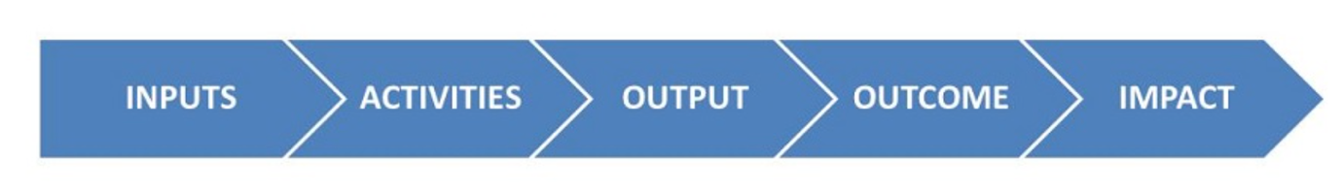
Figure 1: From Inputs to Impact (Walter 2015)
To achieve impact, there must be input. Congress inputs can come from the main stage, in seminars, or through informal learning. Inputs must then lead into activities. Young people need the opportunity to respond. Tangible examples of activities are accepting a missions call, heeding an invitation to pray, or sharing testimonies with people who do not yet know Christ. Next should come output, which could be, for example, the creation of a program on how to share the gospel with one’s Muslim neighbor. The outcome will be the effect that output has on people. Note that outputs and outcomes are measurable. Finally, the impacts are the long-term or indirect effects of the outcomes.
What is the powerful effect of an event helping a young person to take up action? Organizers plan with the belief that the preached Word of God provides opportunities for the Spirit to move. But the Holy Spirit is writing stories on people´s hearts in ways event organizers neither envision nor work towards.
Some events might focus only on inputs, but in general organizers all want to achieve impact that is long-lasting and sustainable. Urbana student conferences have not solely relied on delivering high quality and relevant input, otherwise they would not have seen nearly 300,000 young people respond to a call to missions. A central challenge, then, facing conference organizers must be determining the kind of event impact they should expect, and for which they should plan and pray.
Categories of Event Impact
What follows is a list of event impacts. To the author’s knowledge, such a list has not been compiled or published before. This draft list could thus profit from further input and refining.
The most researched event impact is the financial one. Subsequent to exploring this financial or economic impact, various non-economic impacts will also be introduced.
- Financial Impact
To calculate an event’s financial impact, a cost-benefit analysis is used to determine if the financial outcome has been positive or negative. Different key figures have been developed for such an analysis. Along with the overall economic impact, one can measure the return on investment (ROI), return on objectives (ROO), and the business value of meetings (BVOM). While the ROI is the result represented by loss or gain from an event, the ROO is a percentage of possible outcomes, based on attendees’ conference evaluations and suggested areas for improvement.
Economic impact or economic efficiency calculation is described by Vanhofe (2011:223ff.), who divides the economic impact into seven major groups:
- Income (value) added generation
- Employment generation
- Tax revenue generation
- Balance of payment effects
- Improvement of the economic structure of a region
- Encouragement of entrepreneurial activity
- Economic disadvantages
To be able to measure the economic impact of an event, there are various categories of effect. There are direct or primary tangible effects such as the number of participants, organisers and sponsors, exhibitors or participating groups, and speakers.
Indirect or secondary effects are seen through the event organisation, for example caterers, audio-visual equipment suppliers, and mobile toilets. Financial impact results from payments to such suppliers.
As for impacts other than financial ones, it has only been in the last ten years that the event market has started to analyze and measure non-financial event impacts. Edwards, Foley, and Schlenker in Australia were among the first to analyse conferences and their non-economic impact, for example in their “Business events and friendship: Leveraging the social legacies” (Foley, Edwards, and Schlenker 2011). In this study they developed the measurement of ‘Business Value of Meetings’ (BVOM) in order to discern non-financial impact. Not surprisingly, BVOM varies greatly according to the meeting type, budget, geographic region, and other variables.
It is worth noting three characteristics among organisations that measure BVOM:
- Clearly defined event objectives and expectations
- Data collection methods that measure these objectives
- Result evaluation that leads to improvement (MPI 2011:6)
No matter what kind of non-economic impact identified, using the BVOM is important. Organizers of every event should define objectives, decide on how the data is going to be collected, and decide what to do with the results. In Mission-Net, a team worked over a six-month period to identify objectives for the key stakeholders and revisited them after each congress (Rodemann 2014a).
The list below of non-financial impacts is in an arbitrary order and should not be understood to indicate priority levels. For future research, some of these impact categories might need to be moved to outcomes.
- Socio-cultural Impact
Socio-cultural impact can happen where the identity of a region is developed and participants of events are supported in their intercultural understanding and integration.
- Psychological Impact
Through attending an event a person starts to identify with the sponsoring organisation, possibly leading to further networking, donations, or collaboration.
- Cognitive or Educational Impact
Conference participants gain deeper knowledge of specific topics, which can help them in future decision-making. Awareness of the importance of cognitive impact has led the organizers of the annual European Leadership Forum session and seminar to survey, participants at the event’s conclusion. Participants surveyed not only rate the speaker(s) but also record their take-aways so as not to lose their new knowledge. In general, mission conferences are characterized by plenary presentations and talks. Careful planning needs to incorporate steps for new knowledge retention, so that participants will not simply replace their educational impact with new knowledge they will gain at whatever conference they might attend next.
- Emotional Impact
Attending an event can be an emotional highlight, a proverbial ‘mountain top experience’ that lasts until one enters the valley of post-event routine. Event participants make new friends and might even find collaboration partners, both providing emotional uplift. Research shows as well that attending a congress can support emotional well-being and produce endorphins connected with euphoric spiritual sensations (Schwab 2013).
- Awareness Impact
An event can raise the profile of an organisation, including for fundraising. Awareness can also be raised about such important topics as missions, social injustices, and human rights.
- Ecological Impact
‘Ecological’ or ‘sustainable impact’ are used interchangeably here. ‘Environmentally sustainable’ is a major concern for young people and needs to be addressed at events. For example, the Mission-Net organizing team was often asked about what was being done to ensure that the conference would have contributed positively to the environment, for example by producing less rubbish.
- Spiritual Impact
It should go without saying that missions conference organizers need to discern beforehand what kind of spiritual impact they would love to see as an outcome. A missions conference should serve as a frame within which the Holy Spirit can work. There will always be elements of surprise when God graciously works, and there very well could be disruptions to the programme schedule. When conference participants understand the word of God, they will be led to action. Their prayer life might be deepened, they might read the word of God more regularly, they might care for the homeless more intentionally. A spiritual impact will always lead to action, since Christians are admonished to “Not only be hearers of the word, but doers” (James 1:22). Measuring and evaluating the spiritual impact of conferences, along with the other impacts listed above, should therefore be one of the organizers’ central responsibilities.
Mission-Net and the Business Value of Meetings
From the first Mission-Net congress in 2007 through the final one in 2016, the organizing team sought information that would be valuable for evaluating and improving these European youth mission congresses. Though only four Mission-Net congresses took place, the collected data can serve to highlight some meaningful findings and lessons learnings.
After the first Mission-Net congress, team members collected surveys and evaluations from participants, volunteers, and exhibitors – the three largest groups. Over the next nine years, further strategies surveying before each congress as well, in order to have an immediate comparison of cognitive and emotional impact. The organizing team added surveys one year post-congress to learn where participants were in their journeys, since the congress’s spiritual impact can be evaluated much better once the participants go home to put a missional lifestyle into practice.
The Mission-Net team especially wanted to discover the event’s lasting impact by surveying participants who had attended at least two Mission-Net congresses.
The data was collected in various steps, visualized in Figure 2. First an online questionnaire was sent to all attendees of the fourth Mission-Net congress (in 2016) who had attended at least one previous Mission-Net congress. Out of the 402 returnees, 121 filled in the questionnaire. However, only 92 of these 121 are complete and valid.
At the end of the anonymous questionnaire, 53 (58%) of the former congress attendees supplied their email addresses to indicate their willingness to participate in further research. They were then asked if they were willing to participate in an interview. All 13 people who responded within a week were then interviewed, from which twelve interview data were gathered (one needed to be disqualified).
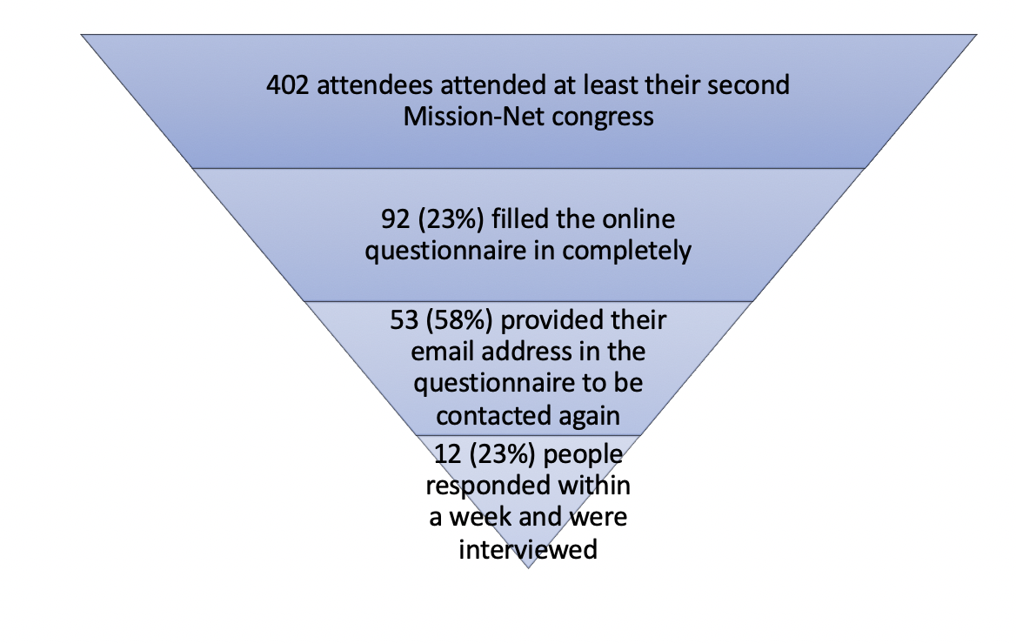Figure 2: Funnel of Group Response
At the fourth Mission-Net congress, 18% of the attendees had at least attended one previous congress. The question was, why did they come back? Had they developed a missional lifestyle and wanted to learn more? Had they made some friends through the common journey and used this event as a meeting point?
The interviews undertaken highlight some of the impact categories. At that time (2016), however, not all the event impact categories listed above had been identified by the author. Some of the findings from the 12 interviews and 92 online questionnaires will follow.
First, we will consider the impact of these Mission-Net Congresses. What were some of the changes that were discovered through the surveys and the interviews?
- Cognitive Changes
Young people reported understanding more about a missional lifestyle and described how their view on missions had changed through attending the congress. Those who had attended at least two congresses reported an even greater understanding.
- Spiritual Changes
The attendees described their renewed commitment to reading and studying the word of God, which had impacted their relationships with God. Some respondents even mentioned they made a first-time faith commitment at the Mission-Net congress, which had not been intentionally designed to bean evangelistic event. The respondents had also started to read more Christian and mission related books, and they received encouragement and support for their Christian walks. They also gained a new perspective on Europe and how this continent is once again a place which needs to receive missionaries.
- Action-inducing Changes
Respondents not only understood a missional lifestyle cognitively but wanted to live it out. Some had pursued further theological training, whether formally or informally, and some had become more engaged with their own churches and related ministries. Others had entered youth work and had been mentored by some of the Mission-Net related youth ministries. Their engagement against social injustice had grown, and they could no longer simply pass by homeless people in their streets. Some respondents had started to invest intentionally in younger people. Some had reactivated their prayer lives.
Attending Mission-Net had also affected these respondents’ use of time and finances. They were including God much more in their daily lives, committing each day as well as their money to him.
Second, what were some of the discoveries made along the way?
- Participants might have attended for very different reasons then they had expected.
During the last family group session (family groups consisted of 6-10 people from the same country who met every morning during the congress), the participants of the fourth Mission-Net congress were asked to complete a paper questionnaire about their motivation for coming. Of the 1000 people who attended a family group, 312 completed this survey. However, since not all family group leaders actually collected their members’ questionnaires, the results are highly skewed with respect to the countries represented by the responders.
Here are the findings, grouped according to respondents’ motivations for attending:
Group | Synthesized Personas
Encouragement and renewed faith  32% of the base | The main focus is to be encouraged and strengthened in his/her faith. This person might be interested in missions in general but mission opportunities are not (yet) important to them.  It is not important to who is speaking in the plenary programme.
Mission Seeker  24% of the base | This person has a general interest in missions and the opportunities within the mission field. Getting to know other Christians is a secondary reason for them to attend.  This person is also looking for encouragement/strengthened faith. Who is speaking in the plenary programme is not important for them.
Meet new friends  14% of the base | This person is particularly interested in getting to know other Christians – possibly from different backgrounds/cultures.  This person has a general interest in the different mission opportunities available but the overall interest in missions is quite low.  This person furthermore does not seek encouragement or a strengthened faith.  The person is often in his/her 30s.
Programme oriented  11% of the base | This person is attending because of one/several of the speakers and/or artists who have been invited.  Mission is a minor interest to them.  This person is generally younger.
Other  19% of the base | This person can come for various reasons. 60% of the people in this group say that someone invited them.  Generally, this person does not show much interest in meeting other Christians.  Another important reason for some people in this group is the fact that they attended Mission-Net before and liked it.  A lot of people in this group are exhibitors.
Figure 3: Mission-Net Attendees’ Personality Profiles
The Mission-Net team realized early on that participants’ main motivations for coming were not necessarily for missions, though Mission-Net is a missions conference. Exhibitors and other congress leaders serving the attendees would have been helped by knowing beforehand at least a sketch of participants’ motives behind their attending. The congress organizers tried to move people from knowing little about missions to an understanding of what missions is, then further along to implementing a missional lifestyle. The goal was to progress from inputs to impact. Such growth takes time, however, and involves a process which rarely can be completed by attending one missions conference.
- Change of Roles
One of the first discoveries was the change in roles of the interviewees between congresses. While most of them started as Mission-Net participants, some then moved on to join the service team at the next congress, then became Mission-Net staff, which for some involved serving on Mission-Net national teams or as a congress advocate. The author took a similar journey as just described. Mission events need to take this possibility into account and welcome people to embark on such a journey.
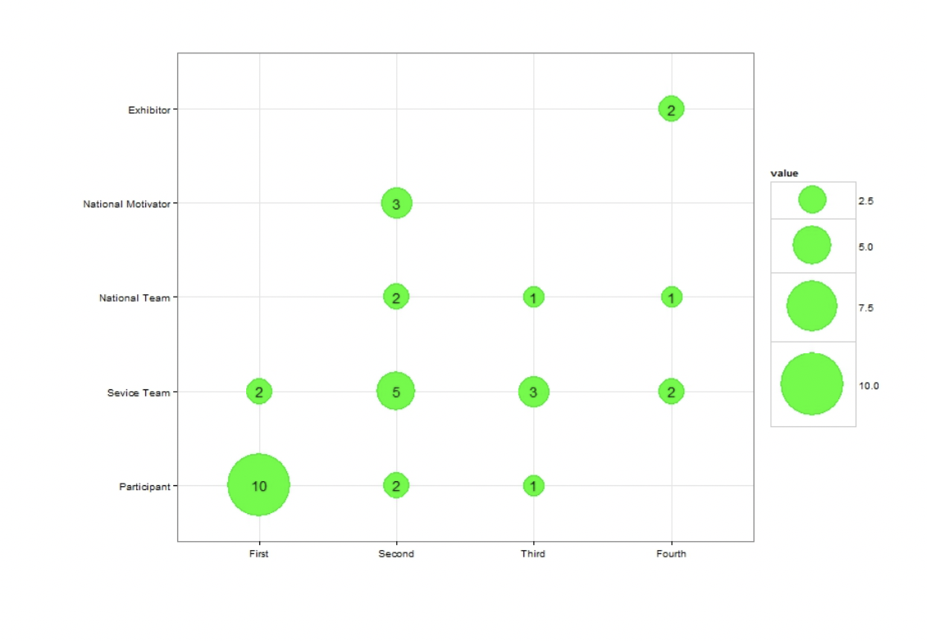Figure 4: Interviewees´ Changing Involvement in Mission-Net
The graph depicted in Figure shows individuals’ different involvements within Mission-Net. Since not everyone who participated in the interviews attended the same congresses, an individual scale was calculated for each person. (The first congress denotes the first congress a particular individual attended, the second congress the second congress attended, and so on.)
Most attendants (83%) attended their first Mission-Net congress as a participant. Less than 17% returned as a participant for the second congress. Instead they returned either as a service team member (42%) or as part of the national Mission-Net team (42%). The national team was made up of the national motivator who headed up the national team. This shows a clear tendency that they put into practice what they learned during the first congress and wanted to be more involved within the mission field now. The involvement distributions of the third and fourth congresses show a similar picture. For the third time, 60% of the attendants returned as service team members. For the fourth congress we saw a slight shift as for the first time former participants returned as exhibitors (40% of those who attended four congresses). The interviews were very emotional at that point, as people shared how God had called them into missions and how others had journeyed with them along the way. The one who came back as an exhibitor explained how she now wanted to invest in young people, just as others had invested in her.
- The Importance of Invitations by Leaders
Half of the interviewees were invited to a Mission-Net congress by their pastors or/and youth leaders. They would have never come on their own, but coming with a group and being asked by the person responsible for the youth or even the pastor made the difference. The positive influence leaders can and should give should never underestimated. Once people return from mission events, it is important for leaders to walk with them and help them with the commitments they have made.
- Provide Spiritual Companions or Like-minded People
The young people interviewed shared that, in order to follow through with their decisions taken at Mission-Net, they looked for like-minded people who would walk with them, and with whom they could share and pray together. Interestingly, at Mission-Net congresses prayer partnerships were encouraged, and about 300 people from one congress agreed to pray for each other for six months. Some became friends and started to visit each other across languages and nations. There is a deep need for mentors who will help people on the way. Some can serve as spiritual companions; some others can serve as older and wiser mentors who have already taken some steps further and serve in missions. Most young people would not like to journey on their own nor try to follow through with commitments on their own.
Conclusion
Missions conferences still play a vital role in recruiting for missions. The impact seen through such events is not only evident through stories of lives transformed but also through data. To see impact grow, event organizers should record their goals so to be able to measure them. For missions conferences, it is vitally important to clearly articulate the vision and mission, as well as the desired outcomes and impacts which are expected and prayed over. While some Christians may resist planning for spiritual events, in fact they very much require not only wise planning but evaluation as well. God through the Holy Spirit will do whatever he seeks best for this world. Mission event organizers have an important part to play to impact young people to be part of God´s mission.
References
Barna, G. (2003). Transforming Children into Spiritual Champions: Why Children Should Be Your Church’s #1 Priority. Ventura, Calif: Regal Books.
Deery, M. and Jago, L. (2010). “Social Impacts of Events and the Role of Anti‐social Behaviour” International Journal of Event and Festival Management, 1(1):8-28.
Edwards, D., Foley, C., and Schlenker, K. (2014). “Business events and friendship: Leveraging the social legacies” Event Management Vol. 18:53–64. DOI: https://opus.lib.uts.edu.au/bitstream/10453/31801/1/Foley_Edwards_Schlenker%20EMgt%202014%2018,1,%2053-64.pdf (accessed March 29, 2020).
Huber, Stefan and Huber, Olio W. (2012). “The Centrality of Religiosity Scale (CRS)” Religions 2012, 3(3):710-724. Available online at https://doi.org/10.3390/rel3030710 (accessed April 2, 2020).
IFES Europe (n.d.). “Revive” EFES Europe website, https://www.reviveeurope.org/ (accessed April 2, 2020).
Meeting Professionals International (2011) “Business Value of Meetings” MPI Foundation and AIBTM. Available online at: http://www.ibtmevents.com/RXUK/RXUK_IBTMEvents/document/MPI_and_AIBTM_BVOM.PDF (accessed March 29, 2020).
Morse, MaryKate (2016). “Do Large Christian Conferences Really Make a Difference? Reflections on Urbana 15” Missio Alliance website, http://www.missioalliance.org/large-christian-conferences-really-make-difference-reflections-urbana15/#.VqMNEkDyPZ4.twitter (accessed April 2, 2020).
Movida (n,d,). “Movida International’s History” Movida website, https://movida-net.com/en/ (accessed April 2, 2020).
Oxford Advanced Learner's Dictionary (2020). “impact noun” Oxford Learner's Dictionaries website, Oxford University Press, https://www.oxfordlearnersdictionaries.com/us/definition/english/impact_1 (accessed April 2, 2020).
Powell, Kara E. (2009). Deep Justice Journeys Student Journal: Moving from Mission Trips to Missional Living. Grand Rapids, MI: Zondervan/Youth Specialties.
Rodemann, E., ed. (2014a). “Purpose, Outcomes, Values MN”. Unpublished paper.
Rodemann, E. (2014b). “Mission-Net History”. Unpublished paper.
Rodemann, E. and Voegelin, M. (2013), in Rodemann, E., ed. “Mission-Net – What is it all about?”. Unpublished paper.
Rodemann, E. and Duarte, C. (2015), in Rodemann, E., ed. “Mission-Net Fundraising Brochure”. Unpublished paper.
Rodemann, E. (2016). “An exploration of the impact of the Mission-Net Congress”. Unpublished Masters Thesis. University of Gloucestershire.
Schwab, Sandra (2013). “An empirical study about the impact of the congress Das Beste für die Stadt on the transforming work of the participants”. Unpublished Masters Thesis. University of South Africa.
Summer Madness (2015). “Faith in the Future Survey” Summer Madness website, http://www.summermadness.co.uk/festival/faith-in-the-future-survey-2/ (accessed March 28, 2020).
Urbana Conference (n.d.). “Past Urbanas” Urbana website, https://urbana.org/past-urbanas (assessed March 28, 2020).
Vanhove, N. (2011). The Economics of Tourism Destinations. 2nd. ed. London: Elsevier Ltd. DOI: 10.1016/B978-0-08-096996-1.00008-X.
Walter, Fabian. (2015) “Welche Wirkungen hat dein Projekt” Erfolgreich Projekte leiten website, https://erfolgreich-projekte-leiten.de/output-outcome-impact/ (accessed March 30, 2020).

In this article, the terms ‘congress’ and ‘conference’ are used interchangeably. The United Nations World Tourism Organization (UNWTO) seeks to unify terminology and uses the generic phrases ‘Meeting Industry’ and ‘International Meetings Industry’ to describe the organisation, promotion of events, congresses, and conferences. Currently, however, there is not an agreed upon usage of ‘congress’ and ‘conference’. In particular, different continents use the terms differently.

