How Does a Global Missions Network Engage with the Younger Generation?
Evi Rodemann, Nana Yaw Offei Awuku
Published in Global Missiology, www.globalmissiology.org, April 2020
Abstract
In 2016, the Lausanne Movement launched a ten-year strategy of engaging with younger leaders globally called Lausanne Younger Leaders Generation (YLGen). Within YLGen, different initiatives were formed, tested, and adapted. As the strategy is now in its second phase, what has been learned from the first three years of engagement? How do younger leaders need to develop as disciples, followers, and leaders? How can senior leaders encourage, support, and challenge? What are some of the gaps between the generations, and how should Lausanne seek to bridge those gaps on a global scale? This article will seek to answer such questions by drawing from a number of relevant surveys.
Key Words: events, Lausanne Movement, missions network, world, younger generation
Introduction
Various global Christian mission networks, such as the World Evangelical Alliance, have a new or renewed commitment to developing younger leaders. Many national networks, national Evangelical Alliances, and mission agencies have made similar commitments. Some have realized that young people are not, or are no longer, part of their networks. Some know that their senior leadership team will soon retire and, if they do not invest now, no younger leaders will be available to step in and step up.
The Lausanne Movement intentionally decided to launch a ten-year strategy with younger leaders globally starting in 2016 and finishing with the fourth YLG in 2026. The motivation is not primarily to raise younger leaders to fill leadership positions but to see the cause of world evangelization advanced. To reach the world for Christ, we need leaders who have a humble heart, are prayerful, and have a servant attitude – or as Chris Wright has said, “living HIS lifestyle – in humility, integrity and servanthood” (Wright 2010).
The Lausanne Movement and Its Commitment to Global Younger Leaders
At its core, the Lausanne Movement is about global mission. Its mission is to connect influencers and ideas for global mission, with a vision of the gospel for every person, an evangelical church for every people, Christ-like leaders for every church, and kingdom impact in every sphere of society (Lausanne Movement n.d.f).
In 1974, the first International Congress on World Evangelization took place at the invitation of Dr. Billy Graham in Lausanne, Switzerland. The location gave the movement its name. Since then, two other global Lausanne Congresses have taken place: in Manila, Philippines in 1989 and in Cape Town, South Africa in 2010. Each congress provided unique contributions to world evangelization, particularly the Lausanne Covenant, Manila Manifesto, and Cape Town Commitment as significant outcome documents.
From the start, younger leaders were involved. Ramez Attalah, a global statesman and Egyptian director of the Bible Society, was only 22 years old when he was asked to contribute to the first Lausanne Congress. He encouraged other younger leaders to participate over the following congresses.
In 1987, the first younger leaders gathering took place in Singapore 1987 (YLG 1987), a meeting inspired by Leighton Ford. Key leaders serving the local and global church today emerged from YLG 1987. A second YLG followed in Malaysia in 2006, then a third in Jakarta in 2016 (YLG 2016). Each YLG took place between the global Lausanne congresses of 1974, 1989, and 2010.
The third gathering was the best-attended YLG in its history, with 865 younger leaders from 140 nations present, and another 150 mentors who came to serve this generation. What was unique about this gathering was the preparation time, which was expected of everyone registering. One year before the gathering, registered attendees received monthly online assignments which ranged from listening to a message by Dr. Billy Graham to studying the Lausanne Covenant to Bible stories. The YLG Facebook community went live more than six months before the gathering, enabling participants to get connected all over the world, with some becoming friends even before face-to-face encounters.
Each participant, when signing up to attend, expressed a commitment to a ten-year journey with Lausanne. However, what that commitment would entail was not specifically laid out.
The Vision for the Younger Leaders – Younger Leaders Generation
In April 2016, a team of five people under the leadership of Lausanne Global Executive Director/CEO Michael Oh (who was himself one of the younger leaders at YLG 2006) was invited to discuss and determine a follow up strategy after the YLG 2016. The team formed and started to strategize, plan, and pray about how to maximize the impact of the upcoming gathering of gifted and influential younger leaders.
After four months, at the end of YLG 2016, the team’s new initiative called Younger Leaders Generation (YLGen) was formed. YLG participants were invited to join this new initiative through the closing address of the recently appointed YLGen Director, Nana Yaw Offei Awuku from Ghana. After YLG 2016 in November, 778 out of the 865 younger leaders (89.9%) who had attended had accepted the invitation to join the YLGen community. YLGen hopes to build, over the span of ten years, connections across generations through mentors walking alongside younger leaders and connecting them more intentionally to Lausanne issue networks, regions, missional resources, and each other through peer groups.
YLGen has adopted the six core values for leaders that Billy Graham called the Lausanne “spirit”: serving in humility, friendship, study, prayer, partnership, and hope (Lausanne Movement n.d.c). Through intentional discipleship, YLGen wants to help develop Christ-serving leaders that embody Lausanne’s values.
Backgrounds of the Younger Leaders Who Signed Up for YLGen
The Lausanne Movement defines young leaders as people predominately between 25-35 years old, though Lausanne recognizes that some countries would consider 40 years of age as “young” and therefore makes some exceptions.
To understand not only the background of younger leaders but also their development within the Lausanne Movement, in total five different surveys have been undertaken so far, with more planned in the future:
- The pre-YLG 2016 survey (Brierley 2016a)
- The post-YLG 2016 survey (Brierley 2016b)
- One year after YLG 2016 survey (Rodemann 2017)
- Two years after YLG 2016 survey (Hofmann 2019)
- 2.5 years after YLG 2016 survey - engagement of younger leaders (Lausanne n.d.d)
Who are these younger leaders?
The 865 younger leaders who attended YLG 2016 came from 140 countries. Due to security reasons, the Chinese delegation (16 persons) was excluded. While most have English as their primary language (607), other language groups included French (48), Korean (12), Portuguese (43), Russian (10) and Spanish (42). While material was produced into at least five different languages, the communication language for YLGen is primarily English.
The participants come from all over the world, though some regions have the largest contingencies, for example 112 from English-speaking Africa, 108 from Europe, 98 from North America, and 91 from Latin America.
In the survey “Two years after YLG 2016”, the younger leaders were asked about their spheres of influence. Their main sphere is found in missions, followed by church and other.
When asked about their current influence on a multi-layered scale, the majority answered that they were working nationally, followed by locally and then globally.
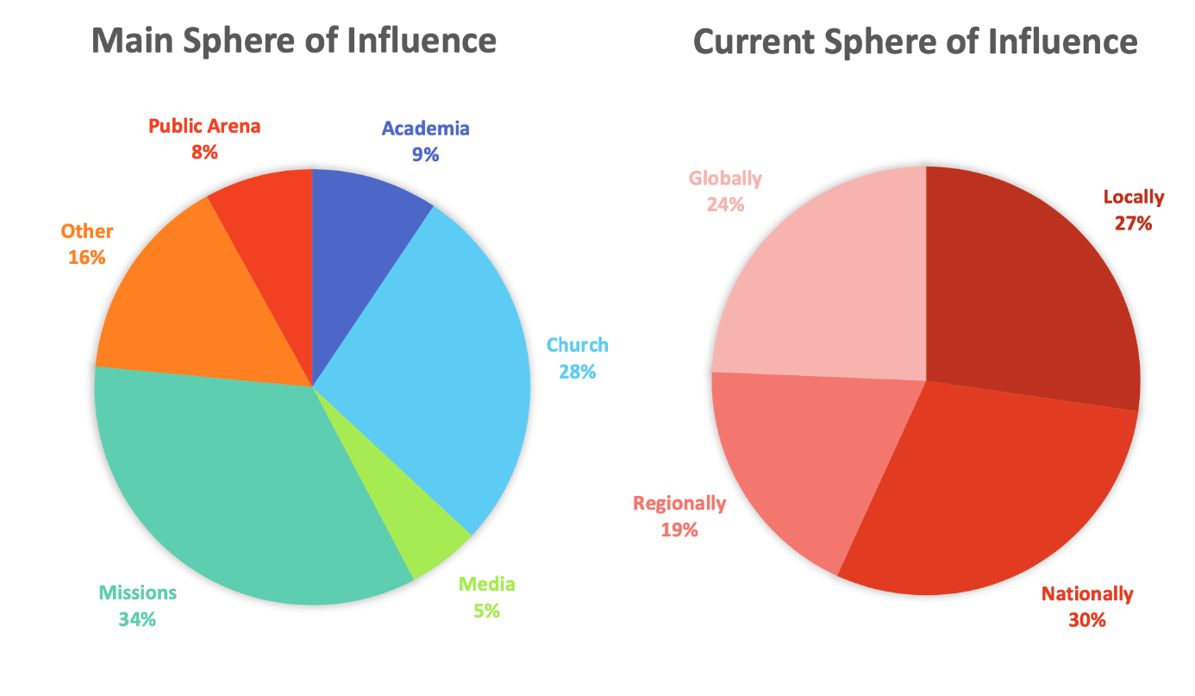
Figure 1: Main and current sphere of influence
The younger leaders were also surveyed about their leadership and training.
Academic Background: The overwhelming majority (96%) of participants had attended college or university.
Leadership Experience: The average age of appointment as a leader for those at YLG 2016 was 21 years of age. On average, they had eight years of leadership experience.
Training: Most of them (50%) were informally trained as leaders, while 30% had received formal training in leadership at a theological college or Bible school.
Leadership Mentoring: Lausanne also wanted to know if the younger leaders have a mentor or someone else walking with them, as well as if they themselves are mentoring another person.
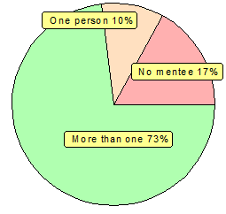
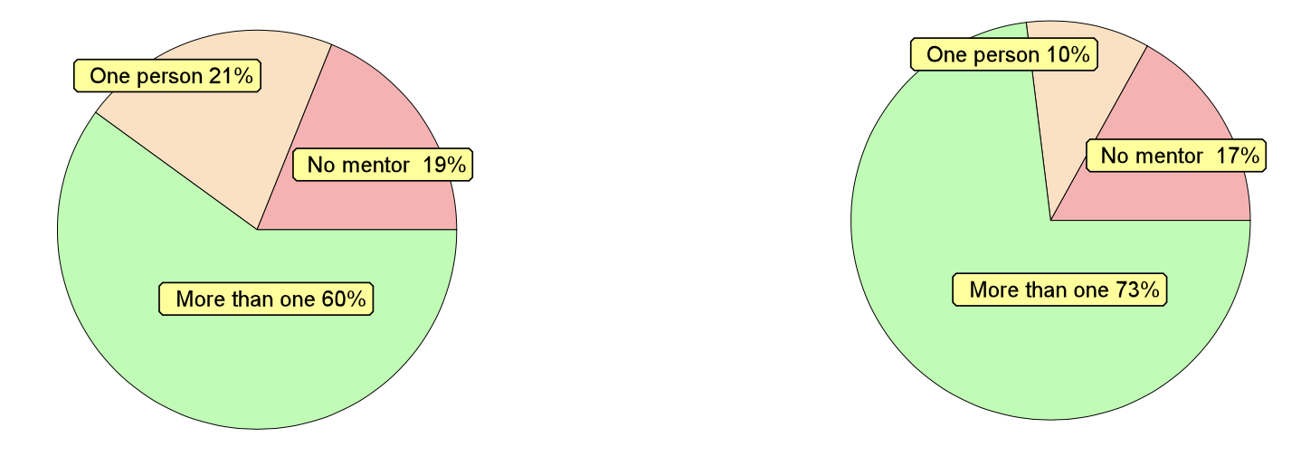
Figure 2:
Having a mentor for the journey Mentoring someone else?
As Figure 2 shows, more than 60% at YLG 2016 had at least one mentor, and more than 73% were mentoring more than one person. The mentoring itself was not defined here, although in Lausanne it is often used about walking alongside someone and sharing life experiences, more than just structured sessions.
Leadership Breaks: The younger leaders were also asked if they have ever had a break in their leadership: 65% said no, 35% said yes. Of these 35%, 27% had taken only one break. When asked for the reasons for taking a break, 26% were for training, 19% were due to personal issues, and 14% were caused by burnout.
Getting to Know the Lausanne Movement
YLG 2016 wanted to foster relationships and partnerships in the gospel. It was also expected that these younger leaders will connect with each other, as well as know better what the Lausanne Movement does and how they can participate. Every delegate was expected to make time beforehand to read the monthly emails and make time to prepare.
To be able to track progress, a survey was undertaken directly before the event and one directly after.
In the pre-gathering survey (Brierley 2016a), the younger leaders were asked how and if they had already connected with fellow participants before the gathering.
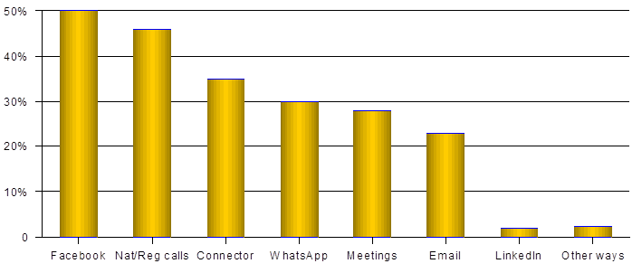
Figure 3: How friends were made in advance
Connecting with Others: Along with social media, there were also national and regional conference calls, an online platform called “Connector”, plus other tools. Seven out of every eight delegates had made some friends or connections beforehand. Once everyone had arrived at the gathering, there was already an atmosphere of being among friends and like-minded people.
New Relationships: Many new relationships were formed as a result of YLG 2016. On average each participant made 13 connections during the gathering. Two-thirds of the attendees also entered into some kind of new partnership with others. When asked two years later, 42% indicated that they were still in touch with 1-5 fellow participants, 26% with 6-10, and 16% with the sizeable number of more than 20.
Knowledge of and Connecting with Lausanne: When asked in the pre-gathering survey who they would like to connect more with, the younger leaders listed the issue network leaders as well as regional directors within the Lausanne Movement. These two groups are strategic for the development of the entire movement, since the issue network leaders connect around 35 strategic mission issues (Lausanne Movement n.d.a). Here, though, lies a challenge: Many of the younger leaders indicated that these expectations for connecting have not yet been met.

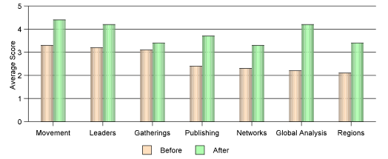
Figure 4: Comparison of what was known about Lausanne before YLG participants prepared and
after they had done so
Because of the preparation for YLG, overall the younger leaders received more understanding about what the Lausanne Movement offers. This trend toward increased understanding has continued through the past three years.
Lausanne YLGen’s Strategy
The YLGen team offers three main areas of support. Though the areas have stayed the same, they have developed further and become clearer through the first three years (Lausanne n.d.g).
Mentoring: When the younger leaders were asked about mentoring, 324 out of the 579 who had completed the YLGen launch confirmation form indicated that they had no mentor and would like to select one from the newly launched YLGen mentor directory.
Mentors were an essential part of the YLG 2016 programme, and it was vitally important to check their availability to continue to mentor the younger leaders through the ensuing YLGen process. More than 50% of the mentors then agreed to become long-term mentors. In addition, various Lausanne connections provided more names so that there is now a directory with over 250 mentors who are available to connect for mentoring at no charge.
Missional Resources: The YLGen Missional Resources team provides cutting-edge, on-going formal or informal training for the younger leaders in partnership with other institutions.
One of the initiatives is called “YLGen Educate”. Partnering theological institutions are identified to offer scholarships for graduate degrees, particularly to majority world leaders. The aim is to have one partner institution in each of Lausanne´s 12 regions (Lausanne Movement n.d.b) and maintain 30-40 full-tuition scholarships each year, ranging from MAs to PhDs.
Currently, there are partnerships with 12 colleges and universities, and since 2018 over 20 younger leaders have enrolled in various formal fields of study. The value of these scholarships is well over US$1 million.
Another area of missional resources is “YLGen Equip”, which offers informal and non-formal training in specific topics of high need among younger leaders. In the surveys undertaken by the YLGen team, several needs were identified. These have been incorporated into the monthly webinars, offered by high profile speakers. These webinars are free, and speakers often generously provide participants with free books related to the topic. More than 200 younger leaders have benefitted from these over the 2018-2019 two-year period.
Groups and Gatherings: At first it was thought that some of the interest groups which came about through YLG 2016 would continue. In fact, most of them did not continue. The focus has thus shifted to helping younger leaders launch national or regional younger leaders’ gatherings to multiply the impact of YLG 2016. These YLGen gatherings are to provide a place for younger leaders to meet, share hearts, and discuss relevant topics on missions consistent with the vision of the Lausanne Movement. For this purpose, a manual for gatherings was launched in January 2019.
At the same time, there is still an interest in having discussion groups on various topics. Out of the 579 younger leaders, 270 had indicated their willingness to facilitate such a discussion group. So far, however, matching the interest with the need for groups has not been realized. Furthermore, the technology for this venture has not been in place, which might have contributed to a slowing down of the whole process. The Lausanne Movement has therefore developed a secure platform, “CONNECTOR 2.0”, to provide the needed safe environment for these affinity communities.
Connecting with Lausanne Issue Networks: In addition to these three commitment focus areas, the highest concern and interest of the YLGen team is to connect younger leaders with the 35 issue networks which exist within Lausanne. As noted earlier, the younger leaders also expressed an interest in making these connections. These networks have been formed in response to the Calls to Action in the Cape Town Commitment (Lausanne Movement n.d.e). They focus on key global mission issues which are not already covered by other global networks. Much effort has been poured into these connections, and there has been progress. For the second phase of YLGen (from November 2019), it is hoped to appoint a younger leader on each of the issue network’s leadership teams. From the surveys, the younger leaders are most interested in Leadership Development (274), Business as Mission (133), Church Planting (120), and Scripture Engagement (109).
Connecting with Lausanne Regions: The Lausanne Movement 12 regions of operations are mainly categorized by language. It is the supporting goal of YLGen not only to connect younger leaders with each of the twelve regional directors but also to develop good relationships in their own country and continental contexts. The aim is to encourage ongoing growth in healthy intergenerational leadership communities and build intentional catalytic collaborations for Kingdom mission. In Phase 2 (2020-2023), the Lausanne Generations Issachar Initiative and the Graham-Stott-Mensah Institute (GSMI) are being developed. These new entities will help facilitate more effective integration between the younger leaders and Lausanne Issue Networks and regions.
Tracking the Initial Progress and Impact of YLG 2016/YLGen
To understand how the Lausanne Movement is reaching its goals, as well as to gain better understanding of the needs and trends among the younger global leaders, a team within YLGen was tasked with measuring impact. First, YLG 2016 participants were surveyed one week before the gathering, and another survey was undertaken immediately afterwards.
Survey Response Rates: The 865 leaders who attended YLG 2016 were surveyed before the gathering. More than 93% (801) filled in the online survey, with 700 responses submitted within the first 24 hours. Not only was this an outstanding and marked achievement in the history of the Lausanne Movement, but also in comparison to other surveys undertaken among various Christian conferences. The response rate for the immediate post-gathering survey was 83%. The subsequent survey response rates have been much lower at 63% for the first year after the survey and 21% for the second year after the survey. The number of active participants and poor timing may have impacted adversely on the two later surveys’ response rates. Even so, comparisons to the average survey response rates of 10-15% for external surveys and 30-40% for internal surveys (Fryrear 2015) give evidence of the strength and sustainability of YLGen surveys. Clearly a great deal of work has been poured into the younger leaders over the period leading up to YLG 2016 and into the community connections they have developed after the gathering through YLGen.

Impact of Interventions: In each of the two years after YLG 2016, the younger leaders were surveyed about how much they had benefited from YLGen initiatives over the previous year. The two surveys’ combined results are presented in the graph below.
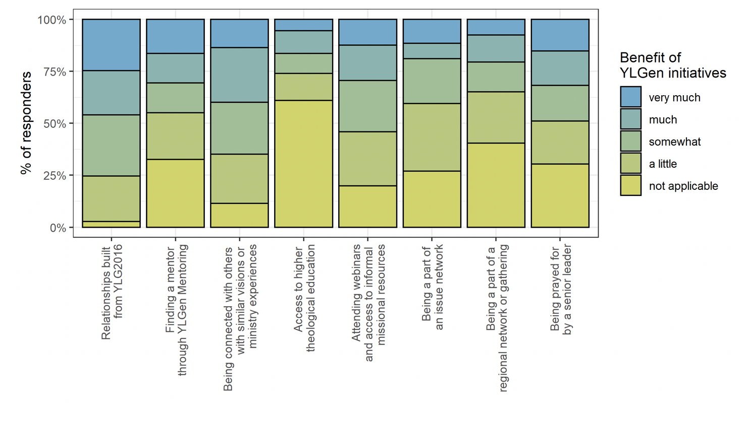

Figure 5: Personal and Ministry Benefits of YLGen Initiatives to Younger Leaders
Highlights ranged from the relationships built because of YLG 2016 to finding a mentor through YLGen Mentoring and being prayed for by a senior leader.
Younger Leaders’ Future Development and Mentoring
Survey results and YLGen strategy suggest themes for the development of younger leaders as disciples, followers, and leaders. Themes emerge as well for how senior leaders can encourage, support, and challenge younger leaders through mentoring relationships.
Lessons from the First Three Years of Engagement
The YLGen team has completed its first 3-year phase (2016–2019) and has therefore entered its second phase (2020–2023), the third of an overall ten-year strategy. Evaluations have been completed at various levels, and the transition into the second phase has been carefully processed in order to serve the younger leaders even more fruitfully. The phase transition was marked by a highly praised Online Anniversary with nearly 150 persons attending from some 90 locations globally representing 45 countries.
Key Leadership Life Challenges: In the survey two years after the gathering, the younger leaders were asked to cite some of the key challenges they faced at that moment in life and ministry leadership, as well as indicate how their challenges might have changed over the past year. One challenge cited was “having too much to do”. The leadership life improvements they have experienced included “better facing of loneliness” and in their relationships with the older generations. For 20% of them, though, the situation had worsened compared to the year before. They indicated “lack of pastoral care”.
Access to Theological Education: While YLGen Educate has provided new opportunities, about 64% of the respondents indicated that they still have no access to good biblical and theological training for their current leadership needs.
Non-formal Training Needs: The highest needs indicated by topic pointed to strategic planning, discipleship training, and organisational fundraising/development.
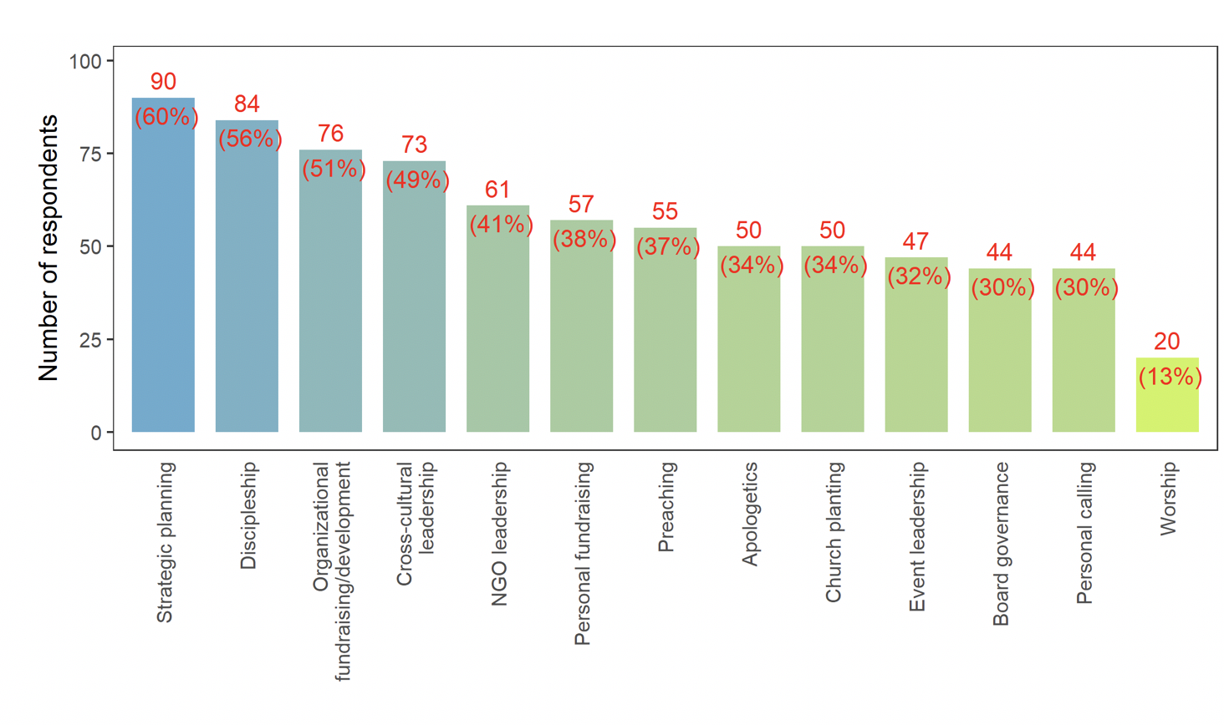
Figure 6: Ministry Training Needs, with Informal Training Desired
Looking Ahead
Upon transitioning from Phase 1 to Phase 2, lessons learned for on-going development of younger leaders include the following:
Start Early with Core Planning Team
In retrospect, it may have been smoother if the core YLGen team had a clearer strategy in place much earlier, well before YLG 2016. The core YLGen team was constituted only four months before the event and thus faced many pressures in planning details before the actual gathering. At a minimum, a 12-month period is recommended for such a global initiative, for more effective integration and interfacing with the Younger Leaders Team which served as the planning team for the Gathering itself. The ten-year strategy could have improved if planning for national or regional YLGs had been included in a structured follow-up plan. This need for planning has, however, been addressed with increasing emphasis since 2018, including a ‘YLGen Gatherings Manual’ written to guide planning efforts. An initial strategy aims at ten national or regional YLGs each year, distributed globally.
Intergenerational Bridging in the Global Church: The coming transition of leadership in the global church will present a major challenge due to the significant gap between boomers and millienials – with the latter needing to assume leadership when the former retire. Often the tension is felt or perceived between younger and senior leaders across different cultures and institutions globally. Such tension need not be so, as many mutually encouraging generational bridging opportunities exist for global mission. Lausanne hopes to bridge and connect influencers and ideas across generations, helping both sides to understand each other better and work towards building the Kingdom of God together.
The younger leaders are willing to start initiatives, and the YLGen team receive their requests for senior leaders to come alongside them. Younger leaders request mentoring relationships, desire to set up specific issue interest groups, organize country or regional gatherings, and take many more initiatives. Youngers leaders should not be a threat to senior leaders but a wonderful new generation displaying God’s gifts of leadership for his global mission into the future. These younger leaders need and desire the wisdom, generosity, friendship, and experience of the older generation.
3-G Leadership Teams Are Needed for Global Mission: The YLGen team also seeks to implement more intentionally a 3-G leadership structure at all levels to reflect good balance across the “3 G’s” of generations, gender, and geographic locations/global cultures. This approach presents a significant paradigm shift in much of the prevailing perceptions of leadership transitions. The idea is not simply to wait for the torch to be passed on but to lead together from an intergenerational perspective. Each generation, gender, and global culture contributes unique callings, gifts, and strengths to the intergenerational team. Lausanne as a movement is integrating this 3-G approach at all levels of leadership from the board to regional leadership.
Challenges for the Younger Leaders in the YLGen Initiative
Discrepancy between Desire and Reality: As the surveys showed, younger leaders are interested in developing and engaging with Lausanne, but reality shows gaps in relation to engaging with the 250 available mentors, with the 35 global mission Issue Networks, and in the 12 regions of the movement. Corresponding communication, cross-cultural, and generational gaps may be contributing factors. This desire-reality discrepancy sheds important light on discernment and planning for Phase 2 (2020–2023).
Busyness of Younger Leaders
In addition to the four end-of-year annual surveys, a survey focused specifically on the availability and engagement of younger leaders was taken six months after the fourth survey, or 2.5 years after YLG 2016. Out of all YLGen participants, 343 indicated “actively engaged” in one or more of the YLGen initiatives, while 236 are “passively engaged” which means regularly receiving all the information but not actively engaging or responding. The remainder seem tuned out. When a focused video call was arranged and a survey was sent to the “passively-engaged and tuned-out participants”, 13% responded. Interestingly, the findings showed that, for this category, the gap was often lack of information. Others were more engaged in the regional events, which had not been included in the global engagement survey. However, the primary reason cited for non-engagement was “busyness of life”. This survey result has provided a very helpful realization for the YLGen team’s strategy audit.
The Global versus the Local: The YLGen team has realized that proximity makes a huge difference, though being part of something ‘global’ sounds very exciting. Mentors are offered on a global scale, but the most fruit is seen when the mentors have the opportunity to meet face to face with younger leaders. Therefore, a renewed emphasis is being placed on national gatherings to deepen relational depth in peer connections and in encouraging whole-life mentoring relationships in local and national contexts. The YLGen team is aiming at the best fruit from the glocal (global and local) mission opportunities for this “connected generation”.
Conclusion
The authors count it a privilege being part of God’s work in raising a new generation of leaders in his global church for his global mission to the ends of the earth and to the end of the age. The Lausanne Movement, through YLGen, is passionately and intentionally committed to strategically investing in a new generation of younger leaders in a healthy and helpful intergenerational community. Careful plans are being made toward a next YLG in 2026, with sensitive adaptations to the changing needs of younger leaders. Impact research and responsive webinars have provided an insightful, experiential learning model and have been a major asset in this YLGen generational initiative.
The unique calling of each generation – each having unique gifts, strength of vision, leadership capacity, and life experience, is being harnessed through Lausanne YLGen for God’s global mission and glory. YLGen is looking forward with hope to the fullness of time when God, our Immanuel will dwell with us, and the kingdom of this world will become the Kingdom of our Lord and his Christ – the Lord we love because he first loved us (1 John 4:19).
References
Brierley, Peter (2016a). “Report on the Pre-YLG Survey”. Unpublished Paper.
Brierley, Peter (2016b). “Report on the Post-YLG Survey”. Unpublished Paper.
Fryrear, Andrea (2015). “What´s a good survey response rate?” surveygizmo website, https://www.surveygizmo.com/resources/blog/survey-response-rates/ (accessed February 9, 2020).
Hofmann, Deborah (2019). “Survey Analysis – two years after YLG 2016”. Unpublished Paper.
Lausanne Movement (n.d.a). “All Issue Networks” Lausanne Movement website, https://www.lausanne.org/all-issue-networks (accessed March 24, 2020).
Lausanne Movement (n.d.b). “All Regions” Lausanne Movement website, https://www.lausanne.org/all-regions (accessed March 24, 2020).
Lausanne Movement (n.d.c). “Billy Graham and John Stott” Lausanne Movement website, https://www.lausanne.org/billy-graham-and-john-stott (accessed March 23, 2020).
Lausanne Movement (n.d.d). “Report: YLGen Short Survey Analysis January 2019”. Unpublished paper.
Lausanne Movement (n.d.e). “The Cape Town Commitment” Lausanne Movement website, https://www.lausanne.org/content/ctcommitment (accessed March 30, 2020).
Lausanne Movement (n.d.f). “The Lausanne Movement´s Unique Calling” Lausanne Movement website, https://www.lausanne.org/about-the-movement (accessed February 9, 2020).
Lausanne Movement (n.d.g). “Younger Leaders Generation” Lausanne Movement website, https://www.lausanne.org/ylgen (accessed February 9, 2020).
Rodemann, Evi, ed. (2017). “One year after YLG 2016 Survey Analysis”. Unpublished Paper.

Wright, Chris (2010). “Calling the Church Back to Humility, Integrity and Simplicity” Lausanne Movement website, https://www.lausanne.org/content/calling-the-church-back-to-humility-integrity-and-simplicity-2 (accessed March 23, 2020).

