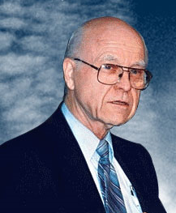
Every time I would meet with Dr. Ralph Winter in public gatherings or personal interactions I have been positively impressed by him. My first exposure to him was as a graduate student in a Missiology course in 1973. My encounters with him over the decades have included countless Urbana Student Missions Conventions as well as at mission congresses and conclaves around the world. How could anyone forget his red hot passion to reach the lost, his big-picture thinking, his relentless flow of stimulating ideas, and his diligent pursuit of the frontiers in global mission.

With his defining plenary address at the 1974 Lausanne Congress World Evangelization he captured the attention of the missiological world. Since then he has been a powerful influence through his teaching, writing, mentoring and networking he stimulated hundreds around the world to mobilize and engage in pioneering cross-cultural evangelism.

Thousands have benefited from Dr. Winter’s prolific missiological writings. His observations often were thought-provoking and sometimes controversial; his style was often persuasive and sometimes even prophetic. Ralph’s massive contribution has significantly shaped and structured the way we approach world evangelization.

Dr. Winter’s legacy is more than the U.S. Center for World Mission, William Carey International University, Theological Education by Extension, American Society of Missiology, Perspectives on the World Christian Movement Study Program, Mission Frontiers, etc. but how he lived a simple lifestyle and sacrificed so much of his energy, time and resources to expand the frontiers of God’s Kingdom.

As a catalytic missiologist, brilliant strategist, pioneering entrepreneur, global networker and tireless mobilizer, Dr. Winter was truly a giant among us!
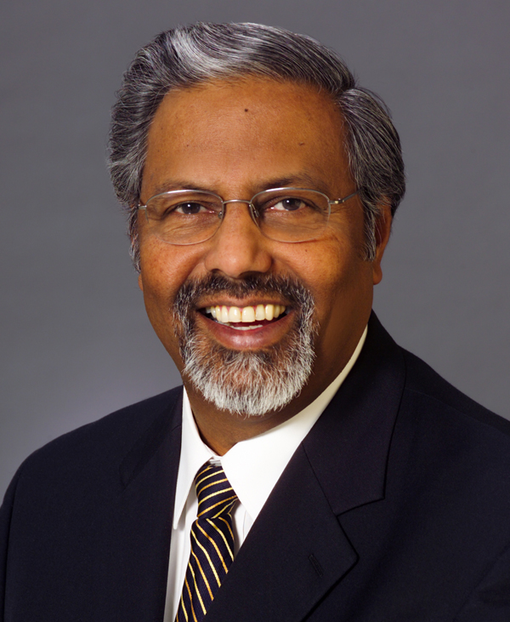
Rev. Dr. T.V. Thomas
Director, Centre for Evangelism & World Mission
Regina, Saskatchewan CANADA

June, 2009

Published in the July 2009 issue of the multi-lingual online journal www.GlobalMissiology.org

